ENERGY AND ENVIRONMENT CABINET

Matthew G. Bevin Department for Natural Resources Charles G. Snavely
Governor Division of Mine Safety Secretary
300 Sower Boulevard
Frankfort, Kentucky 40601
Phone (502) 573-0140
Fax (502) 573-0152 Allen Luttrell
Commissioner

SAFETY ALERT
(Alert – No. 2 – 2017)

Kentucky DMS – Highwall Safety

The following information is being provided in hopes of protecting our most valuable resource, the miner.

This alert is a result of several highwall failures that have occurred within the state, one of which resulted in the loss of one of our fellow miners.

- Barbourville Branch Accident – A 33-year-old miner with 8 years of experience was fatally injured while working at a surface mine. The victim was positioned in front of an auger machine changing out worn cutting bits. A section of the wall measuring 9’4” by 7’4” wide and 3’1” thick dislodged from the base of the wall and struck him, resulting in fatal injuries.
- Hazard Branch Incident – A near miss shared during a behavior-based observation identified that a co-worker had noticed a working highwall and directed the surface drill operator working directly beneath it to move the drill. The wall fell just after the operator had moved the drill to a safe location.
- Hazard Branch Incident – A highwall failure occurred on an evening shift when a berm that had been put in place due to an unstable highwall had been removed. The dozer operator had been directed to remove the berm and after removing, it had proceeded to park the machine in the previously bermed area. Shortly after the section of wall fell and entrapped the machine. The dozer was recovered during the next shift.

HIGHWALL SAFETY

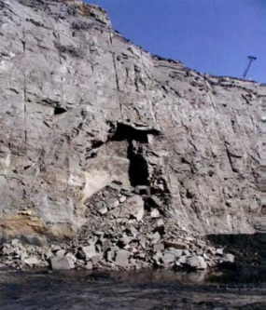

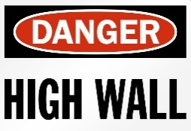

RECOMMENDATIONS
- Ensure that miners at all times work, travel, and operate mining systems/equipment at a safe distance from the toe of the highwall.
- Safely examine a highwall from as many perspectives as possible (bottom, sides, and top) before work begins.
- Use adequate lighting during non-daylight hours to conduct examinations and to illuminate work areas.
- Conduct additional examinations as necessary, especially during periods of changing weather conditions.
- Remove highwall hazards or barricade hazardous areas to keep miners away.
- Train all miners to recognize hazardous highwall conditions.

