An illustrated history of the miners' safety lamp
By Mark Carlyle Published: 01 February 2016

Mark Carlyle, Curator of Industry at the National Coal Mining Museum for England, gives a brief history of the miners' safety lamp
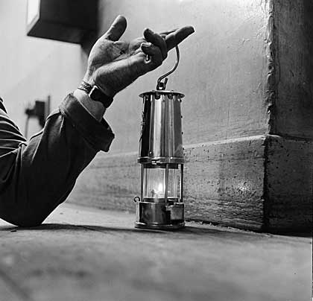
© The National Coal Mining Museum for England
Coal miners were frequently at danger from explosive mixtures of methane gas in the atmosphere of the mine. At the beginning of the nineteenth century, pressure mounted to find an alternative to naked flames that would provide adequate and safe light to enable miners to work underground.
In the end, two of the period’s finest minds raced to produce the first safe lamp for the mining industry.

The Davy Lamp
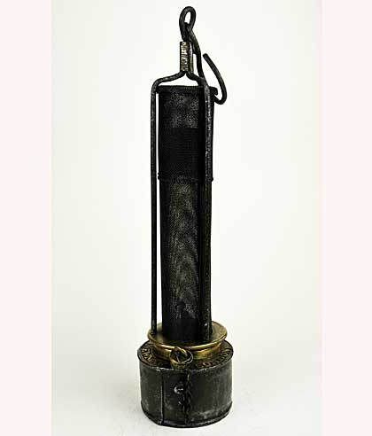
The Clanny Lamp © The National Coal Mining Museum for England
Sir Humphry Davy successfully tested his prototype safe lamp at Hebburn colliery, Tyne and Wear, in early January 1816.
Davy found that flame could not pass through the small apertures in fine gauze meaning the flame inside the gauze would not ignite the gas in the atmosphere outside the lamp. Davy was one of the most celebrated scientists of his day and his discovery, based on scientific principles, became the foundation for most flame-safety lamps that followed.

The Stephenson Lamp
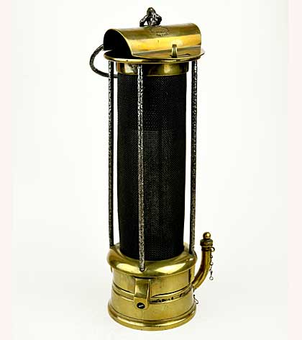
The Stephenson Lamp© The National Coal Mining Museum for England
At the same time that Davy was working on a design, George Stephenson had been creating his own lamp based on mechanical principles. While Stephenson later became well known for his work with locomotives, at the time he was an engineer and engine wright from High Pit, Killingworth in Northumberland.
His lamp used fine tubes and an internal glass to separate the flame and the atmosphere, and was frequently championed by miners from the North-East.

The Clanny Lamp
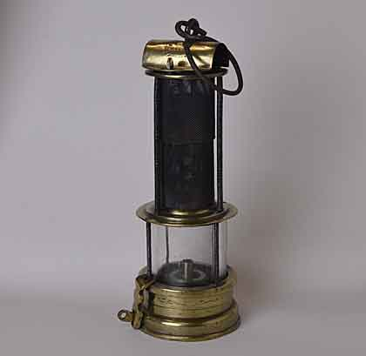
The Clanny Lamp© Courtesy The National Coal Mining Museum for England
A long-term worker in this field, the doctor William Reid Clanny, continued to refine his ideas on lamps after both Davy and Stephenson had moved on to other work.
The culmination of his research was the invention, in 1839, of the lamp that now bears his name. The gauze around the flame was replaced with glass, both increasing the amount of light and shielding the flame.

The Mueseler Lamp
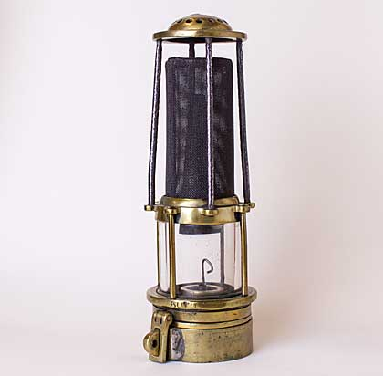
The Mueseler Lamp© The National Coal Mining Museum for England
A significant lamp emerged from Europe soon after the Clanny lamp was introduced. The Mueseler lamp was designed by a Belgian engineer, Mathieu Louis Mueseler, in 1840.
The lamp was similar to Clanny’s but, by adding a conical internal chimney to aid the air flow within the lamp, Mueseler reduced the tendency for the internal glass to become sooty and so gave a clearer light.

The Marsaut Lamp
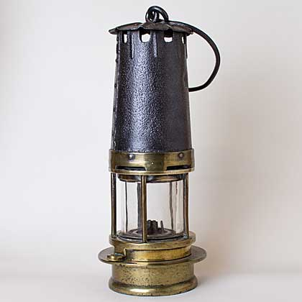
The Marsaut Lamp© The National Coal Mining Museum for England
In 1882 Jean Marsaut, a French mining engineer, adapted a Mueseler Lamp by replacing the internal chimney with a second conical gauze and added a full bonnet to protect the gauze.
The lamp was highly praised and many manufacturers went on to produce their own variations on what became the blueprint for the modern mining lamp.

The Clowes Hydrogen Lamp
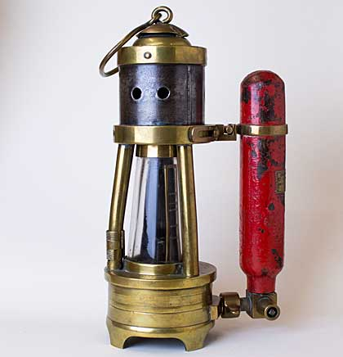
The Clowes Hydrogen Lamp© The National Coal Mining Museum for England
Soon after the introduction of the safety lamp underground, miners noticed that its flame changed if there were gases in the atmosphere. In the late-nineteenth century, lamp makers began to develop dedicated gas-testing lamps, such as the Clowes Hydrogen lamp, that would give more sensitive readings of methane levels.

The Electric Cap Lamp
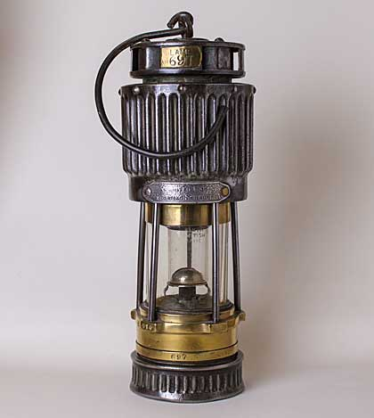
Electric Cap Lamp© The National Coal Mining Museum for England
In the 1890s electric hand lamps were being developed and by the 1920s, the electric cap-lamp began to take over as the miner’s main light source.
To compete with the strong light produced by the new electric lamps, makers started to produce high-candle-power lamps. These were larger lamps, often with elaborate bonnets, that produced considerably more light.

The Flame-safety Lamp
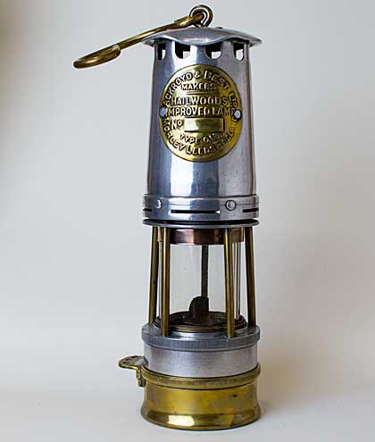
Flame Safety Lamp© The National Coal Mining Museum for England
As electric lamps became the standard lighting equipment, flame-safety lamps were still used to test for gas. Deputies were required by law to carry a flame-safety lamp and an electric safety lamp during their pre-shift checks.

Garforth Lamps
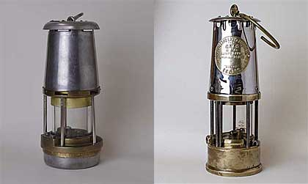
Garforth Lamps© Courtesy National Coal Mining Museum for England
The final development in flame-safety lamps came when Protector and Wolf, the last major flame-safety-lamp manufacturers, produced their Garforth lamps.
The Wolf FG and the Protector GR6S were the result of many years of lamp development and research. By the 1990s, Protector had become the main supplier to the British coal-mining industry.
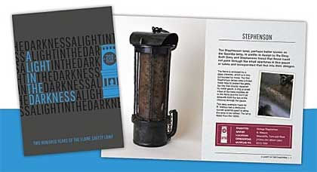
The exhibition ‘A Light in the Darkness’ ran at the National Coal Mining Museum for England until January 24 2016. If you want to read more about flame-safety lamps, the accompanying publication is still available from the museum shop. Visit www.ncm.org.uk or Telephone : 01924 848 806.

