Basic types of fire extinguishers
The two most common types of extinguishers, pressurized dry chemical and carbon dioxide extinguishers:
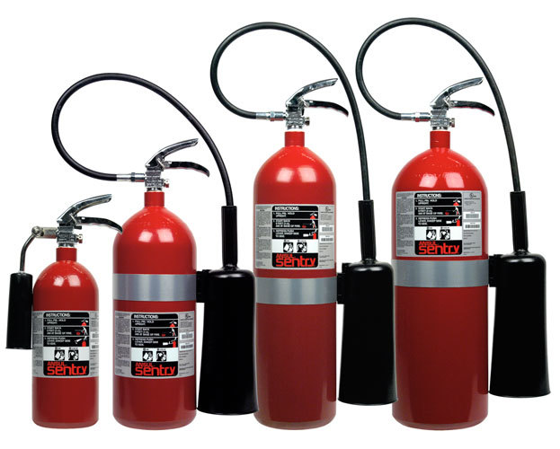
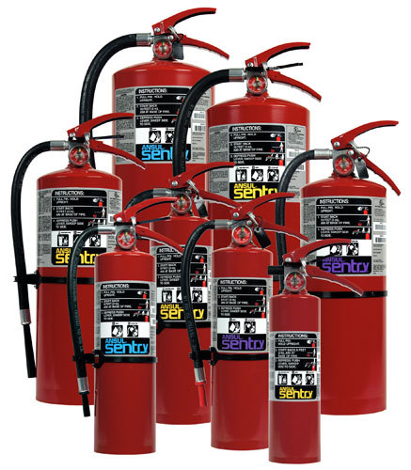

Knowing what fire your fire extinguisher can handle is important. There are 5 types of fire extinguishers that match the fire class:
- Class A fires are ordinary materials like burning paper, lumber, cardboard, plastics etc.
- Class B fires involve flammable or combustible liquids such as gasoline, kerosene, and common organic solvents used in the laboratory.
- Class C fires involve energized electrical equipment, such as appliances, switches, panel boxes, power tools, hot plates and stirrers. Water can be a dangerous extinguishing medium for class C fires because of the risk of electrical shock unless a specialized water mist extinguisher is used.
- Class D fires involve combustible metals, such as magnesium, titanium, potassium and sodium as well as pyrophoric organometallic reagents such as alkyllithiums, Grignards and diethylzinc. These materials burn at high temperatures and will react violently with water, air, and/or other chemicals. Handle with care.
- Class K fires are kitchen fires. This class was added to the portable extinguishers Standard 10 in 1998.
There are both dry chemical and Carbon dioxide (CO₂). Dry chemical are useful on all fires but leaves a residue that can damage electrical equipment. So, for electrical equipment (Computers, Servers, etc.) CO₂ extinguishers are better suited.
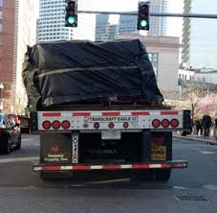
“The real act of discovery is not in finding new lands, but in seeing with new eyes” Marcel Proust

