ENERGY AND ENVIRONMENT CABINET

Matthew G. Bevin Department for Natural Resources Charles G. Snavely
Governor Division of Mine Safety Secretary
300 Sower Boulevard
Frankfort, Kentucky 40601
Phone (502) 573-0140
Fax (502) 573-0152 Allen Luttrell
Commissioner

SAFETY ALERT
(Alert – No. 1 – 2017)

Kentucky DMS – Electrical Safety Alert No.1

The following information has been provided in hopes of protecting our most valuable resource, the miner.

This alert is a result of the occurrence of three electrical incidents, each with the potential of having resulted in fatal injuries.

- Pikeville Branch Incident - After the restocking of an electrical cable coupler a mechanic placed his hands on the coupler as he began to stand. At this time an arc flash occurred at the coupler, resulting in 2^{nd-} degree burns to both hands of the mechanic.
- Hazard Branch Incident – While moving the section/unit, the locks, and tags associated with a roof bolter trailing cable in need of repair had been removed during a shift change. As the cable was in the process of being moved by the oncoming shift, a second worker inadvertently re-energized the circuit, resulting in flash burn injuries to the eyes of the cable handler.
- Madisonville Branch Incident – A continuous miner operator was at the face of an entry extracting a cut of coal when a nearby splice in the machines trailing cable blew-out. As a result, he was taken to the hospital and returned to work the next day.

ELECTRICAL SAFETY IS A MATTER OF LIFE AND DEATH

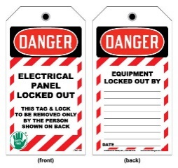
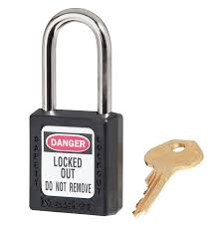

RECOMMENDATIONS
- Ensure electrical circuits are locked and tagged out of service by all persons performing work on the circuits, and that the locks and tags remain in place until the repairs are completed.
- Wear proper protective equipment for the task performed.
- Never work outside of your scope of knowledge.
- Electrical work shall be performed by or under the direct supervision of a certified electrician.
- Communicate your intentions prior to working on an electrical circuit to ensure the circuit is, and remains, de-energized. Each person performing work on the circuit must apply an individual lock and tag and locks may only be removed when the work is completed or replaced with another lock prior to removal.
- Conduct thorough exams of all electrical equipment at required intervals to ensure the proper operation of safety components.

