Find the Area of Irregular Shapes

Name:_______________________

Find the area of the following shapes. Show all of your work and label units. Circle your answer. Do not round.

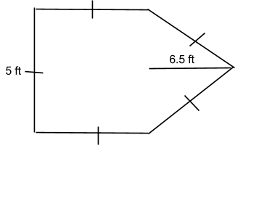

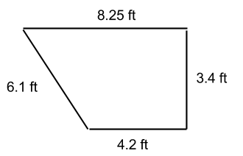

Find the Area of Irregular Shapes 2

Name:_______________________

Find the area of the following shapes. Show all of your work and label units. Circle your answer. Do not round. Not drawn to scale.

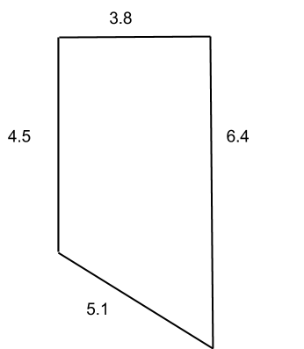

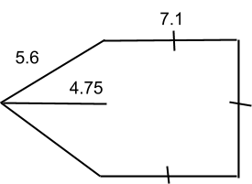

Find the Area of Irregular Shapes

ANSWER KEY

Find the area of the following shapes. Show all of your work and label units. Circle your answer. Do not round.

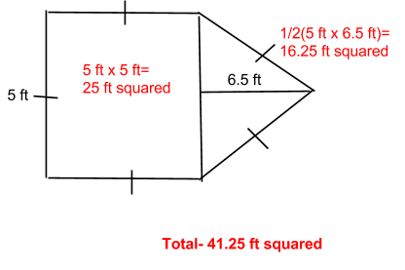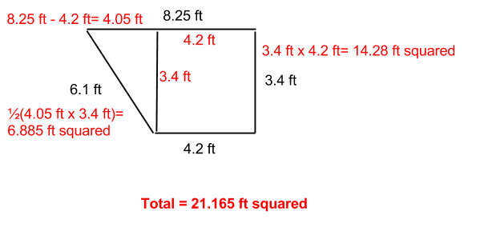

Find the Area of Irregular Shapes 2

Name:_______________________

Find the area of the following shapes. Show all of your work and label units. Circle your answer. Do not round. Not drawn to scale.

