**SOUTHEAST**

**REGIONAL**

**MINE RESCUE CONTEST**

**First Aid Problem**

**2025**

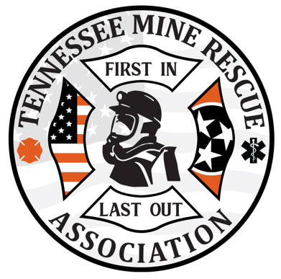

**Team Statement:**

**You and your team are dispatched to the 97 Volunteer Belt Line for an unknown incident. Initial statements coming out state that the belt crew was in process of inspecting the belt line. Upon arrival, you find what appears to be a underground light duty vehicle accident into fixed infrastructure with three victims. One victim appear to be unresponsive, another semi-responsive, and the other appears to be pinned between Kubota and belt line in obvious pain as he is screaming for help. *Transportation is delayed.***

**Thank you for your response – there is no time limit for this problem; once completed, hand this statement back to the judges to stop the clock.**

**Evaluator Notes:**

1. **The power to the belt MUST be disconnected and locked out. Additionally, the Kubota MUST be secured against movement, turned off, and put in park. Failure to do so would equal team endangerment for all team members and discounted under scorecard A #11 – critical skill not ensuring scene safety; lock out supplies are stationed around the disconnect box and a chock is in the back of the Kubota.**
2. **When the power is disconnected, the judge should advise that the power is off. Additionally, when Kubota is secured, judge should advise secured/safe.**
3. **Following simple triage, both the driver and pinned victim are high priority patients. The victim under the Kubota is deceased upon arrival.**
4. **Teams should call to surface to gain instructions for BP management for the pinned victim prior to moving Kubota.**
5. **Ensure glove changes are happening between patients.**
6. **Teams will also need to provide supervisor with some instructions as a bystander in the incident.**
7. **After teams initiate checking for vitals, the sheet with vitals will be given to the teams for each patient.**
8. **The time and problem starts when the scenario is given to the teams; problem and time stops once scenario is given back to the judge.**

**Scene Set Up**

**20’**

**17’**

**Power box**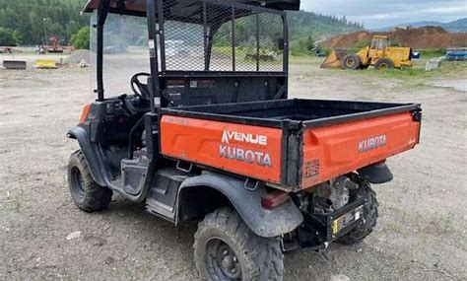



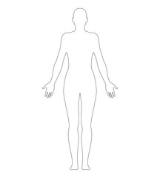



**17’**

**TEAMS MATERIALS**

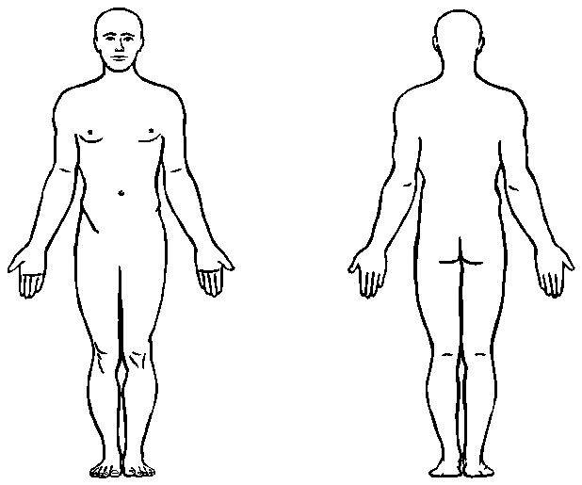**Pinned Victim**

2in forehead laceration

Bruised Chest.

Bruised abdomen.



Lower Back Injury (bruising Noted)

Open Forearm Fracture

Closed femur fracture

No PMS

Initial Assessment:

Orientation: Responsive

Airway: Open

Respirations: 38

Circulation:

Facial bleeding

Cool and Pale Skin

Pulse = 110

Once team treats and removes driver from Kubota, and calls for medical direction from surface to treat pinned victim, Kubota can be pushed back enough to free pinned patient. NOTE – teams will need to also remove and cover the deceased patient under the Kubota prior to moving back.

Patient under Kubota is deceased upon assessment.

**Kubota Driver**

4in Cheek laceration.

Nose Bleed

Black Eye

Bruised abdomen from steering wheel.

Patient will vomit when teams starts assessment and a bag of pills will be visible in an open phany pack.

Upper neck and spine injury (obvious bruising).

Teams should consider closed head trauma given extent of facial injuries.

Orientation: semi-responsive

Airway: Open

Respirations: 11 (slow and shallow)

Circulation:

Facial bleeding

Cool and Clammy Skin

Pulse = 128

Disoriented and disgruntled; tries to get out, wont stay still . .

**Kubota Driver**

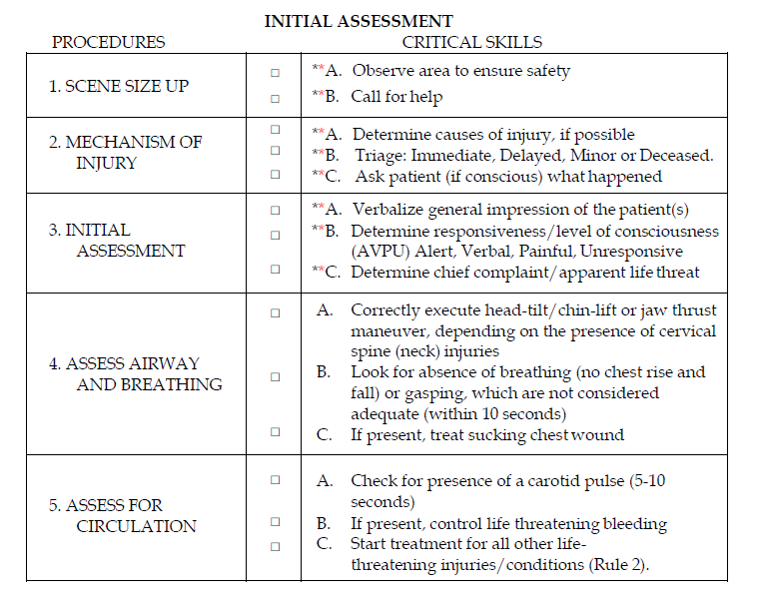

IMMEDIATE: Rapid Patient Assessment treating all life threats Load and Go. If the treatment interrupts the rapid trauma assessment, the **assessment** will be completed at the end of the **treatment**.

DELAYED: Detailed Patient Assessment treating all injuries and conditions and prepare for transport.

MINOR: (Can walk) Detailed Patient Assessment treating all injuries and conditions and prepare for transport. After all IMMEDIATE and DELAYED patient(s) have been treated and transported.

DECEASED: Cover

**\*NOTE: Each critical skill identified with an asterisk (*) shall be clearly verbalized by the team as it is being conducted at contest not utilizing moulage. Each critical skill identified with a double asterisk (**) shall be clearly verbalized by the team as it is being conducted at all contests.**

**After initially stating what BP-DOC- Bleeding, Pain, Deformities, Open wounds stands for, the team may simply state BP-DOC- Bleeding, Pain, Deformities, Open wounds when making their checks. Teams may use the acronym “CSM” when checking circulation, sensation and motor function.**

**Transportation is delayed: The Team will have to perform a full assessment and treat all injuries on both patients.**

**Pinned Patient**



IMMEDIATE: Rapid Patient Assessment treating all life threats Load and Go. If the treatment interrupts the rapid trauma assessment, the **assessment** will be completed at the end of the **treatment**.

DELAYED: Detailed Patient Assessment treating all injuries and conditions and prepare for transport.

MINOR: (Can walk) Detailed Patient Assessment treating all injuries and conditions and prepare for transport. After all IMMEDIATE and DELAYED patient(s) have been treated and transported.

DECEASED: Cover

**\*NOTE: Each critical skill identified with an asterisk (*) shall be clearly verbalized by the team as it is being conducted at contest not utilizing moulage. Each critical skill identified with a double asterisk (**) shall be clearly verbalized by the team as it is being conducted at all contests.**

**After initially stating what BP-DOC- Bleeding, Pain, Deformities, Open wounds stands for, the team may simply state BP-DOC- Bleeding, Pain, Deformities, Open wounds when making their checks. Teams may use the acronym “CSM” when checking circulation, sensation and motor function.**

**Scene size up would generally not be applied for this one as this has been capture with drivers initial assessment or the teams entrance to the scene.**

**Transportation is delayed: The Team will have to perform a full assessment and treat all injuries on both patients.**

**PT under Kubota (Deceased) at rear**



IMMEDIATE: Rapid Patient Assessment treating all life threats Load and Go. If the treatment interrupts the rapid trauma assessment, the **assessment** will be completed at the end of the **treatment**.

DELAYED: Detailed Patient Assessment treating all injuries and conditions and prepare for transport.

MINOR: (Can walk) Detailed Patient Assessment treating all injuries and conditions and prepare for transport. After all IMMEDIATE and DELAYED patient(s) have been treated and transported.

DECEASED: Cover

**\*NOTE: Each critical skill identified with an asterisk (*) shall be clearly verbalized by the team as it is being conducted at contest not utilizing moulage. Each critical skill identified with a double asterisk (**) shall be clearly verbalized by the team as it is being conducted at all contests.**

**After initially stating what BP-DOC- Bleeding, Pain, Deformities, Open wounds stands for, the team may simply state BP-DOC- Bleeding, Pain, Deformities, Open wounds when making their checks. Teams may use the acronym “CSM” when checking circulation, sensation and motor function.**

**Scene size up would generally not be applied for this one as this has been capture with drivers initial assessment or the teams entrance to the scene.**

**Team should cover the deceased patient.**

**Driver**

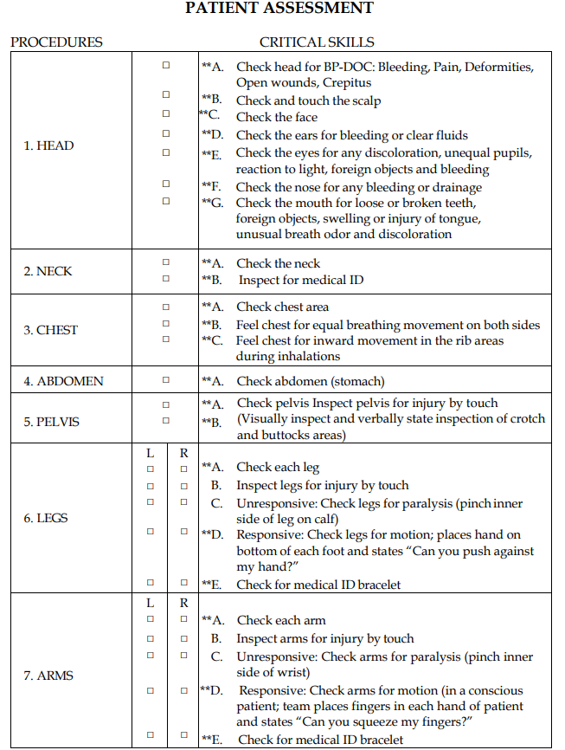



**Driver**

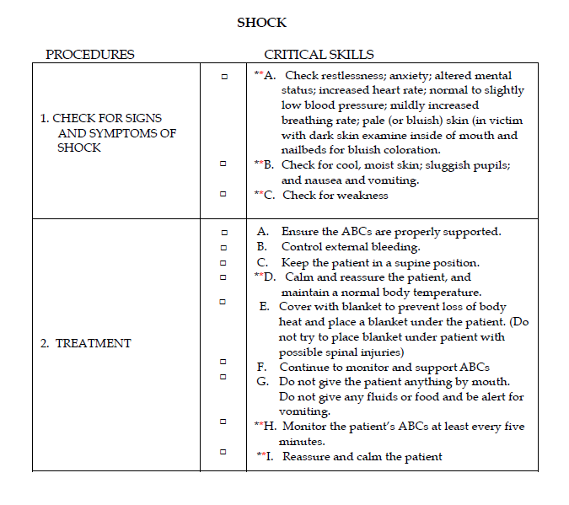

**Teams shall give Supervisor instructions to remain by their side while caring for other PTs. They shall also reassure and calm supervisor throughout the process helping treat for shock. supervisor will be very vocal during care and care of other PTs.**

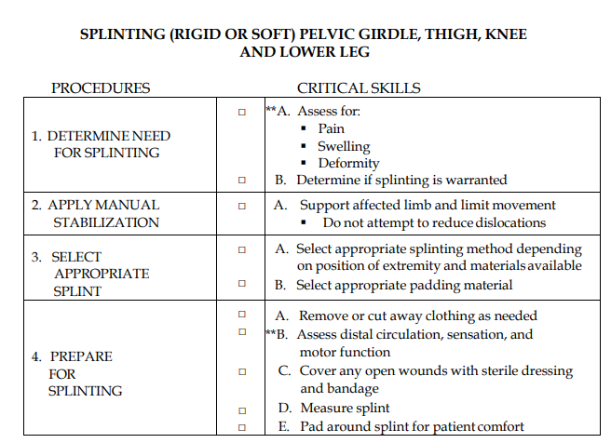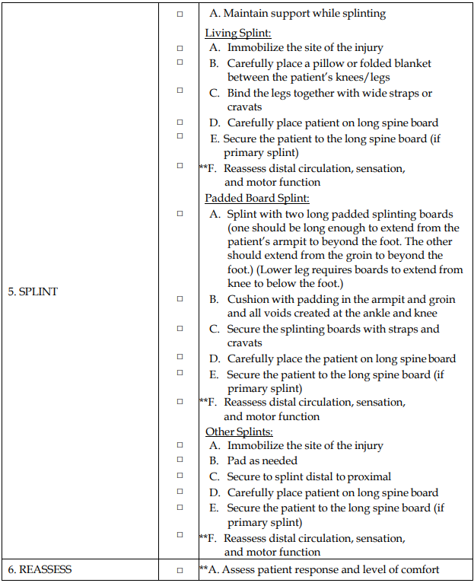

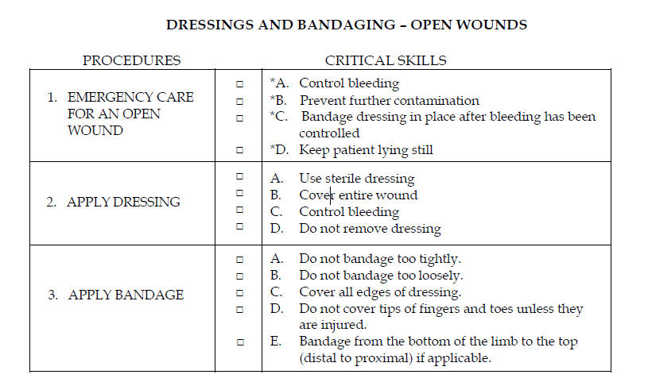

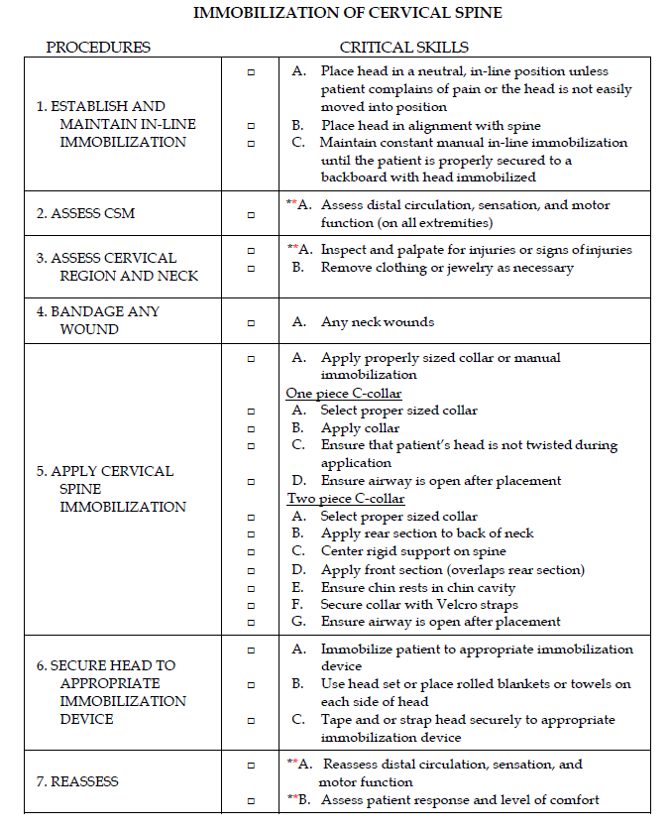

**Pinned Patient**





1. **Pinned patient can be treated and Kubota moved only after Driver has been removed from Kubota and deceased patient has been removed from under the Kubota. Then Kubota can be rolled back enough to get patient free and start treatment. Teams must resecure Kubota from movement after moved or discounted accordingly for team safety.**

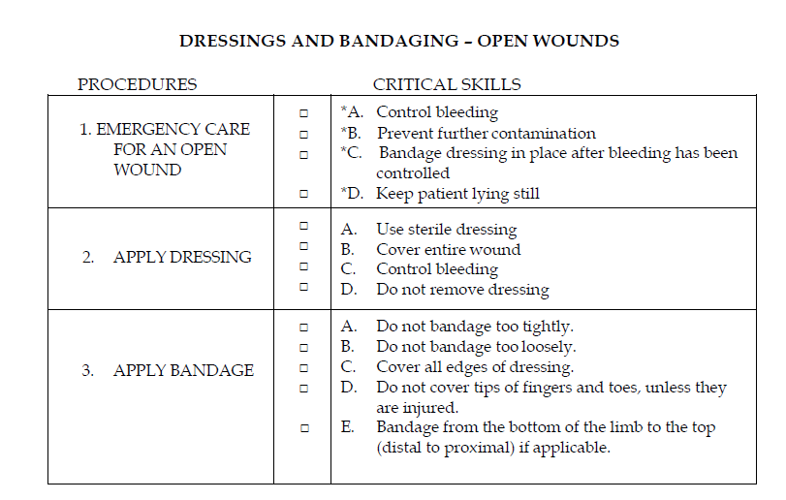

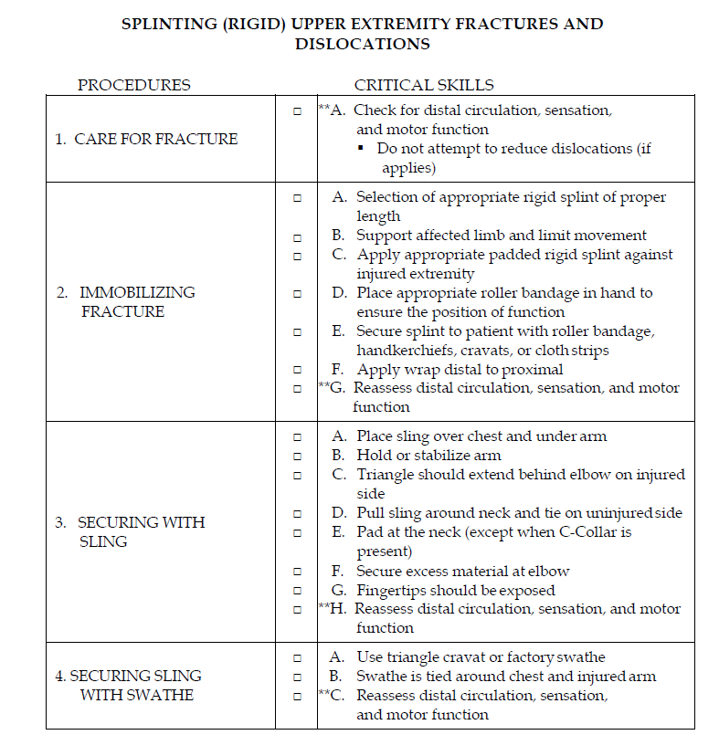

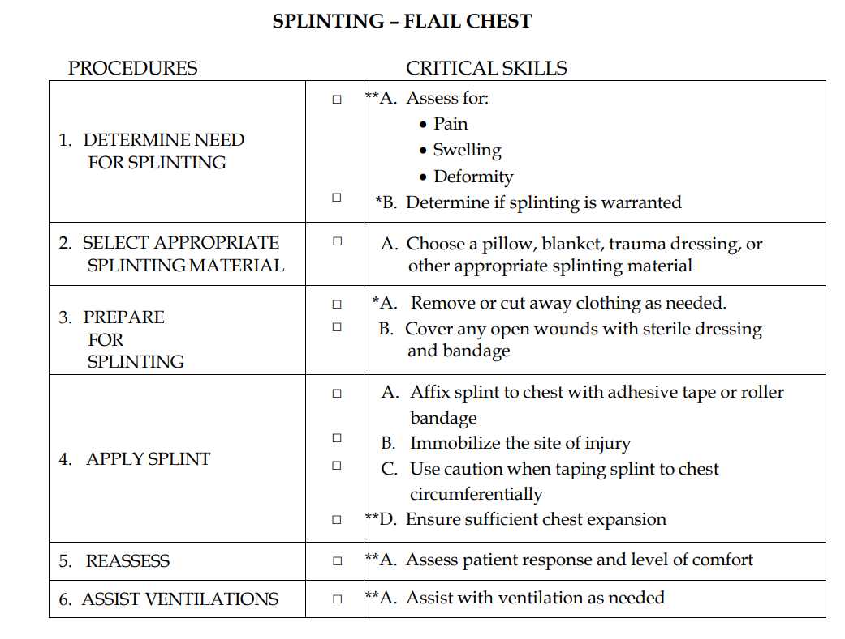

Added to the problem



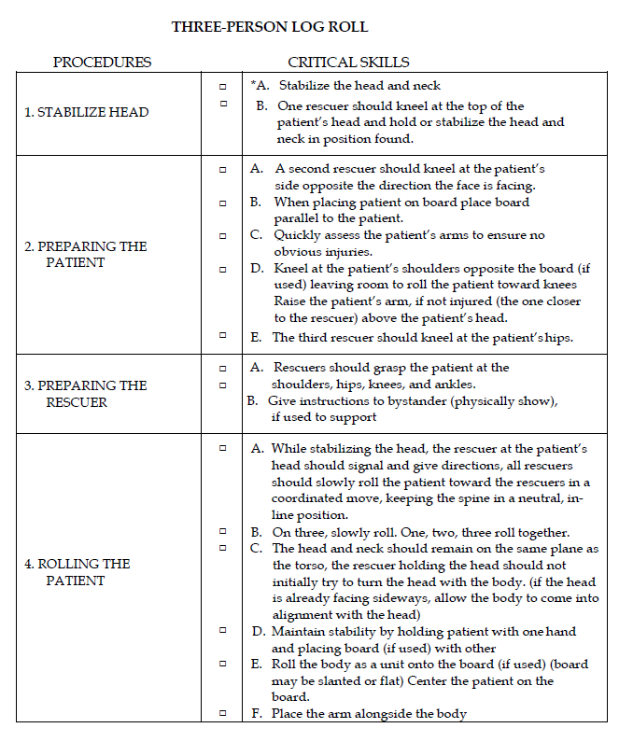

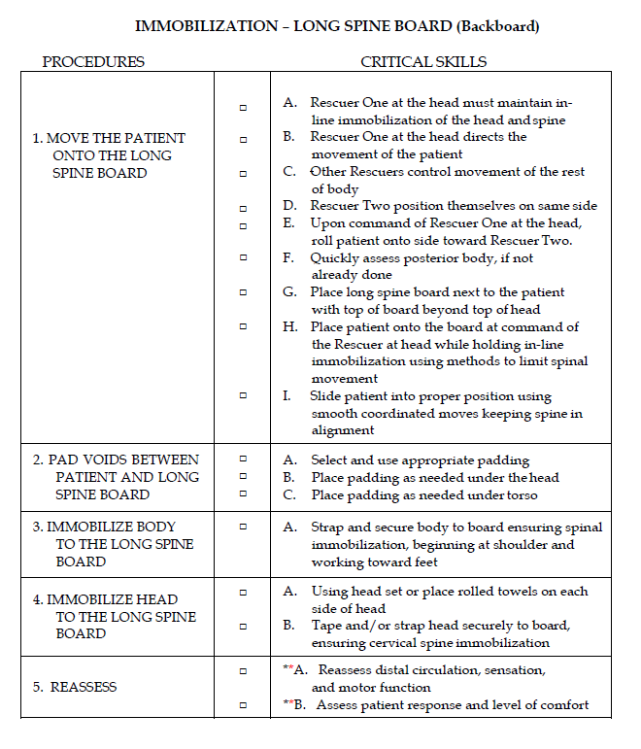

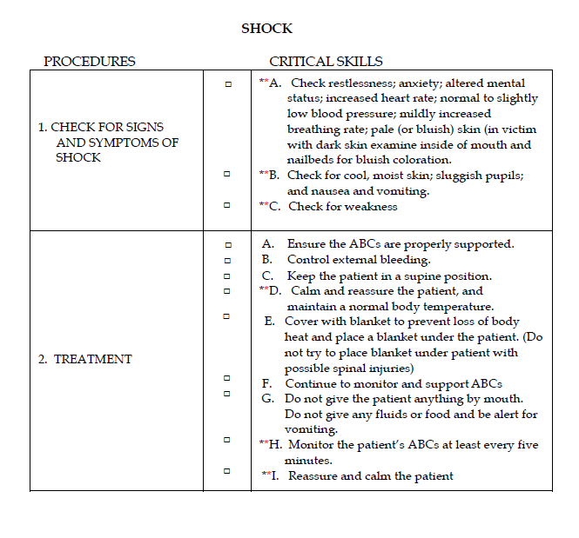

**Points of interest:**

1. It is not uncommon for a team or provider to use different acronyms than what is used in the Brady 11th edition. It is of my opinion that not penalty should occur if a team member uses a different acronym but accurately assesses and treats the patient. The first example would be CSM and PMS, another example could be BP-DOCS and DCAPBTLS. Both memory aids are developed to help the rescuer remember the steps and are expected by the healthcare community. Regardless of the acronym/mnemonic used, the evaluation of performance should be made on the overall assessment and treatment and not which memory aid was used.
2. This problem is intended to test the skills of mine rescuers in the event of an emergency and shall be made as realistic as possible. All live props used are intended to help enhance the training and test the skills and knowledge of those involved. Patients will play a vital role in helping make as realistic as possible and all injuries will be utilized with realistic moulage and blood.