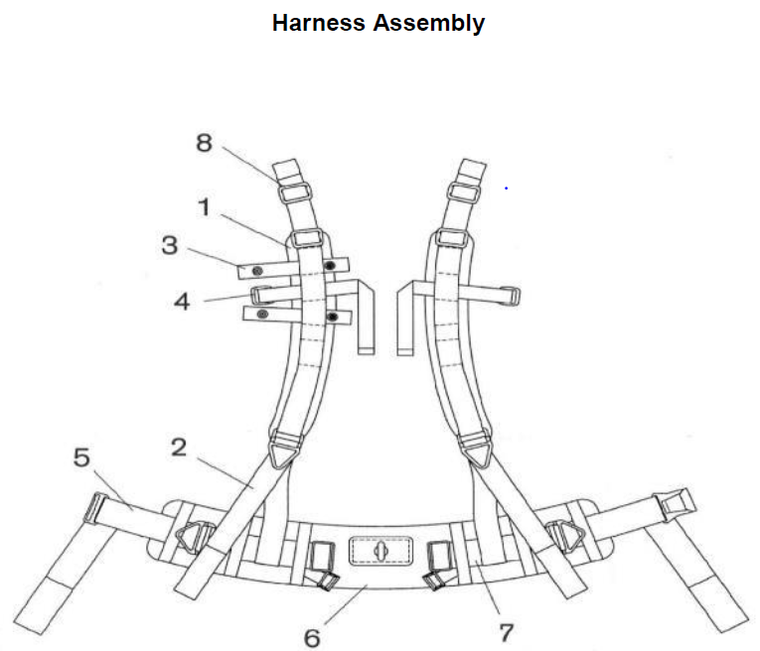

|  |  |
| --- | --- |
| 1 2  Cons. No. Designation | 1 2  Cons. No. Designation |
| 1 Shoulder _____ Assembly **(11)**  2 Shoulder Adjusting Strap  3 _____ Clip **(12)**  4 Hose _____ Harness **(13)** | 5 Adjusting _____ Assembly **(14)**  6 Waist Belt  7 Belt ______ **(15)**  8 Buckle |

**(11) (12) (13) (14) (15)**

A. Pad A. Line A. Buckle A. Strap A. Assembly

B. Strap B. Cable B. Strap B. Belt B. Harness

C. compress C. Hose C. Belt C. Harness C. Strap



|  |  |
| --- | --- |
| 1 2  Cons. No. Designation | 1 2  Cons. No. Designation |
| 1-8 Refillable _______ **(16)**  2 ______ **(17)**  3 _____, Refillable Cartridge **(18)**  4 Strap with Tention Spring Hook | 5 Refillable Scrubber ______ **(19)**  6 Filter Mats  8 _______ Approved Label **(20)** |

**(16) (17) (18) (19) (20)**

A. Regencanister A. Cover A. Seal A. Screen A. OSHA

B. Canister B. Lid B. O-ring B. Mats B. NIOSH

C. Cartridge C. Cap C. Gasket C. Filter C. MSHA