SOUTHEAST
REGIONAL
MINE RESCUE CONTEST
First Aid Problem
2023
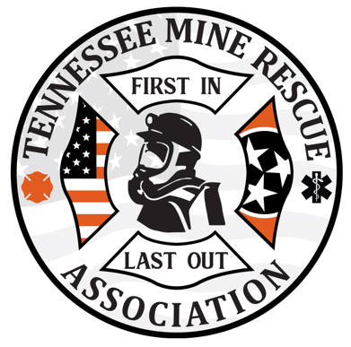
Team Statement:

You and your team are dispatched to the 187 Beltline for an unknown incident. Initial statements coming out state that Stinky Pete’s shirt got caught up in the belt; then, Silly Billy jumped up onto the belt to cut the power off to save Stinky Pete when he lost footing and grabbed the electric cable blowing him off the belt. Upon arrival, you find what appears to be a belt related incident with two victims. One victim (Silly Billy) appears to be unresponsive and the other (Stinky Pete) appears to be entangled in the belt and in obvious pain as he is screaming for help. Transportation is delayed.

Thank you for your response – there is no time limit for this problem; once completed, hand this statement back to the judges to stop the clock.
Evaluator Notes:
- The power to the belt should be disconnected and locked out. Failure to do so would equal team endangerment for all team members and discounted under scorecard A #11 – critical skill not ensuring scene safety; lock out supplies are stationed around the disconnect box.
- When the power is disconnected, the judge should advise that the belt is secured.
- Following simple triage, Stinky Pete is the highest priority patient. Given that Stinky Pete is verbal, Silly Billy should be checked 1st and then teams should move to Stinky Pete following rules of triage.
- Teams would be required to go back to Silly Billy after freeing, and treating Stinky Pete; ensure glove changes are happening between patients.
- Teams will also need to provide Stinky Pete with some instructions, kept calm for shock, and keep check on him as they work on Silly Billy; if teams do not provide instructions or keep a check on him, then have patient walk away from scene.
- After teams initiate checking for vitals, the sheet with vitals will be given to the teams for each patient.
- The time and problem starts when the scenario is given to the teams; problem and time stops once scenario is given back to the judge.

All props will be shown on a table prior to teams starting the clock – without looking at the field set up. LOTO and scaling bar.

Scene Set Up

20’
17’
Power box
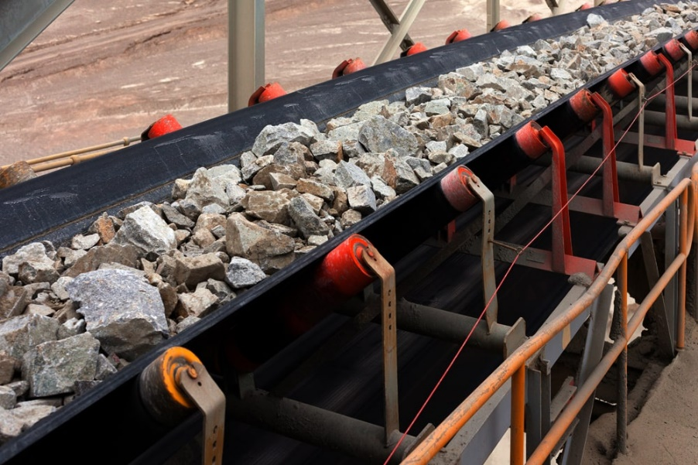
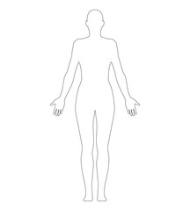
Beltline

Stinky Pete

17’ Silly Billy laying on muckpile

Foam blocks as muckpile
TEAMS MATERIALS

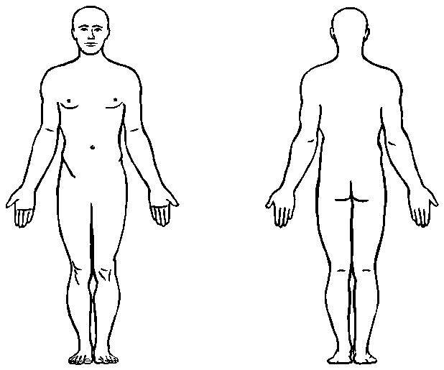
Silly Billy
2in cheek laceration.
Suspected head, neck, and back injury.
Flail chest; 3 rib fractures.

Electrical burn entry wound; left hand.

Right foot, electrical burn exit wound.
Initial Assessment:
Orientation: Unresponsive
Airway: Open
Respirations: 8 and labored – Flail chest
Circulation:
Bleeding to check
Cool and Pale Skin
Pulse = 30

Once team frees and treats Stinky Pete, teams should go back and reassess Silly Billy and find that the pules is absent; CPR should be started on Silly Billy. After 1st shock with AED, Silly Billy will raise up and scream; then will lye back down responsive to painful stimuli only. Stinky Pete will freak out around this time asking what are you doing to my buddy?

Secondary Assessment After CPR:
Orientation: Awake, responsive to painful stimuli
Airway: Open
Respirations: 12 and labored – non labored after splinting of flail chest
Circulation:
Bleeding to cheek and forearm
Cool and Pale Skin
Pulse = 68

Stinky Pete

Entrapped right arm in belt.
Teams just need to simply use scaling bar to pry up belt to free arm.
Once pressure is released, arm will fall off and patient will pump bulb for arterial bleed until tourniquet is placed.
No other injuries upon completion of secondary assessment.
Teams will have to treat for shock and calm patient to get vitals down.
Patient can walk at this point; if team does not check or leaves alone, patient will walk off field.

Orientation: Responsive
Airway: Open
Respirations: 26
Circulation:
Amputation to right arm with arterial bleed
Cool and Clammy Skin
Pulse = 132

Disoriented and disgruntled after treatment while team works on Silly Billy.

Silly Billy

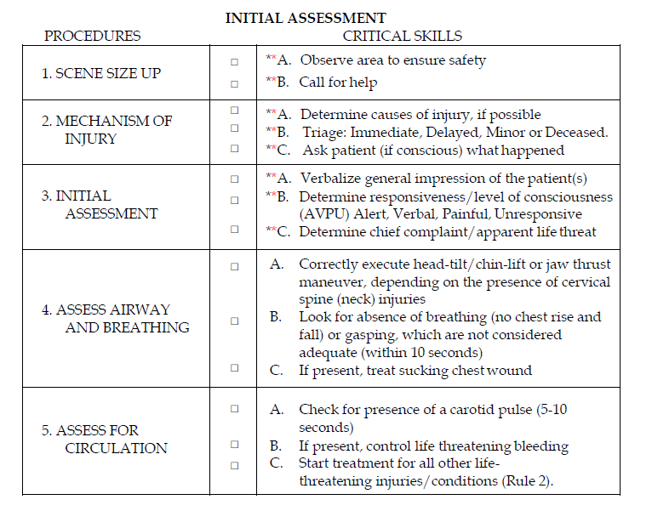
IMMEDIATE: Rapid Patient Assessment treating all life threats Load and Go. If the treatment interrupts the rapid trauma assessment, the assessment will be completed at the end of the treatment.

DELAYED: Detailed Patient Assessment treating all injuries and conditions and prepare for transport.

MINOR: (Can walk) Detailed Patient Assessment treating all injuries and conditions and prepare for transport. After all IMMEDIATE and DELAYED patient(s) have been treated and transported.

DECEASED: Cover

*NOTE: Each critical skill identified with an asterisk (*) shall be clearly verbalized by the team as it is being conducted at contest not utilizing moulage. Each critical skill identified with a double asterisk (**) shall be clearly verbalized by the team as it is being conducted at all contests.
After initially stating what BP-DOC- Bleeding, Pain, Deformities, Open wounds stands for, the team may simply state BP-DOC- Bleeding, Pain, Deformities, Open wounds when making their checks. Teams may use the acronym “CSM” when checking circulation, sensation and motor function.

Transportation is delayed: The Team will have to perform a full assessment and treat all injuries on both patients.

Stinky Pete
IMMEDIATE: Rapid Patient Assessment treating all life threats Load and Go. If the treatment interrupts the rapid trauma assessment, the assessment will be completed at the end of the treatment.

DELAYED: Detailed Patient Assessment treating all injuries and conditions and prepare for transport.

MINOR: (Can walk) Detailed Patient Assessment treating all injuries and conditions and prepare for transport. After all IMMEDIATE and DELAYED patient(s) have been treated and transported.

DECEASED: Cover

*NOTE: Each critical skill identified with an asterisk (*) shall be clearly verbalized by the team as it is being conducted at contest not utilizing moulage. Each critical skill identified with a double asterisk (**) shall be clearly verbalized by the team as it is being conducted at all contests.
After initially stating what BP-DOC- Bleeding, Pain, Deformities, Open wounds stands for, the team may simply state BP-DOC- Bleeding, Pain, Deformities, Open wounds when making their checks. Teams may use the acronym “CSM” when checking circulation, sensation and motor function.
Scene size up would generally not be applied for Stinky Pete as this has been capture with Silly Billy’s initial assessment or the teams entrance to the scene.
Transportation is delayed: The Team will have to perform a full assessment and treat all injuries on both patients.

Stinky Pete

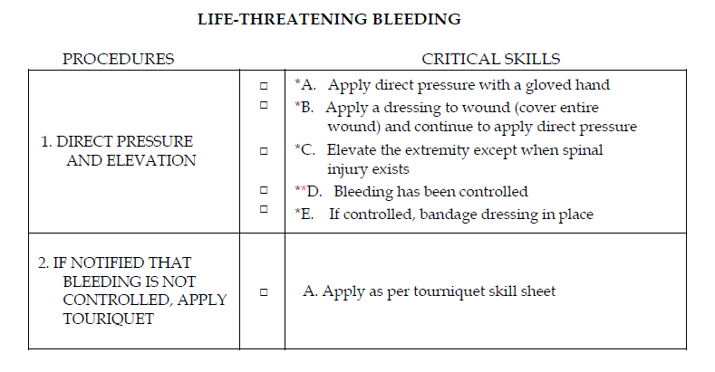

External Bleeding
To Control: 1st: Direct pressure
2nd: Elevation & direct pressure 3rd:Last Resort: Tourniquet

Team is unable to control the arterial bleeding from amputation and must apply a tourniquet to the right forearm. Amputated part will need care as well per Brady standards.

Amputations
**1. Wrap in slightly moistened sterile dressing
2. Place in plastic bag or wrap in plastic
*3. Keep part cool avoid freezing
*4. Do not place in water or direct contact with ice
**5. Transport with patient
6. Label with patients name

NOTE:
A sling and swathe are generally effective for musculoskeletal injuries to the shoulder, upper arm, elbows, lower arm and wrists. Slings will not be required for upper extremity burns. However, if a burn and wound and/or fracture/dislocation are present on the same upper extremity, a sling shall be applied.
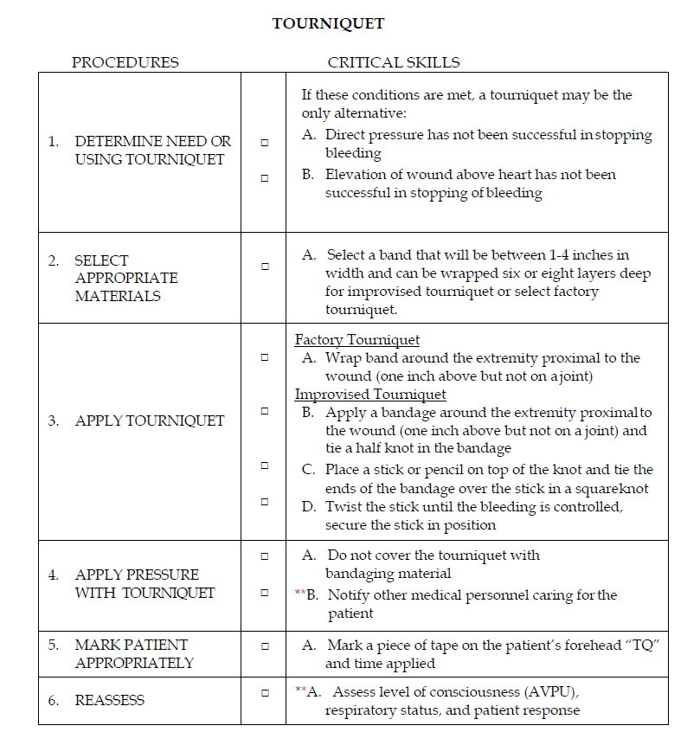
Stinky Pete
Once the tourniquet is applied, the judges should ask the team, “How do you know when the tourniquet is tight enough?” Appropriate answer will consist of: when the bleeding is controlled.
With the correct answer, the judges will inform the team that the bleeding is now controlled or with correct application method.
*The Team should now start Patient Assessment*

Stinky Pete

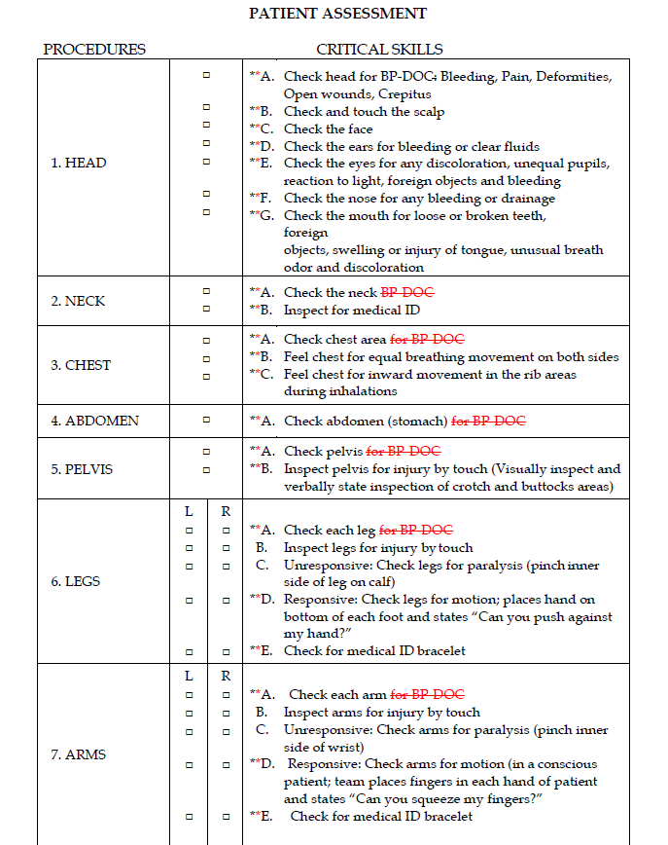
Stinky Pete

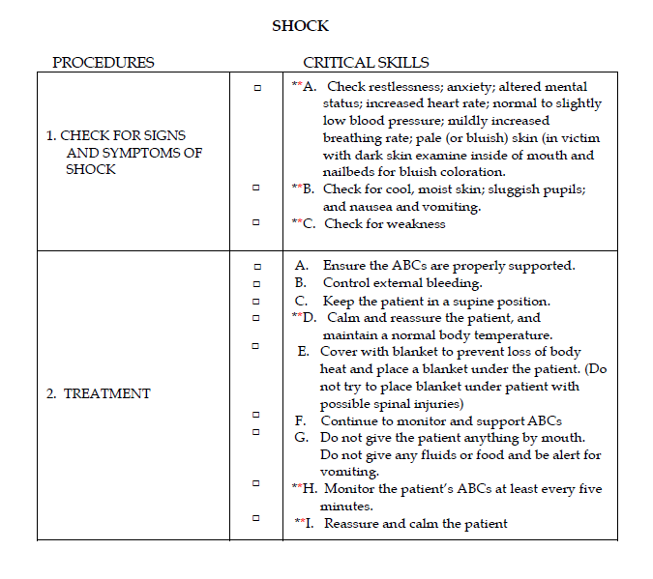
Shock Care with Stinky Pete
Teams shall give Stinky Pete instructions to remain by their side while caring for Silly Billy. They shall also reassure and calm Stinky Pete throughout the process helping treat for shock. Stinky Pete will be very vocal during care and care of Silly Billy.
If teams forget out Stinky Pete or don’t provide instructions, Stinky Pete will walk away from the scene. Teams will then be discounted under Scorecard A rule 9 - Handling of a patient by a team or team member in such a manner that could compromise condition of the patient. Not ensuring patient safety at the scene while other patients are tended to or when other work is done can be considered mishandling of the patient.

Silly Billy
After completion of care and assessment of Stinky Pete, teams should go back and re-assess Silly Billy. Pulse is now absent, and teams should start CPR on Silly Billy. Giving the initial statement of “Silly Billy jumped up onto the belt to cut the power off to save Stinky Pete when he lost footing and grabbed the electric cable blowing him off the belt” team members should automatically suspect possible head, neck, and back injuries. Thus, establishing an airway of suspected cervical spine patients.
Teams shall be discounted accordingly for failure to use modified jaw thrust.

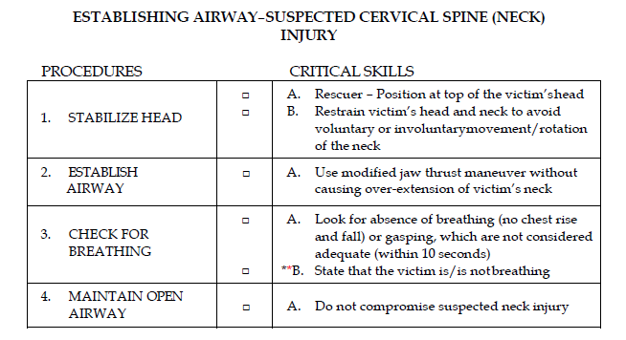
Silly Billy

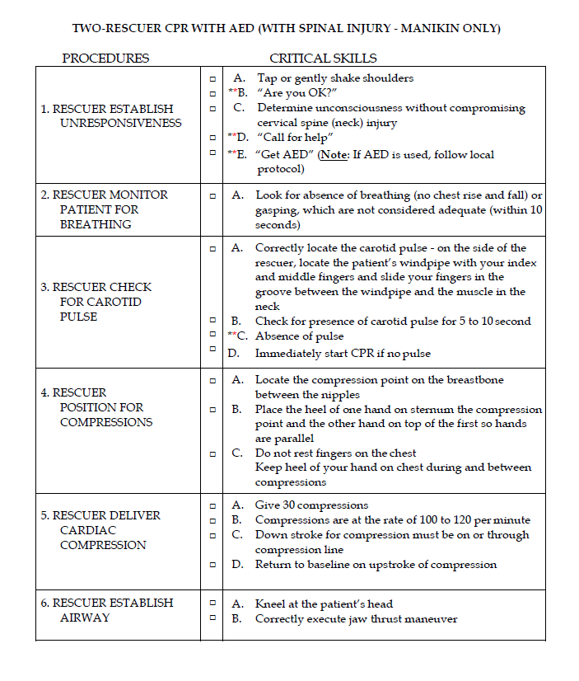
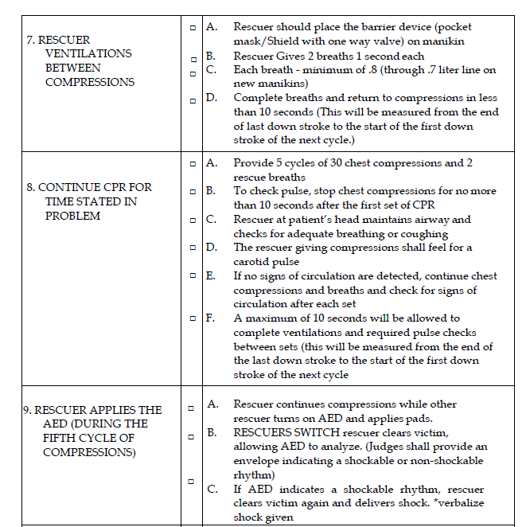
Silly Billy
CPR will stop after 1 shock has been given as Silly Billy will be instructed to raise up and scream once AED advises shocking; thus, CPR scorecard will end at #9 for this scenario. Silly Billy will lye back down awake, but only responding to painful stimuli only for rest of assessment. Silly Billy will be instructed to scream out upon assessment of injured areas.
New vitals will be dropped after shock is given and Silly Billy raises up and screams. Teams should then move from the CPR dummy back to patient to complete PT assessment and treatment.
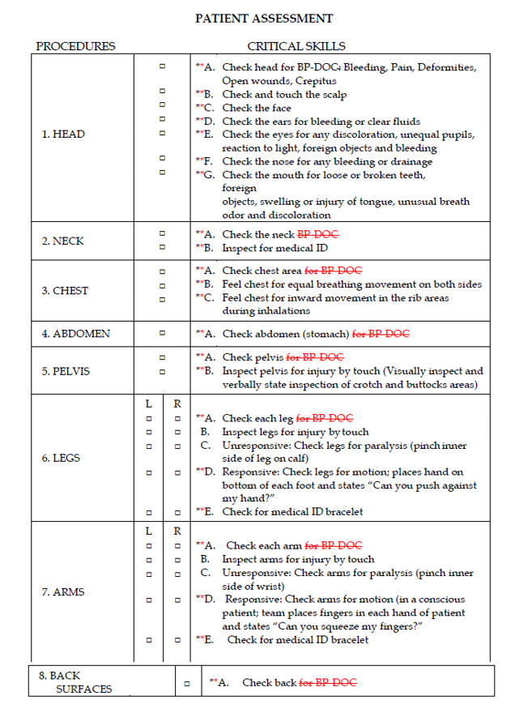
Silly Billy
Silly Billy

The patient assessment for Silly Billy will denote the following findings:
- 2in laceration to the cheek.
- Tracheal deviation indicating pressure in the lung and pleural cavity is less than the other side; complications from the flail chest.
- Flail chest – severe pain when palpating the area.
- Burn entrance wound left hand.
- Burn exit wound right foot.

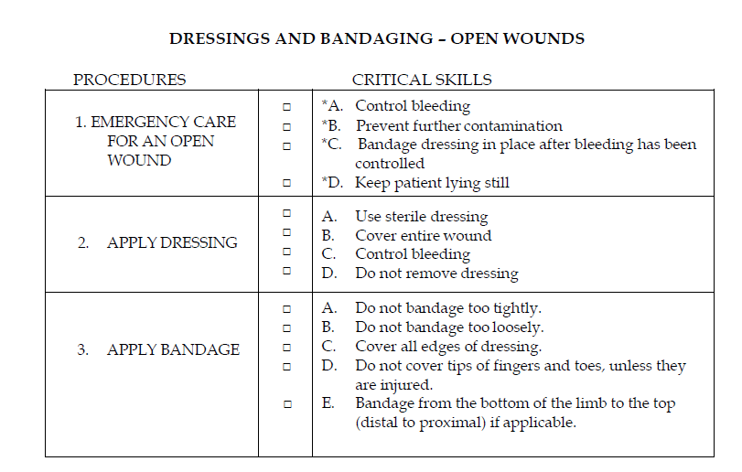

Silly Billy

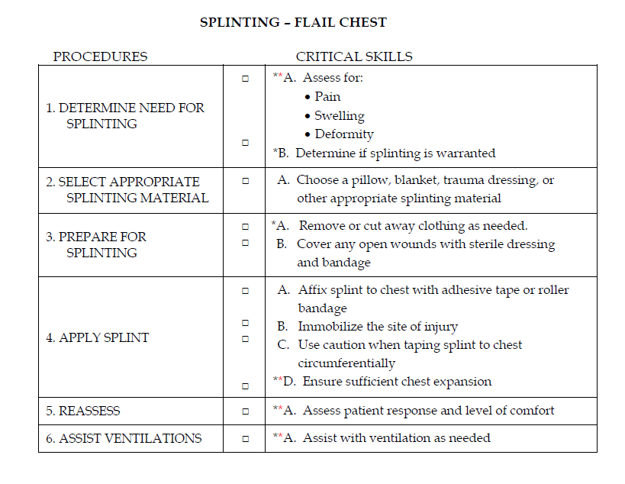

Silly Billy
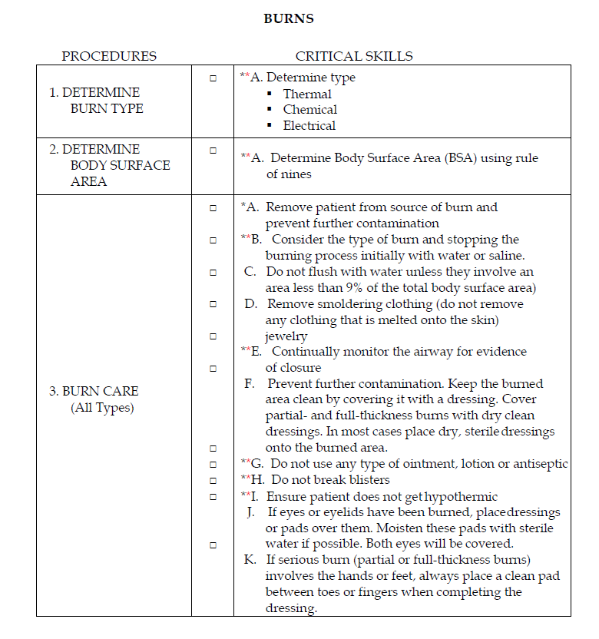
Teams must determine and state to the judge the total body surface area burned using rule of nines – burns rule 2-A.

Silly Billy

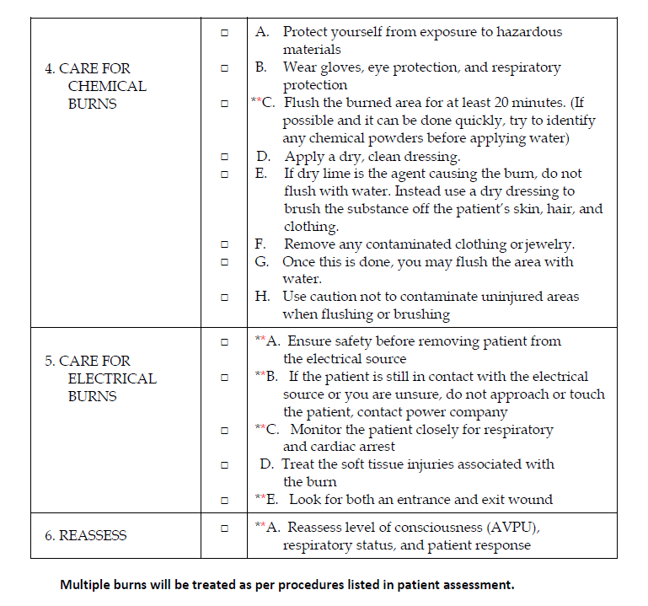
For this scenario, burns 4. A-H will not apply as not a chemical burn.
Burns will need to be assessed twice for both the hand (entry wound) and foot (exit wound).
Burns will have to be treated as per procedures listed in patient assessment – teams will systematically conduct a patient assessment. Each area of the body shall be examined in its entirety prior to treating injuries in that area (except taking support). All injuries must be treated on the area being examined prior to moving to the next area to be examined.
Therefore under systematic assessment, the foot (exit wound) must be treated before the hand (entry wound).
Silly Billy

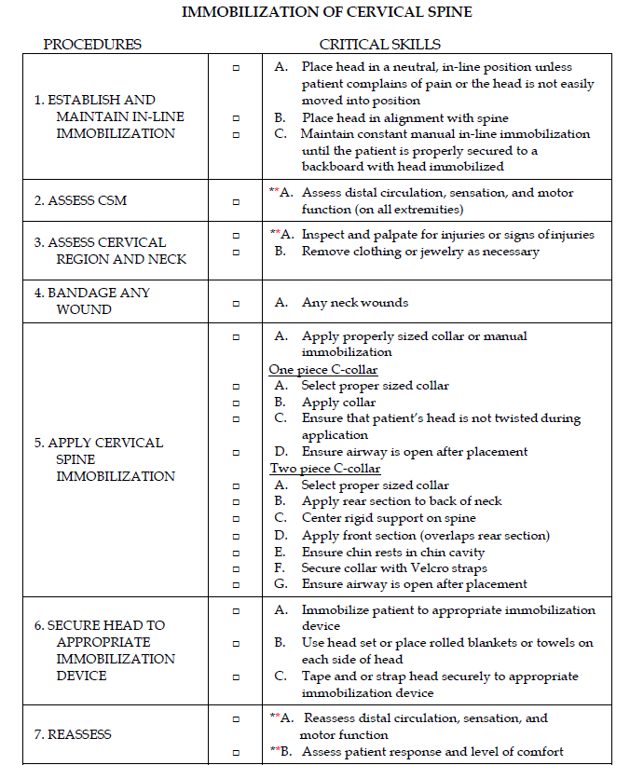
Silly Billy

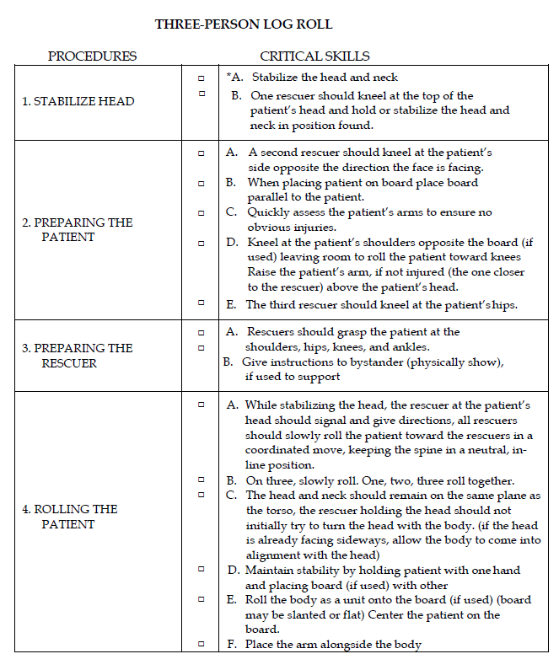
Silly Billy

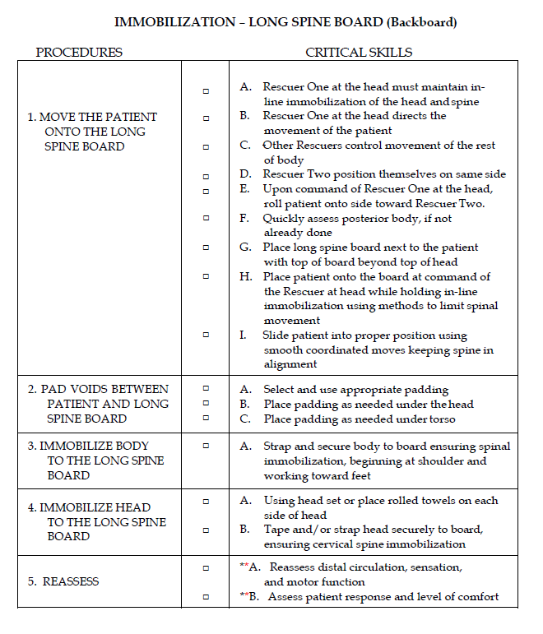

Silly Billy

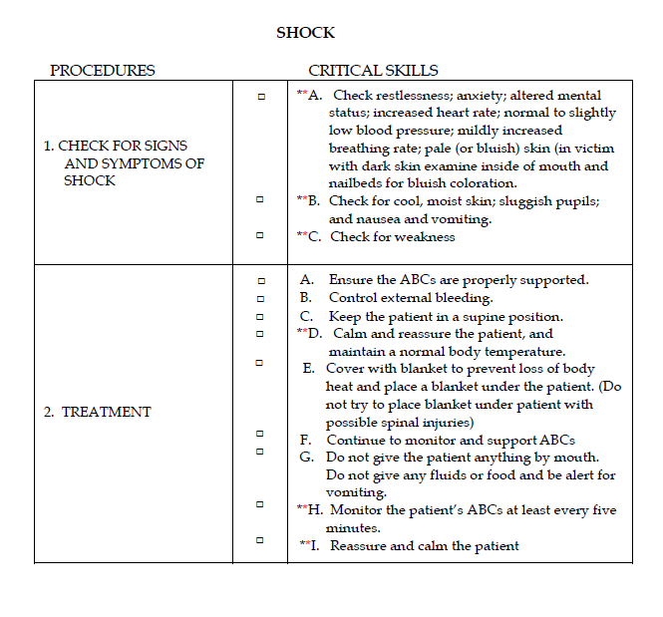
Once Silly Billy has been loaded onto the spine board and treated for shock, teams will have completed the problem and may turn their statement back in to stop the clock.
Please ensure teams do not pick the patient up after on backboard for patient safety.

Points of interest:
- It is not uncommon for a team or provider to use different acronyms than what is used in the Brady 11th edition. It is of my opinion that not penalty should occur if a team member uses a different acronym but accurately assesses and treats the patient. The first example would be CSM and PMS, another example could be BP-DOCS and DCAPBTLS. Both memory aids are developed to help the rescuer remember the steps and are expected by the healthcare community. Regardless of the acronym/mnemonic used, the evaluation of performance should be made on the overall assessment and treatment and not which memory aid was used.
- This problem is intended to test the skills of mine rescuers in the event of an emergency and shall be made as realistic as possible. All live props used are intended to help enhance the training and test the skills and knowledge of those involved. Patients will play a vital role in helping make as realistic as possible and all injuries will be utilized with realistic moulage and blood.

