Tech Problem
The Field of Dreams Mine is a 3 entry development. Air enters the mine through the #1 entry and exits the mine through the #2 and #3 entries. You are standing in the #2 entry. You will need to determine the airflow in the #2 entry using a vane anemometer and using a smoke tube. Take a reading from the test port in the permanent stopping with man door between the #1 and #2 entries using the magnehelic gauge.

Field Set-Up

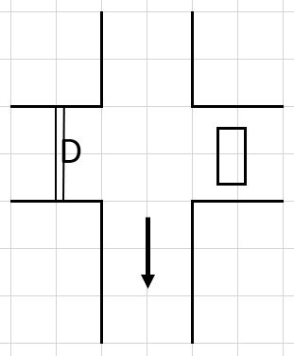
Field Set-Up Notes
Use 10 feet widths on the field. The pipe used for height can be anything measurable. I am providing the heights and widths for each exercise (anemometer and smoke tube). They will be different.
Anemometer
Width 19 feet
Height 9 feet
Anemometer Reading – “See Anemometer Picture”
Anemometer Reading is 1222 ft/min
Correction Factor is -35
Corrected Anemometer Reading is 1187 ft/min
Area is 171 ft²
Airflow is 1187 ft X 171 ft² = 202,977 CFM

Smoke Tube
Width 18 feet
Height 7 feet
Smoke Tube – measure off 10 feet

Quadrant 1 time is 12 seconds
Quadrant 2 time is 13 seconds
Quadrant 3 time is 15 seconds
Quadrant 4 time is 10 seconds

Avg Time = 12.5 sec
Velocity = 10 ft/12.5 sec = 0.8 ft/sec = 48 ft/min
Area = 126 ft²
Air Flow = 126 ft² X 48 ft/min = 6,048 CFM

Magnehelic
Magnehelic Reading – “See Magnehelic Picture”
Magnehelic Reading is 0.16 in H₂O
Reflected as “Positive” [should use high pressure hose]
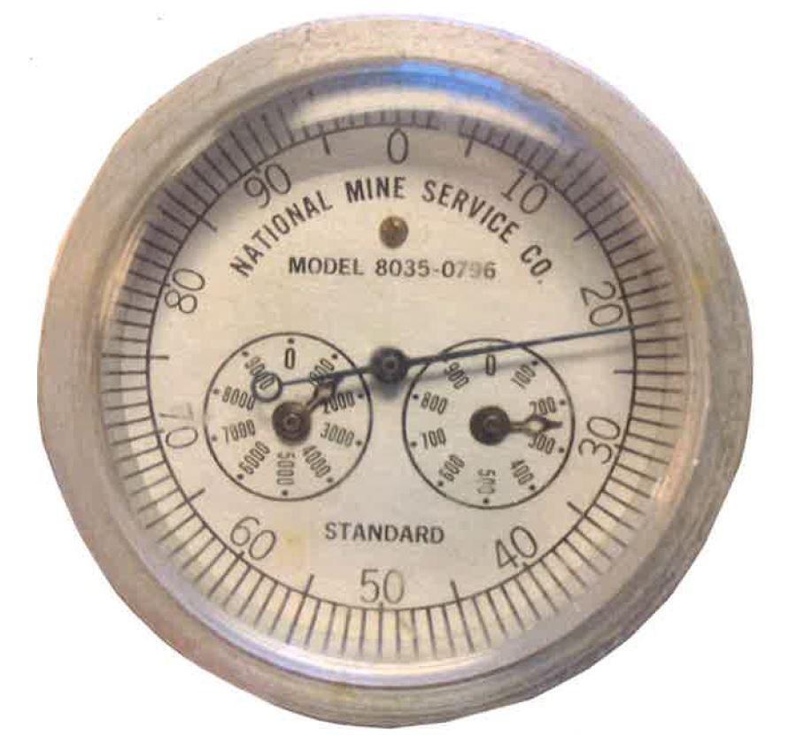
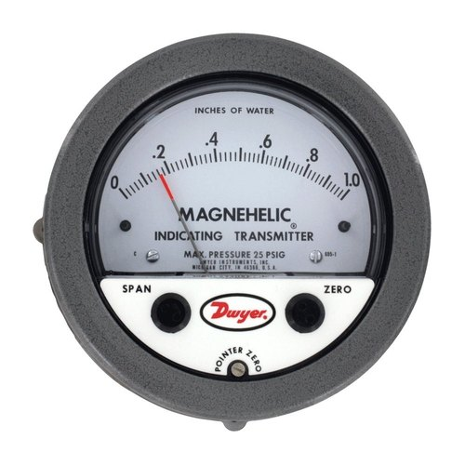

2022 Southeast Regional Mine Rescue Contest Technician Team Test

Name:__________________________________ Team______________________________

- Turn the instrument on by pressing and holding the center [Enter] navigation button on the _______ front of the instrument for at least 3 seconds.
  - Upper
  - Middle
  - Lower

- Visually check the _________ for damage. Visually inspect the LCD display after it stabilizes.
  - MX-6
  - Detector
  - Instrument

- BATTERY STATUS – Under the main menu [______] option, select [BATTERY] to view the battery status.
  - CONFIGURE
  - DISPLAY
  - VIEW

- When activated, instrument detects and measures concentration of carbon monoxide, methane, oxygen and nitrogen dioxide in the ________ air continuously and simultaneously.
  - Mine
  - Room
  - Ambient

- In case of an alarm, the sensor(s) in alarm will be ________ on the display.
  - Highlighted
  - Flashing
  - Red

- Atmospheric pressure – Force exerted by _________. Atmospheric pressure is measured on a barometer.
  - Air
  - Temperature
  - Weather

- _________ - To scatter, spread out, or blend.
  - Disperse
  - Diffuse
  - Mix

- Main fan – A mechanical ventilator installed at the surface which operates by either exhausting or blowing (pushing) to ______ airflow through the mine.
  - Create
  - Induce
  - Cause

- Regulator – An adjustable door or opening in a stopping/Bulkhead used to control and adjust the _________ of airflow in the mine in order to ensure proper distribution.
  - Quantity
  - Amount
  - Volume

- Return – the air course along which the ventilated air of the mine is _________ or conducted to the surface.
  - Moved
  - Conveyed
  - Returned

- Two gases that are highly soluble in water are hydrogen sulfide and ___________
  - Methane
  - Nitrogen dioxide
  - Sulfur dioxide

- A gas that is normally found near the roof or in high place in the mine is said to have a _____ specific gravity.
  - High
  - Middle
  - Low

- Of the gases we’ve talked about, which ones are toxic if you inhale them?
  - Carbon monoxide, nitrogen oxide, hydrogen sulfide, sulfur dioxide, and acetylene.
  - Carbon monoxide, oxides of nitrogen, hydrogen sulfide, sulfur dioxide, and acetylene.
  - Carbon monoxide, oxides of nitrogen, hydrogen sulfide, radon, and acetylene

- Line Brattice – Line brattice is used to _________ intake air from the last open crosscut to the working face.
  - Direct
  - Divert
  - Channel

- Auxiliary Fans and Tubing – Auxiliary fans and tubing are used to provide ________ airflow to face areas during mining operations.
  - Adequate
  - Sufficient
  - Needed

