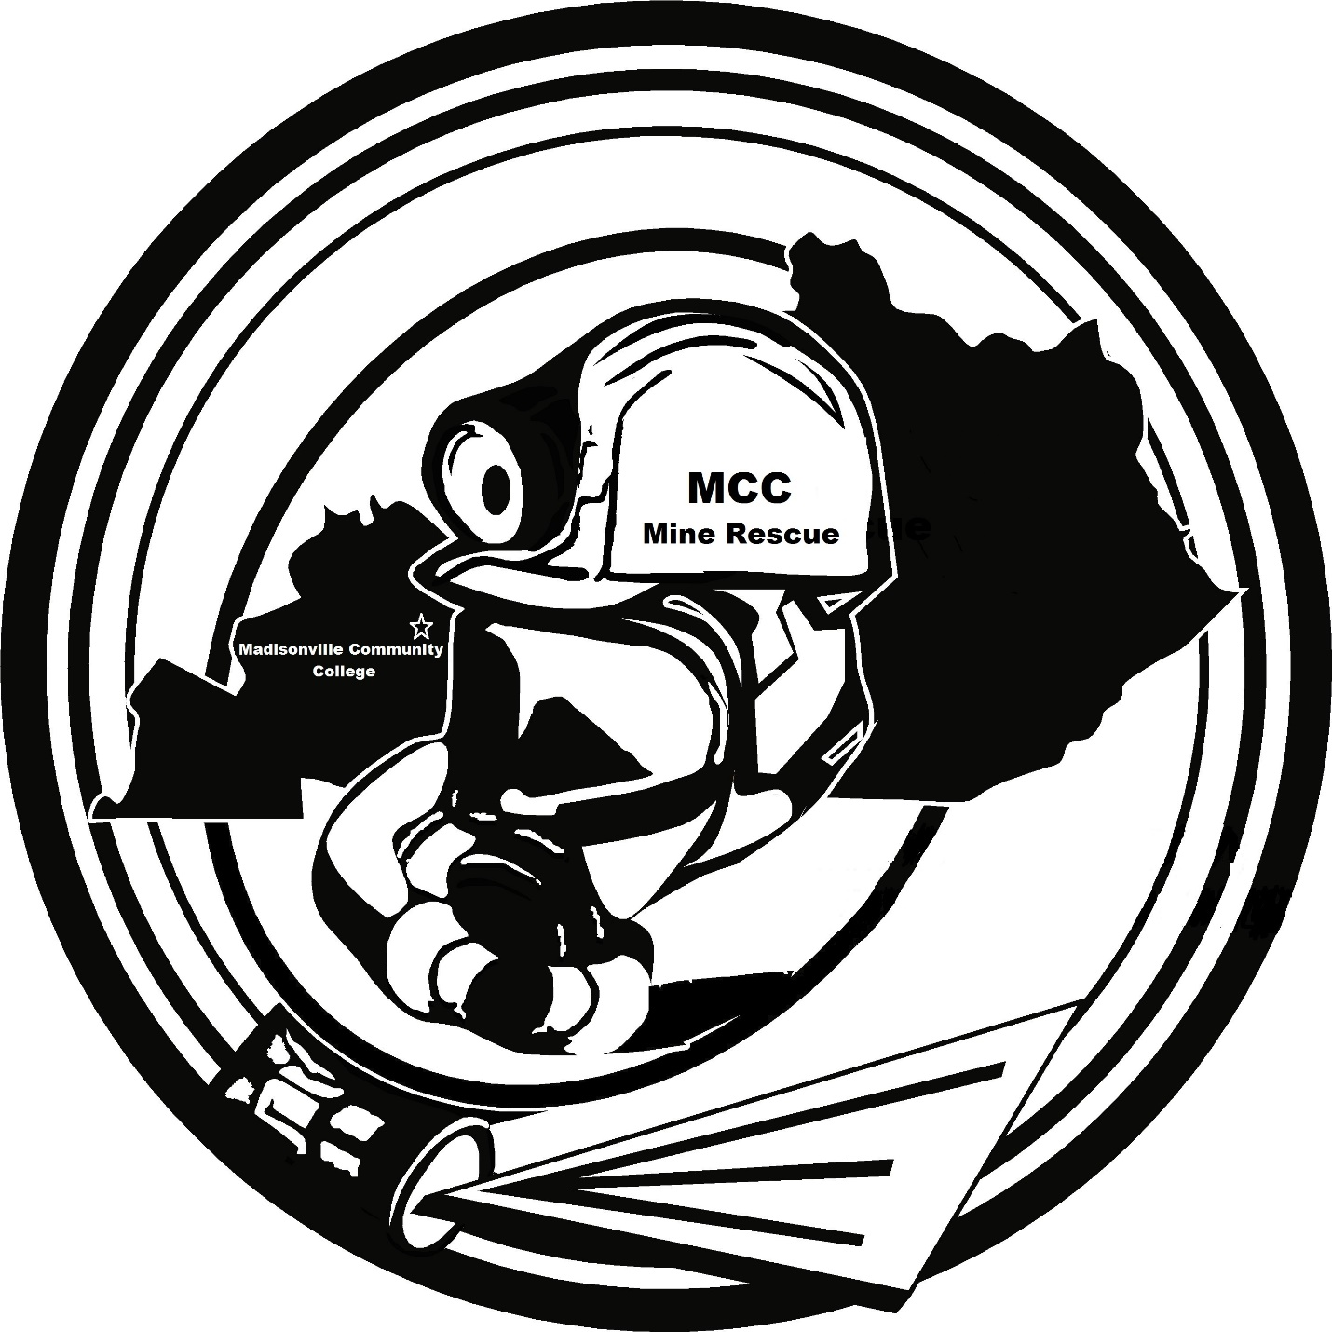

2019 MCC SKILLS Contest
October 16, 2019

2019 MCC SKILLS CONTEST
STATEMENT

EARLY THIS MORNING A FIVE MAN CREW ENTERED THE MINE EARLY TO PREPARE FOR PRODUCTION. AT 7:02, THE FAN ALARM ACTIVATED. THE FAN WAS CHECKED AND THE EXPLOSION DOORS HAD BEEN BLOWN OPEN AND THE FAN WAS OFF.
WE BEGAN ATTEMPTING TO CONTACT EVERYONE UNDERGROUND AND WAS UNSUCESSFUL. WE THEN BEGAN NOTIFYING MINE RESCUE TEAMS AND THE STATE AND FEDERAL AGENCIES.
MINE RESCUE TEAMS HAVE EXPLORED TO WITHIN A FEW CROSSCUTS OF THE SECTION AND HAVE ESTABLISHED A FRESH AIR BASE UNDERGROUND.
THE EXHAUST FAN HAS BEEN REPAIRED AND CAN BE TURNED ON AND OFF BY A SWITCH LOCATED IN THE COMMAND CENTER OUTSIDE. THE MINE MAPS ARE NOT UP TO DATE AND WE ARE MINING NEAR AN OLD PART OF THE MINE THAT WAS SEALED OFF YEARS AGO. ALSO, WE DO HAVE AN AIRSHAFT INBY THE LAST OPEN CROSSPLEASE BE CAREFUL AND THANK YOU FOR RESPONDING TO OUR EMERGENCY…

2019 MINE RESCUE SKILLS CONTEST
WRITTEN INSTRUCTIONS

- EXPLORE ALL ACCESSIBLE AREAS OF THE MINE

- BRING ALL SUVIVORS TO THE FRESH AIR BASE

- WHEN A BODY IS FOUND OR LOCATED, DO NOT USE THE WORD “BODY” WHEN RELAYING COMMUNICATIONS ON RADIOS TO EACH OTHER OR TO THE COMMAND CENTER / BO, USE THE WORD “ITEM” INSTEAD.
(EXAMPLE: ITEM # 1 HAS BEEN FOUND OR LOCATED, ITEM # 2 HAS BEEN FOUND OR LOCATED)
- MUST CLEAR ANY EXPLOSIVE MIXTURE INBY THE LAST OPEN CROSSCUT BEFORE STOPPING THE CLOCK

Mine Rescue Field Problem

The Mine Rescue Field exercise will be conducted using a simulated mine layout with entries and crosscuts similar to a traditional mine rescue field. Teams will be required to advance in the mine using the 2+2+1 procedure for exploring the mine. Teams must follow procedures outlined in rules when advancing in the mine.
When working in 2, 2 and 1 person groups any member can perform the duties of the Captain or other members, including the 20 minute apparatus check.
Teams are not allowed to take Skill Sheets onto the field
Two, Two and One Exploration Procedures
Each group must have the following equipment; handheld radio, gas detector, roof sounding device and chalk.
THIS EXPLORATION METOD MUST BE USED FOR BOTH THE MINE RESCUE FIELD SEGMENT AND THE FIRST AID SEGMENT
1. Teams may explore the areas of the mine that are smoke free in 2, 2 and 1 person groups.

2. The team Captain will decide which members are paired up in the 2, 2 and 1 person groups.

3. The 1 person must be in line of sight (in the crosscuts) of one of the 2 person groups.

4. Each member of each group can perform the duties of any team member including the Captains duties.

5. The groups will not be required to maintain a map. The Briefing Officer will maintain a map which will be scored according to 2019 NATIONAL MINE RESCUE RULES (Briefing Officer Map requirements).

6. The 2, 2 and 1 person groups must stay within one crosscut of an adjacent team when exploring.

7. An outside group will notify the center team that they have stopped or ready to advance. The center group will notify the Briefing Officer that the groups have stopped or are advancing. All other communications can be between the 3 groups and the Briefing Officer.

8. When encountered the following conditions or situations will require the 2, 2 and 1 person groups come together and function as a 5 person team A. Locating a Person requiring any type of action or treatment, including providing First Aid Treatment
B. Entering a Refuge Alternative or Barricade (Must follow 2019 National Mine Rescue Rules)
C. Fire Fighting (Must follow 2019 National Mine Rescue Rules)
D. Ventilating the Mine (Must follow 2019 National Mine Rescue Rules)
E. Pumping Water (Must follow 2019 National Mine Rescue Rules)
F. Setting Timbers (Must follow 2019 National Mine Rescue Rules)
G. Traveling into or through any SMOKE (Must follow 2019 National Mine Rescue Rules)

9. If a 2, 2 and 1 person group is blocked in the entry they are exploring, they can retreat and advance up the adjacent entry to tie back into the entry they were exploring at the first accessible crosscut.

10. Failure to follow explorations procedures will result in a 2 point discount per occurrence maximum of 10 points.

11. Failure of any group to stay within 1 crosscut of an adjacent group when exploring 2 point discount per occurrence maximum of 10 points.

Anytime stretchers are transported through water they must be elevated to above the level of water.
If radios are used for communications by the team, the team must visually check the radio, before going underground for safe operating condition and level of battery charge.
Patient Statement behind Barricade

Have patient say ‘Help get me out ! When first team member enter intersection outby barricade

