2017 Post #5 BIOPAK 240 R Written Test
Contestants Name: ___________________ Team Name: ___________________

- Prior to using the BioPak 240 Revolution it must be determined that the user is __________ fit.
mentally physically medically

- Do not open the cylinder valve in the presence of open flame, ______ or high radiant heat.
sparks oil low

3. The use of an SCBA will add to the workload and stress of the ______.
wearer user person

- Allow the oxygen cylinder to cool after filling to determine the correct_______.
pressure size weight

- Oxygen will not cause materials to _______ without the presence of an ignition source.
burn ignite flare

6. The fiber optic cable may only be __________ to the BioPak 240R remote gauge assembly.
attached connected assembled

7. ___________ after completion of BioPak use, remove the used CO2 scrubber canisters.
soon shortly immediately

8. Use only _________ and disinfectants that are approved by Bio marine.
cleaners bleach soaps

9. Remove the oxygen cylinder making sure the seal _______ remains in place and install the regulator cover.
gasket o-ring washer

10. C.O.P.D. could limit or _________ the use of the BioPak 240 Revolution.
prohibit limit prevent

11. Place freeze forms onto a level surface in a freezer for a minimum of ___ hours period at a temperature of 10 degrees F or less.
12 20 8

12. To ________ mold growth remove the moisture control foam pads after each use.
limit prevent prohibit

13. Pre-packing the BioPak 240 R with carbon dioxide scrubbers is only permitted when utilizing ________ carbon dioxide scrubber.
factory refillable Orbsorb

14. Moisture control sponges must be _________ dry when pre-packing the BioPak.
placed positioned installed

15. Users are not permitted to mix _________ of the Orbsorb within a BioPak.
versions containers types

16. The oxygen cylinder must be fully charged to above _____ psi to perform a high pressure leak test.
2600 3000 1500

17. The Cylinder should be ________ regularly for signs of damage to the outer wrapping.
checked inspected tested

18. Never pry an O-ring from its glands with a ___________. Remove O-rings by hand or with the pick tool provided in the service kit.
wrench screwdriver pry-bar

19. Cylinders are to be retired from service ___-years after the date of manufacture.
15 10 5

20. The Alarm module will require ___________ if any damage to the housing is discovered.
servicing attention replacement

Identification of Parts

21. Item # 3 of the upper housing assembly drawing
oxygen cylinder knob external oxygen knob green knob

22. Item # 2 of the upper housing drawing
Coil spring Stainless coil spring Diaphragm springs

23. Item # 7 0f the upper housing drawing
diaphragm spacer vent spacer key spacer

24. Item # 18 of the upper housing drawing
Hold down strap hold down grip carrying handle
Upper housing assembly
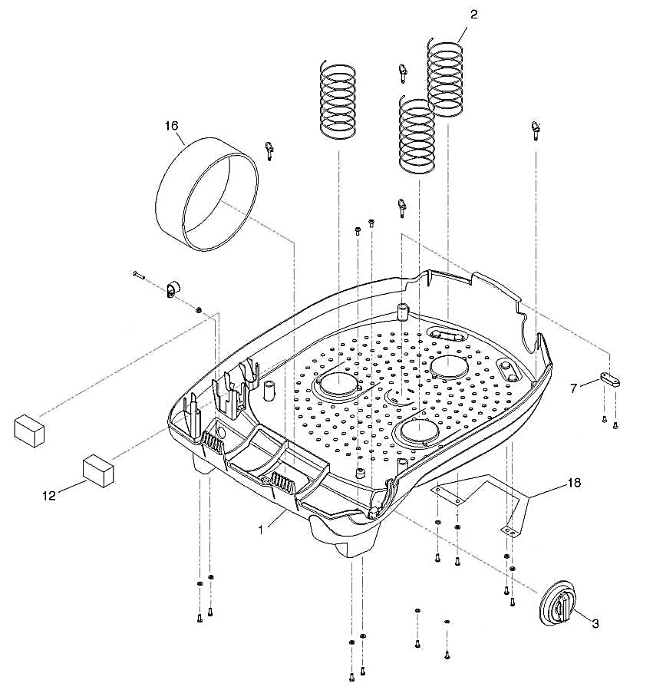
18

25. Item # 1 of the Pneumatic Assembly
supply line oxygen supply line bypass feed tube

26. Item # 2 of the Pneumatic Assembly
bypass line bypass return tube supply line

27. Item # 11 of the Pneumatic Assembly
gauge visor remote assembly remote gauge assembly

28. Item # 9 of the Pneumatic Assembly
Oxygen regulator assembly regulator assembly regulator

29. Item # 10 of the Pneumatic Assembly
remote shut off remote shut off gauge remote gauge shut off assembly

30. Item # 12 of the Pneumatic Assembly
Remote Gauge feed tube Assembly Feed Tube Remote feed Tube

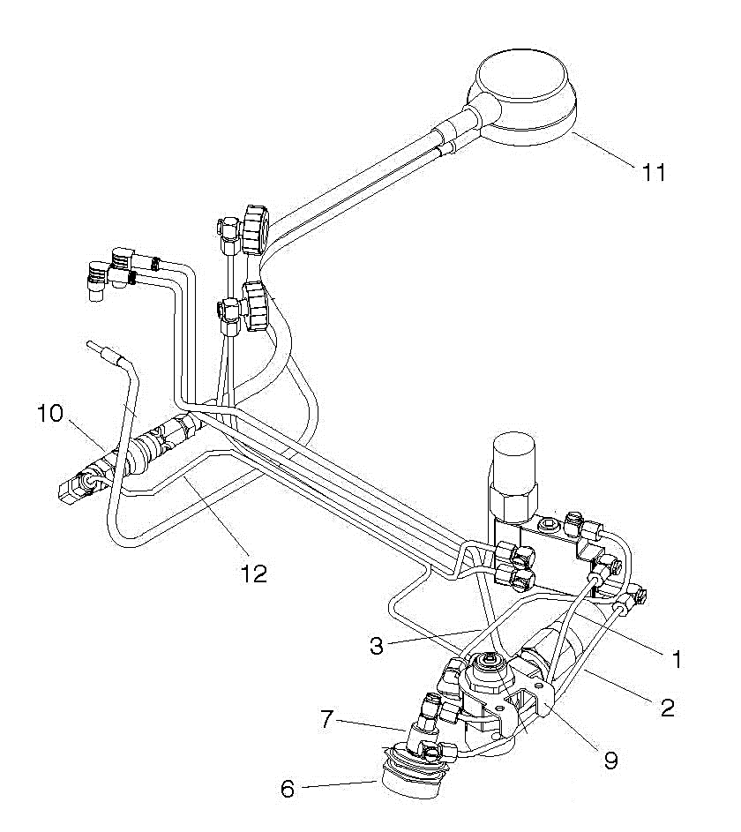
Pneumatic Assembly

2017 BIOPAK 240 R Written Test Answers

- medically SF 5 17. inspected SF 50

- sparks SF 7 18. screwdriver SF 55

- user SF 10 19. 15 SF 59

- pressure SF 13 20. replacement SF 60

- ignite SF 9

- connected SF 22

- immediately SF 25

- cleaners SF 28

- washer SF 30

- prevent SF 33

- 8 SF 34

- prevent SF 38

- Orbsorb SF 40

- installed SF 42

- versions SF 45

- 1500 SF 48

2017 BIOPAK 240 R Identification of Parts Answers

21. external oxygen knob

22. diaphragm springs

23. vent spacer

24. carrying handle

25. bypass feed tube

26. bypass return tube

27. Remote Gauge assembly

28. oxygen regulator assembly

29. Remote Gauge Shut Off Assembly

30. Remote Gauge Feed Tube Assembly

