2017 Tri State Post No. 6
240 R Bio Pak 240 R Bench Contest
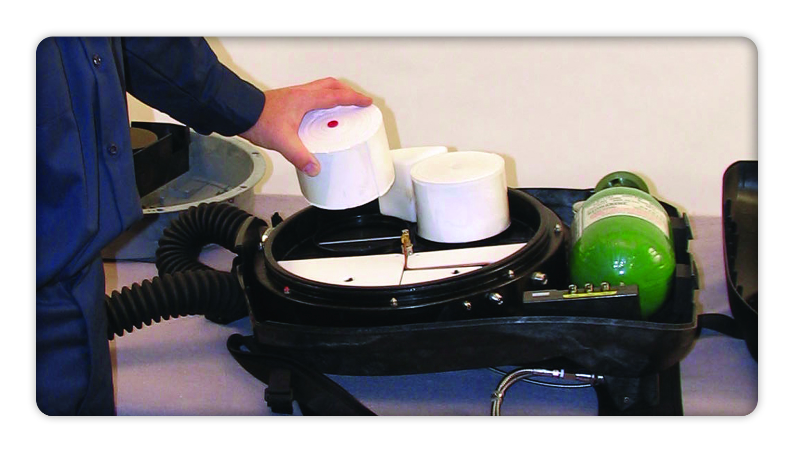

Table Layout for Bio-Pak 240-R Contest
Test Apparatus  With Upper Housing  And Hose Connector Installed |  | Test Apparatus Mask |  | Upper Housing With Parts |  | Visual Apparatus
 |  | Test Kit

2017 Contest Year

Bio Pak 240 R
2017 Post # 6 Bench Contest

VISUAL
Missing PCM
Bottom Screw Loose on Facemask
Waist Female Buckle Reversed
Missing Vent Spacer Screw
Missing Mask Wiper
Speech Diaphragm pulled off Nose Cup User Right
Missing Harness Washer Lower Right Waist Belt

TESTER
NONE

BioPak 240 R BENCH CONTESTANT ____________________________WORKING TIME_____MIN._____SEC.

VISUAL APPARATUS CHECKS |  | TEST APPARATUS
 | Check if ok |  | CONNECTIONS
 | UPPER HOUSING |  | Vent Valve Assembly - Hand Tight
 | LOWER HOUSING |  | Diaphragm Worm Gear - Wrench Tight
 | Harness Assembly |  | Flow Restrictor - Wrench Tight
 | External Gage |  | Breathing Hose Worm Gear - Wrench Tight
 | O2 Regulator / Seal |  | Add / Constant Fittings - Hand Tight
 | RMS |  | Center Section Lid - Hand Tight
 | CENTER SECTION ASSEMBLY |  | Center Section Push Pins - Hand Tight
 | Diaphragm |  | Cylinder Connection - Hand Tight
 | Check O-Ring for damages/lubrication |  | Adapter to Facepiece - Hand Tight
 | Sealing Edges |  | Test Fixture Connections - Hand Tight
 | Demand Valve Assembly |  | Check if ok
 | Moisture Pads |  | Zero Adjust the Mag. Gauge
 | PCM |  | CONSTANT FLOW TEST
 | CARBON DIOXIDE SCRUBBER |  | Flow Between 1.6 and 2.4 Lpm - State Reading
 | Defects / Damage |  | DEMAND VALVE TEST
 | Gasket |  | EMERGENCY BYPASS TEST
 | Expiration Date |  | VENT VALVE TEST
 | CENTER SECTION LID ASSEMBLY |  | At or below 2 inches wg - State Reading
 | Examine for defects / damage |  | LOW PRESSURE LEAK TEST
 | Sealing Edges |  | RMS GAUGE AND TRIM TEST
 | Ice Canisters |  | Observe lights/gauges +/- 10% - State Reading
 | Coolant Lids |  | HIGH PRESSURE LEAK TEST
 | CYLINDER TEST |  | LOW PRESSURE ALARM TEST
 | Hydrostatic Test Date |  | Alarm 650-1000 psig - State Reading
 | Cylinder Pressure on Gauge |  | Power down below 25 psig
 | Pressure Rating on Cylinder | VI | C | VISUAL
 | HOSES |  |  | Bottom Screw Loose on Facemask
 | Sealing Edges |  |  | Waist Female Buckle Reversed
 | Stretching of Hoses for Pliability |  |  | Missing Vent Spacer Screw
 | Adapter Assy O-ring damage & lubrication |  |  | Missing Mask Wiper
 | FACE PIECE TEST |  |  | Speech Diaphragm pulled off Nose Cup User Right
 | Head Strap Assembly |  |  | Missing Harness Washer Lower Right Waist Belt
 | Mask Body / Nose Cup | VI | C | Missing PCM
 | Sealing Edges |  |  | VISUAL
 | Speech Diaphragms |  |  | NONE
 | Lens / Anti-Fog Insert
 | Magnetic Wiper
BioPak 240 R BENCH CONTESTANT ____________________________WORKING TIME_____MIN._____SEC.

VISUAL APPARATUS CHECKS |  | TEST APPARATUS
 | Check if ok |  | CONNECTIONS
 | UPPER HOUSING |  | Vent Valve Assembly - Hand Tight
 | LOWER HOUSING |  | Diaphragm Worm Gear - Wrench Tight
 | Harness Assembly |  | Flow Restrictor - Wrench Tight
 | External Gage |  | Breathing Hose Worm Gear - Wrench Tight
 | O2 Regulator / Seal |  | Add / Constant Fittings - Hand Tight
 | RMS |  | Center Section Lid - Hand Tight
 | CENTER SECTION ASSEMBLY |  | Center Section Push Pins - Hand Tight
 | Diaphragm |  | Cylinder Connection - Hand Tight
 | Check O-Ring for damages/lubrication |  | Adapter to Facepiece - Hand Tight
 | Sealing Edges |  | Test Fixture Connections - Hand Tight
 | Demand Valve Assembly |  | Check if ok
 | Moisture Pads |  | Zero Adjust the Mag. Gauge
 | PCM |  | CONSTANT FLOW TEST
 | CARBON DIOXIDE SCRUBBER |  | Flow Between 1.6 and 2.4 Lpm - State Reading
 | Defects / Damage |  | DEMAND VALVE TEST
 | Gasket |  | EMERGENCY BYPASS TEST
 | Expiration Date |  | VENT VALVE TEST
 | CENTER SECTION LID ASSEMBLY |  | At or below 2 inches wg - State Reading
 | Examine for defects / damage |  | LOW PRESSURE LEAK TEST
 | Sealing Edges |  | RMS GAUGE AND TRIM TEST
 | Ice Canisters |  | Observe lights/gauges +/- 10% - State Reading
 | Coolant Lids |  | HIGH PRESSURE LEAK TEST
 | CYLINDER TEST |  | LOW PRESSURE ALARM TEST
 | Hydrostatic Test Date |  | Alarm 650-1000 psig - State Reading
 | Cylinder Pressure on Gauge |  | Power down below 25 psig
 | Pressure Rating on Cylinder | VI | C | VISUAL
 | HOSES |  |  | Bottom Screw Loose on Facemas
 | Sealing Edges |  |  | Waist Female Buckle Reversed
 | Stretching of Hoses for Pliability |  |  | Missing Vent Spacer Screw
 | Adapter Assy O-ring damage & lubrication |  |  | Missing Mask Wiper
 | FACE PIECE TEST |  |  | Speech Diaphragm pulled off Nose Cup User Right
 | Head Strap Assembly |  |  | Missing Harness Washer Lower Right Waist Belt
 | Mask Body / Nose Cup | VI | C | Missing PCM
 | Sealing Edges |  |  | VISUAL
 | Speech Diaphragms |  |  | NONE
 | Lens / Anti-Fog Insert
 | Magnetic Wiper
BioPak 240 R BENCH CONTESTANT ____________________________WORKING TIME_____MIN._____SEC.

VISUAL APPARATUS CHECKS |  | TEST APPARATUS
 | Check if ok |  | CONNECTIONS
 | UPPER HOUSING |  | Vent Valve Assembly - Hand Tight
 | LOWER HOUSING |  | Diaphragm Worm Gear - Wrench Tight
 | Harness Assembly |  | Flow Restrictor - Wrench Tight
 | External Gage |  | Breathing Hose Worm Gear - Wrench Tight
 | O2 Regulator / Seal |  | Add / Constant Fittings - Hand Tight
 | RMS |  | Center Section Lid - Hand Tight
 | CENTER SECTION ASSEMBLY |  | Center Section Push Pins - Hand Tight
 | Diaphragm |  | Cylinder Connection - Hand Tight
 | Check O-Ring for damages/lubrication |  | Adapter to Facepiece - Hand Tight
 | Sealing Edges |  | Test Fixture Connections - Hand Tight
 | Demand Valve Assembly |  | Check if ok
 | Moisture Pads |  | Zero Adjust the Mag. Gauge
 | PCM |  | CONSTANT FLOW TEST
 | CARBON DIOXIDE SCRUBBER |  | Flow Between 1.6 and 2.4 Lpm - State Reading
 | Defects / Damage |  | DEMAND VALVE TEST
 | Gasket |  | EMERGENCY BYPASS TEST
 | Expiration Date |  | VENT VALVE TEST
 | CENTER SECTION LID ASSEMBLY |  | At or below 2 inches wg - State Reading
 | Examine for defects / damage |  | LOW PRESSURE LEAK TEST
 | Sealing Edges |  | RMS GAUGE AND TRIM TEST
 | Ice Canisters |  | Observe lights/gauges +/- 10% - State Reading
 | Coolant Lids |  | HIGH PRESSURE LEAK TEST
 | CYLINDER TEST |  | LOW PRESSURE ALARM TEST
 | Hydrostatic Test Date |  | Alarm 650-1000 psig - State Reading
 | Cylinder Pressure on Gauge |  | Power down below 25 psig
 | Pressure Rating on Cylinder | VI | C | VISUAL
 | HOSES |  |  | Bottom Screw Loose on Facemask
 | Sealing Edges |  |  | Waist Female Buckle Reversed
 | Stretching of Hoses for Pliability |  |  | Missing Vent Spacer Screw
 | Adapter Assy O-ring damage & lubrication |  |  | Missing Mask Wiper
 | FACE PIECE TEST |  |  | Speech Diaphragm pulled off Nose Cup User Right
 | Head Strap Assembly |  |  | Missing Harness Washer Lower Right Waist Belt
 | Mask Body / Nose Cup | VI | C | Missing PCM
 | Sealing Edges |  |  | VISUAL
 | Speech Diaphragms |  |  | NONE
 | Lens / Anti-Fog Insert
 | Magnetic Wiper
BIO-PAK 240-R
VISUAL APPARATUS (BREAK DOWN)

Upper Housing Assembly-Removed
Hoses-Removed
Coolant Lids and Ice Canisters - Removed
Center Section Lid Assembly - Removed
Moisture Pads - Removed
Carbon Dioxide Scrubbers and Gasket - Removed
PCM Canister - Removed
Loosen (But do not remove) Flow Restrictor
Center Section – Removed
Diaphragm and worm gear-Removed
Vent Valve Assembly - Removed as a unit
Oxygen Cylinder-Removed

BIO-PAK 240-R TOOL KIT

Leak Check Adapter Fitting
Flow Test Fixture
Test Key
Vent Valve Hand Wrench
Center Section Pneumatic Plug
Regulator Wash Cover
Combination Pick Tool
#00 Phillips Head Screwdriver
#1 Phillips Head Screwdriver
#2 Phillips Head Screwdriver
1/4” Hex Driver
3/16” Nut Driver
5/16” Nut Driver
9/32” Nut Driver
3/8” x 5/16” Open End Wrench
7/16” Combination Wrench
½” Combination Wrench
5/8” x 9/16” Open End Wrench
Stop Watch
Bypass Valve Tool

STATEMENT TO BENCH CONTESTANT
The bench participant will be provided with two Bio-Pak 240- R apparatus (one disassembled, one assembled), a stopwatch, leak detector fluid, test kit, and tool kit. Only the tools and fluid provided will be used for testing and assembly of the apparatus. The work at the bench will consist of:
- A visual examination of a disassembled Bio-Pak 240-R and the proper assembly and preparation for use in rescue work. This will include correcting any predetermined problem(s) so that the apparatus is in proper working order. Simulating defogging of the facepiece lens will be done as a part of the visual examination. This visual examination, correcting predetermined problem(s), and proper assembly can be done at any time allowed for the working of the problem.
- Test the assembled Bio-Pak 240-R apparatus with a tester, and correct the predetermined problem(s) so that the apparatus is in proper working condition. Except for removing the facepiece storage plug from the breathing hoses, the assembled Bio-Pak 240-R apparatus cannot be disassembled to look for problems, until the apparatus fails a test. When testing is completed on the assembled Bio-Pak 240-R apparatus, the hoses shall be removed from the tester, connected to the facepiece, and the upper housing installed. This shall be done before the clock is stopped.
When an unplanned deficiency is encountered in the apparatus, the participant will be notified by the judge(s) that the deficiency is not part of the problem. The judge will stop the clock and any time used to correct the deficiency will not be charged to the working time.
A maximum of 30 minutes will be allowed to complete the problem. The judge will tell you when 25 minutes has passed. At the completion of the problem, the judge(s) and the participant will note the working time of the problem with the official timekeeper. Work done after the clock is stopped will not be recognized.

