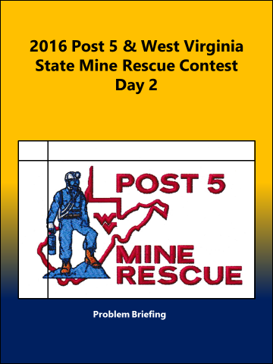
Mine Rescue Written Exam Day 2

2016 Post # 5 Mine Rescue Written Exam Day 2
Contestant’s Name________________ Team’s Name /No. _______________
- ____________ seals are built before permanent seals are ________ in order to seal off a fire area as quickly as possible.
Permanent/built Temporary/erected Permanent/erected

- One method of indirect firefighting is flooding the sealed fire area with _______.
nitrogen silt water

- For teams using a compressed oxygen breathing apparatus, the captain usually notes each team member’s gauge reading at each _____ _____ and reports the lowest reading to the fresh air base.
team stop rest stop pack check

- As the team advances, the map man records what the team encounters by marking the information on a ______ ______.
team map section map mine map

- ______ _________ foam is light and resilient and can travel long distances to a fire without breaking down.
Low expansion High expansion Highly volatile

- Sulfur dioxide and hydrogen sulfide are _______ soluble gases.
very easily water

- Ventilation controls are used underground to properly distribute air to all _________ of the mine.
areas production sections

- The roof and ribs should be ________ before extinguishing a fire.
examined tested sounded

- All ___________ seals should be well hitched in the floor roof, and ribs to improve their strength.
temporary permanent constructed

- A self-contained breathing apparatus is a completely __________ unit that supplies oxygen or air independently of the surrounding atmosphere.
independent maintained portable

2016 Post # 5 Mine Rescue Written Exam Day 2 Answers

- Temporary/erected SF #11

- water SF # 16

- rest stop SF # 31

- mine map SF # 35

- High expansion SF # 43

- water SF # 51

- sections SF # 58

- tested SF # 71

- temporary SF # 81

- portable SF # 89

