2016 Post #6 BIO PAK 240 R Written Test
Contestants Name: ___________________ Team Name: ___________________

- Prior to using the BioPak 240 Revolution it must be determined that the user is _________ fit.
physically mentally medically

- Do not open the cylinder valve in the presence of open flame, ______ or high radiant heat.
sparks oil low

3. The use of an SCBA will add to the workload and stress of the ______.
wearer user person
4. A foreign _____ may cause cylinder corrosion.
body gas object

5. DOT requires carbon fiber wrapped aluminum cylinders be tested by an approved facility on a __-year cycle from the date of manufacture.
2 10 5

6. The fiber optic cable may only be __________ to the BioPak 240R remote gauge assembly.
attached connected assembled

7. ___________ after completion of BioPak use, remove the used CO2 scrubber canisters.
soon shortly immediately

8. Use only _________ and disinfectants that are approved by Bio marine.
cleaners cleansers soaps
9. Remove the oxygen cylinder making sure the seal _______ remains in place and install the regulator cover.
gasket o-ring washer
10. C.O.P.D. could limit or _________ the use of the BioPak 240 Revolution.
prohibit limit prevent

11. The manual(s) are the ________ recommended procedures for maintaining the BioPak 240R.
maximum minimum specific

12. To ________ mold growth remove the moisture control foam pads after each use.
limit prevent prohibit

13. Pre-packing the BioPak 240 R with carbon dioxide scrubbers is only permitted when utilizing ________ carbon dioxide scrubber.
factory refillable Orbsorb

14. Pre-packed carbon dioxide scrubbers may only be stored in the __________ for a maximum period of 1-year.
containers apparatus boxes

15. Users are not permitted to mix _________ of the Orbsorb within a BioPak.
versions containers types

16. The oxygen cylinder must be fully charged to above _____ psi to perform a high pressure leak test.
2600 3000 1500

17. The Cylinder should be ________ regularly for signs of damage to the outer wrapping.
checked inspected tested

18. Never pry an O-ring from its glands with a ___________. Remove O-rings by hand or with the pick tool provided in the service kit.
wrench screwdriver pry-bar

19. Cristo-Lube and Dow-111 are the only __________ approved for use in the apparatus.
lubricants chemicals pastes

20. The Alarm module will require ___________ if any damage to the housing is discovered.
servicing attention replacement

Identification of Parts

21. Item # 3 of the upper housing assembly drawing
green knob oxygen knob external oxygen knob

22. Item # 7 of the upper housing drawing
spacer bar vent spacer vent valve spacer

23. Item #12 of the upper housing drawing
foam pad vibration pad latch foam pad

24. Item # 18 of the upper housing drawing
Hold down strap hold down grip carrying handle
Upper housing assembly
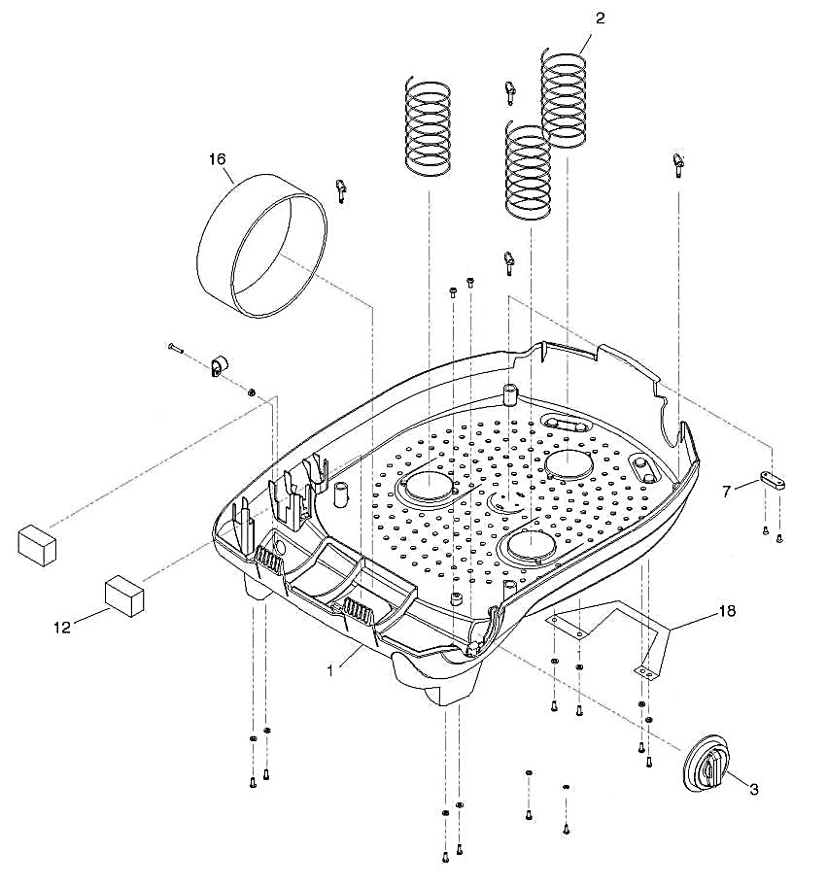
18
25. Item # 1 of the Pneumatic Assembly
supply line oxygen supply line bypass feed tube

26. Item # 2 of the Pneumatic Assembly
bypass line bypass return tube supply line

27. Item # 6 of the Pneumatic Assembly
bypass valve button bypass valve push button bypass valve

28. Item # 9 of the Pneumatic Assembly
Oxygen regulator assembly regulator assembly regulator

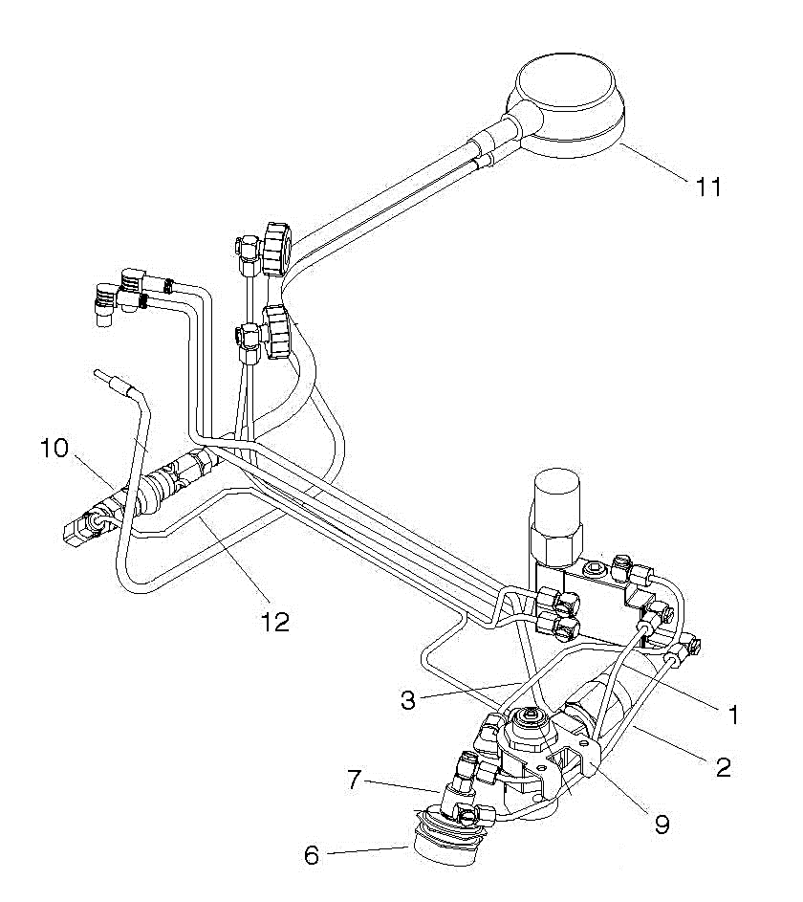
Pneumatic Assembly

29. Item # 3 of the Center Section Lid Assembly
scrubber holder scrubber brace flow baffle

30. Item #4 of the Center Section Lid Assembly
Metal screw self-tapping screws stainless screw

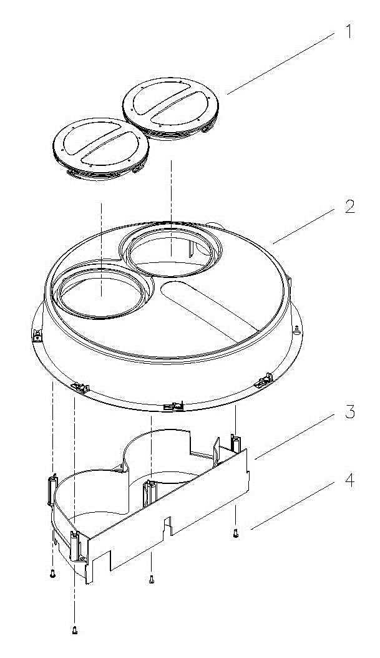
Center Section Lid Assembly

2016 BIO PAK 240 R Written Test Answers

- medically 17. inspected

- sparks 18. screwdriver

- user 19. lubricants

- Gas 20. replacement

- 5

- connected

- immediately

- cleaners

- washer

- prevent

- minimum

- prevent

- Orbsorb

- apparatus

- versions

- 1500

2016 BIO PAK 240 R Identification of Parts Answers

21. external oxygen knob

22. vent spacer

23. latch foam pad

24. carrying handle

25. bypass feed tube

26. bypass return tube

27. bypass valve push button

28. oxygen regulator assembly

29. flow baffle

30. self-tapping screws

