2014 Northern Mine Rescue Contest
Written Exam
(Team Trainer)

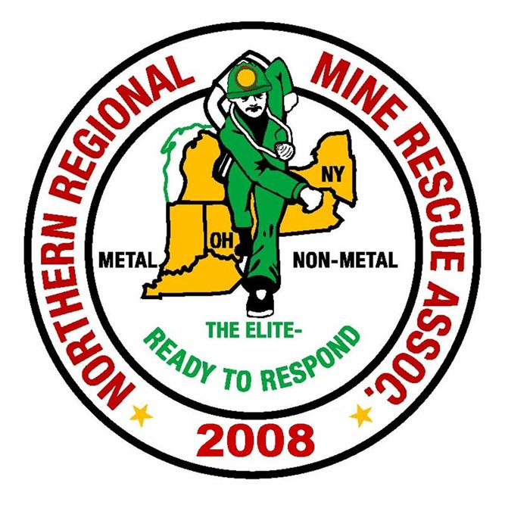
2010
2014

June 17, 2014
Findley Lake, New York

2014 Northern Mine Rescue Contest
Findley Lake, NY
Written Test – Team Trainer

Name____________________________ Company___________________________

Team Name_______________________ Contest Position No.__________________

Team Member No._________________

Directions: Circle the letter preceding the correct answer to each of the following questions. Circle only one answer per question.

- Advancing - When stops are made at the openings of crosscuts, intersections, or drifts turned off the drift that is being traveled, separate gas tests must be made across each entry (rib-to-rib) within no more than 3 feet of each opening to the place turned off the entry.
  - True
  - False

- Advancing - If it becomes necessary to break a stopping, the team shall erect a temporary stopping or stoppings that would have the same effect on the area that the original stopping would have provided.
  - True
  - False

- Advancing - Regulators shall not be opened without prior knowledge of the effects of the mine ventilation system, unless a temporary stopping has been erected.
  - True
  - False

- For the purposes of contest work, no barricade will be breached without ventilating in front of the barricade if: Nitrogen Dioxide (NO₂) exceeds _____; or Sulfur Dioxide (SO₂) exceeds ______.
  - 20 ppm NO₂ or 1,000 ppm SO₂
  - 200 ppm NO₂ or 100 ppm SO₂
  - 20 ppm NO₂ or 100 ppm SO₂
  - None of the above

- The date and the captain’s initials must be marked at the point of farthest advance of the team in any direction such as at:
  - Impassable falls
  - Faces of rooms and drifts
  - Water Over Knee Deep
  - All of the above

- When setting roof supports through an unsafe area, the first support is always set a minimum of 1-foot from the area designated as unsafe.
  - True
  - False
- If the team performs an act that may result in the death or injury of a survivor(s), the team will be assessed ______ discounts.
  - 50 discounts per survivor endangered
  - 50 discounts total
  - 75 discounts total
  - None of the above

- When the teams arrive at the mine site, they should be checked in and assigned to a team area. The safety director should develop a “rotation schedule” for the deployment of all teams called to the mine site.
  - True
  - False

- Which of the following statements is true for any gas?
  - An increase in temperature makes a gas diffuse more rapidly.
  - An increase in pressure speeds up the rate of diffusion.
  - A decrease in temperature slows down the rate of diffusion.
  - Only A and C

- In mechanical ventilation, the greater the temperature difference the fan creates, the faster the flow of air.
  - True
  - False

- Class B fires involve flammable and combustible liquids. Think of Class B fires as those that involve contents that will Boil.
  - True
  - False

- Under certain circumstances, even when you are working well within the time limits originally set, your captain may order the team to return immediately to the fresh air base. Which one of the following examples is not a valid reason?
  - A team member’s apparatus malfunctions.
  - The team encounters gas conditions that present an imminent explosion hazard.
  - Dense smoke is slowing you down.
  - A fire that the team cannot extinguish.
- It is recommended that you don’t eat within 1 hour prior to wearing an apparatus.
  - True
  - False

- Carbon monoxide (CO) can be classified as an asphyxiating gas. It is very dangerous in even very low concentrations.
  - True
  - False

- When mixed with the moisture in your lungs, oxides of nitrogen form acids that corrode your respiratory passages and cause them to swell. Often, such symptoms show up within minutes after you’re exposed to the gas.
  - True
  - False
- Ethane (C₂H₆), Propane (C₃H₈), and Butane (C₄H₁₀) are referred to as “heavy hydrocarbons.” Which of the following statements is false?
  - These gases are highly toxic and at high concentrations they can displace enough oxygen to cause death by asphyxiation.
  - All three gases are flammable and have explosive ranges in normal air.
  - These gases are often found in mines adjacent to oil or gas wells.
  - Because they are heavy, these gases collect in low areas of the mine.

- Smoke is not normally considered to be an asphyxiant. However, it usually contains carbon monoxide and other toxic or asphyxiating gases produced by fires. This is why it is so dangerous to inhale smoke.
  - True
  - False
- If survivors found in a refuge chamber or behind a barricade, they should be provided with the necessary breathing apparatus. If the survivors can walk, they will be assisted to fresh air. If they are unable to walk, they will have to be carried out on stretchers.
  - True
  - False

- During mine recovery, which of the following statements is false?
  - The main objective of recovery work is to put the mine or affected area of the mine back in operation as soon as conditions permit after a mine disaster.
  - Reestablishing ventilation and bringing fresh air to an area damaged by fire or explosion is the main task of mine rescue teams.
  - Once ventilation has been reestablished and fresh air is advanced, non-apparatus crews can take over the rehabilitation and clean-up effort.
  - None of the above

- The rapid secondary assessment is a head-to-toe physical exam of the patient that should take no more than ____ to complete. It is performed on patients who have a significant mechanism of injury (MOI).
  - 120 seconds
  - 60 seconds
  - 90 seconds
  - None of the above

- Of the following options, which is not a sign or symptom of respiratory compromise?
  - Labored or difficulty breathing
  - Inaudible breathing sounds
  - Rapid or slow rate of breathing
  - Abnormal pulse rate (too fast or too slow)
- During a multiple-casualty incident, triage is one of the primary aspects of emergency care. The triage system was developed to help identify those victims who are most in need of immediate care.
  - True
  - False
- Of the following options, which is a common sign or symptom of a head injury?
  - Unresponsiveness
  - Nausea and vomiting
  - Convulsions
  - All of the above
- The moment both heart beat and respiration stop, a condition called ______ occurs.
  - Biological death
  - Apnea
  - Cardiac arrest
  - Clinical death
- Neurogenic shock is a form of hypovolemic shock, which occurs when the body loses a significant amount of whole blood from the circulatory system.
  - True
  - False
- The OPQRST tool is most commonly used to assess __________.
  - Pain or discomfort
  - Cardiac arrest
  - A suspected spinal injury
  - None of the above
- Examples of situations where a patient may benefit from supplemental oxygen include: apnea, heart failure, and/or shock.
  - True
  - False
- Per Federal regulation, each member of a mine rescue team shall be examined annually by a physician who shall certify that each person is physically fit to perform mine rescue and recovery work for prolonged periods under strenuous conditions. The first such physical examination shall be completed within 30 days prior to the scheduled initial training.
  - True
  - False

- Per Federal regulation, each mine rescue station shall be provided with at least the following equipment:
  - Twelve self-contained breathing apparatus, each with a minimum of 4 hours capacity (approved by MSHA and NIOSH under 42 CFR Part 84, Subpart H), and any necessary equipment for testing such breathing apparatus.
  - A portable supply of liquid air, liquid oxygen, pressurized oxygen, or oxygen generating chemicals, and carbon dioxide absorbent chemicals, applicable to the supplied breathing apparatus and sufficient to sustain each team for eight hours while using the breathing apparatus during rescue operations.
  - Two extra, fully-charged oxygen bottles for every six self-contained breathing apparatuses.
  - All of the above
- Per Federal regulation, prior to serving on a mine rescue team each member shall complete, at a minimum, an initial 20-hour course of instruction as prescribed by MSHA’s Office of Educational Policy and Development, in the use, care, and maintenance of the type of breathing apparatus which will be used by the mine rescue team.
Upon completion of the initial training, all team members shall receive at least 40 hours of refresher training annually. This training shall be given at least 4 hours each month, or for a period of 8 hours every two months.
A mine rescue team member will be ineligible to serve on a team if more than 8 hours of training is missed during one year, unless additional training is received to make up for the time missed.
  - True
  - False

2014 Northern Mine Rescue Contest
Findley Lake, NY
Written Test – Team Trainer Competition
ANSWER KEY

Q Answer Source
1. B. Pgs. 26-27 2014 MNM Mine Rescue Contest Rules (Questions 1 to 7)
2. A. Pg. 27
3. B. Pg. 27
4. C. Pg. 28
5. D. Pg. 29
6. A. Pg. 34-38
7. A. Pg. 44
8. B. Pg. 1-4 MSHA Publication 3027 (Questions 8 to 19)
9. D. Pg. 2-7
10. B. Pg. 3-5
11. A. Pg. 5-5
12. C. Pg. 4-32
13. A. Pg. 4-12
14. B. Pg. 2-16
15. B. Pg. 2-17
16. A. Pg. 2-26
17. A. Pg. 5-12
18. A. Pg. 6-7
19. D. Pgs. 7-3, 7-4, and 7-12
20. C. Pg. 265 Brady’s Emergency Medical Responder, 9th Edition
21. B. Pg. 294 (Questions 20 to 27)
22. A. Pg. 587
23. D. Pg. 448
24. C. Pg. 137
25. B. Pg. 399
26. A. Pg. 219
27. A. Pg. 181
28. B. 30 CFR § 49.7(a)
29. A. 30 CFR § 49.6(a)(1) through (a)(3)
30. A. 30 CFR § 49.8(a) through (c)

