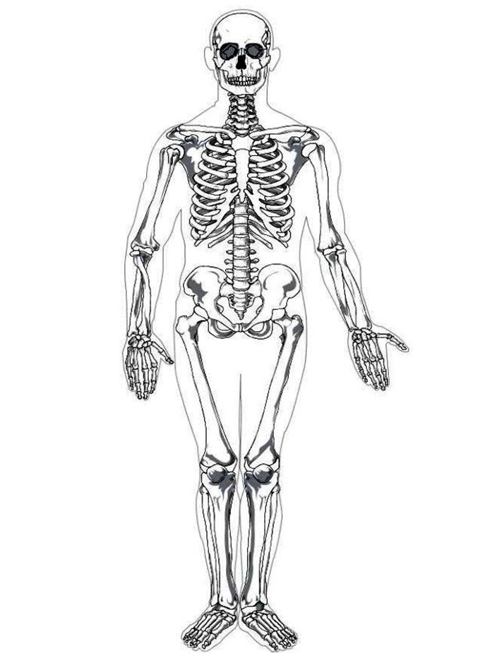

Closed pelvic fracture right side pg. 432-434

Closed fracture right elbow pg. 429-431

Severe bruising abdominal and rib area right side.

Pg. 471-474

Lacerations & abrasions to face pg. 372, 447, & 448

Femoral arterial Bleed pg. 358-365

Welding rod penetration

Pg. 375-378

Bruising to back of head and neck pg. 371-372