First Aid Problem Price UT 2013

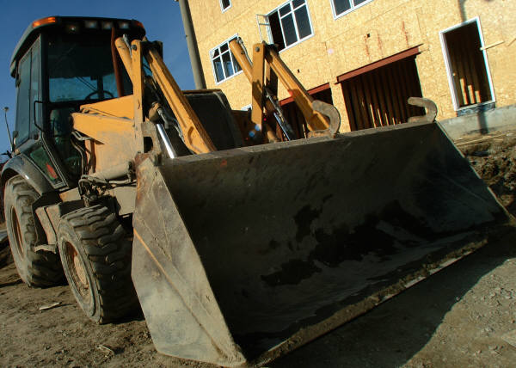

You are called to a structure contractors are building. You find the loader operator Jake, lying on the ground unconscious. A witness saw him fall head first from the cab of the loader. Jake landed on a pile of wood. There is life threatening bleeding. The ambulance will be delayed.

