TEAM ____________________ FIELD ____________________

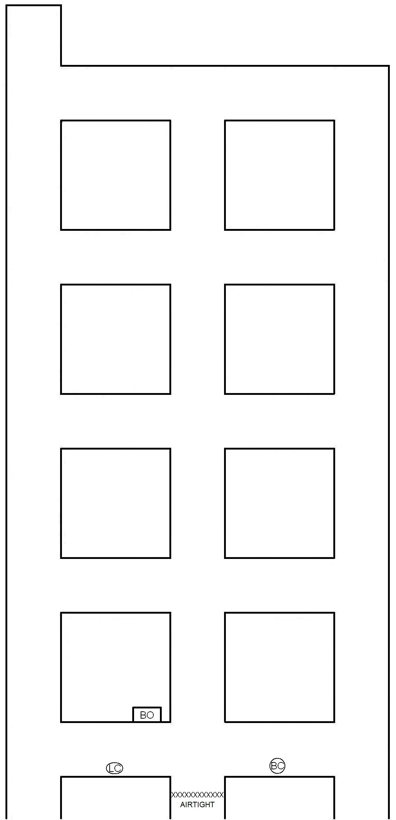

BRIEFING OFFICER’S MAP

