PROBLEM 1
DEH: JANUARY – 2013

STATEMENT

YOU ARE LOCATED IN THE FRESH AIR BASE

YOU MUST ASK FOR LINE CURTAIN

3 PEOPLE ARE MISSING

MINE MAP IS UP TO DATE

FAN IS OPERATIONAL

POWER IS LOCKED OUT AND GUARDED

BACK UP TEAM IS AVAILABLE

AGENCIES HAVE BEEN NOTIFIED AND ARE PRESENT

MINE IS WALKING HEIGHT

SUPPORTED BY ROOF BOLTS UNLESS OTHERWISE NOTED

METHANE IS PRESENT

CARBON MONOXIDE HAS BEEN DETECTED

LOW OXYGEN MAY BE FOUND

TEAM INSTRUCTIONS

LOCATE THE MISSING PEOPLE

BRING ANY LIVE PEOPLE TO THE FRESH AIR BASE

EXPLORE THE MINE IN ITS ENTIRETY

FAN CANNOT BE STOPPED, STALLED OR REVERSED

BRIEFING OFFICER’S STATION IS AIRTIGHT WHEN
BRIEFING OFFICER IS IN IT!

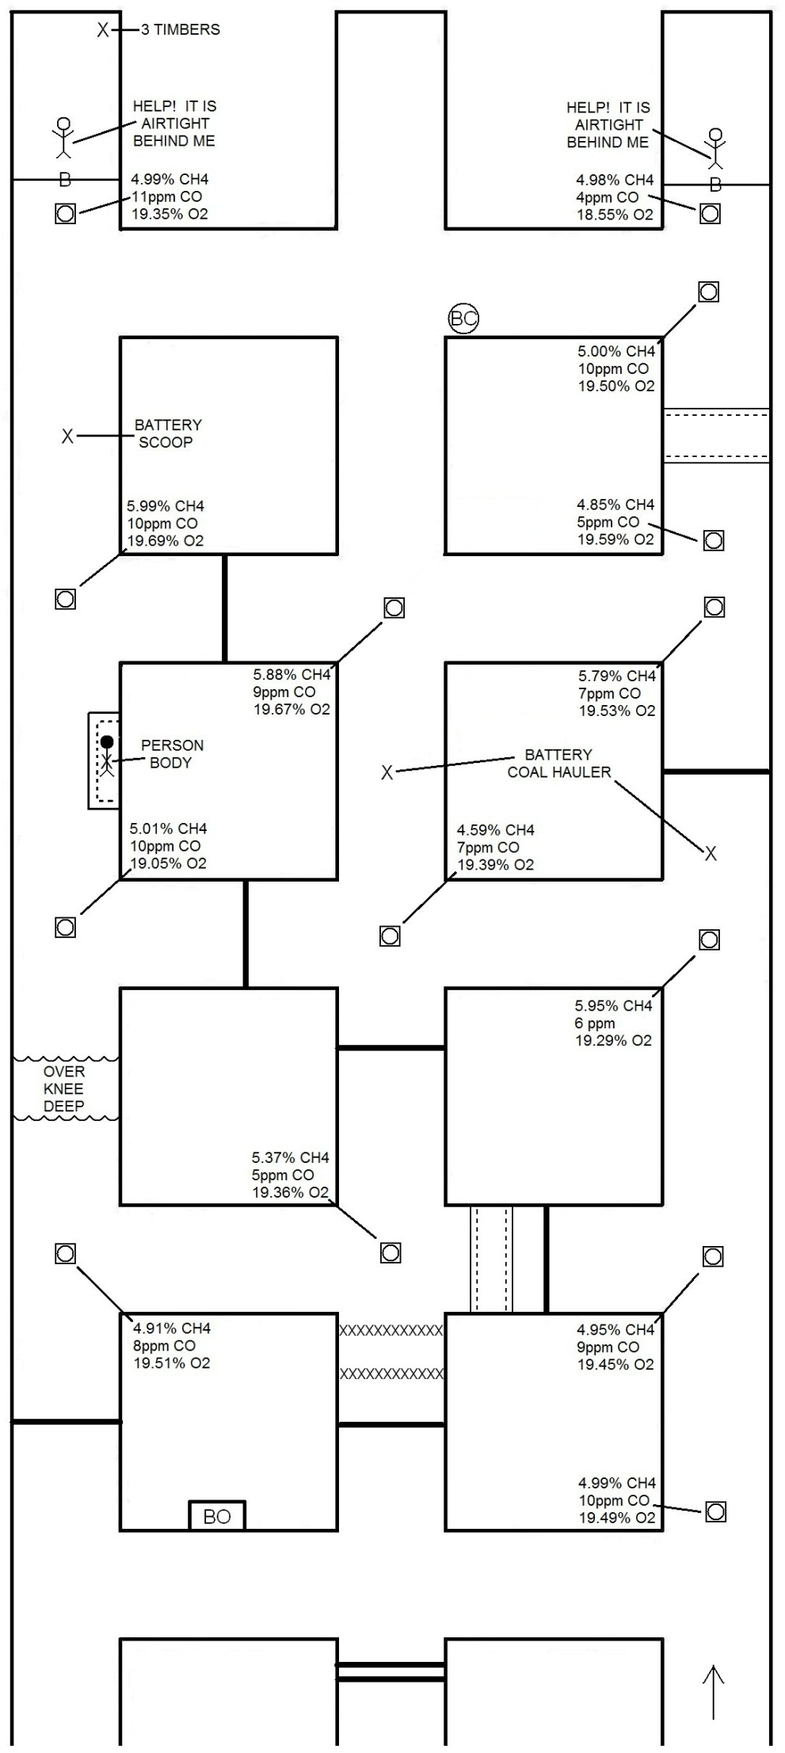
PROBLEM EXPLANATION

TEAM SHOULD REALIZE WHEN THEY GET TO THE BACKSIDE OF TEMPORARY STOPPING FOUND AT TEAM STOP 5, THE TEAM HAS THE MEANS TO TIE ACROSS AND BEHIND.

TEAM MUST BUILD AT LEAST 4 TIMES (1, 2, 3, and 4) IN ORDER TO TIE ACROSS AND BEHIND.

IF TEAM MOVES TO TEAM STOP 12 PRIOR TO MOVING TO TEAM STOP 10 AND TEAM STOP 11, TEAM HAS FAILED TO ADVANCE IN ADJACENT ENTRY AND TIE IN TO THE CONTAMINATED ENTRY.

UPON COMPLETING TEAM STOP 11, THE TEAM HAS MEANS TO VENTILATE THE BARRICADE IN THE #3 ENTRY.

IF TEAM TRAVELS TO TEAM STOP 12 PRIOR TO VENTILATING THE #3 BARRICADE AND RESCUING THE PERSON, THE TEAM HAS DELAYED THE PATIENT IN BARRICADE #3.

FOUR VENTILATIONS REQUIRED TO RESCUE PERSON IN #3 BARRICADE.

FIFTH VENTILATION REQUIRED TO RESCUE PERSON IN #1 BARRICADE AND FIND TIMBERS.

***note: Builds in each ventilation step may vary as long as air cannot
move in any area other than shown in ventilation step.

TIMBER TO THE PERSON IN THE ELONGATED UNSAFE ROOF, AFTER TAKING PERSON IN #1 BARRICADE TO FRESH AIR BASE.

GAS PLACARDS IN PROBLEM TO GENERATE CONFUSION. TEAM MEMBERS MUST RELAY ACCURATE INFORMATION. MAPMAN MUST RECORD PLACARDS VERBATIM. BRIEFING OFFICER MUST HAVE GASES ACCURATE ON MAP.

TEAM STOPS
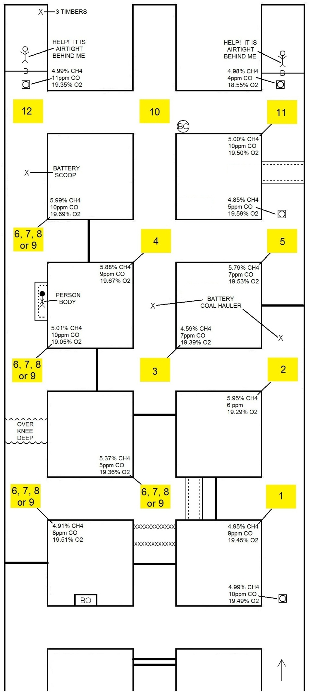
BUILDS FOR EXPLORATION
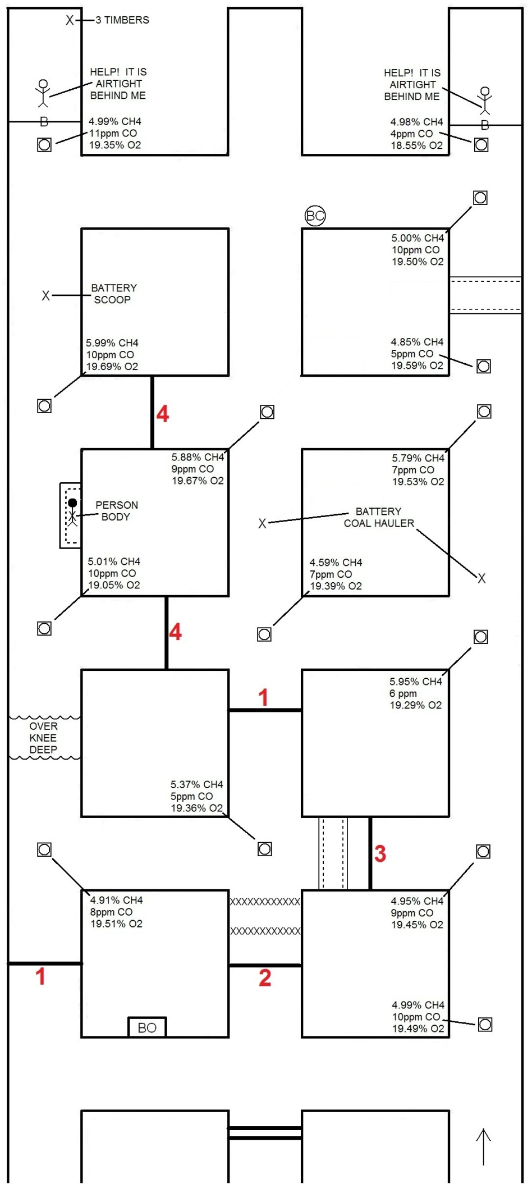
VENTILATION 1
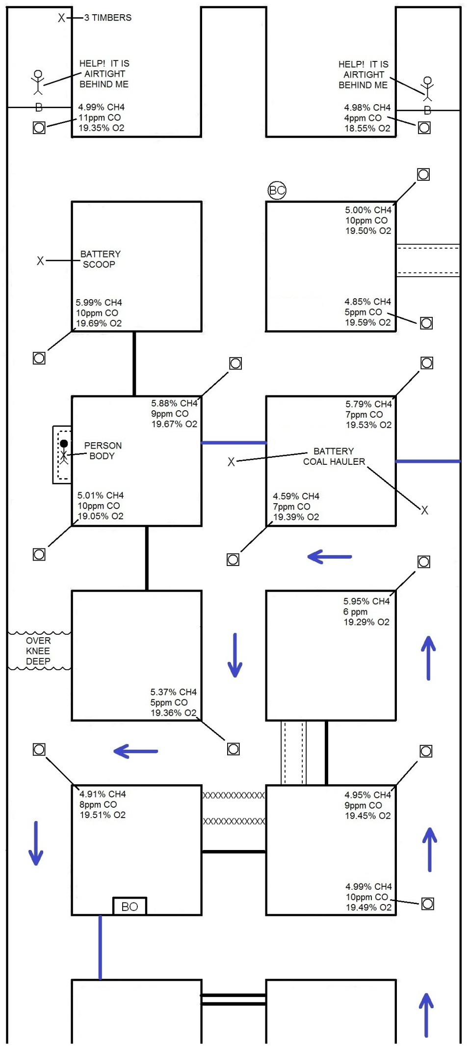
VENTILATION 2
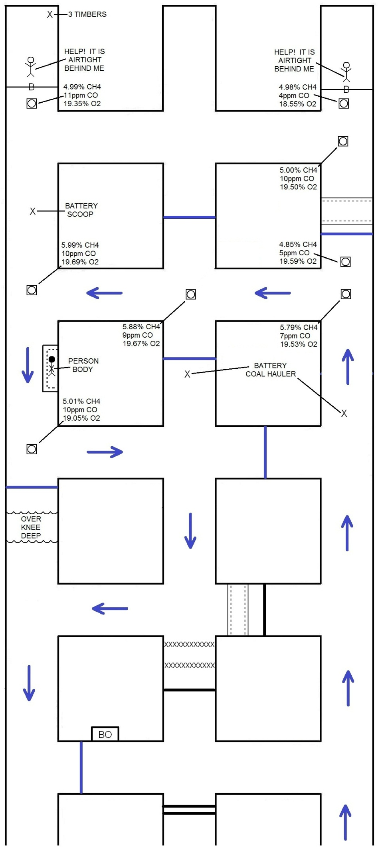
VENTILATION 3
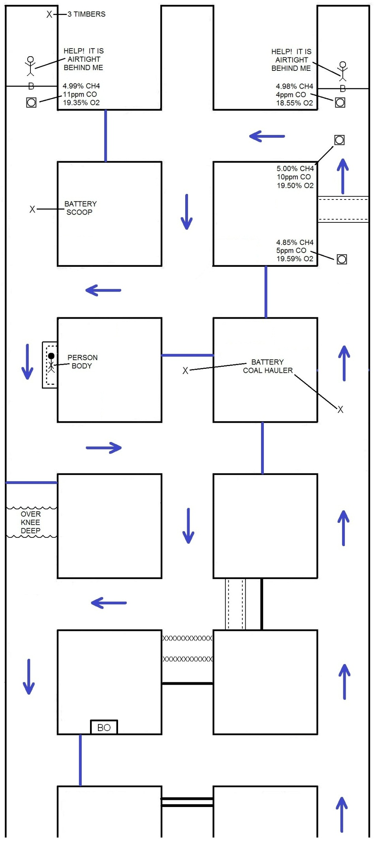
VENTILATION 4
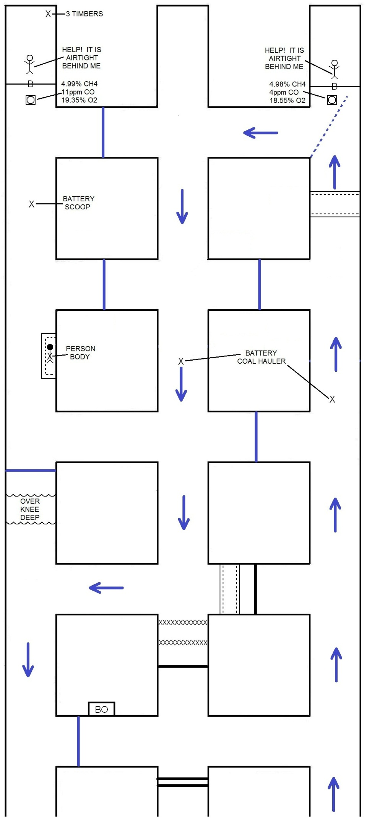
VENTILATION 5
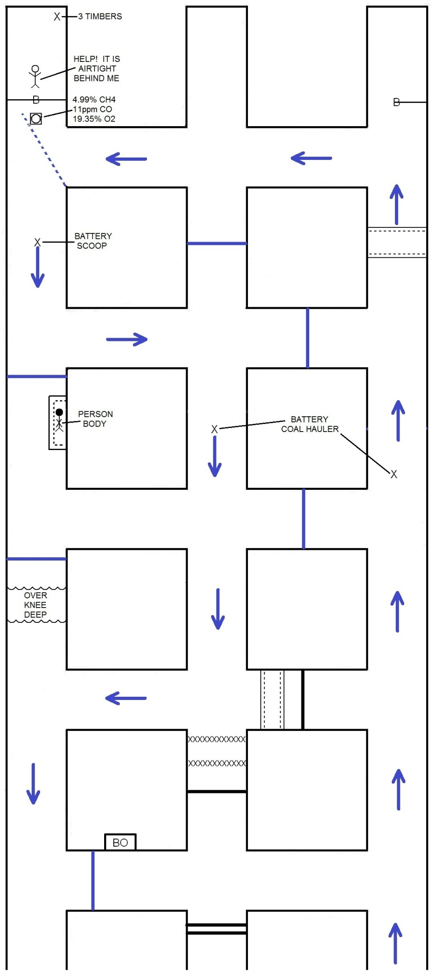
TIMBER TO PERSON
