BEST OF THE BEST – 2012
INITIAL STATEMENT TO BE GIVEN TO ALL TEAMS
UPON THEIR ARRIVAL AT MTTC!!!

WE HAVE BEEN DEVELOPING A THREE ENTRY BLEEDER SECTION TO AN AIRSHAFT FOR USE IN ESTABLISHING A BLEEDER SYSTEM. THE BLEEDER SECTION COMPLETED CONNECTION TO THE AIRSHAFT ON THURSDAY, SEPTEMBER 13, 2012. LAST NIGHT WE HAD A SIGNIFICANT ELECTRICAL STORM WHICH KNOCKED POWER TO THE MINE. A FOREMAN AND TWO PEOPLE WERE COMPLETING VENTILATION WORK ON THE BLEEDER SECTION WHEN THE POWER WENT OFF. AT THE TIME OF THE POWER DISRUPTION, THE FOREMAN HAD WALKED TO THE MANTRIP TO EAT HIS LUNCH. WHEN THE FOREMAN NOTICED THE AIR DIMINISHED HE CALLED THE RESPONSIBLE PERSON WHO TOLD HIM THE POWER WAS OFF. THE FOREMAN TOLD THE RESPONSIBLE PERSON HE WAS GOING TO GET HIS PEOPLE AND WOULD THEN HEAD OUTSIDE. WHILE WAITING FOR THE POWER TO BE RESTORED, THE GROUND SHOOK OUTSIDE LIKE THERE WAS A BUMP OR EARTHQUAKE. THE MINE FOREMAN AND ASSISTANT MINE FOREMAN IMMEDIATELY WENT UNDERGROUND AND LEFT ORDERS THAT IF THE POWER CAME BACK ON NOT TO PUT THE POWER IN UNDERGROUND OR START THE FAN UNDER ANY CIRCUMSTANCES. THE MINE FOREMAN ALSO HAD US ALERT ALL AGENCIES, ENTITIES AND CALL FOR MINE RESCUE TEAMS. WHEN THE MINE FOREMAN AND HIS ASSISTANT GOT THREE CROSSCUTS FROM THE BLEEDER SECTION FACES, THEY WERE BLOCKED BY WATER AND UNSAFE ROOF. THEY ALSO ENCOUNTERED LOW OXYGEN, CARBON MONOXIDE AND METHANE. AT THAT POINT, THE MINE FOREMAN AND HIS ASSISTANT RETURNED TO THE SURFACE TO WAIT FOR YOU. THE FOREMAN AND HIS TWO PEOPLE NEVER CAME TO THE SURFACE FROM THE BLEEDER SECTION.

POST IN LOCKUP AND STAGING AREA
BLEEDER SECTION MINE MAP – updated September 14, 2012
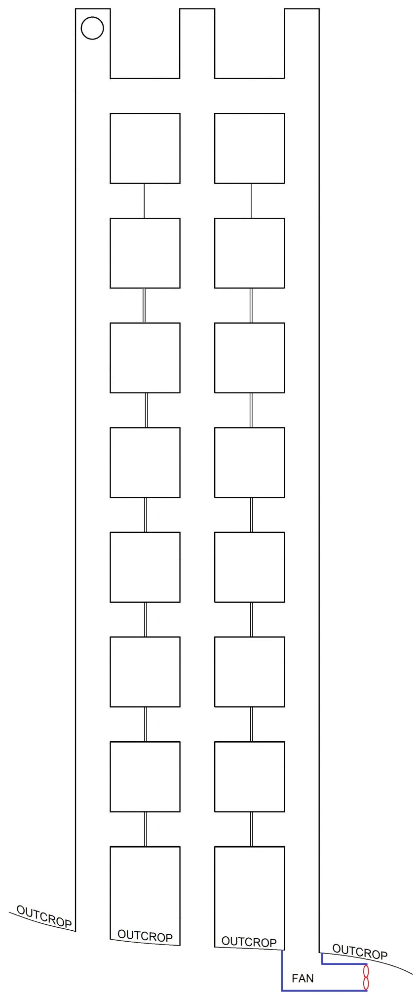
STATEMENT TO BE GIVEN TO TEAMS
UPON ARRIVAL AT FRESH AIR BASE!!!

THE BLEEDER SECTION WAS DEVELOPED USING EXHAUST VENTILATION. LAST WEEK WE COMPLETED CHANGE OVER TO A NEW BLEEDER FAN WHICH WILL BE DEDICATED TO THE BLEEDER SYSTEM ONCE IT IS ESTABLISHED. THE NEW BLEEDER FAN, WHICH WAS INSTALLED ON THE SURFACE, IN THE NUMBER THREE ENTRY, IS NOW USED TO VENTILATE THE BLEEDER SECTION. DURING THE PROCESS OF PREPARING THE BLEEDER SECTION FOR USE, THE VENTILATION STRUCTURES ON THE SECTION WERE TO CHANGE SIGNIFICANTLY. WE WERE TO BUILD AN OVERCAST, TEAR OUT STOPPINGS, INSTALL VENTILATION DOORS, ETC. WE KNOW THE VENTILATION DOORS WERE BUILT AND ARE CURRENTLY CLOSED; HOWEVER, WE DO NOT KNOW THE STATIS OF VENTILATION STRUCTURES INBY THE FRESH AIR BASE. WE ARE PROVIDING YOUR TEAM WITH A MAP SHOWING THE LOCATION OF THE VENTILATION DOORS.

LOCATION OF VENTILATION DOORS
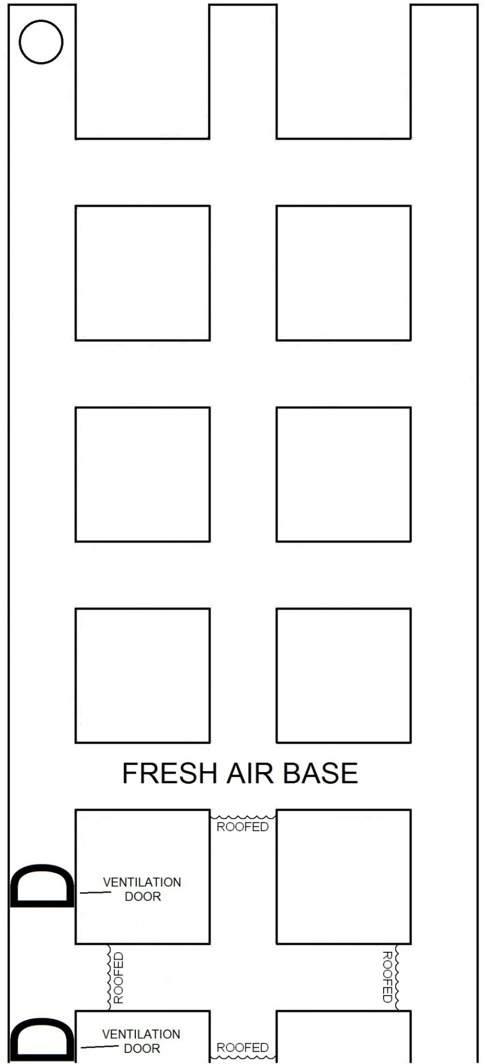
PROBLEM

EXPLORE THE MINE IN ITS ENTIRITY

LOCATE ALL THREE MISSING PEOPLE

BRING SURVIVORS TO THE FRESH AIR BASE

THE BLEEDER FAN IS CURRENTLY OFF, BUT CAN BE STARTED AS AN EXHAUST FAN OR A BLOWING FAN IF NEEDED.

IF THE FAN IS STARTED, YOU MUST SPECIFY WHETHER YOU WANT IT TO BE EXHAUSTING OR BLOWING

YOU START THE FAN BY ASKING THE SUPERINTENDENT

THE VENTILATION DOORS CAN BE OPENED SHOULD YOU NEED TOO

YOU OPEN THE VENTILATION DOORS BY ASKING THE SUPERINTENDENT

YOU WILL HAVE 60 MINUTES TO COMPLETE THE PROBLEM

#3 OUTBY BARRICADE
PATIENT STATEMENT

“HELP! GET ME
OUT OF HERE!”

REFUGE ALTERNATIVE
PATIENT STATEMENT

“HELP! GET ME
OUT OF HERE!”

#3 INBY BARRICADE
PATIENT STATEMENT

“HELP! IT IS
AIRTIGHT
BEHIND ME!”

PROBLEM MAP
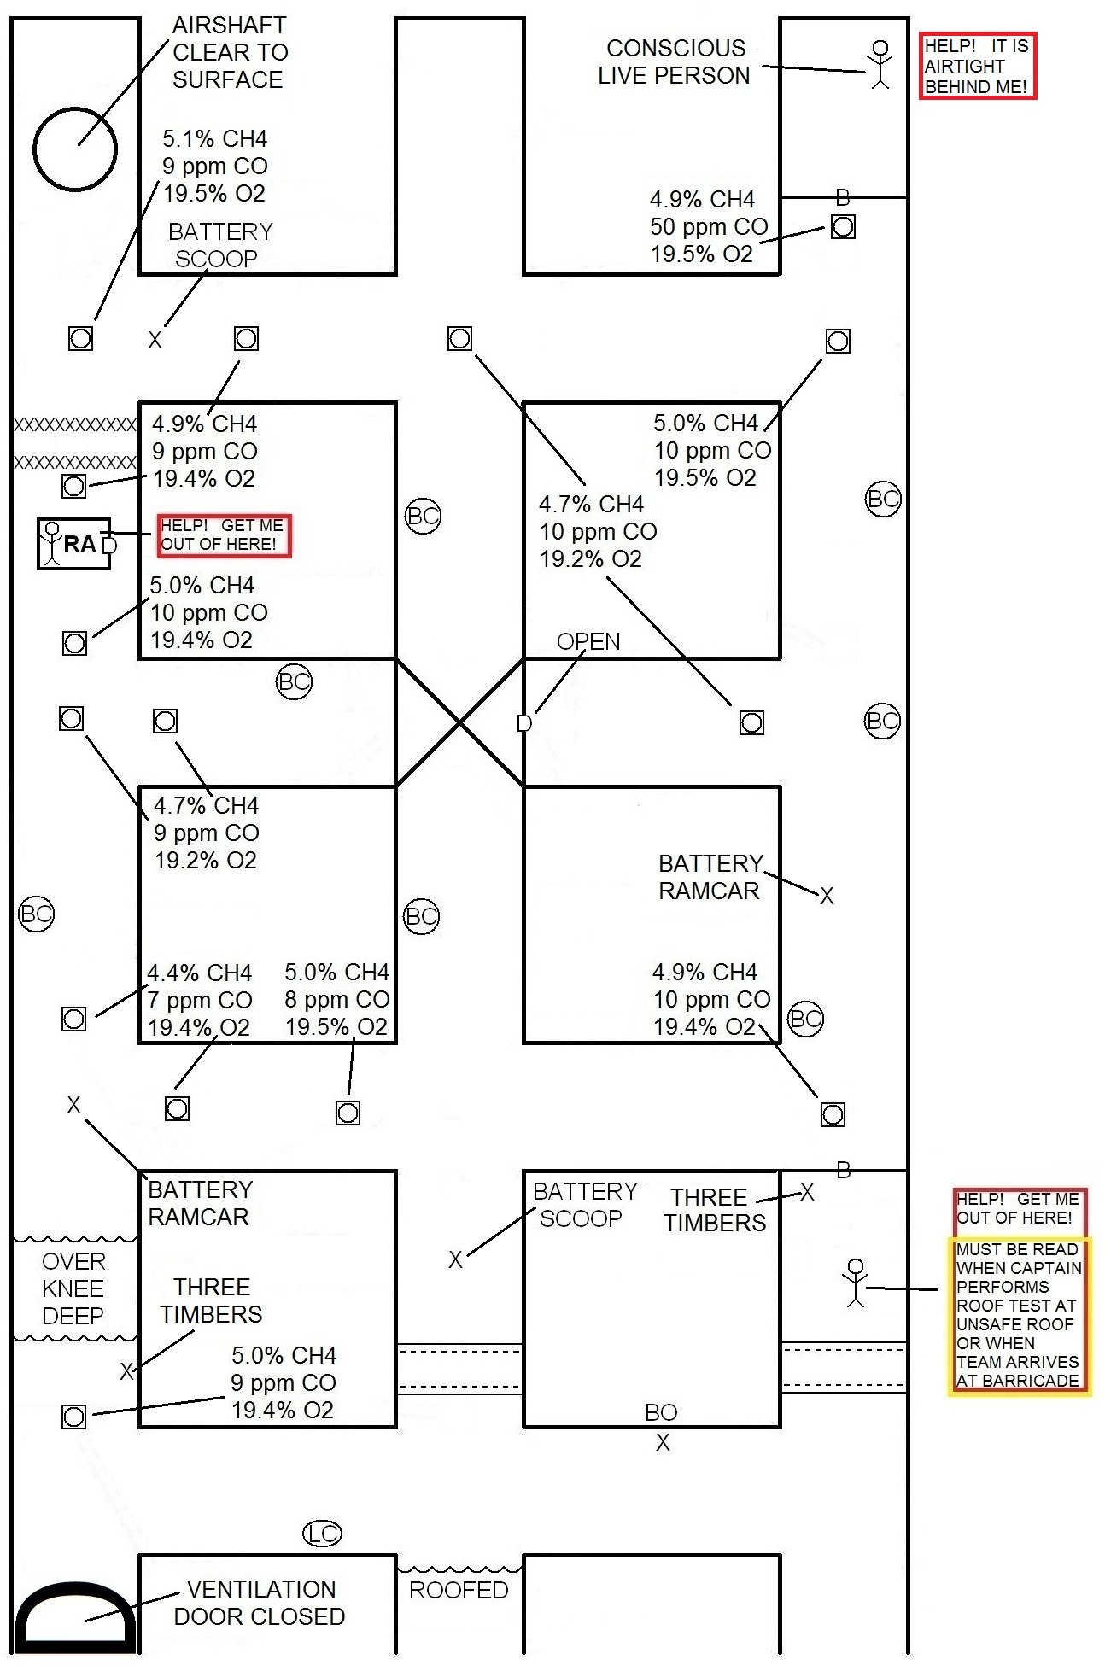
RULES GOVERNING START OF PROBLEM

Rule 24
Part C Teams must check all entrances to the area to be explored prior to the entire team going underground or inby the fresh-air base. Entrances may be checked in air clear of smoke without the use of a lifeline so long as the entire team does not go underground or inby the fresh-air base.

Rule 42
Part C.
#1 If a team finds a patient(s) under or inby an area of unsafe roof and has the necessary roof support available to recover the patient(s), the team must stop and recover the patient. If a team subsequently finds necessary roof support to recover the patient(s), the team must stop (prior to the No. 5 team member passing the roof support), retrieve the roof support and recover the patient(s).

Rule 45
Part B Unless blocked, teams must advance in the contaminated entry or in entries adjacent to the contaminated entry. When a contaminated entry and adjacent entries are blocked, teams may explore/advance in other nearest accessible entries. However, the team will be discounted if it fails to return to the contaminated or adjacent entry at the first open crosscut, and if not blocked, make all further explorations in the contaminated or adjacent entries before advancing into other areas of the mine.

TEAM STOPS
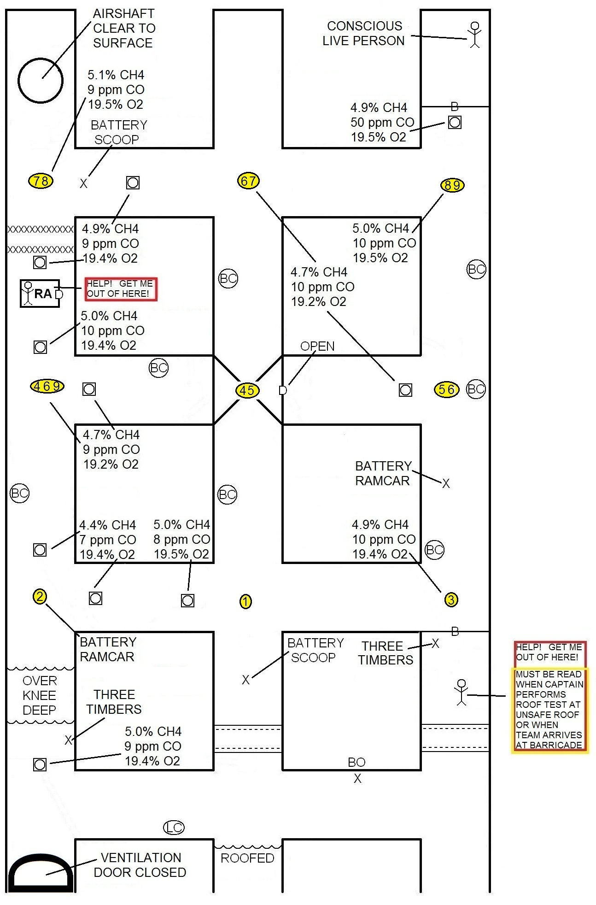
GAS TESTS, ROOF, RIB AND FACE TESTS,
DATE AND INITIALS
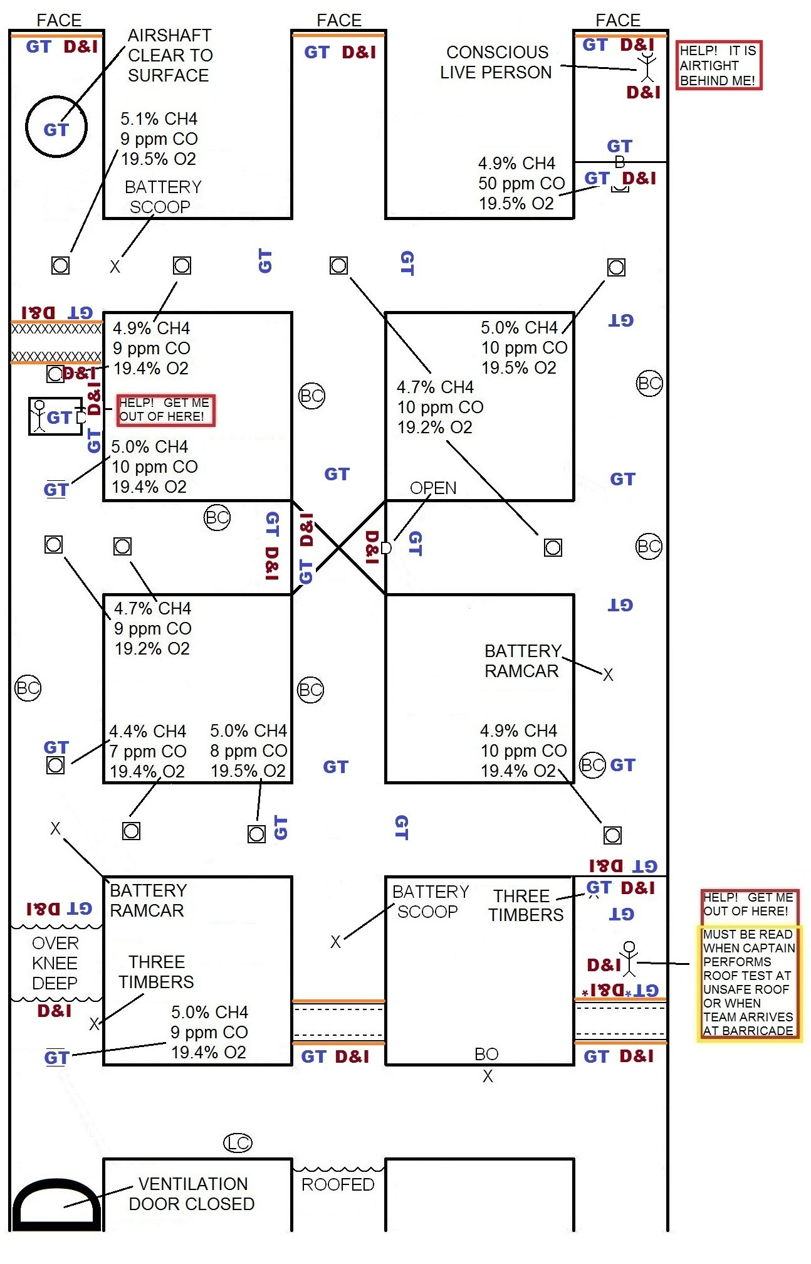
EXTENT OF GASES
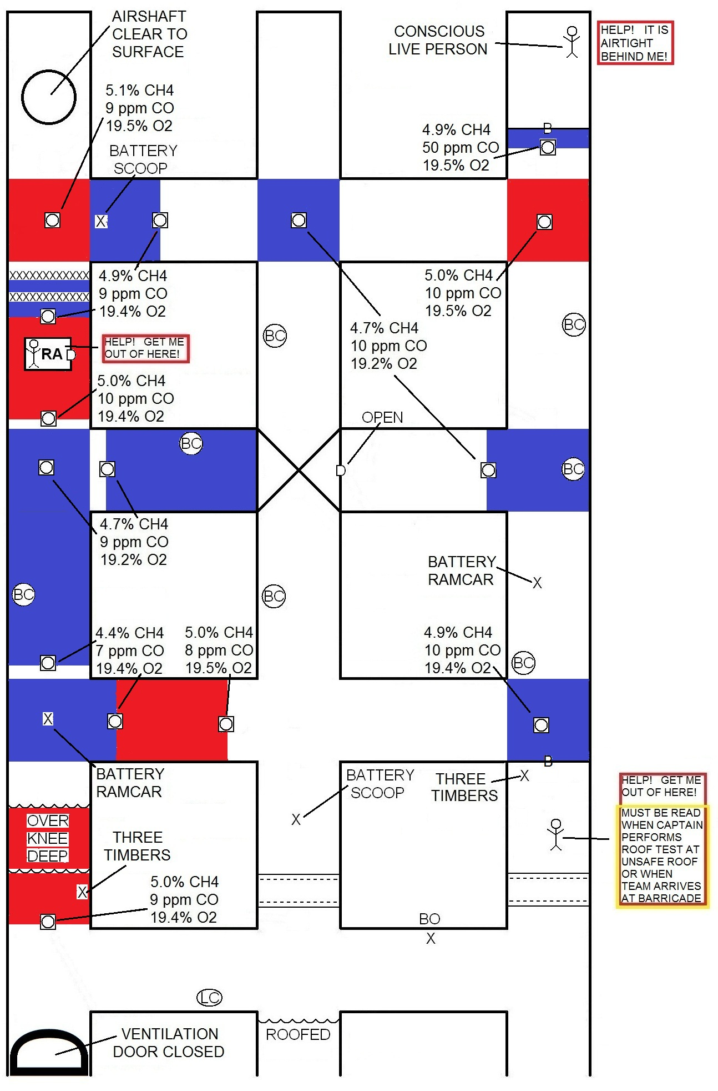
BEST OF THE BEST PROBLEM DISCUSSION

THE TEAMS WORKING THIS PROBLEM WERE GIVEN INFORMATION PRIOR TO LOCKUP. IT IS A MAP OF THE MINE FROM DRIFT MOUTH TO FACE WHICH WAS UPDATED ON FRIDAY, SEPTEMBER 14. THEY WILL RECEIVE A MAP WITH THE FRESH AIR STATEMENT THAT WILL SHOW VENTILATION DOORS BUILT IN THE MINE BETWEEN SEPTEMBER 14 AND TODAY. THE ONLY THING IMPORTANT IN ALL THE INFORMATION THEY HAVE RECEIVED UP UNTIL THEY START THE CLOCK IS WHERE THE FAN IS LOCATED!!!

AFTER THE CLOCK IS STARTED, THEY WILL BE REQUIRED TO ACCOUNT FOR THE MISSING PEOPLE AND BRING SURVIVORS TO THE FRESH AIR BASE WITH A TIME LIMIT OF 60 MINUTES. THE TEAMS WILL NOT BE TOLD THE FAN CAN BE STOPPED. IF THEY ASK YOU AFTER THE CLOCK IS STARTED YOU CAN TELL THEM “YES!”

WHEN MAKING THE OPENINGS THE TEAM WILL FIND 5% METHANE, 9 ppm CARBON MONOXIDE AND 19.4% OXYGEN INBY THE FRESH AIR BASE IN THE NUMBER 1 ENTRY. THE TEAM WILL ALSO FIND 3 TIMBERS AND WATER OVER KNEE DEEP WHEN MAKING THE NUMBER 1 OPENING. THE TEAM WILL FIND UNSAFE ROOF WHEN THEY MAKE THE NUMBER 2 AND NUMBER 3 OPENINGS. THE CAPTAIN WILL NEED DATE AND INITIAL AT THE WATER OVER KNEE DEEP IN #1. CAPTAIN WILL NEED TO ROOF AND RIB TEST AT THE UNSAFE ROOF IN #2 AND #3 OPENINGS. TEAM IS REQUIRED TO GAS TEST IN THE #1, #2 AND #3 OPENINGS. WHEN THE CAPTAIN MAKES THE ROOF TEST IN THE NUMBER 3 OPENING PERSON WILL SAY “HELP! GET ME OUT OF HERE” FROM BEHIND THE UNSAFE ROOF.

AFTER MAKING ALL OPENINGS THE CAPTAIN SHOULD GET THE TIMBERS FROM NUMBER 1 AND TIMBER THE UNSAFE ROOF IN NUMBER 3 ENTRY IN ORDER TO RESCUE THE PERSON CALLIING FOR HELP.

IF THE CAPTAIN TIMBERS INTO THE NUMBER 3 ENTRY AND THE NO. 5 PERSON (TAIL CAPTAIN) ADVANCES INTO THE NUMBER 3 ENTRY THE TEAM IS TO BE DISCOUNTED UNDER RULE 45 B. FAILURE TO ADVANCE IN CONTAMINATED OR ADJACENT ENTRIES.

IF THE CAPTAIN TIMBERS INTO THE NUMBER 2 ENTRY RATHER THAN TIMBER TO THE PERSON IN THE NUMBER 3 ENTRY FIRST, THE TEAM WILL BE DISCOUNTED UNDER RULE 42 C 1. FAILURE TO REMOVE PATIENT PROMPTLY.

THE KEY IS THE TEAM REMOVES THE PATIENT IN THE NUMBER 3 ENTRY WHILE THE NO. 5 PERSON STAYS IN THE FRESH AIR BASE THEN THE TEAM TAKES THE TIMBERS THEY FIND WITH THE PATIENT IN NUMBER THREE AND TIMBERS THE NUMBER 2 ENTRY IN ORDER TO ENTER THE MINE!!!

TEAM STOP 1:
CAPTAIN MUST MAKE ALL OPENINGS, TEAM MUST TAKE GAS TESTS IN ALL THREE OPENINGS.
NOTE: TEAM IS ALSO REQUIRED TO MAKE 50 FOOT CHECK AT FIRST STOP (ALL TEAM MEMBERS INBY FRESH AIR BASE).

TEAM STOP 2:
CAPTAIN MUST MAKE ALL OPENINGS, PLUS DATE AND INITIAL AT THE INBY SIDE OF WATER OVER KNEE DEEP OUTBY THE INTERSECTION.

TEAM STOP 3:
CAPTAIN IS TO DATE AND INITIAL THE BARRICADE. CAPTAIN MAY OPEN BARRICADE AND WALK OUTBY TOWARD FRESH AIR BASE IF THE TEAM HAS RECOVERED THE PATIENT WHO WAS BEHIND THE BARRICADE. CAPTAIN WILL ALSO MAKE THE OPENING INBY. TEAM MUST TAKE GAS TEST AT THE BARRICADE AND IN BOTH OPENINGS.
NOTE: IF TEAM DID NOT REMOVE PATIENT BEHIND OUTBY BARRICADE IN THE NUMBER 3 ENTRY, THE PATIENT WILL AGAIN SAY: “HELP! GET ME OUT OF HERE!” CAPTIAN WILL HAVE TO DATE AND INTIAL AT THE BARRICADE AND TEAM WILL HAVE TO TAKE A GAS TEST AT THE BARRICADE. CAPTAIN WILL ALSO HAVE TO TAKE A GAS TEST WHEN HE DOES ENTER THIS BARRICADE.

TEAM STOP 4:
IF SECOND INTERSECTION OF THE NUMBER 1 ENTRY:
BOTH OPENINGS WILL NEED TO BE MADE BY THE CAPTIAN. TEAM MUST TAKE GAS TESTS IN BOTH OPENINGS. TEAM WILL HAVE TO DETERMINE IF ANYONE IS IN REFUGE ALTERNATIVE (PATIENT SHOULD SAY: HELP! GET ME OUT OF HERE!”), CAPTAIN WILL DATE AND INITIAL DOOR OF REFUGE ALTERNATIVE. IF CAPTAIN TRAVELS INBY REFUGE ALTERNATIVE, CAPTAIN MUST DO ROOF AND RIB CHECK PLUS DATE AND INITIAL AT CAVED
NOTE: A GAS TEST AT THE WALL OF THE OVERCAST IN THE #1 TO #2 CROSSCUT WILL SUFFICE FOR THE GAS TEST IN THE CROSSCUT IF DONE
WHILE AT THE ORIGINAL TEAM STOP IN THE NUMBER 1 ENTRY. CAPTAIN IS REQUIRED TO DATE AND INITIAL THE OVERCAST WALL.

IF SECOND INTERSECTION OF THE NUMBER 2 ENTRY:
THE CAPTAIN MUST DATE AND INITIAL THE OVERCAST WALLS AND MAKE BOTH OPENINGS (STEP THROUGH DOOR IN OVERCAST WALL). TEAM IS REQUIRED TO TAKE GAS TEST AT OVERCAST WALL WITHOUT DOOR AND IN TWO OPENINGS

TEAM STOP 5:
IF SECOND INTERSECTION OF THE NUMBER 2 ENTRY:
PLEASE REFER TO TEAM STOP 4.

IF SECOND INTERSECTION OF THE NUMBER 3 ENTRY:
THE CAPTAIN MUST MAKE BOTH OPENINGS AND THE TEAM MUST MAKE A GAS TEST IN EACH OPENING.

TEAM STOP 6:
IF SECOND INTERSECTION OF THE NUMBER 1 ENTRY:
PLEASE REFER TO TEAM STOP 4.

IF SECOND INTERSECTION OF THE NUMBER 2 ENTRY:
PLEASE REFER TO TEAMS STOP 5

IF THIRD INTERSECTION OF THE NUMBER 2 ENTRY INBY THE FRESH AIR BASE: CAPTAIN MUST MAKE ALL THREE OPENINGS AND THE TEAM MUST MAKE A GAS TEST IN EACH OPENING. ADDITIONALLY, THE CAPTAIN WILL NEED TO MAKE A ROOF, RIB AND FACE TEST IN THE FACE OF THE NUMBER 2 ENTRY PLUS DATE AND INITIAL AT THE FACE.
NOTE: A GAS TEST AT THE FACE OF THE NUMBER 2 ENTRY WILL SUFFICE FOR THE GAS TEST IN THAT OPENING.

TEAM STOP 7:
IF THIRD INTERSECTION OF THE NUMBER 2 ENTRY:
PLEASE REFER TO TEAM STOP 6

IF THIRD INTERSECTION OF THE NUMBER 1 ENTRY:
CAPTAIN WILL MAKE BOTH OPENINGS, ROOF AND RIB TESTING CAVED OUTBY INTERSECTION PLUS DATE AND INITIAL AT THE CAVED. TEAM WILL MAKE GAS TEST IN BOTH OPENINGS. THE GAS TEST AT THE FACE WILL SUFFICE FOR THE OPENING. CAPTAIN WILL BE REQUIRED TO PERFORM A ROOF, RIB AND FACE CHECK AT THE FACE OF THE NUMBER 1 ENTRY. CAPTAIN IS ALSO REQUIRED TO DATE AND INITIAL AT THE FACE OF NUMBER 1.
NOTE: IF THE TEAM HAS NOT REMOVED THE PATIENT IN THE OUTBY BARRICADE OF THE NUMBER 3 ENTRY, THE TEAM MUST IMMEDIATELY START WORKING TO REMOVE THAT PATIENT
AFTER COMPLETING THIS TEAM STOP (TEAM HAS MEANS TO REMOVE PATIENT).

TEAM STOP 8:
IF THIRD INTERSECTION OF THE NUMBER 1 ENTRY:
PLEASE REFER TO TEAM STOP 7

IF THIRD INTERSECTION OF THE NUMBER 3 ENTRY:
CAPTAIN WILL MAKE BOTH OPENINGS. CAPTAIN WILL DATE AND INITIAL BARRICADE. TEAM WILL MAKE GAS TEST IN EACH OPENING. GAS TEST AT BARRICADE SUFFICES FOR OPENING. PERSON IN BARRICADE WILL SAY: “HELP! IT IS AIRTIGHT BEHIND ME!” AT THIS POINT CAPTAIN MUST GO INTO BARRICADE TAKING GAS TEST BEFORE ANYONE ENTERS (NO VENTILATION REQUIRED). CAPTAIN IS TO MAKE ROOF, RIB AND FACE CHECK AT FACE OF NUMBER 3 PLUS DATE AND INITIAL AT PATIENT LOCATION AND AT FACE. PATIENT MUST NOW BE TAKEN TO FRESH AIR BASE.

TEAM STOP 9:
IF SECOND INTERSECTION OF THE NUMBER 1 ENTRY
PLEASE REFER TO TEAM STOP 4

IF THIRD INTERSECTION OF THE NUMBER 3 ENTRY:
PLEASE REFER TO TEAM STOP 8.

ONCE ALL NINE TEAM STOPS ARE COMPLETED THE REFUGE ALTERNATIVE CAN BE VENTILATED AND THE PATIENT REMOVED TO THE FRESH AIR BASE. NOTE: BECAUSE OF ROUTE OF TRAVEL OUT OF THE MINE, CAREVENT MUST BE USED). IF THE TEAM HAS EXPLORED THE ENTIRE MINE THE PROBLEM WILL BE COMPLETED.

CORRECT STEP 1
TIMBER # 1
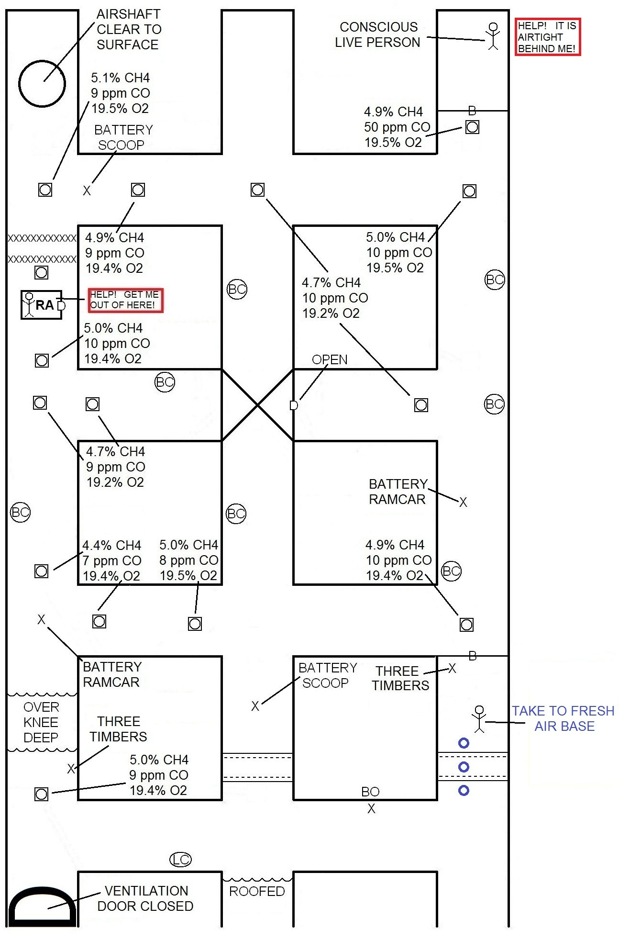
CORRECT STEP 2
TIMBER # 2
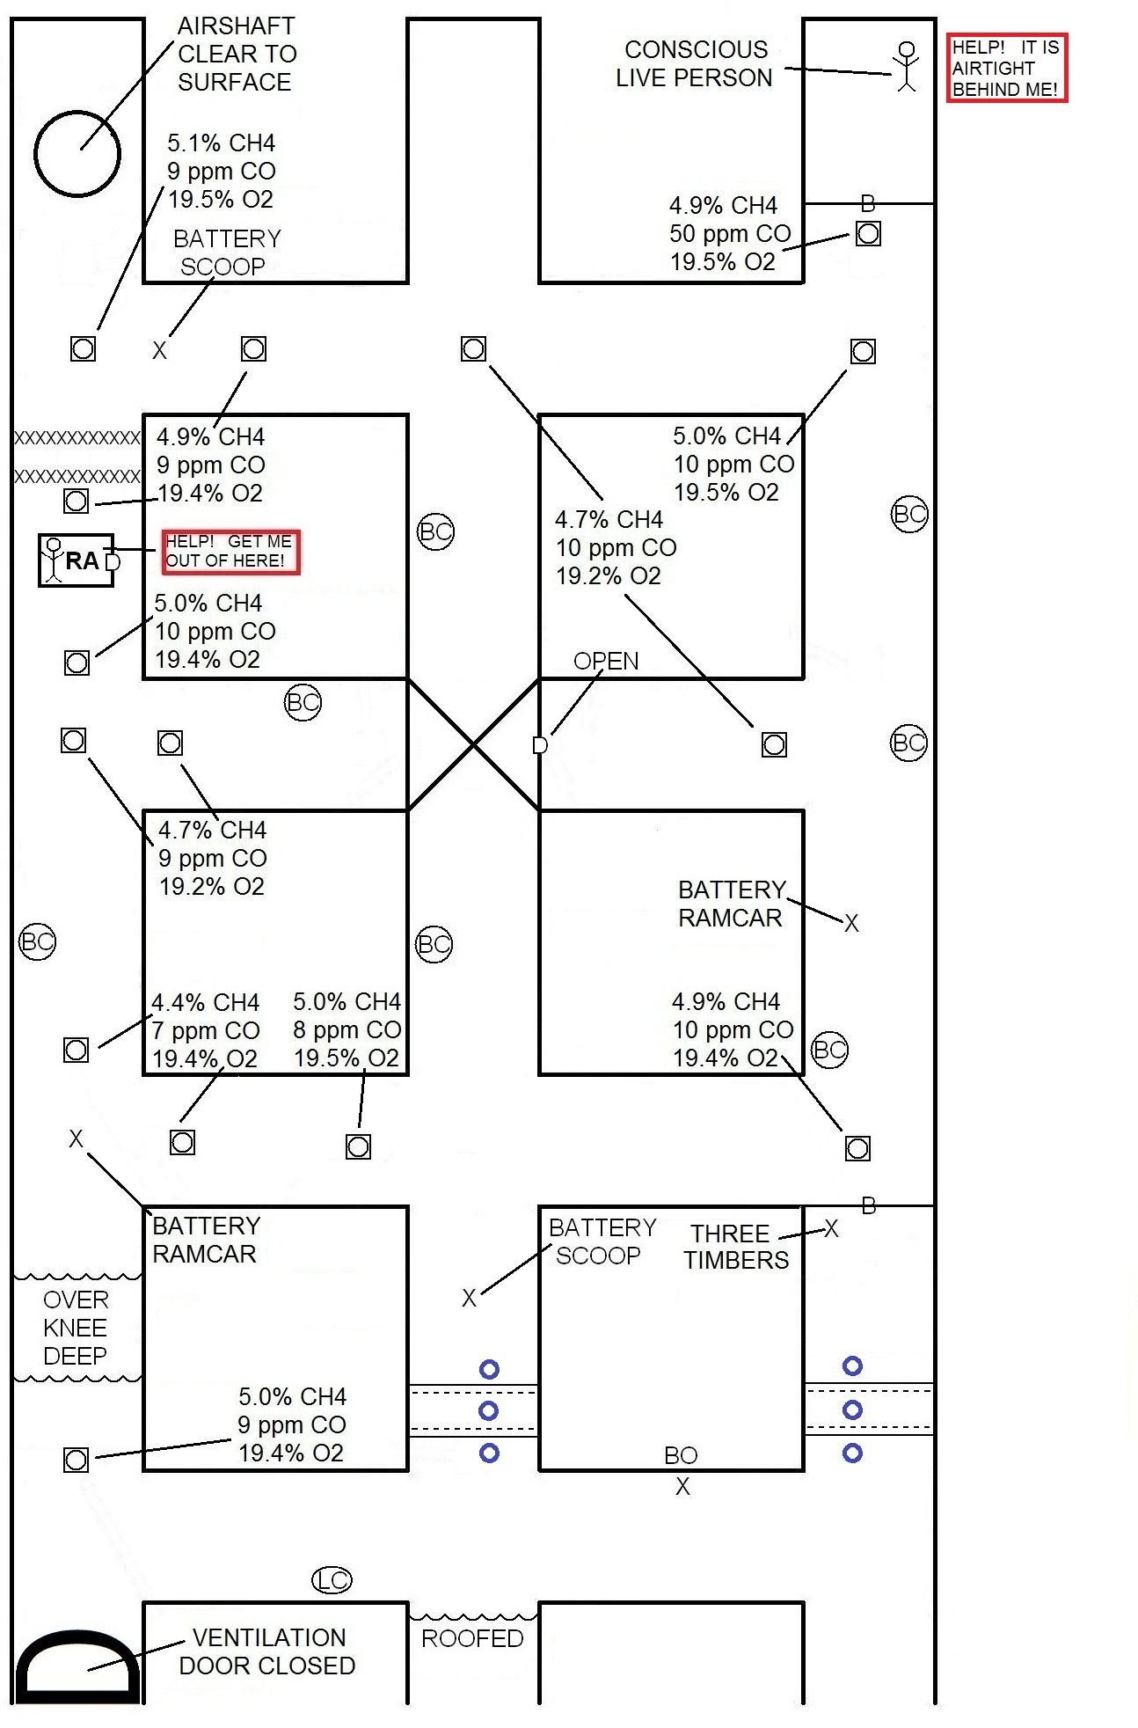
CORRECT STEP 3
RESCUE PERSON # 3 BARRICADE
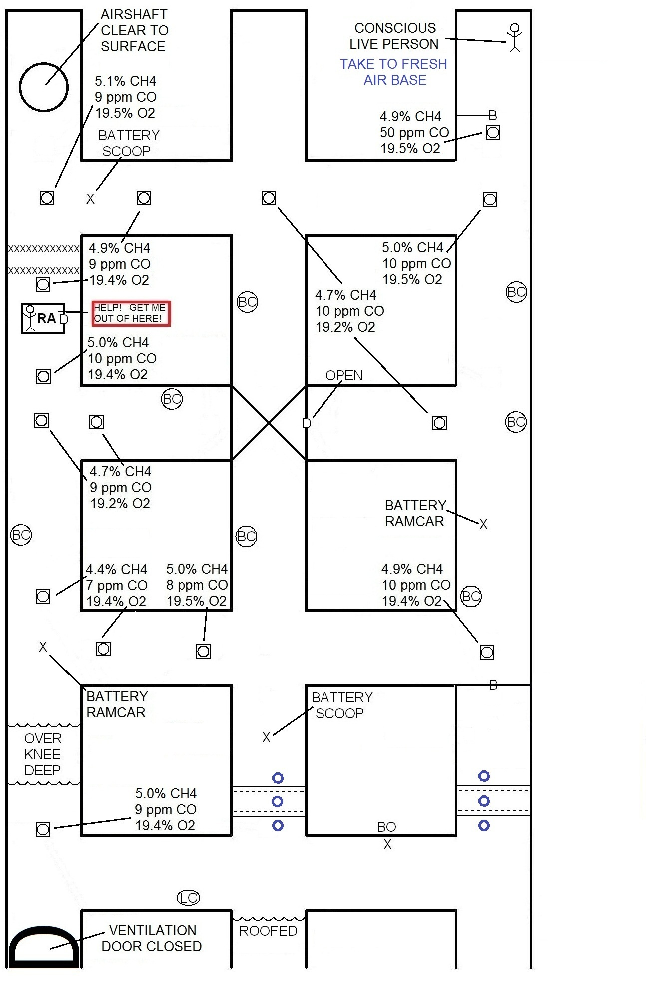
CORRECT STEP 4 – VENTILATION 1
CLEAR METHANE OUTBY SHAFT
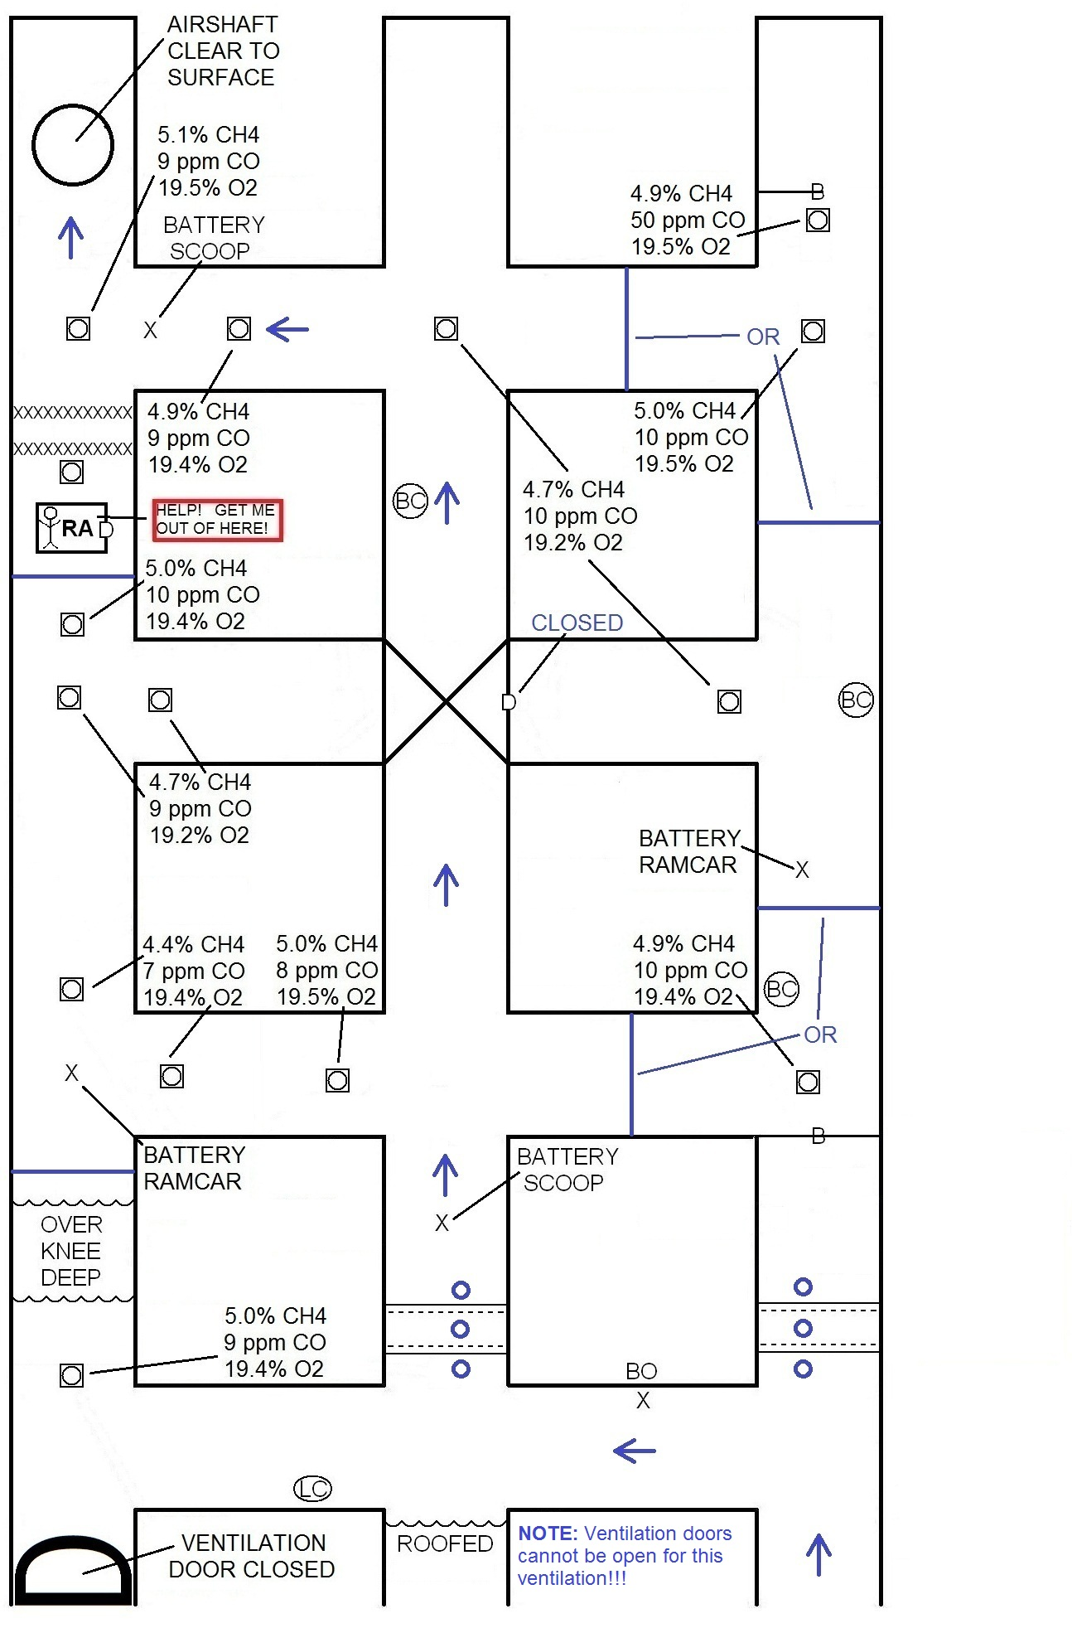
CORRECT STEP 5 – VENTILATION 2
VENTILATE REFUGE ALTERNATIVE
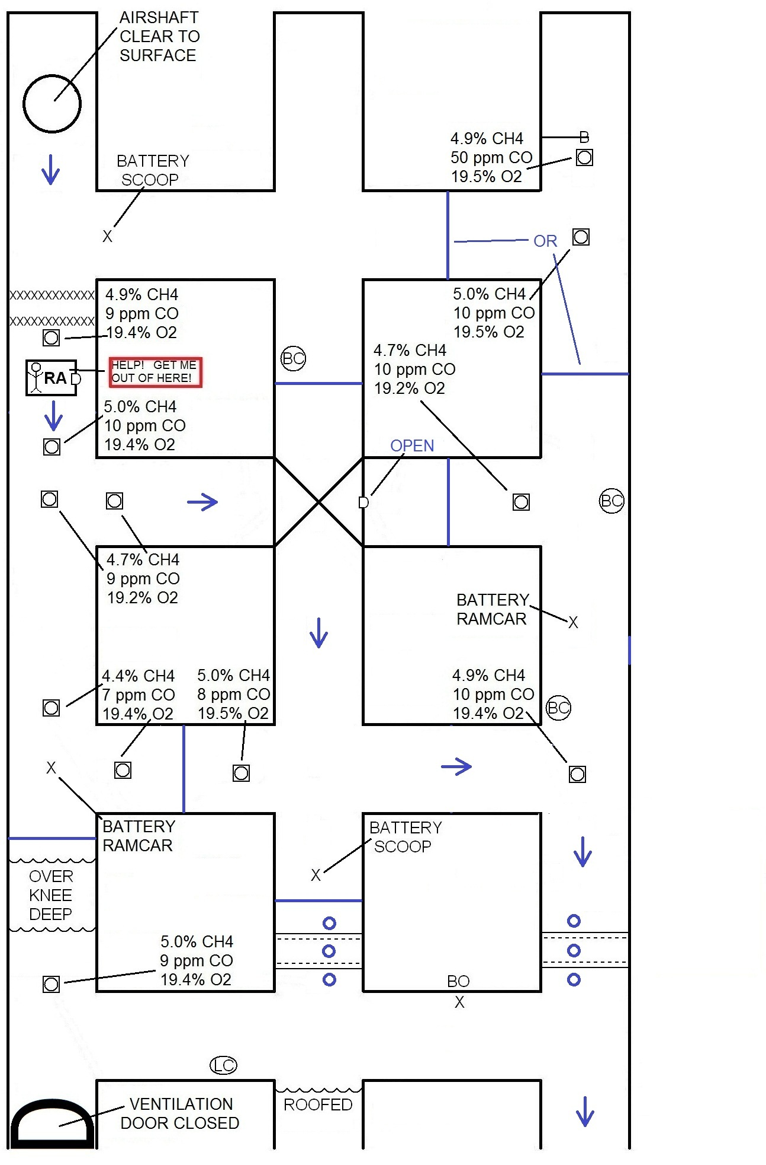
INCORRECT STEP 1
TIMBER IN # 2
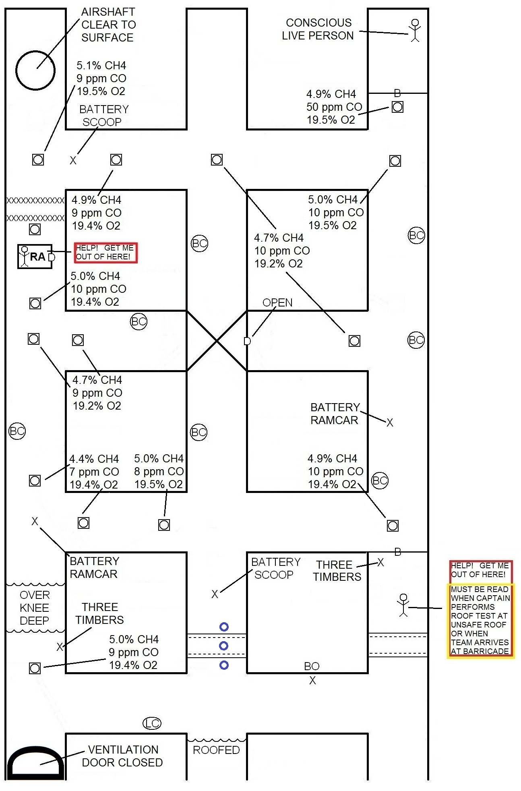
INCORRECT STEP 2 – VENTILATION 1
VENTILATE OUTBY BARRICADE
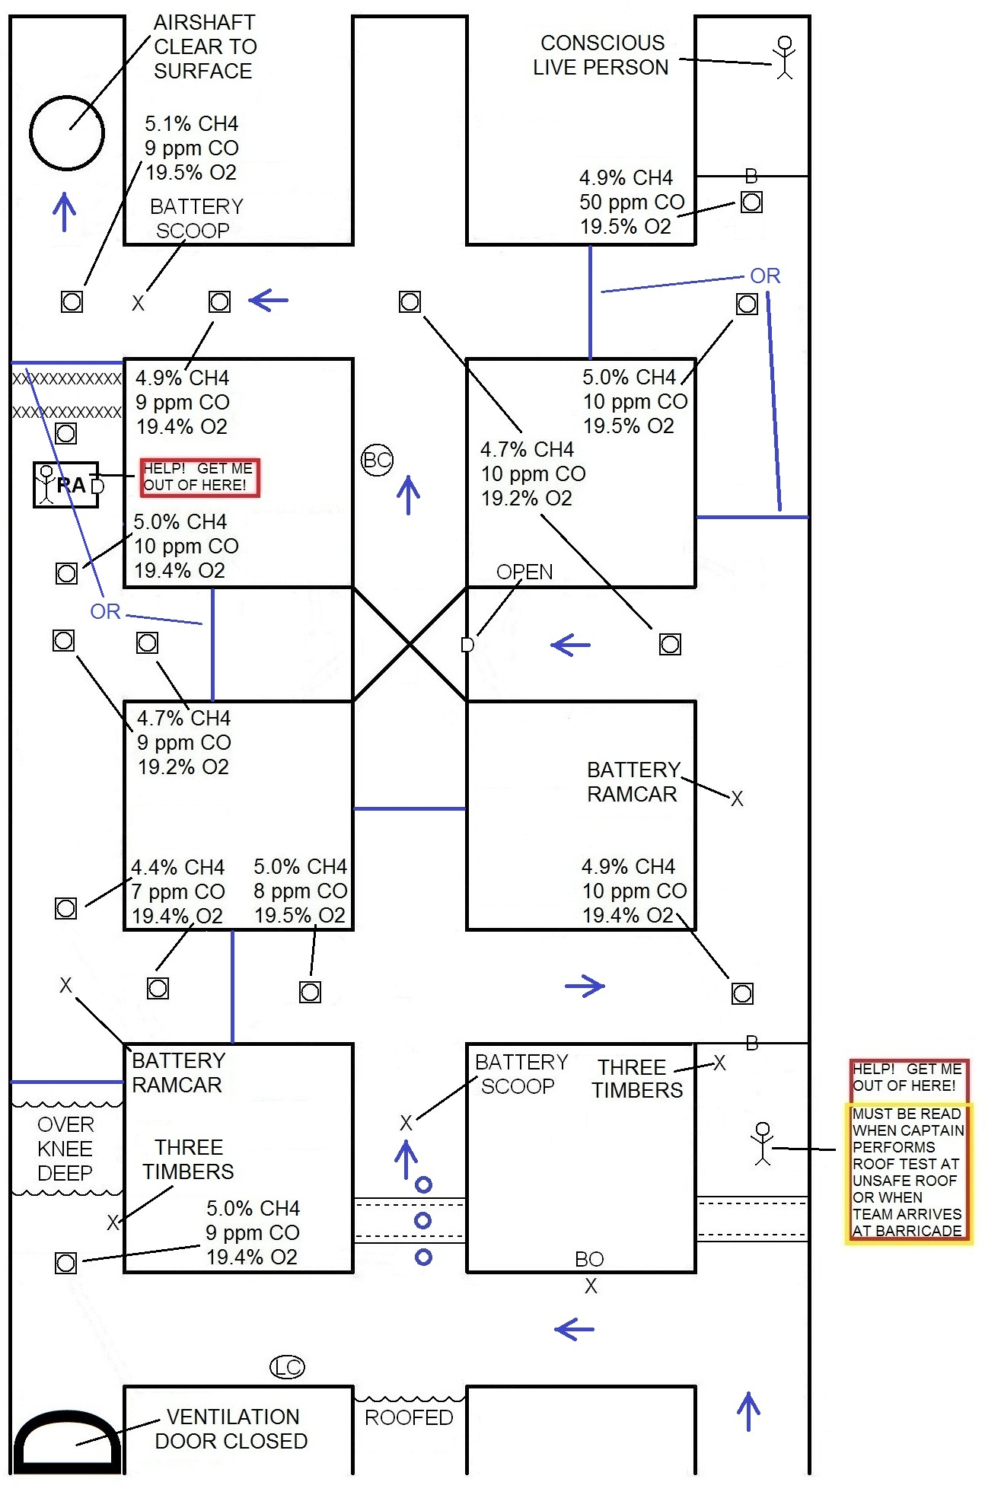
INCORRECT STEP 3
RESCUE PERSON # 3 OUTBY BARRICADE
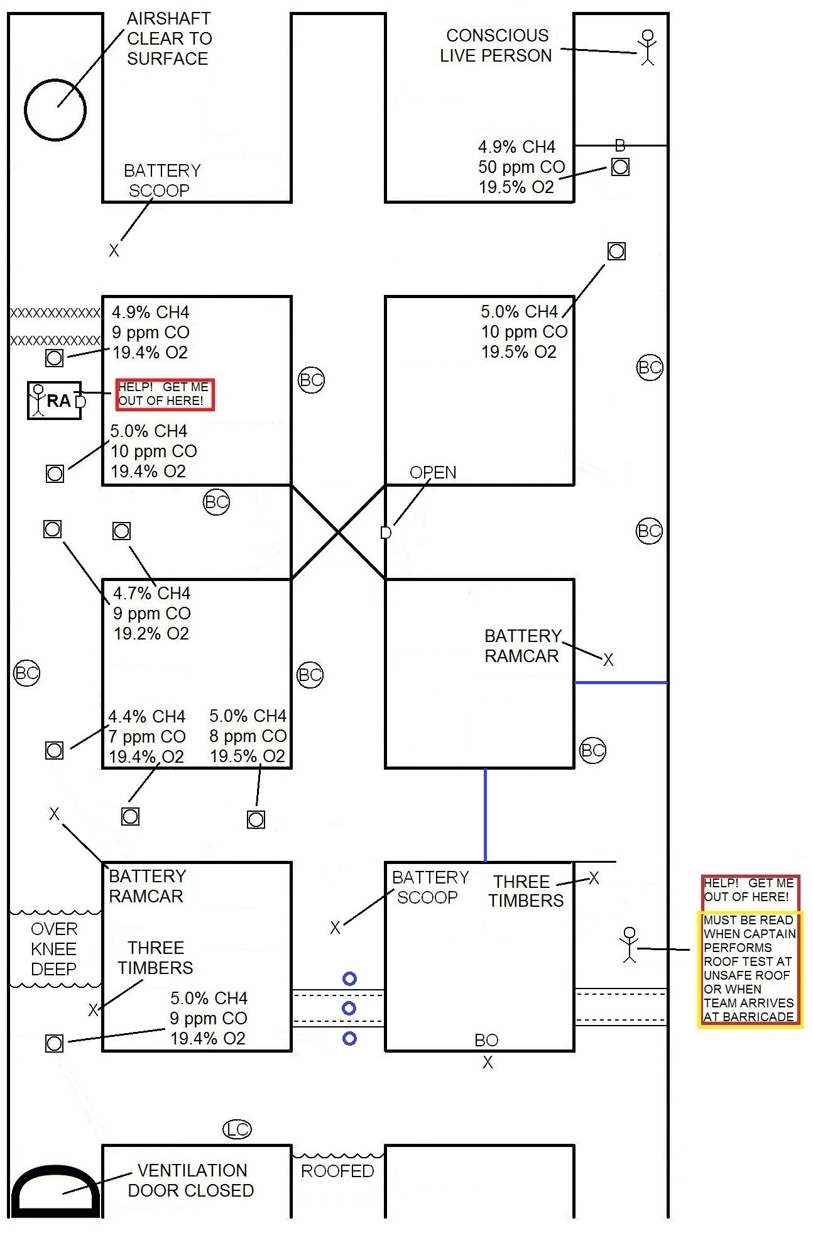
INCORRECT STEP 4
RESCUE PERSON # 3 INBY BARRICADE
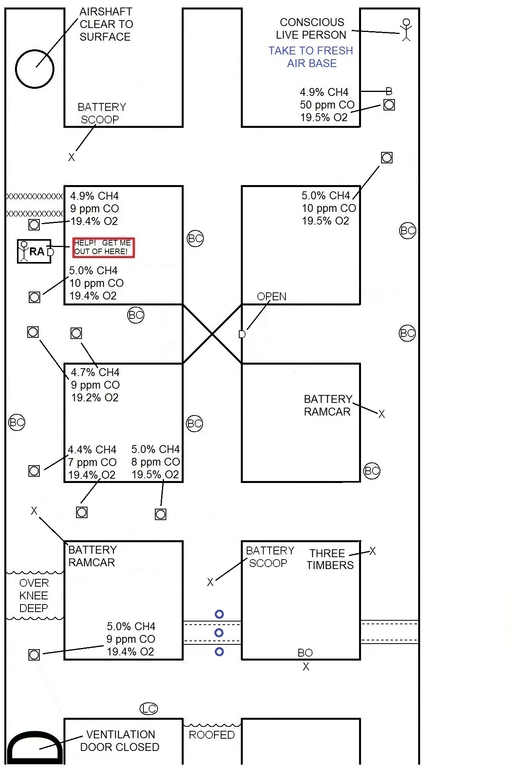
INCORRECT STEP 5
TIMBER # 3
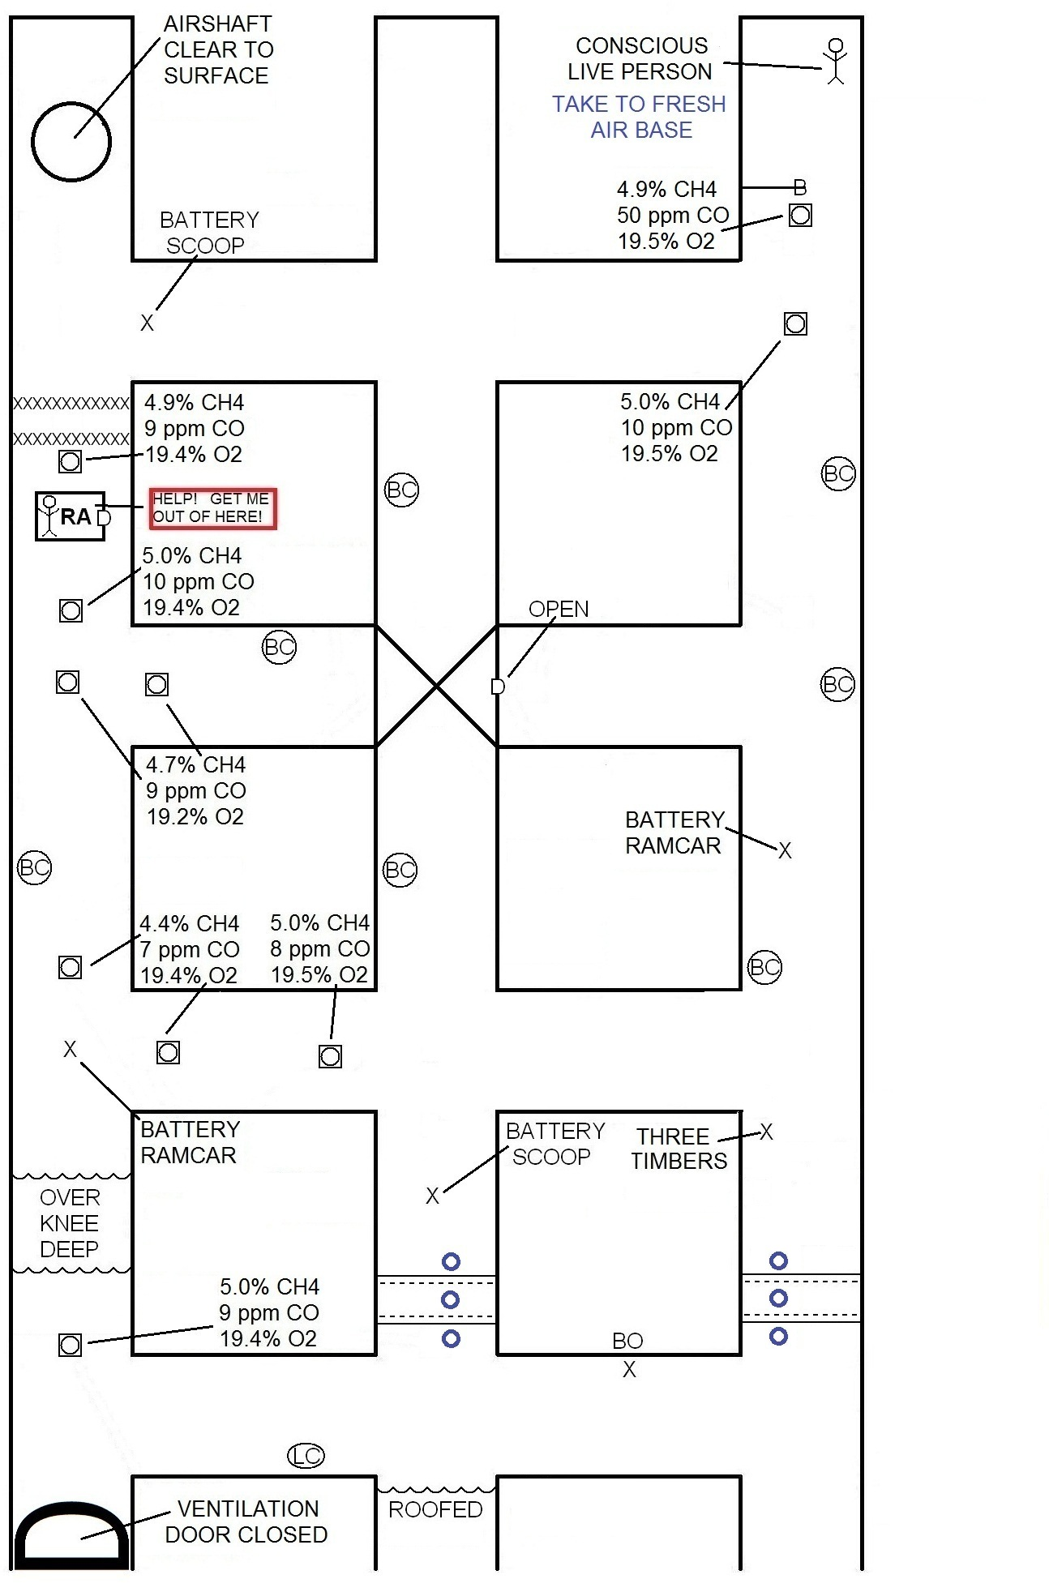
INCORRECT STEP 6 – VENTILATION 2
VENTILATE REFUGE ALTERNATIVE
