Metal and Nonmetal Mine Rescue Map Legend Exam
Taken from the 2016 Mine Rescue Contest Rules

- Identify this symbol:

- Go Through
- Good Thing
- Gas Test
- Greater Than

- Identify this symbol:
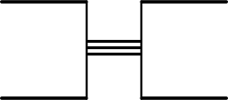

- Double Walled Stopping
- Seal
- Triple-Thick Check Curtain
- Permanent Stopping Intact

- Identify this symbol:

- Permanent Stopping Intact
- Door Closed
- Regulator Closed
- Temporary Stopping

- Identify this symbol:
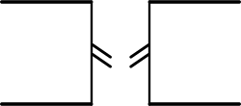

- Temporary Stopping Not Intact
- Regulator Open
- Permanent Stopping Not Intact
- Airlock

- Identify this symbol:
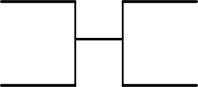

- Permanent Stopping Intact
- Temporary Stopping Not Intact
- Check Curtain
- Temporary Stopping Intact

- Identify this symbol:
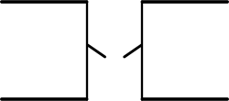

- Regulator Open
- Temporary Stopping Not Intact
- Permanent Stopping Not Intact
- Check Curtain Down

- Identify this symbol:
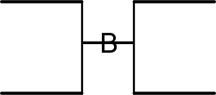

- Bulkhead
- Barricade
- Brattice Cloth
- Regulator

- Identify these symbols:
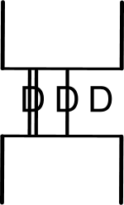

- Different Symbols for an Airlock
- Different Symbols for a Regulator
- Different Symbols for a Door
- None of the Above

- Identify this symbol:
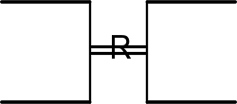

- Water Roofed
- Restricted Access
- Regulator
- Retreat

- Identify this symbol:
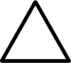

- Yield
- Fire
- Father, Son, and the Holy Ghost
- Gas Test

- Identify this symbol:

- Direction of Travel
- Arrow Indicating Mining Equipment
- Air Movement
- Team Went This Way

- Identify this symbol:

- Water
- Smoke
- Barricade
- Mined Out Area

- Identify this symbol:
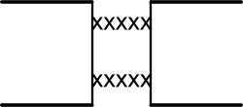

- Caved
- Loose Roof Rib to Rib
- Water Roofed
- Unexplored

- Identify this symbol:
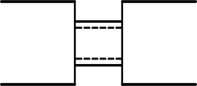

- Water Roofed
- Permanent Stopping Intact
- Unsafe Roof Rib to Rib
- Airlock

- Identify this symbol:

- Overhanging Brow
- Unsafe Roof Partially Across Entry
- Unsafe Rib
- Caved

- Identify these symbols:
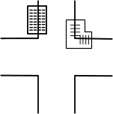
- Caved
- Unsafe Roof Partially Across Entry
- Gas Test
- Unsafe Rib or Overhanging Brow

- Identify this symbol:

- Live Person
- Body
- Gas Test
- Air Movement

- Identify this symbol:
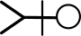

- Body
- Live Person
- Air Movement
- Gas Test

- Identify this symbol:
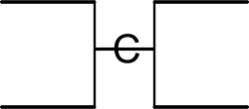

- Temporary Stopping with Door Closed
- Permanent Stopping with Door Closed
- Check Curtain
- Team Check

- Identify this symbol:

- Pipeline
- Track
- Furthest Point of Advance
- Line Brattice or Line Curtain

- Identify this symbol:
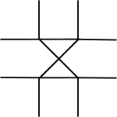

- Overcast
- Undercast
- Rail Crossing
- Caved Airtight

- Identify this symbol:

- “X” Marks the Spot
- Overcast
- Undercast
- Dinner Bucket

- Identify this symbol:
- Infiniti
- Fan
- Figure Eight
- None of These

- Identify this symbol:
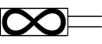
- Mouse Trap
- Track Equipment
- Shuttle Car
- Fan with Tubing
- Identify this symbol:

- Brattice Frames
- Track
- Bunk Beds
- Belt Conveyor

- Identify this symbol:
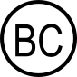

- Toilet
- Brattice Cloth
- Barricading Check Curtain
- Before Christ

- Identify this symbol:

- Gas Well
- Borehole
- Toilet
- Gas Mixture

- Identify this symbol:

- Smoke
- Water
- Emergency Exit
- None of These

- Identify this symbol:

- Elongated Object
- Magic Wand
- Line Brattice
- Belt Conveyor
- Identify this symbol:

- Fenced Off Area
- Track
- Caved
- Loose Roof

- Identify this symbol:

- Mobile Equipment
- Designated Point of Safety
- Caved
- Water Roofed

- Identify this symbol:

- 50 Minutes Remaining
- 50 Foot or First Team Check
- 50 Minutes Elapsed
- 50 degrees Fahrenheit

- Identify this symbol:

- Twenty Minutes Remaining
- 20 Minutes Elapsed
- 20 Minute Apparatus Check
- None of the Above

- Identify this symbol:

- Free of Paticulate
- Fire Protected Area
- Furthest Point of Advance
- Fully Permissible Authorized

- Identify this symbol:

- David Ingersol
- Date and Initials
- Duly Investigated
- Does Include

- Identify this symbol:

- People Check
- Particulate Containment
- Personal Computer
- Power Center

- Identify this symbol:

- “X” Marks the Spot
- Extreme Conditions
- Other Objects, Conditions, Equipment
- End of Problem

