Hand Protection Policy

The guidelines of this policy are meant to be a minimum standard for all XXXXX locations. Individual facility managers may impose stricter guidelines at their discretion. This policy applies to all personnel working on mine property, including management, vendors, and contractors.

DEFINITIONS
Material Handling - The act of gripping, holding, carrying, moving, hanging, or using any object that could reasonably be expected to cause a hand injury if handled improperly and/or hand protection was not used. Any material with sharp edges (other than paper), abrasive surfaces, or prone to breakage or splintering would require hand protection. Handling of fuel, solvents, chemicals, etc. also requires hand protection.

Properly Rated Gloves – Properly rated gloves means leather “outer” gloves with electrically rated rubber inserts designed for either medium or high voltage circuits, as designated by the glove manufacturer. Gloves are rated as follows: “00” class for up to 500 volts, “0” Class for 1000 volts or less; Class 1 up to 7500 volts; Class 2 up to 17,000 volts; Class 3 up to 26,500 volts, Class 4 up to 36,000 volts; etc.

SURFACE MINES & SHOPS, SURFACE AREAS OF U/G MINES, & PREP PLANTS

- General Requirements
- Gloves are required when using any type of knife such as: razor knife, hawk-bill knife, pocket knife, belt cutters, etc.
- No cotton palm gloves are allowed unless worn inside another approved glove.
- Gloves are required at all times inside prep plants.
- Gloves are recommended but not required “full-time” in other areas of surface facilities, but are required when handling material, cutting, welding, grinding, and when handling solvents, powder, emulsion, etc. as defined elsewhere in the policy.
- A variety of gloves will be available for use, depending on the type of task being performed.
- No fingerless gloves are allowed unless worn with other approved gloves that provide full finger protection.
- People performing mechanical work may remove their gloves for short periods of time only when performing “precision” work defined as handling small screws, etc.
- Some people may have to remove their gloves for short periods of time to write notes, eat lunch, clean safety glasses, etc.
- Gloves are not required in control rooms, offices, or enclosed cabs of equipment or trucks unless performing a task that would require hand protection (example: electrical work, material handling, etc.)
- Rubber gloves can not be worn alone when handling any sharp objects or material

- Ceramic Tile
  - Cut resistant gloves such as Kevlar or leather must be worn at all times when handling ceramic material. Rubber or latex gloves may be worn over leather or Kevlar gloves when gluing ceramic tiles. Rubber coated Kevlar gloves will satisfy the requirements of this section for gluing ceramic tiles.

- Troubleshooting
Low & medium voltage circuits only (troubleshooting not permitted on high voltage circuits)

  - Protective gloves must be worn for troubleshooting on circuits that exceed 40 volts in accordance with the following table:

--------------------------------------------------------------------------------------------------
Circuit voltage Type of glove required
--------------------------------------------------------------------------------------------------
Greater than 120 volts but less Rubber insulating gloves
than 1000 volts (nominal) with leather protectors.
(Example: See picture of Class ‘0’ gloves)

40 volts to 120 volts (nominal) Either rubber insulating
gloves with leather
protectors or dry, all-leather gloves.
--------------------------------------------------------------------------------------------------

  - Rubber insulating gloves must be rated at least for the nominal voltage of the circuit when the voltage of the circuit exceeds 120 volts

- Handling energized low & medium voltage cables

Energized medium and high voltage trailing cables shall be handled only by persons wearing properly rated gloves (see definitions and 30 CFR 77.606-1) and, with such other protective devices as may be necessary and appropriate under the circumstances. {per 30 CFR Part 77.606}

  - Dry leather palm or rubber palm gloves must be worn when handling energized low voltage cables. Wet conditions require durable all rubber gloves or properly rated gloves when handling energized cables.
  - Properly rated gloves must be worn while handling energized medium voltage cables. (660 to 1000 volts) Gloves shall not be worn inside out or without protective leather gloves. { see 30 CFR Part 77.606-1(b)}

- Handling high voltage cables

All work on high voltage lines shall be in compliance with all federal & state regulations, including 30 CFR Parts 77.704 through 77.704-11 (surface mines) and 75.705 through 75.706 (surface areas of U/G mines).

  - Minimum 20,000 volt rated gloves with leather protectors
  - Higher rated gloves according to voltage being handled (AND)
  - Other protective devices as necessary & appropriate under the circumstances
  - Rubber high voltage gloves must be:
    - Inspected before use and at least once per shift while in use
    - Defective gloves shall be discarded
    - Tested once each month according to ASTM standards (refer to 30 CFR Part 77.704-8 or 75.705-8)

- Material Handling – Leather or leather palm gloves required (examples: when handling steel cables, cribbing material, rebar, concrete, steel, supplies, machine or equipment parts, etc.) (Exception: See ceramic tile)

- Mechanics / Electricians – Mechanics & electricians are required to wear gloves at all times whenever they are performing work that does not require “precision” work (such as handling small screws, etc.) This would include wearing gloves at all times when they are working on mobile equipment, handling parts, conduit, using hand tools, etc. Any appropriate glove that is listed in the “Glove Appendix” may be used for these general tasks. (EXCEPTION: When qualified personnel are troubleshooting, handling energized cables, etc., they must wear appropriate gloves as defined in TROUBLESHOOTING section or sections for CABLE HANDLING.)

- Solvents, Fuels, Powder, Emulsion, and Chemicals – must wear gloves consistent with requirements as listed on MSDS

- Cutting, Welding, and Grinding
  - Leather welder’s gloves shall be worn whenever welding is performed
  - Leather gloves and other PPE, as appropriate, shall be worn whenever using a cutting torch. (This may include long sleeve shirts, Kevlar sleeves, etc.)
  - Only tight fitting gloves should be worn when grinding, and other PPE such as Kevlar sleeves, full face shields, etc. are also needed.

UNDERGROUND MINES

- General Requirements

- All underground personnel, including management, must wear full finger hand protection. Gloves worn must be deemed appropriate for the tasks as defined by this policy.
- Gloves shall be worn from portal to portal except as noted below.
- No cotton palm gloves are allowed unless worn inside another approved glove.
- A variety of gloves will be available for use, depending on the type of task being performed.
- No fingerless gloves are allowed unless worn with other approved gloves that provide full finger protection.
- People performing mechanical work may remove their gloves for short periods of time only when performing “precision” work defined as handling small screws, etc.
- Some people may have to remove their gloves for short periods of time to write notes, eat lunch, clean safety glasses, sound roof, etc.

- Troubleshooting (Does not address longwalls or high voltage miners)

Low & medium voltage circuits only (troubleshooting not permitted on high voltage circuits)
  - Protective gloves must be worn for troubleshooting on circuits that exceed 40 volts in accordance with the following table:
--------------------------------------------------------------------------------------------------
Circuit voltage Type of glove required
--------------------------------------------------------------------------------------------------
Greater than 120 volts but less Rubber insulating gloves
than 1000 volts (nominal) with leather protectors.
(Example: See picture of Class ‘0’ gloves)

40 volts to 120 volts (nominal) Either rubber insulating
gloves with leather
protectors or dry, all-leather gloves.
--------------------------------------------------------------------------------------------------

  - Rubber insulating gloves must be rated at least for the nominal voltage of the circuit when the voltage of the circuit exceeds 120 volts nominal and is not intrinsically safe.

- Handling energized low & medium voltage cables
  - Dry leather palm or rubber palm gloves must be worn when handling energized low and medium voltage cables.
  - Wet conditions require durable all rubber gloves or properly rated gloves when handling energized cables.

- Handling high voltage cables

Section 75.705 specifically prohibits work on or handling of energized high-voltage lines underground. Refer to 30 CFR Part 75.705 through 75.706 and to any appropriate state regulations for working on high voltage lines in surface areas of underground mines.

- Roof Bolting Functions – Metacarpal gloves required (Gloves containing rubber are prohibited for roof bolting functions due to potential heat / melting hazards.)

- Material Handling – Leather or leather palm gloves required (examples: hanging curtains, shoveling activities, handling concrete blocks, parts, steel cables, timbers, other supplies, etc.)

- Solvents, Fuels, & Chemicals - must wear gloves consistent with requirements as listed on MSDS (examples: rubber gloves for mine sealants, changing battery cells, etc.)

- Miner Operators – “Hy-Flex”, leather, metacarpal, “meta-miner”, “mechanics” gloves, or similar types providing proper protection

- Mobile Equipment Operators - “Hy-Flex”, leather, metacarpal, “meta-miner”, “mechanics” gloves, or similar types providing proper protection

- Examiners, Surveyors, Supervision, Visitors, etc. – Gloves appropriate for the task being performed (could be leather, “Hy-Flex”, rubber, mechanics, “meta-miner”, metacarpal, etc.)

- Cutting, Welding, and Grinding
  - Leather welder’s gloves shall be worn whenever welding is performed
  - Leather gloves and other PPE, as appropriate, shall be worn whenever using a cutting torch. (This may include long sleeve shirts, Kevlar sleeves, etc.)
  - Only tight fitting gloves should be worn when grinding, and other PPE such as Kevlar sleeves, full face shields, etc. are also needed.

Any questions as to the content of this policy or for hand protection requirements for specific tasks not mentioned herein should be referred to safety personnel.

Some Approved Styles of Gloves for Hand Protection

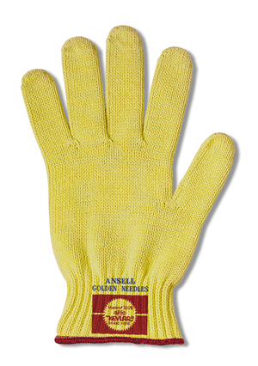
100% Kevlar String Knit Gloves
Available in 3 sizes
Should use only medium or heavy weight glove

-----------------------------------------------------------------------------------------
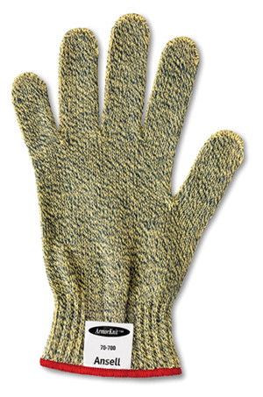

ArmorKnit Glove
Kevlar Armor & Kevlar Standard blend
Also available with PVC dots

---------------------------------------------------------------------------------------
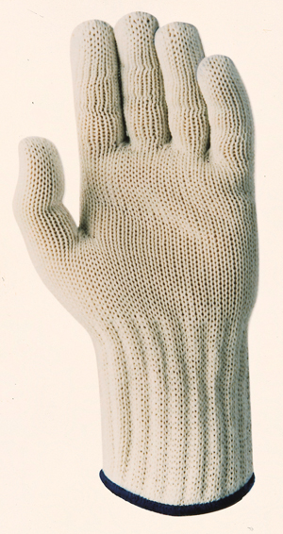
Knifehandler Glove
Kevlar & Stainless Steel Combination
Available in ½ arm length. (below)

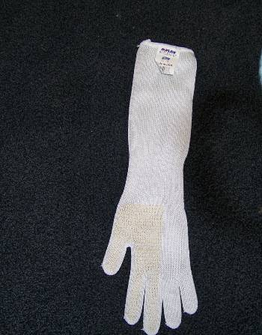

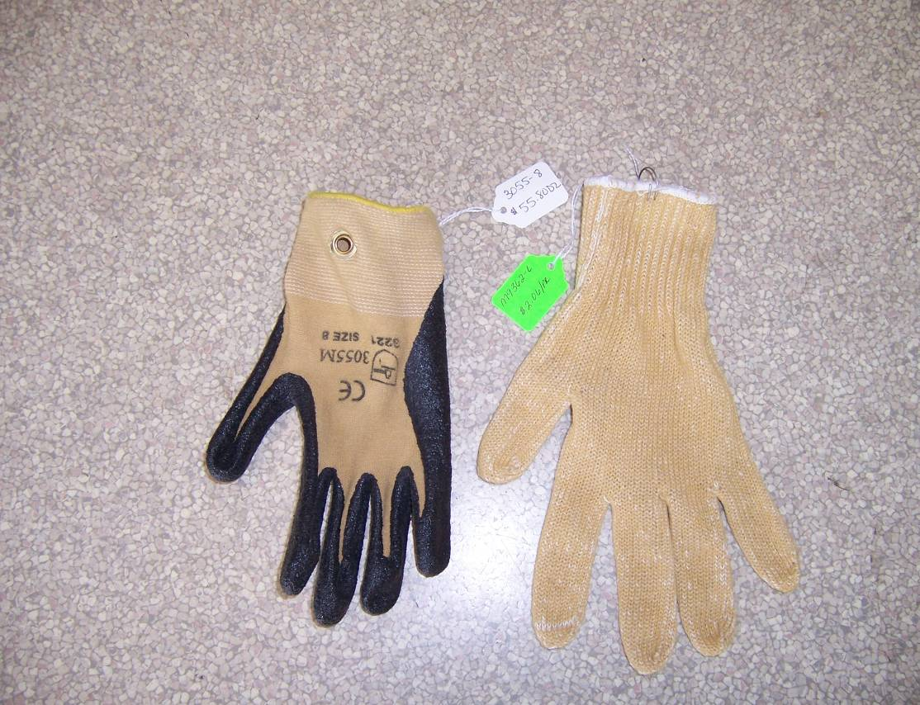
Two types of Kevlar gloves….one with coated palm

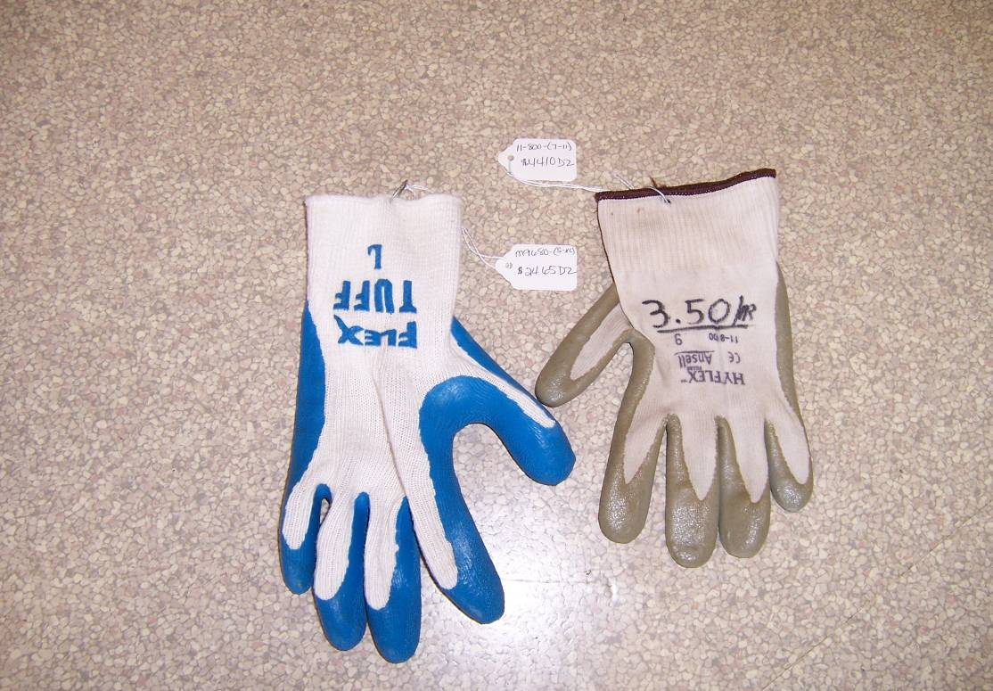
Two types of Hy-Flex gloves. Hy-Flex is not as cut-resistant as the Kevlar gloves, and the Kevlar glove with coated palm (top photo) provides similar flexibility plus more cut resistance at a reasonable price. Hy-Flex gloves with blue coating should NOT be purchased…..they have poor cut resistance.

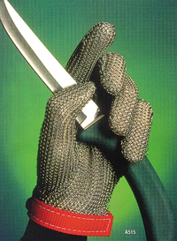
Stainless Steel Glove
Constructed of individually-welded tough stainless rings. Offers
maximum protection against knife cuts, slashes, and punctures
without impeding worker speed or mobility.
Must specify left or right hand.

Approx. $82 each, but only $15 each if you order in quantities
of 6 or more.

Sizes Small to XL.

EASILY CLEANED WITH SOAP AND WATER.

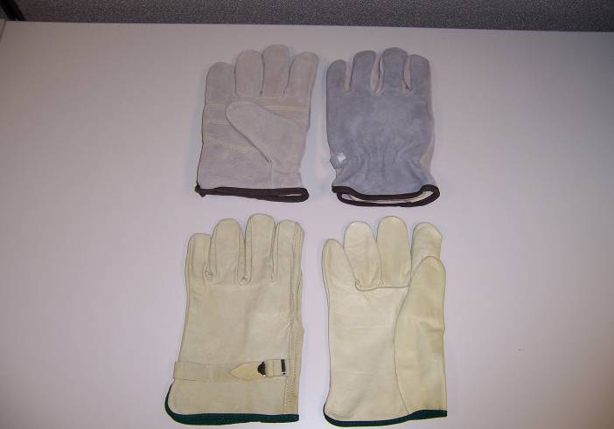
Two Types of All-Leather Gloves

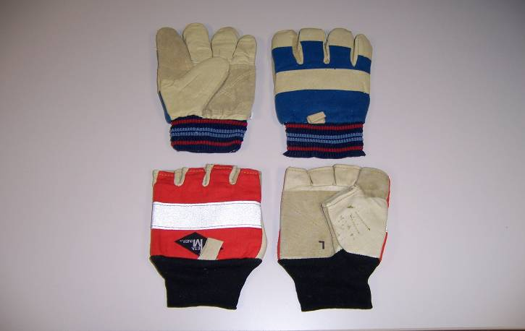
Full Metacarpal & Fingerless Metacarpal Gloves

NOTE:

Full finger protection is required. If wearing fingerless metacarpal gloves, they must be worn over another pair of gloves that provide full-finger protection.

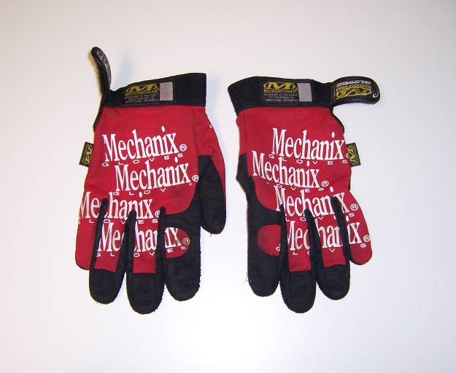
“Mechanix” Brand Glove

Also made by Snap-on and other manufacturers. Good flexibility and leather palms. Washable.

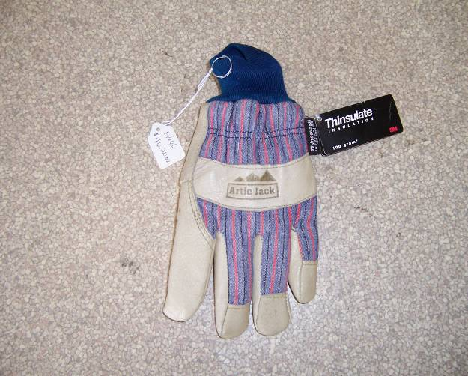
Insulated Glove

This is one example of a leather palm glove with “Thinsulate” protection for cold weather.

Other full-leather and cut-resistant insulated gloves are available.

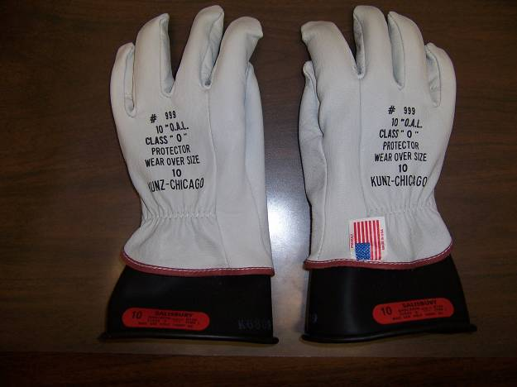

Low and Medium Voltage Glove

Rubber insert with leather protector
for Class “0” (medium voltage) and
Class “00” (low voltage)

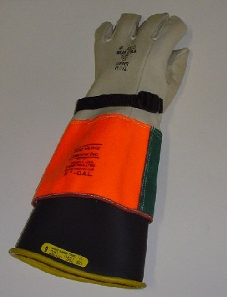
High Voltage Glove

Rubber insert with leather protector for high voltage (greater than 1000 volts)

