Glove Policy

Policy Statement

xxxxxxxxxxx will provide all Employees the proper size and type of glove necessary to complete work tasks safely and without harm.

Engineering and Administrative controls shall be the primary methods used to eliminate or minimize hazard exposure in the workplace. When such controls are not practical or applicable, personal protective equipment, including gloves, shall be employed to reduce or eliminate personnel exposure to hazards. Appropriate gloves will be provided by the Company. The employee will usemaintain these gloves when completing work tasks to reduce the likelihood of occupational injuries to the hands.

All employees, contractors, and visitors are expected to follow the safety rules of the xxx locations. It shall be the responsibility of each site General Mine Manager to implement and administer this glove policy.

Scope

xxxxxxxxxxxxx believes that it is our obligation to provide a safe working environment to our employees. Any employee or contractor encountering conditions that could cause injury to the hands and fingers must apply the proper gloves to protect themselves against potential hazards. The purpose of glove use is to shield or isolate individuals from chemical, mechanical, environmental, physical, biological, or other hazards that may be present in the workplace.

It is the responsibility of every employee and contractor performing work at xxxxxxxxxxxxxxxxx locations, to insure that the proper glove is selected for the task assigned. Safety Managers, Safety Professionals and Supervisors are responsible for assisting employees with glove selection and training in the use of various types of gloves required in the work assignment. Supervisors have the responsibility to ensure this policy is followed.

General Policy Statement

Protective gloves shall be worn when handling materials or performing work which might cause hand injury. All gloves used to perform work tasks at xxx locations shall meet NIOSH (National Insitute of Occupational Safety and Health) and/or ANSI (American National Safety Institue) standards. Gloves of the appropriate design and construction must be used for the task being performed. All gloves shall be maintained in suitable and reliable condition as not to introduce additional hazards to the work task.

The Safety Manager of each location shall have the primary responsibility to ensure gloves meet the above requirements, and the types of gloves as specified in Appendix A are made available to employees.

Appendix A addresses, the glove requirement for work tasks and work groups. Additional assessments maybe required to determine the appropriateness of the glove identified, based on the conditions present in each work task.
Risk Assessments

A risk assessment shall be done prior to work beginning. This assessment can be informal “SLAM” (Stop, Look, Assess, and Manage) or formal written assessment completed by the employee and/or Supervisor. Continual situational assessments should be conducted as work progresses to bring awareness to changes in the work environment and to ensure the glove in use is still the most appropriate type to complete the task. In

Risk/hazard assessment will consist of a survey of the workplace to identify sources of hazards to workers. Consideration will be given to hazards such as impact, penetration, laceration, compression (pinched fingers), chemical exposures, heat, electrical hazards, etc. Where such hazards are present, or likely to be present, the Supervisor and/or employee shall:

- Apply controls to eliminate the hazard or reduce it to as low of level as possible.
- Select, and have each affected employee(s) use, the glove that ensures a level of protection to meet or exceed the minimum requirements to protect employees from identified hazards.
- Insure proper fit for each employee. Poorly fitting gloves cannot provide the necessary protection and may introduce additional hazards.
- Ensure employees are aware of all warning labels for and limitations of the gloves selected
- Train employees in the use and care of the gloves. Employees must demonstrate that they understand how the glove is to be used and the limitations of the selected glove.

Gloves should be selected on the basis of the material being handled, the particular hazard involved, and their suitability for the operation being conducted. One type of glove will not work in all situations.

In work tasks where gloves might cause a greater hazard or injury to the hands (for example become entangled in moving parts of equipment, machinery or tools), an assessment shall be performed to identify controls that should be used to eliminate entanglement hazards prior to work beginning, including elimination of glove use for particular tasks.

At any time where gloves are not worn, a written assessment must be completed and other controls in place to mitigate hazards identified, prior to the work beginning. This assessment must be dated and signed by the Supervisor in charge and by all employees that have participated in the assessment. This assessment should be retained for future reference by the Department Manager.

Controlling Hazards

Gloves alone should not be relied on to provide protection against hazards, but should be used in conjunction with guards, engineering controls, and sound work practices.
When using chemicals the first consideration in the selection of gloves for use is to determine, if possible, the exact nature of the substances to be encountered. Read instructions and warnings on chemical container labels and Material Safety Data Sheets “MSDS” before working with any chemical. Recommended glove types are often listed in the section for personal protective equipment (section 8).

All glove materials are eventually permeated by chemicals. However, they can be used safely for a limited period of time if specific glove characteristics are known (i.e., thickness, permeation rate and time). The risk assessment can assist in determining the specific type of glove material that should be worn for a particular chemical.

Gloves should be replaced periodically, depending on frequency of use and permeability to the substance(s) handled. Gloves which become overly contaminated should be disposed of properly. Wearing worn or contaminated gloves can put employees at risk. STOP the work if you see an employee using worn gloves or if your gloves become worn or unreliable, and get a new pair of gloves that are suitable for your work task before continuing the work.

xxx is committed to the safety of its employees; careful attention must be given to protecting your hands when working in the daily tasks you perform with tools, machinery and chemicals. Every employee must take the responsibility to protect themselves against injury and xxx empowers every employee to do so.

Appendix ‘A’

Glove types

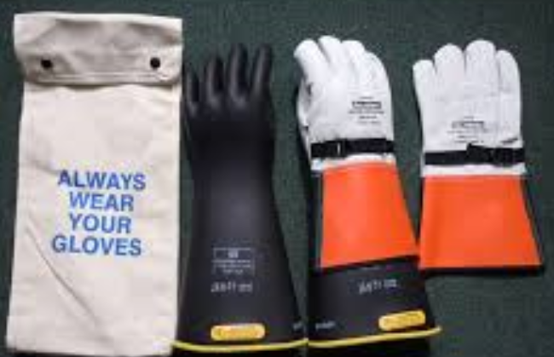
Welding Gloves
High voltage gloves
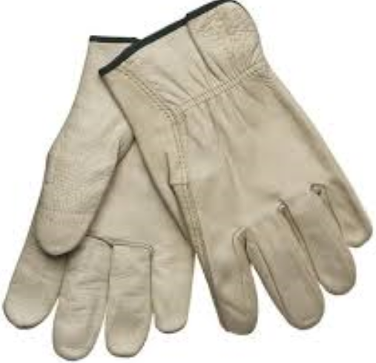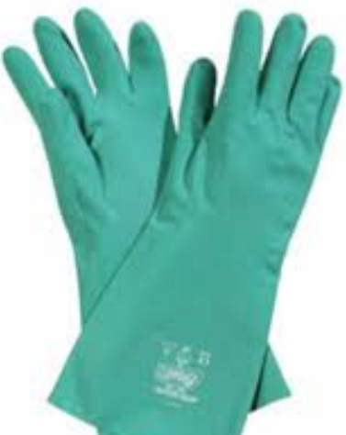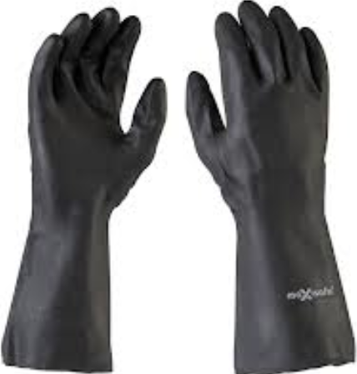
Chemical rubber gloves
Leather gloves

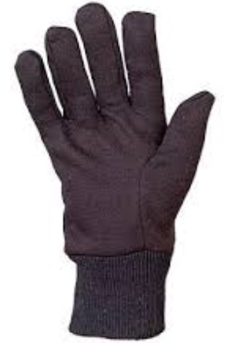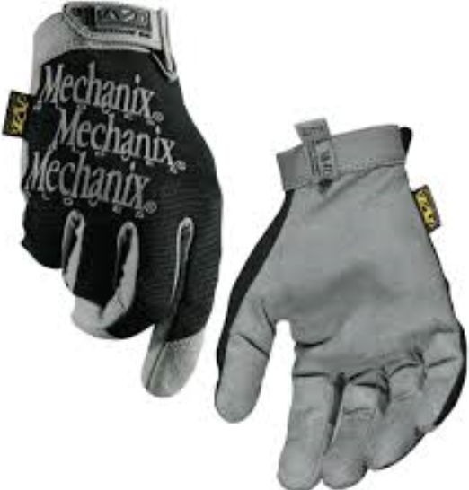
Mechanics gloves
Cotton gloves

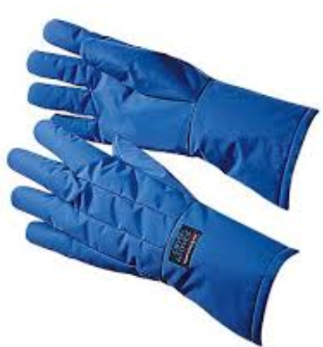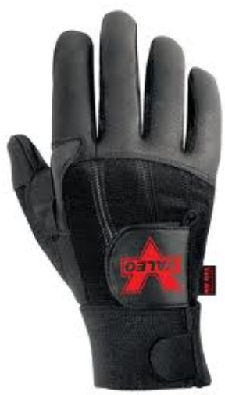
Impact/Anti-vibration gloves
Cryogenic material gloves

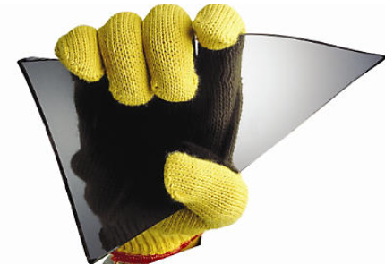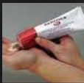
Barrier Creams
Cut Resistant/Kevlar Gloves

The gloves shown are examples only, of the types of gloves used to reduce injury to employee’s hands and fingers. The exact manufacturer brand may vary at various xxx locations.

Review the following chart to determine the recommended glove for the normal job position and work function.

Appendix ‘A’ (cont.)
Glove application to Job Position

Glove to Job Position
 | Cotton Gloves | Leather Gloves | Mechanics Gloves | Anti-vibration Gloves | Welding Gloves | Chemical Rubber Gloves | Cut Resistant Gloves | High Voltage Gloves | Cryogenic Gloves | Barrier Cream
Backhoe | √√ | √√√ | √ | √
Blasters | √√√ | √√√ | √ |  |  | √√
Cable Handling |  |  |  |  |  |  |  | √√√
Cranes | √√ | √√√ | √√ | √
Dragline | √√√ | √√√ | √ | √ | √√ |  |  |  | √√√
Haul Truck | √√√ | √√√ | √√ | √
Loaders | √√√ | √√√ | √√ | √
Lowboy | √√√ | √√√ | √√ | √
Lube Tech | √√√ | √√ | √√ |  |  | √√√
Mechanics |  | √√ | √√√ | √√√ | √√ | √√ |  |  | √√√ | √√√
Motor Grader | √√ | √√√ | √√ | √
Plant Mechanic | √√ | √√√ | √√ | √√√ | √√√ |  | √√√
Pumpers | √√√ | √√√ | √√ |  |  | √ | √
Cable Utility Crew | √√√ | √√√ | √√ |  |  | √ | √
RTD | √√√ | √√√ | √√ | √ |  |  | √
Scraper | √√ | √√√ | √√ | √
Shovel | √√ | √√√ | √√ | √
Supervisor | √ | √√√ | √√
Vendors | √√ | √√√ | √ | √ |  | √√√ |  |  |  | √√
Cleaners | √√ | √ | √ |  |  | √√√ |  |  |  | √√
Surveyors | √√ | √√√ | √
Buildings & Grounds | √√ | √√√ | √√√ |  |  |  | √√
Tire Specialists | √√ | √√√ | √√ | √√√
Track Dozers | √√√ | √√√ | √√ | √√ |  | √
Warehouse | √√√ | √√√ | √√ |  |  |  | √√
Watertruck | √√ | √√√ | √ | √ |  | √
Welding |  | √√ |  |  | √√√ |  | √√ |  | √√√ | √√√
Electrician |  | √√ | √ |  |  |  |  | √√√

Legend;
√√√ Most Preferred | √√ Preferred | √ As a Minimum | No check – Don’t Use

When other than ‘normal’ tasks are performed a risk assessment should be conducted and the following chart used as a guide to select the proper glove for the function to be completed.

Appendix ‘A’ (cont.)

Types of Gloves per Application

Glove selection is dependent upon the task being undertaken and subject to risk assessments
WORK FUNCTION
TYPES OF GLOVES | Electrical Work/Cable Moving | Handling Hot Materials | Handling Sharp Materials | Mechanical Work | Handling Lubricants/Chemicals | Handling Cold Materials | General Work | Impact Tools  Anti-vibration
High Voltage Electrical Gloves | √√√
Low Voltage Electrical Gloves | √√√
Chemical/Rubber Gloves |  |  |  | √ | √√√
Cotton Gloves |  | √√ | √√√ | √√√ | √ |  | √√ | √
Welding/Gauntlet Gloves |  | √√√ | √√√ | √√ |  | √√√
Leather Gloves |  | √√ | √√√ | √√ | √√√ | √√ | √√√ | √
Cryogenic Material Gloves |  |  |  |  |  | √√√
Cut Resistant/Kevlar Gloves |  |  | √√√ | √ |  |  | √√ | √
Mechanics Gloves |  |  | √√ | √√√ | √√ |  | √√√ | √√
Anti-vibration Gloves |  |  | √√ | √√√ |  |  |  | √√√
Barrier Cream |  |  |  |  | √√√ |  | √√

Legend;
√√√ Most Preferred | √√ Preferred | √ As a Minimum | No check – Don’t Use

