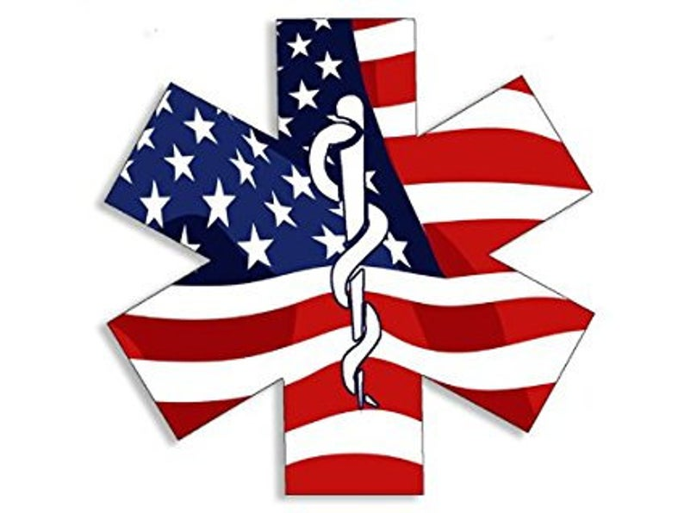

First Aid Problem
2021

You and your team have been requested to assist with miners that are missing and communication has been cut to their location due to power outage. There have been several attempts at radio communication and no return. There has been no communication to the 2 crew members for 20 min. This crew was in charge of moving pallets underground and cutting them down to safely move from the area in a dumpster.
You and you team enter the area there is a patient sitting next to a fork lift and another you can see legs under pallets

Your team will have a total of 30 min to complete this problem.

For Judges information:
Patient 1 was moving the forklift with pallets around he was groggy and did not notice patient 2 had moved location and had a circular saw in his hand. Pallets fell from the forklift striking patient 2 with the saw and cutting down his leg and amputating his small toe. Patient 1 has a drunken stare and slurred words.
Patient 2 is laying on the ground blank stare, is breathing hurts to move, trapped under pallets circular saw is still running. Patient has taped the trigger in the on position.

Field Layout
Pt #2

Pallets

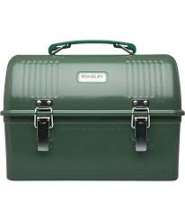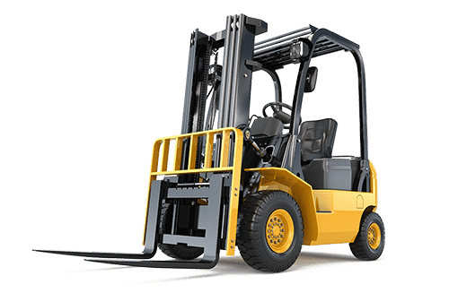
Saw
Pt #1
radio
Team Materials
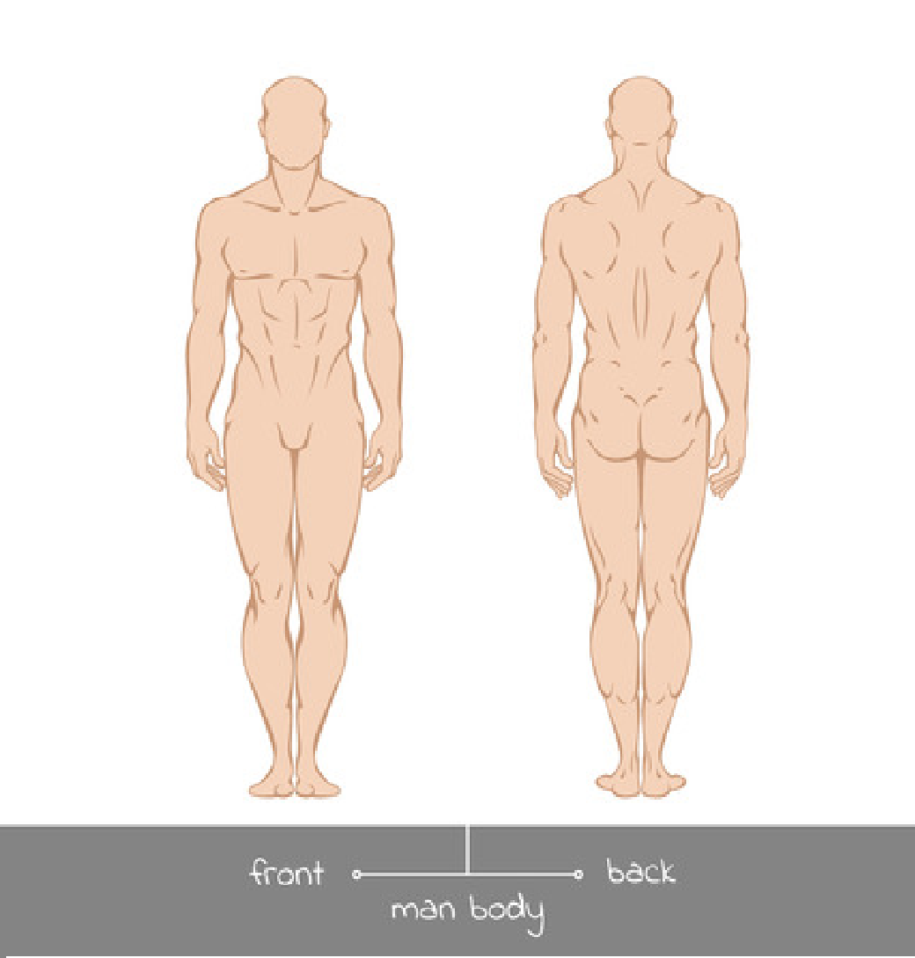
BP: 150/85
Pulse: 150
Resp: 28
CSM: >2
LOC: Slurred words, drunken appearance
List of injuries PATIENT #1
No injuries

INITIAL ASSESSMENT

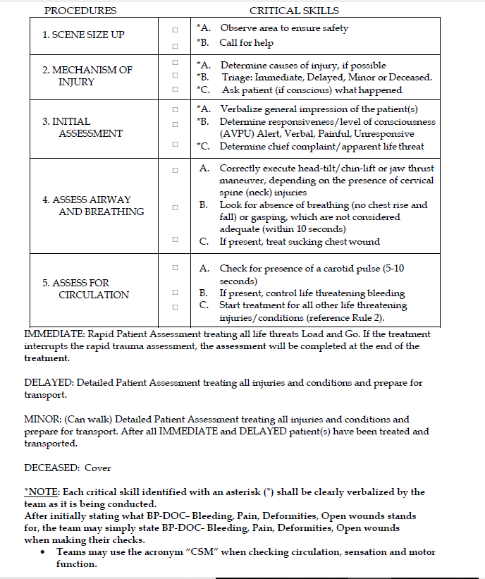
Alert to Verbal smells fruity and slurred words

Alert to Verbal smells fruity and slurred words

PATIENT ASSESSMENT

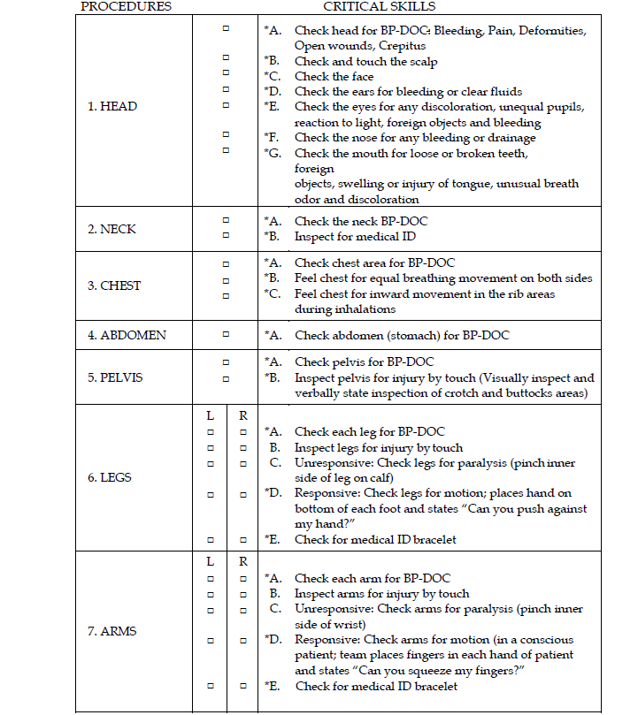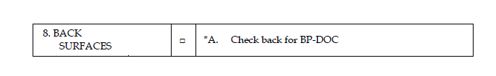
Diabetic medical tattoo
Patient has orange juice and snickers bar in lunch box.

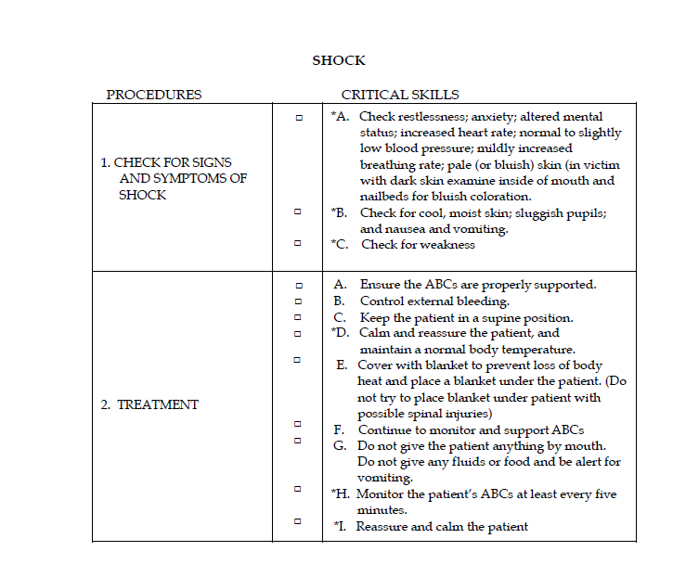
BP: 170/90
Pulse: 120
Resp: 32
CSM: <2
LOC: slow to respond alert and answers questions
List of Injuries PATIENT #2
Patient was working in the area when he was thrown backwards. Patient was still holding the saw in his left hand when it slid down his body upon impact. Patient has bruising on his chest and small scrapes from impact of pallets.

INITIAL ASSESSMENT

PATIENT ASSESSMENT

Lateral cut to left leg bleeding profusely
Cannot feel below here on left side
Can Wiggle Toes, missing left pinky toe

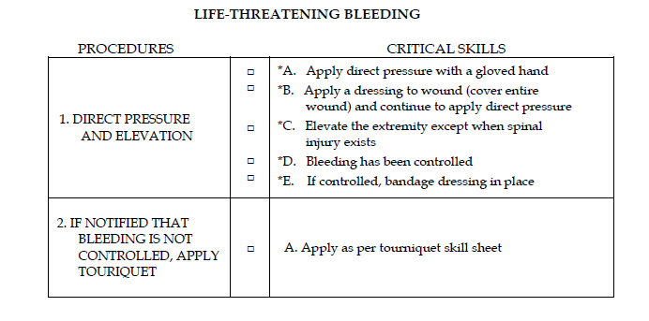
Bleeding from Leg is uncontrolled till tourniquet is in place
Amputations
*1. Wrap in slightly moistened sterile dressing
2. Place in plastic bag or wrap in plastic
*3. Keep part cool avoid freezing
*4. Do not place in water or direct contact with ice
*5. Transport with patient
6. Label with patients name

NOTE: Slings are required for all wounds of upper extremities, including shoulder and armpit wounds. Slings will not be required for upper extremity burns. However, if a burn and wound and/or fracture/dislocation are present on the same upper extremity, a sling shall be applied.

TOURNIQUET

PROCEDURES CRITICAL SKILL
1. DETERMINE NEED OR USING TOURNIQUET | □  □ | If these conditions are met, a tourniquet may be the only alternative:  - Direct pressure has not been successful in stopping bleeding  - Elevation of wound above heart has not been successful in stopping of bleeding
2. SELECT  APPROPRIATE MATERIALS | □ | A. Select a band that will be between 1-4 inches in width and can be wrapped six or eight layers deep for improvised tourniquet or select factory tourniquet.
3. APPLY TOURNIQUET | □  □  □  □ | Factory Tourniquet  - Wrap band around the extremity proximal to the wound (one inch above but not on a joint)  Improvised Tourniquet  - Apply a bandage around the extremity proximal to the wound (one inch above but not on a joint) and tie a half knot in the bandage  - Place a stick or pencil on top of the knot and tie the ends of the bandage over the stick in a square knot  - Twist the stick until the bleeding is controlled, secure the stick in position
4. APPLY PRESSURE WITH TOURNIQUET | □  □ | A. Do not cover the tourniquet with bandaging material  *B. Notify other medical personnel caring for the patient
5. MARK PATIENT APPROPRIATELY | □ | A. Mark a piece of tape on the patient’s forehead “TQ” and time applied
6. REASSESS | □ | *A. Assess level of consciousness (AVPU), respiratory status, and patient response

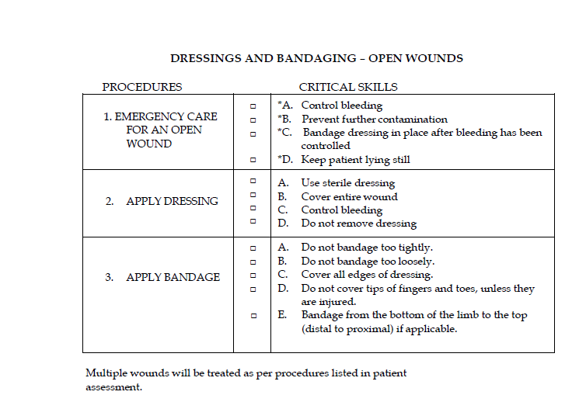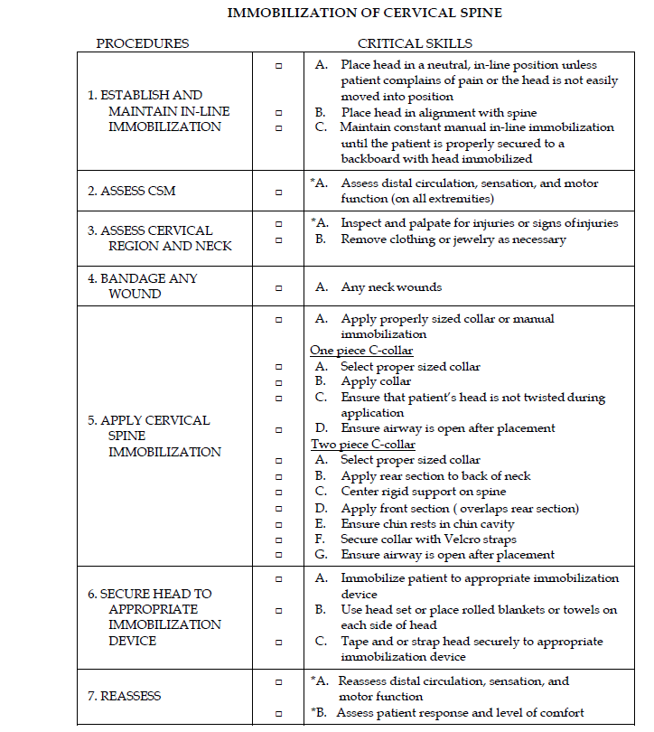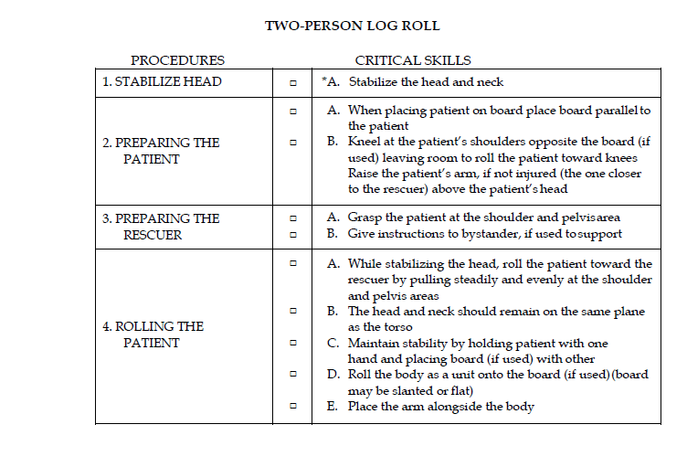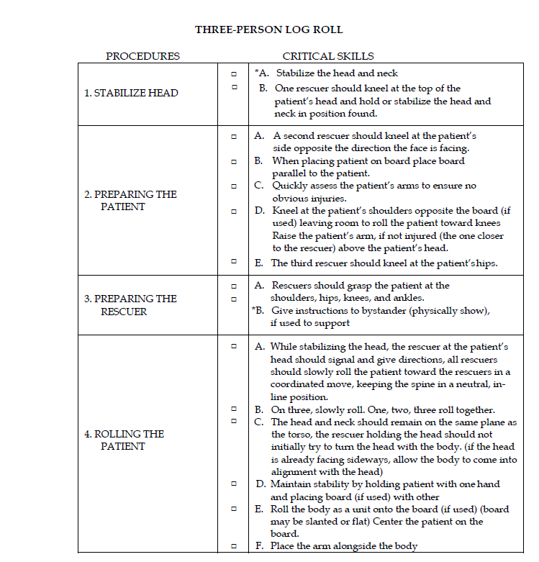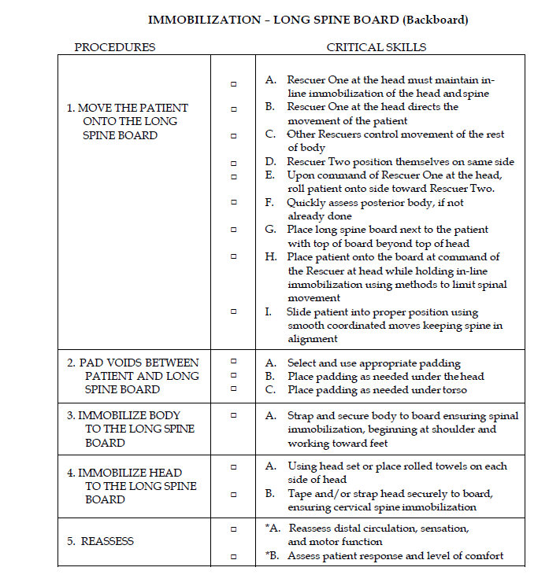
Wrap toe in bandage

