2017 Post 5 & West Virginia State Mine Rescue Contest
Day 2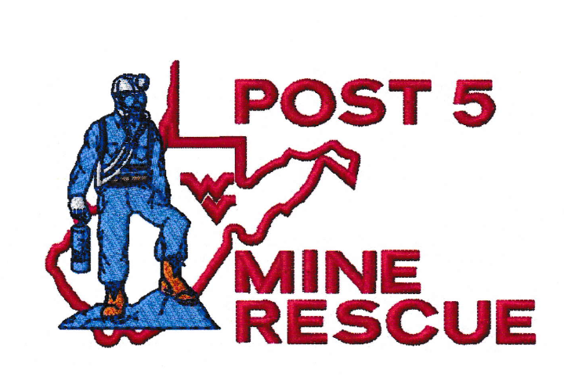

Problem Briefing Day 2

Problem Statement

You are located on the surface of the WV3B mine. This is a new 3 entry drift mine that is developing the main entries to turn left and right in the near future.
The 3rd shift foreman sent a 3 man crew up to the section to do work on the diesel ram car.
A loud boom was heard about 3 hours ago and we tried to enter the mine but found low O2 and methane. The tracking system shows all 3 men are still on the section. Phone communication has been unsuccessful.
We have an exhaust fan in the no.3 entry. Power knocked on the fan, but has been restored and can be turned on by a switch in the command center on the surface. There is a trained mine rescue team here to back you up and the power has been locked out and guarded. The mine maps are up not to date.
Please be careful and find our miners.

Written Instructions

- ACCOUNT FOR ALL MISSING MINERS

- EXPLORE ALL AREAS OF THE MINE THAT CAN BE DONE SAFELY

- TEAM MUST GET APPROVAL IN WRITING FROM SUPERINTENDENT BEFORE MAKING ANY CHANGES TO THE FAN OR FAN DOOR

- THE EXHAUST FAN CANNOT BE REVERSED

- AFTER TURNING ON, THE FAN CANNOT BE STOPPED OR STALLED

- THE DOOR IN THE FAN CAN BE OPENED AND CLOSED SAFELY BY A SWITCH LOCATED IN THE COMMAND CENTER

- TEAM MUST USE NO.2 ENTRY TO ENTER AND EXIT THE MINE

- THE TEAM CAN ONLY CARRY TWO BRATTICE CLOTH WHILE ADVANCING OR RETREATING

Keys to Problem

- Team must follow contaminants while exploring. The team stop map has to be followed

- Team must ventilate first barricade in no.2 entry before going to team stop # 9

- Team must airlock out of first barricade. Team cannot stop or stall the fan once turned on

- Team must use no.2 entry to enter and exit the mine

- Team must remain airlocked after first vent. Air can be pulled from caved area in no.1 entry or air can migrate if an entry is left open with a path going to the fan

- Team must make team stop # 12 before venting the barricade between 1 and 2 entry

- Team must put carevent or SCSR with goggles on patient if team takes patient through crosscut where smoke has not cleared (possibly in crosscut with lunch box in unsafe roof)

Please circle change to Fan or Fan Door

Fan on Fan Door Open Fan Door Closed
Superintendent Initial’s _______
Fan on Fan Door Open Fan Door Closed
Superintendent Initial’s _______
Fan on Fan Door Open Fan Door Closed
Superintendent Initial’s _______
Fan on Fan Door Open Fan Door Closed
Superintendent Initial’s _______
Fan on Fan Door Open Fan Door Closed
Superintendent Initial’s _______
Fan on Fan Door Open Fan Door Closed
Superintendent Initial’s _______
Fan on Fan Door Open Fan Door Closed
Superintendent Initial’s _______
Fan on Fan Door Open Fan Door Closed
Superintendent Initial’s _______
Fan on Fan Door Open Fan Door Closed
Superintendent Initial’s _______
Fan on Fan Door Open Fan Door Closed
Superintendent Initial’s _______
Fan on Fan Door Open Fan Door Closed
Superintendent Initial’s _______

