2016 National Metal and Nonmetal
Mine Rescue Contest

Technician Team Competition
Written Test (Dräger BG-4)

Directions:
- Find the correct answer to each of the questions.
- Select only one answer per question.
- Then, fill in the corresponding circle on the answer sheet for each numbered question.

Good Luck!

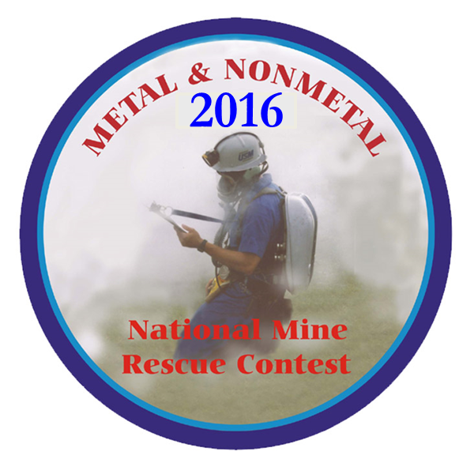

July 25, 2016
2016 Metal/Nonmetal National Mine Rescue Contest
Technician Team Competition – Dräger BG-4 – Written Test

10 Questions for Dräger BG-4:

- Only use organic solvents, avoid acetone, trichloroethylene or similar solvents, and no bleaches! Wipe the switch box and Sentinel with a damp cloth.
- True
- False

- A maximum temperature of 60 °F is limited for drying. The belt and harness must be dried prior to storage, to prevent growth of mold and fungus.
- True
- False

- Minimum Valve provides approximately ____ flow.
- 80 psi
- .1 To 2.5 mbar
- 80 l/min
- 2-5 mbar

- Which item is not one of the major component groups.
- Pneumatics
- Breathing system
- Case and Harness
- Sentinel System

- Even if the recommended period of use is exceeded, the PSS BG4 will operate correctly. Only the temperature of the exhaled air will increase.
- True
- False

- The maintenance Intervals matrix chart indicates Oxygen cylinders be hydro-tested every ____ years for steel cylinders.
- 3
- 4
- 5
- 6

- The maintenance Intervals matrix chart indicates O-rings on plug-in couplings will be replaced every 3 years for BG4s in constant use.
- True
- False

- If a battery warning 2 is displayed, the battery must be replaced before any new operation. Failure to follow this warning could lead to death or serious injury.
- True
- False

- The Moisture Relief trap opens between 2-5 mbar.
- True
- False

- Rubber parts must be particularly protected from direct exposure to radiation.
- True
- False

10 Questions for MX6 iBrid:

- The visual alarm is used as a confidence indicator which, when enabled, blinks the LEDs once every minute.
- True
- False

- During the calibration process, calibration gas should be applied at a flow rate of 0.5 lpm.
- True
- False

- Passwords are a minimum of three characters and a maximum of 10.
- True
- False

- If there is a CO₂ sensor present in the instrument, it is zeroed first
- True
- False

- Oxygen deficient atmospheres may cause combustible gas readings to be lower than actual concentrations.
- True
- False

- “PID” is an abbreviation of a type of sensor technology used in the MX6 ibrid. What does it stand for?
- Proportional Integral Derivative
- Proportional Integrator Differentiator
- Photoionization Detector
- Programmable Instrumental Detector

- If the runtime is less than ______ minutes, instrument alerts the user of impending shutdown by showing “Low Battery” on the lower central part of the display.
- 5
- 10
- 15
- 20

- When sampling with a motorized pump and tubing, how much time should one allow per foot of tubing prior to noting the monitor readings?
- 2 minutes
- 2 minutes plus 2 seconds
- 3 minutes
- 3 minutes plus 3 seconds

- If the user doesn’t remember the password, entering “_______” as the password and pressing the [LEFT] and [RIGHT] navigation buttons simultaneously resets the password to nothing.
- 123
- 000
- 213
- 412

- When calibrated using methane concentrations less than 5% of volume, reading accuracy of the infrared methane sensor may not be guaranteed to be better than +/-_______%.
- 20
- 15
- 10
- 5

10 Questions from MSHA Publication 3027 (Module 2 and Module 3):
- Which Diffusion of Gases statement below is incorrect?
- An increase in pressure causes a gas to contract.
- An increase in pressure causes a gas to expand.
- An increase in temperature causes a gas to expand.
- A decrease in temperature causes a gas to contract.

- The gas’s rate of diffusion is affected by the ventilating air currents in the mine.
The rate of diffusion is greatly decreased by higher velocities of air currents or by
turbulence in the air.
- True
- False
- Gases issuing into still air without mixing tend to stratify according to the gas’s specific gravity. Light gases or mixtures tend to stratify against the back and heavy gases or mixtures tend to stratify along the floor.
- True
- False

- The amount of oxygen that must be present for an explosion to occur is also expressed as “normal air.” When the necessary oxygen concentration approaches that found in normal air, the level is expressed simply as a percentage. The explosive range of hydrogen, for example, is 4.0 to 74.2 percent in the presence of normal air.
- True
- False

- Gases that is neither toxic nor explosive:
- are not found in mine atmospheres
- are not dangerous
- can be dangerous because they can displace oxygen
- cannot be detected with today’s detection instruments

- To help ensure your team’s safety while working underground, the main fan(s) should be monitored or guarded by an unauthorized individual to make sure that it operates continuously. If the fan goes down while you’re underground, and hazardous conditions ensue, you may be recalled from the mine.
- True
- False

- The exhaust air must be at a lower pressure than the intake to get air flow. If this pressure difference exists naturally between the two airways, then the mine has natural ventilation. Natural ventilation is one of two methods of ventilating a mine. The other method is Pressure ventilation where fans are used to create the pressure differential.
- True
- False

- Permanent bulkheads are built of concrete blocks, sandfill, or other incombustible
material. They are sealed tightly against the back, floor, and sides of a mine passage so that no air can leak through. Porous stoppings such as concrete block stoppings are usually plastered on the high-pressure side to reduce air leakage.
- True
- False

- You are taking a smoke tube reading in an entry that is 10’ wide and 10’ high. Your average smoke tube readings averaged 30 seconds in a 25’ distance. What is the quantity of air flow?
- 12,500 cfm
- 5,000 cfm
- 10,000 cfm
- 5,000 f/m

- During rescue team explorations, the main fan:
- Should be kept running.
- Should be continually monitored.
- Both of the above.
- None of the above

2016 Metal/Nonmetal National Mine Rescue Contest
Technician Team Competition – Written Test (Drager BG4)

ANSWER KEY

 | Answer | Page | Publication
1 | B | 16 | 4057781 PSS BG Service Manual
2 | B | 16 | 4057781 PSS BG Service Manual
3 | C | 46 | 4057781 PSS BG Service Manual
4 | B | 43 | 4057781 PSS BG Service Manual
5 | B | 42 | 4057781 PSS BG Service Manual
6 | C | 38 | 4057781 PSS BG Service Manual
7 | B | 38 | 4057781 PSS BG Service Manual
8 | A | 32 | 4057781 PSS BG Service Manual
9 | B | 50 | 4057781 PSS BG Service Manual
10 | A | 39 | 4057781 PSS BG Service Manual
11 | B | 7 | MX 6 Manual Revision 9
12 | A | 35 | MX 6 Manual Revision 9
13 | A | 26 | MX 6 Manual Revision 9
14 | B | 34 | MX 6 Manual Revision 9
15 | A | 4 | MX 6 Manual Revision 9
16 | C | 40 | MX 6 Manual Revision 9
17 | B | 33 | MX 6 Manual Revision 9
18 | B | 5 | MX 6 Manual Revision 9
19 | D | 26 | MX 6 Manual Revision 9
20 | A | 6 | MX 6 Manual Revision 9
21 | B | 5 | MSHA 3027 Module 2
22 | B | 5 | MSHA 3027 Module 2
23 | A | 6 | MSHA 3027 Module 2
24 | B | 7 | MSHA 3027 Module 2
25 | C | 71 | MSHA 3027 Module 2
26 | B | 4 | MSHA 3027 Module 3
27 | B | 5 | MSHA 3027 Module 3
28 | A | 8 | MSHA 3027 Module 3
29 | B | 20 | MSHA 3027 Module 3
30 | C | 49 | MSHA 3027 Module 3

