2016 Northern Mine Rescue Contest
Written Exam
(First Aid Competition)

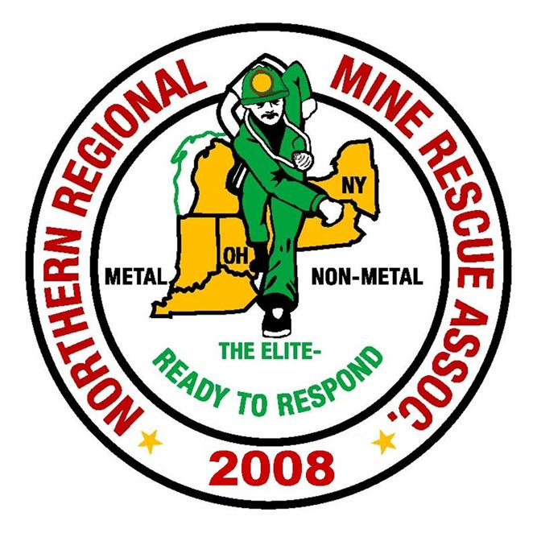
2010
2016

June 14, 2016
Findley Lake, New York

2016 Northern Mine Rescue Contest
Written Exam – First Aid Competition

Directions: Fill in the corresponding bubble on your Scantron sheet to indicate the letter preceding the correct answer to each of the following questions. Select only one answer per question.
- The normal pulse rate for adults is between ___ and ___ beats per minute.
- 50 and 130
- 60 and 100
- 30 and 90
- Spaghetti and meatballs
- Two of the best ways to minimize stress associated with responding to emergencies and caring for patients are to work closely with other experienced responders and to practice skills often.
- True
- False

- Specific signs and symptoms that indicate some type of emergency relating to the heart best describe ______.
- Heart failure
- Myocardial infarction
- Angina pectoris
- Cardiac compromise
- Primary assessment has seven components. Which of the four below is not one of the components?
  - Assess the patient’s breathing
  - Assess the patient’s medical history
  - Assess the patient’s circulation
  - Make a decision on the priority or urgency of the patient for transport
- Activated charcoal is only recommended for what type of poisoning?
- Ingested
- Inhaled
- Topical
- Absorbed
- The moment that both heart rate and respirations stop is known as ___________.
  - Cardiac arrest
  - Biological death
  - Clinical death
  - Apnea

- Decompensated shock is very serious and can quickly become _______.
  - Irreversible
  - Hypoperfusion
  - Compensated
  - Anaphylaxis
- The primary structures of the circulatory system include the heart, blood vessels and blood.
- True
- False
- When breathing becomes compromised the patient is unable to receive an adequate supply of oxygen. If left untreated this could lead to a condition known as __________ .
- Venule
- Dyspnea
- Perfusion
- Hypoxia
- ____________ shock is caused when the spinal cord is damaged and is unable to control the tone of the blood vessels by way of the sympathetic nervous system.
- Psychogenic
- Neurogenic
- Anaphylactic
- Septic
- Injuries to which portion of the spine can cause paralysis, impair breathing and even cause death?
- Sacral
- Lumbar
- Thoracic
- Cervical
- The appendix is located in which quadrant of the abdomen?
- Upper left quadrant
- Upper right quadrant
- Lower left quadrant
- Lower right quadrant
- When treating a patient for signs/symptoms indicating cardiac compromise, prescribed medications carried by the patient should not be provided during treatment.
- True
- False
- Patient assessment at an accident scene reveals the patient has a slight droop to the left side of his face and he seems confused. These signs are most likely indicative of __________________.
- Seizure
- Stroke
- Heart attack
- Shock
- A general cooling of the body best describes which term?
- Hypothermia
- Hyperthermia
- Thermal shock
- Shivering
- Combative behavior, abnormal breathing patterns and repetitive questions are all signs of a(n):
- Cervical-spine injury
- Unresponsive person
- Peripheral nervous system trauma
- Injury to the head
- When caring for a patient with facial injuries, you should do the following:
- Ensure and open and clear airway
- Control bleeding by direct pressure
- Apply a dressing and bandage
- All of the above
- Portable oxygen cylinders should always be kept in the upright position.
- True
- False
- Which type of bleeding is characterized by a steady flow of dark red blood?
- Arterial
- Capillary
- Venous
- Profuse
- A common result of injury to the chest involves the chest cavity filling with air from a ruptured lung. This is called _________________.
- Pneumothorax
- Visceral pleura
- Parietal pleura
- Hemothorax
- Skeletal injuries can be classified into one of two basic types; closed injuries and compound injuries.
- True
- False
- Vital signs of a patient taken at regular intervals can help determine if the patient’s condition is getting better, worse or is staying the same. These vital signs are compared to which of the below.
- Standardized adult vital signs
- Standardized patient vital signs
- Baseline vital signs
- None of the above
- Perfusion is defined as ________________.
- The adequate supply of well-oxygenated blood to parts of the body
- One entire cycle of breathing in and out
- The act or process of inhaling and exhaling
- Breathing that requires increased effort by the patient
- A potential spinal injury patient has a normal breathing pattern; can move, feel, and squeeze with fingers and arms; and cannot feel or move legs or toes most likely has this type of injury to the spine.
- Probably no serious spinal cord injury
- Probable injury to lower spinal cord
- Probable injury to spinal cord somewhere below the neck
- Probable injury to spinal cord in neck
- The tearing loose or the tearing off of a large flap of skin describes which of the following types of wounds?
- Abrasion
- Laceration
- Amputation
- Avulsion
- The triage system has been developed to help identify those victims who are most in need of ___________.
- Standard care
- Immediate transport
- Immediate care
- Long-term care
- A thorough assessment of an extremity injury includes an evaluation of distal CSM. What does CSM stand for?
- Circulation, sensation, motor function
- Color, sensation, motor function
- Color, strength, manual movement
- Circulation, strength, motor function
- The use of the body to facilitate lifting and moving to minimize injury best describes _____?
- Patient movement
- Patient positioning
- Manual stabilization
- Body mechanics
- Which one of the following is the most appropriate care for an open abdominal injury?
- Pack the inside of the wound with clean dressing
- Pour sterile saline over the wound
- Cover the wound with a dry, clean dressing
- Cover the wound with moist, sterile dressing
- _____________ is the application of an electric shock to a patient’s heart in an attempt to convert a lethal rhythm into a normal one.
- Cardiac shock
- Fluctuation
- Defibrillation
- Resuscitation

ANSWER KEY
Written Exam– First Aid Competition

Q Answer Source (Reference Brady’s 9th Edition)
1. B. Chapter 11, pg. 225
2. A. Chapter 3, pg. 47
3. D. Chapter 13, pg. 277
4. B. Chapter 12, pg. 250
5. A. Chapter 15, pg. 319
6. C. Chapter 8, pg. 137
7. A. Chapter 18, pg. 401
8. A. Chapter 4, pg. 68
9. D. Chapter 14, pg. 291
10. B. Chapter 18, pg. 399
11. D. Chapter 20, pg. 449
12. C. Chapter 21, pg. 472
13. B. Chapter 13, pg. 283
14. B. Chapter 15, pages 311-312
15. A. Chapter 16, pg. 339
16. D. Chapter 20, pg. 448
17. D. Chapter 17, pg. 377
18. B. Chapter 9, pg. 173
19. C. Chapter 17, pg. 359
20. A. Chapter 21, pg. 467
21. B. Chapter 19, pg. 413
22. C. Chapter 12, pages 263-264
23. A. Chapter 11, pg. 221
24. B. Chapter 20, pg. 452
25. D. Chapter 17, pg. 373
26. C. Chapter 26, pg. 595
27. A. Chapter 19, pg. 415
28. D. Chapter 5, pg. 93
29. D. Chapter 21, pg. 474
30. C. Chapter 10, pg. 188

