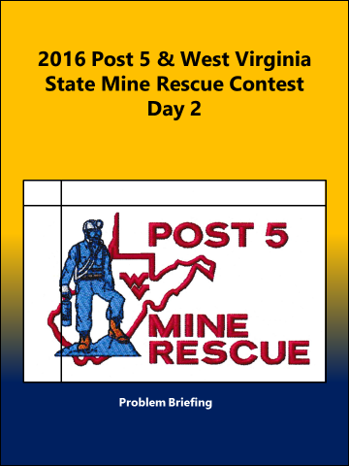
Statement of Fact Test Day 1

Statement
2016 Post 5 Statement of Fact Test Mine Rescue Day # 1

Contestants Name: __________________Team Name/ Number ______________________

- The range of concentrations within which a gas will explode are known as its “_________ ______”.
detonation range explosive range dangerous range

- One method of ________ firefighting is flooding the _______ fire area with water.
Indirect/sealed traditional/known direct/mine

- The rescue team ________ should regulate the team’s pace according to conditions ____________.
leader/found speed/found captain/encountered

- It is recommended that the first stop for a _______ ______ be just inby the fresh-air base.
team check pack check apparatus check

- Smoke causes a lack of orientation which may cause a ______ member to lose his/her sense of balance.
rescue mine team

- If smoke is so _______ as to make visibility poor, you may need to keep in constant physical contact with a rail, a compressed air or water line, or the rib in order to feel your way along.
thick heavy dense

- Gases with specific gravities ______ than 1.0 tend to seek high places.
less more greater

- Elevators should be tested before use following a __________.
fire explosion disaster

- Team captains should _______ roof and ribs before the team members advance into the area.
check observe inspect

- When survivors are located, the location, time, and date should be marked on the ________ map and on the rib where they are found.
B/O team’s mine

2016 Post 5 Statement of Fact Test Mine Rescue Day # 1 Answers

- explosive range (SF # 8)

- indirect/sealed (SF # 16)

- captain/encountered (SF # 24)

- team check (SF # 30)

- team (SF # 37)

- dense (SF # 47)

- less (SF # 59)

- disaster (SF # 65)

- inspect (SF # 70)

- team’s (SF # 78)

