HelloI'm Mitchell Brooks, the shift foreman. Sorry that I can't meet with you, but I had some problems to address at the long wall.
2016 Tri-State Post #6 Pre-Shift Contest Problem
You are to conduct a pre-shift examination of the "M" Submains Right Section.
This part of the mine is running adjacent to the Waterfront Mine's old workings. We have been encountering some methane and lower oxygen levels. As a precautionary measure bore holes are being drilled into the barrier in the #3 entry's intersections to make sure we don't cut into old workings. I'm counting on you to check each bore hole by opening the valves and let me know if anything -is weeping out of them.
The #1 entry is the return
The #2 entry is the intake
The #3 entry is the belt
This area of advancement is the last panel we will be mining on this side of the mine. We are currently drawing up a plan to seal off this area within the next two
(2) years or when mining is completed.
Oh! I almost forgot.... There were a couple of shop men on the section earlier this shift to do some burning and welding on the miner. Please do a thorough examination around the miner in the section.
Last but not least, before you leave the section call your pre-shift report out. The entire M Submains section crew and foreman are involved in evacuation class underground and will be going underground one hour early next shift.
Thanks,
Mitchell

2016 Post #6 Pre-Shift Contest

Roof Control Plan
- Minimum roof support length — 96 inches
Roof support installation — 4 feet x 4 feet
- 9 — 16 foot cable bolts will be installed in every intersection on no more than 6 foot centers
- Maximum entry width — 18 feet
- 67 foot maximum diagonal intersection measurement
- Maximum cut depth — 20 feet
Danger signs and/or physical barriers shall be placed to prevent entry into unsafe or unsupported areas
Pillar size —50 feet x 50 feet
- Mining height averages 8 feet
- All roof and rib areas must be protected only by the approved mesh material that is specified in the roof control plan 48 inch minimum rib bolt length

Ventilation Plan
- Not to scale
- Blowing ventilation
- Belt air is ventilated outby into section belt regulator
- Permanent stoppings, belt lines, overcast and machinery cannot be walked through unless doors or accessible means are provided at these locations
- Permanent stoppings shall be maintained up to and including the third connecting crosscut
- A total of 24 SCRS must remain in the section cache
- CO sensors must be within 100 feet down wind of electrical installations
- The section's refuge chamber must be clear of all obstructions. A 32 foot deployment clearance must be present at this location. The chamber should always be within 1000 feet of the working face.
- Face line curtains must be properly installed to dilute and render harmless any gas accumulation which may occur. They must be adequately hung tight to rib and roof and within 5 feet of face or unsupported area
- No ventilation changes can be made until all accessible areas of the section have been examined
2 air readings are required:
  - Velocity of airflow on belt (minimum 80 velocity)
  - Last open crosscut (minimum 12,000 cfm)

Contestant’s note sheet

Blank Map

Ventilation Map

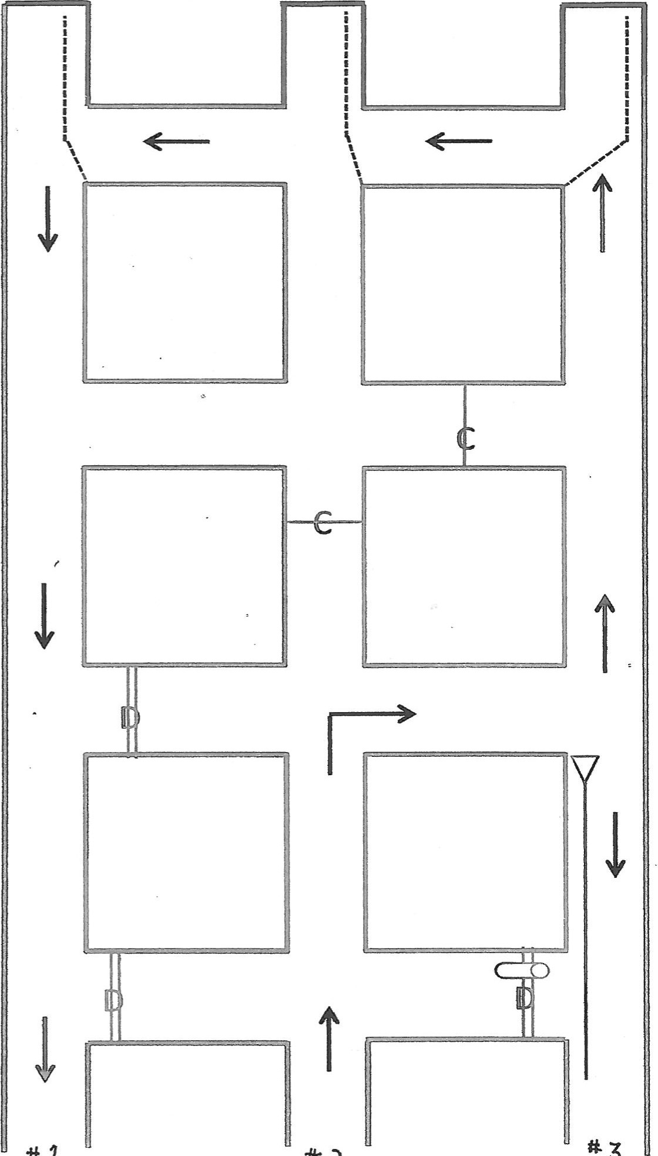

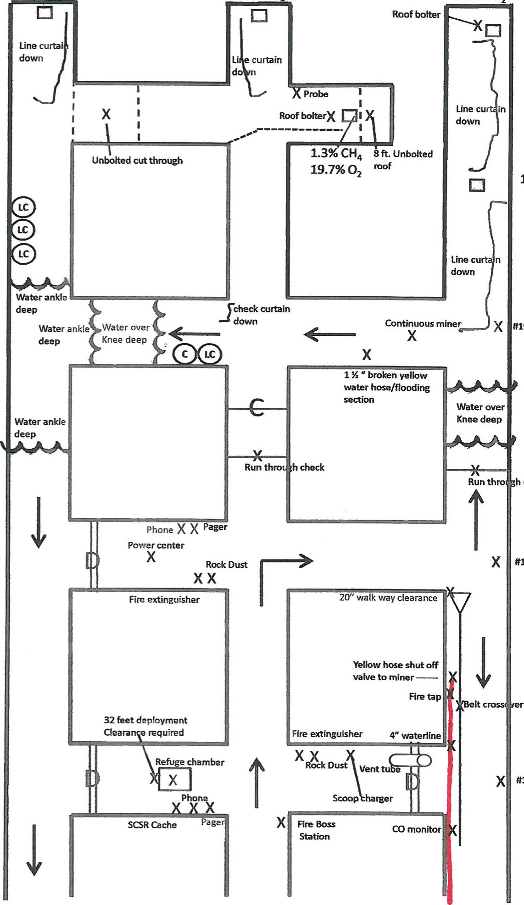
0.0 % CH4 19.4 % O2
N

M

L

K

1.4 % CH4 19.2 % O2
1.2 % CH4 19.5% O2
1.1% CH4 19.5% O2
#19 borehole valve closed

# 18 borehole valve closed

# 17 borehole valve closed

# 3
#2

32
# 1
2016 Post #6 Pre-Shift Contest
Judge’s Discount Sheet

Contestant ______________________________ No. __________________________________
Contestant has 2 minutes to start problem once entering fire boss station.

Fire Boss Station Yes No

Start Clock (rule 1)
Check in (rule 1)
SCSR Check (rule 3)
Gas Detector(s) (rule 19)
Required Equipment (rule 2)
Required Equipment Maintained
Operable (rule 14)

#2 Entry (start)
Gas test/DTl #2 entry 0.0% CH4 20.8%02
(rule 5)
Verbally state visual exam. roof/rib #2 entry (rule 10)

#2 to #1K Crosscut
Check pager and phone at cache (rule 19)

Inspect cache (Judge's state 24 SCSR's inside (rule 14)

Inspects refuse chamber and finds a placard stating 32 feet deployment clearance required. It's requested at this time that examiner measures for proper clearance space. He only finds 26 feet. The examiner states that this is a violation and places a danger sign/DTl at this location.
(rule 11)

#1 Entry
Gas Test/DTl #1 Entry 0.0% CH4 20.8%02 (rule 5)

Verbally state visual examination roof & rib #1 entry
(rule 10)

#1 Entry clear to crosscut M

#1 to #2 M Crosscut
Water over knee deep found. Verbally states that this is a dangerous condition. Places a danger sign/DTl at #1 side of water of knee deep. (rule 11)

#1 to #2 N Crosscut
Unbolted cut through found without danger signs.
Verbally states that this is a dangerous condition. Places a danger sign/DTl at the #1 side of the unsupported cut through. (rule 11)

#1 Face
Line curtain leading into #1 face is down in "N" intersection. Verbally states that this is a violation. State that this line curtain will be rebuilt during proper section ventilation. (rule 11)

CH4 found in #1 Face over 1.0%. (1.1% CH4)
Verbally states that this is a dangerous condition. Places danger sign/DTl at the #1 Face location. States that gases should be reduced or removed through proper

section ventilation. (rule 5 & 12) (A second gas test required after ventilation)
#2 Entry - #2 to #3 K Crosscut
Fire extinguisher and rock dust ok (rule 19)

No violations found at scoop charger location.
Gas test/DTl 0.0% CH4 20.8%02 (rule 5)

#2 to #1 L Crosscut
Fire extinguisher, rock dust, pager and telephone ok. (rule 19)

Power center location gas test/DTl 0.0% CH4
20.8%02 (rule 5)

#2 to #3 M Crosscut
1 h inch yellow miner water hose leaking and flooding section Examiner follows water hose back to shut off valve located outby feeder on belt line and shuts off water. IMPORTANT the examiner must use the proper access back to the water shut off valve. Cannot step into water over knee deep, cross through 20-inch clearance at feeder and must use belt crossover if necessary. (rule 16)

#2 to #1 M Crosscut

Check curtain down. Verbally state this is a violation and air is being short circuited. States that check curtain will be rebuilt during proper section ventilation. (rule 11)

Approaches the #2 side of water over knee deep. Verbally states this is a dangerous condition. Places a danger sign/DTl at the #2 side of the water over knee deep. (rule 11)

#2 to #1 N Crosscut
Approaches the #2 side of the unsupported cut through. No dangers signs found. Verbally states that this is a dangerous condition. Places a danger sign/DTl at the #2 side of the unsupported cut through (rule 11)

#2 to #3 Face N Crosscut
Finds an 8-foot unsupported area without danger signs. Verbally states that this is a dangerous condition. Also finds over 1.0% CH4 (1.3% CH4) This gas test should have been made with probe found at location, at the face. Places danger sign/DTl in front of unsupported area. (rule 11)
(A second gas test required after ventilation)

#2 Face
Line curtain leading into #2 face is down in "N" intersection and is built in exhausting ventilation. Verbally states that these are both violations. State that this line curtain will be rebuilt on the right side of entry during proper section ventilation. (rule 11)

CH4 found in #2 Face over 1.0%. (1.2% CH4) Verbally states that this is a dangerous condition. Places DTI at the #2 Face location.
States that gases should be reduced or removed during proper

section ventilation. (rule 5 & 12)
(A second gas test required after ventilation)

#3 Entry
Gas Test/DTl #3 Entry 0.0% CH4 20.8%02 (rule 5)
Verbally state visual examination roof & rib #3 entry (rule 10)

CO monitor found ok (rule 19)

Examiner MUST use belt crossover to cross belt (rule16)

Opens #17 borehole valve and finds no weeping. Closes valve. (rule17)

Examiner takes air reading on belt line for velocity. Proper air reading procedures must be made. Verbally states direction of air flow. (rule 8 & 9) VELOCITY IS 84

#3 K to L
Feeder location. Gas test/DTl 0.0% Ch4 20.8%02
(this gas test can also include the gas test made for #3 entry) (rule 5)

Finds a tight walkway clearance of 20 inches along feeder. Verbally states that this is a dangerous condition. Places a danger sign/DTl at both approaches to this tight clearance location. (rule 11)

#3 L Intersection
Opens #18 borehole valve and finds no weeping. Closes valve. (rule 17)

Finds water over knee deep. Verbally states that this is a dangerous condition. Places a danger sign/DTl at both approaches to the water over knee deep. (rule 11)
(examiner must go around block to place danger sign on
other approach to water over knee deep)

#3 M Intersection
Opens #19 borehole valve and finds no weeping. Closes valve. (rule 17)

Finds line curtain down. States that this is a violation. Continues inby and finds line curtain down again. Just inby this the examiner finds 19.4%02. (rule 11)
(this is as far as he can go safely)

The examiner must start section ventilation now.
First Step. Should rebuild check curtain #2 to #1 M. This will allow air flow to go up #3 entry.
Second Step. Return to #3 M intersection. Rebuild line curtain going into #3 face.
Third Step. The examiner can advance into #3 entry where low 02 (19.4%) was found.
Fourth Step. Now he can connect the two line curtains together to the face keeping himself on the fresh air side of the line curtain. (rule 16)
Fifth Step. Examiner moves into #3 face. Again finds line curtain down and low 02 (19.2%). Also CH4 over 1.0% (1.4%). Verbally states that three different dangerous conditions were found. At this time he should raise the line curtain and build it up to the face keeping himself on the fresh air side of the line curtain. Once line curtain is built, a second gas test can be made at the face. (Judges should turn placard over). Gases are reduced. (rule 11 & 16)
PROPER SECTION VENTILATION SHOULD BE CONTINUED ACROSS SECTION.
Remove and rebuild line curtain in #2 face in blowing mode.
Must return to #1 face and rebuild line curtain.
A second gas test is required at all three remaining face locations.

LAST OPEN CROSSCUT AIR READING
Area 16.5 feet wide x 8 foot high =132
Velocity 111

14,562

Examiner takes air reading in L.O.C. Proper air reading procedures must be made. Verbally state direction of air flow. (rule 8 & 9)
If ventilation is done improperly,
Area 16.5 feet wide x 8 foot high = 132
Velocity 64

8,448

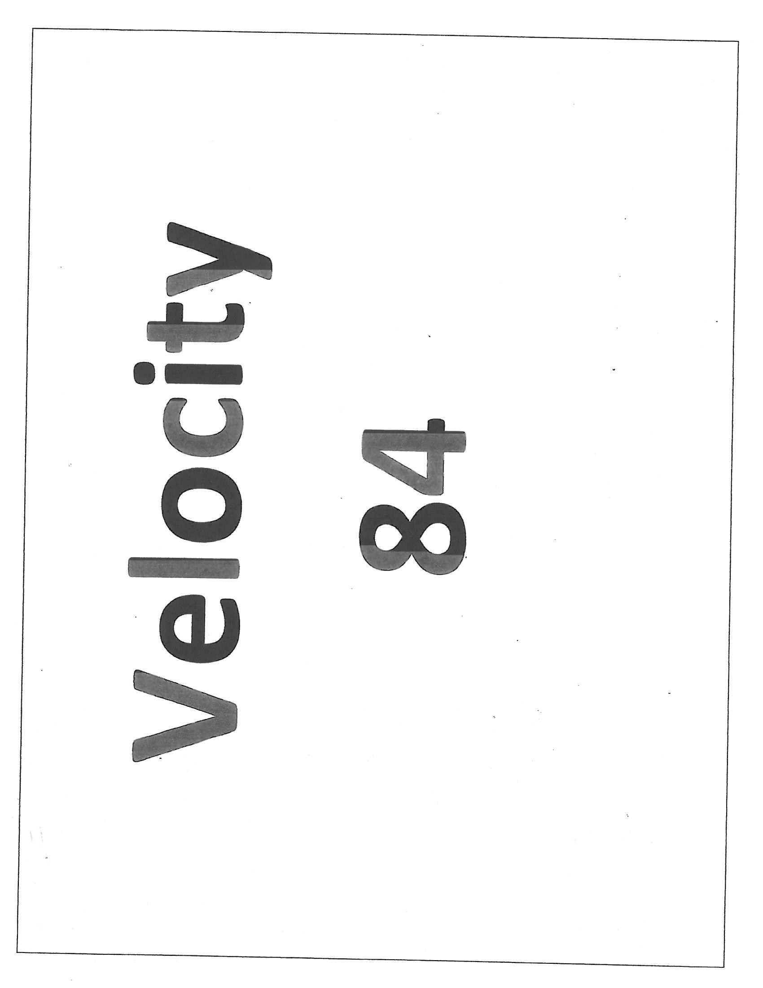
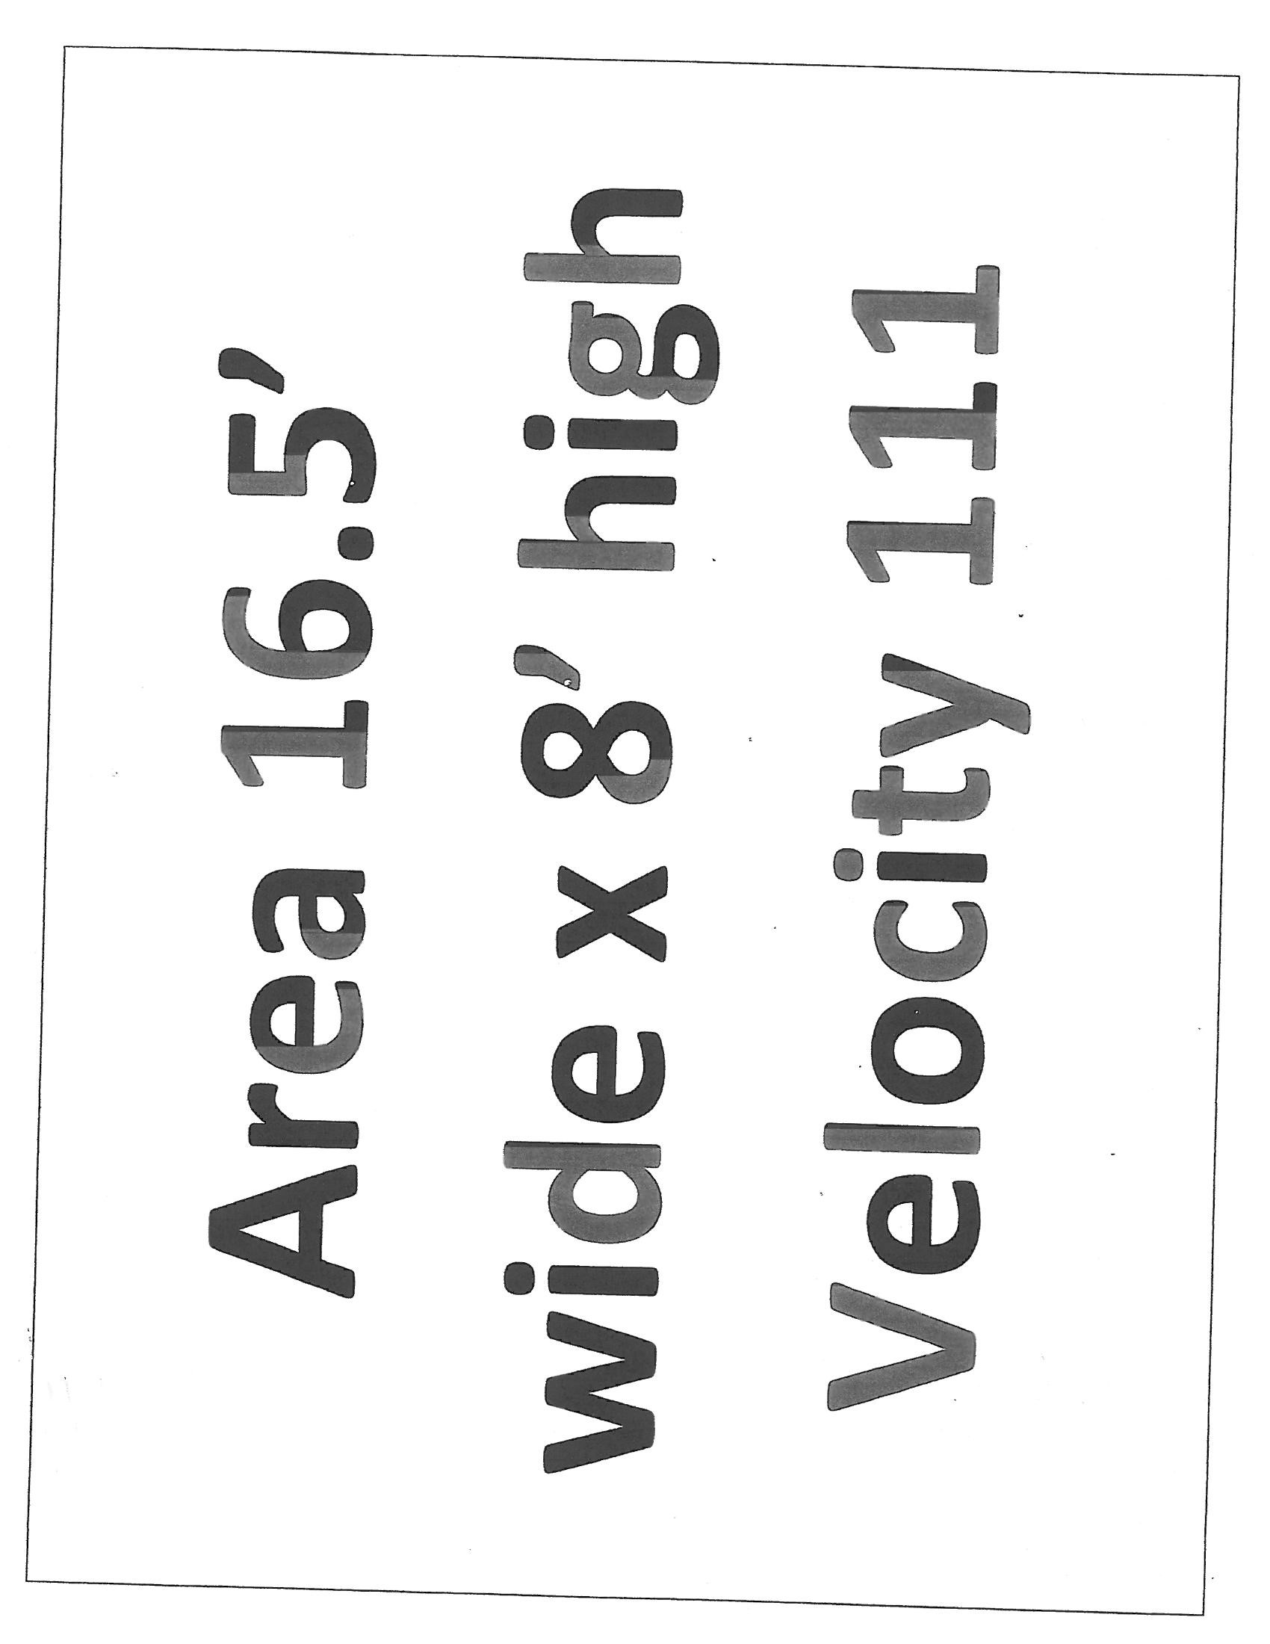
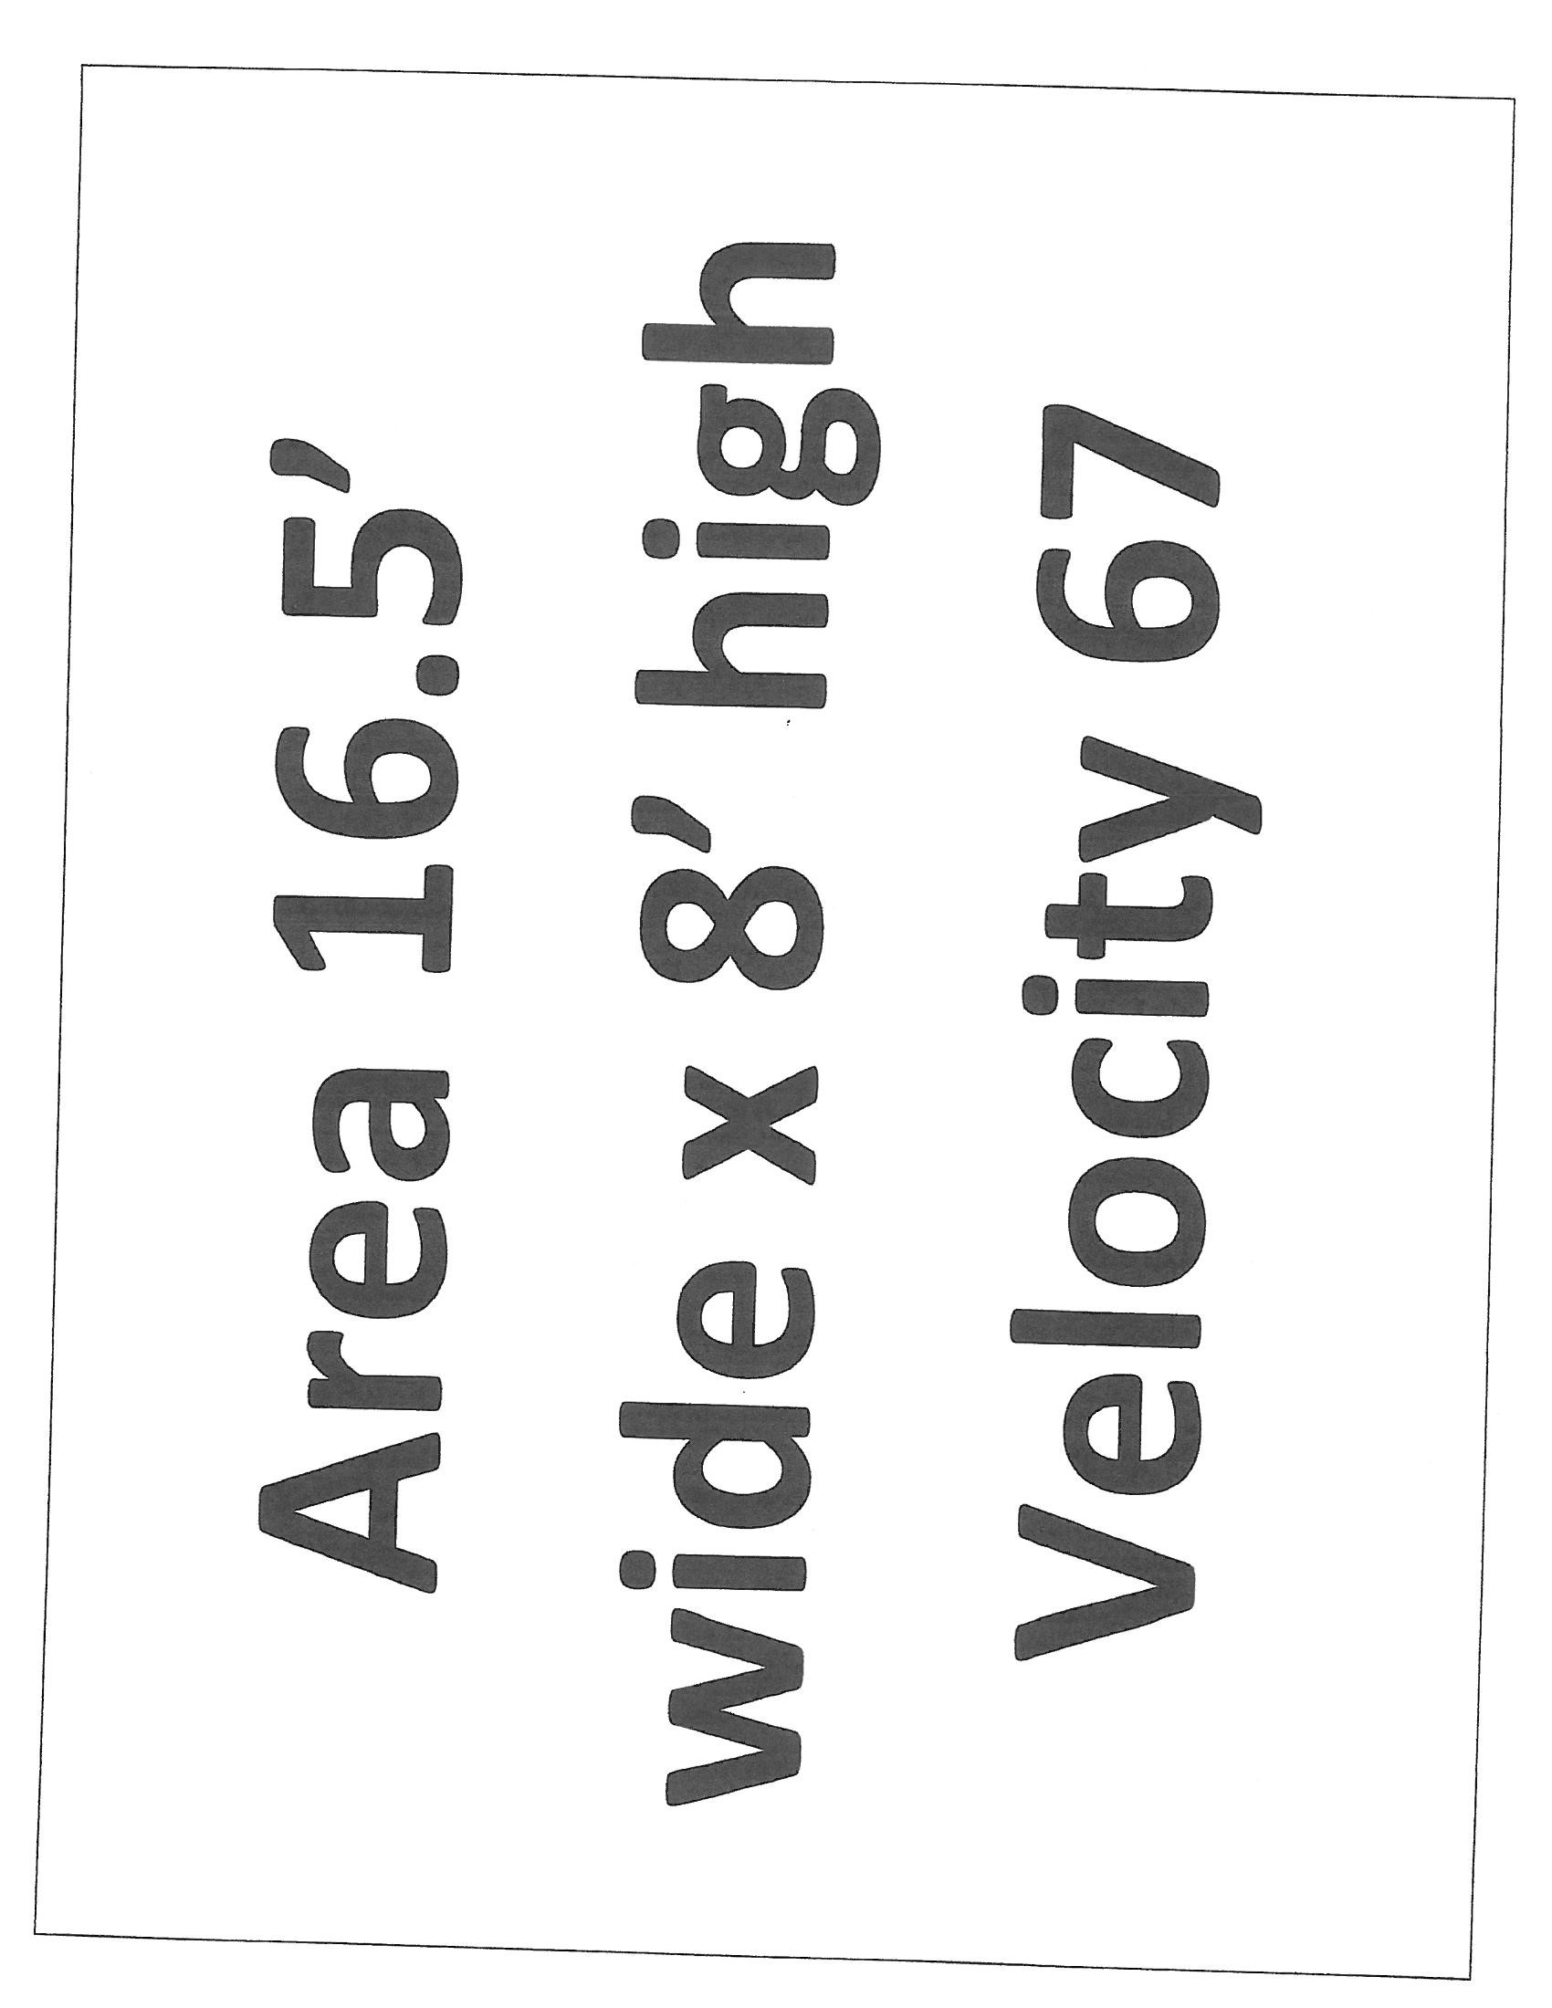

PRESHIFT-CERTIFICATION EXAMINER'S REPORT
Date of Examination |  | Time From:_____ AM PM | To: ______ AM PM
Section/Area: East Mains Left and Right Sections |  | Reported Outside? YES ____NO___ TIME _______ AM PM
Reported By: |  | Received By :
Pre-Shift required within 3 hours prior to any 8 hour interval
Location | Hazardous Condition | Action Taken | CH4 | 02
Air Measurements
Location CFM CHO 02 |  | Location CFM CHA 02
REMARKS:
Signed by Pre Certified Examiner
 |  | Date Certification #
Countersigned by Mine Foreman
 |  | Date Certification #

PRESHIFT-CERTIFICATION EXAMINER'S REPORT
Date of Examination |  | Time From: AM PM | To: AM PM
Section/Area: M Submains Right |  | Reported Outside? YES X NO TIME: AM PM
Reported By: |  | Received By : Mitchell Brooks
Pre-Shift required within 3 hours prior to any 8 hour interval
Location | Hazardous Condition | Action Taken | CH4 | 02
# 1 Face | Line curtain down | Corrected-reinstalled line curtain 1st | 1.1% | 20.0%
# 1 Face | CH4 found in 1.1 % | Corrected-removed by ventilation 2nd | 0.0% | 20.8%
#1 to #2K X-cut | Inadequate deployment clearance | Dangered off- reported
#1 to #2M X-cut | Check curtain down | Correct-built check curtain
#1 to #2M X-cut | Water over knee deep | Dangered off- reported
#1 to #2N X-cut | Cut thru/no danger signs | Dangered off approaches-reported
#2 Face | Line curtain improperly installed | Corrected-properly installed line curtain in blowing mode 1st | 1.2% | 19.9%
#2 Face | CH4 found 1.2% | Corrected-removed by ventilation 2nd | 0.1% | 20.8%
#2 to #3N Face | No danger signs | Dangered off-reported | 0.0% | 20.8%
#2 to #3N Face | CH4 found 1.3% | Corrected-removed by ventilation 2nd | 0.1% | 20.8%
#3 Entry Feeder | Only 20” walkway clearance | Dangered off-reported | 0.0% | 20.8%
#3 Entry L to M | Water over knee deep | Dangered off-reported
#3entryM to Face | Line curtain down | Corrected-reinstalled line curtain
#3entryM to face | Low O2 found 19.4% | Corrected-removed by ventilation
#3 Face | Ch4 1.4% Low O2 19.2% | Corrected-removed by ventilation 1st | 0.2% | 20.8%
# 3 Face | Line curtain down | Corrected-reinstalled line curtain 2nd | 0.2% | 20.8%
Air Measurements
Location CFM CH4 02 |  | Location CFM CH4 02
#2 to #1, LOC 14,652 0.0% 20.8% |  | Power center, scoop charger, feeder 0.0% 20.8%
#3 KTOL Beltline Velocity 84 0.0% 20.8% |  | #1, #2, #3 Entries 0.0% 20.8%
 |  | Boreholes #17, #18, #19 – O.K.
REMARKS: All areas of this section: Travelways, Faces, Beltlines, Machinery, and Electrical installations were found
Free of any unsafe or dangerous conditions other than those noted above. The air is traveling in it’s proper course
And normal volume. Water hose needs replaced. A pump needs to be brought to section to pump water over knee
Deep.
Signed by Pre Certified Examiner
 |  | Date Certification #
Countersigned by Mine Foreman
 |  | Date Certification #
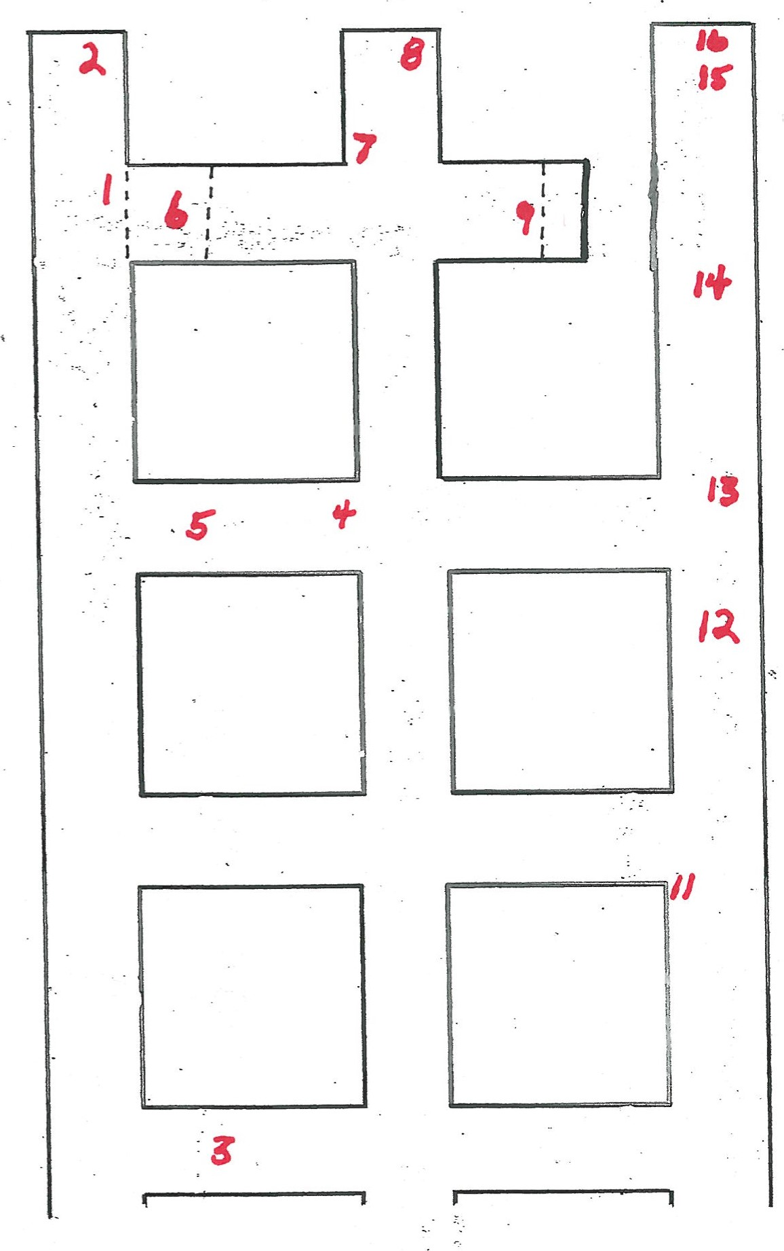
2016 Post 6 Pre-Shift Violation Locations

