2015 Northern Mine Rescue Contest
Written Exam

Technician Team Competition
BioPak 240R

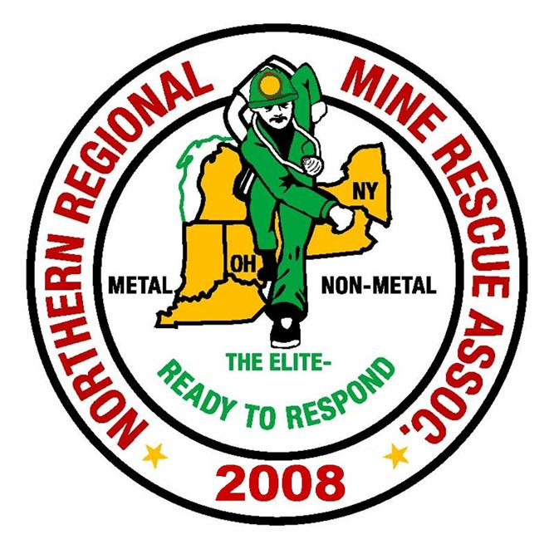
2010
2015

July 28, 2015
Clymer, New York

2015 Northern Mine Rescue Contest
Written Exam – Technician Team Competition
BioPak 240R

Directions: Fill in the corresponding bubble on your Scantron sheet to indicate the letter preceding the correct answer to each of the following questions. Select only one answer per question.
- The quality of OXYGEN used to supply and charge the breathing apparatus (BioPak 240R) must be:
  - Medical or Aviation grade oxygen with a moisture content less than 50 mg/m³ at 207 bar/3000 psig
  - Breathing Oxygen with moisture content above 50 mg/m³ at 207 bar/3000 psig
  - Medical or Aviation grade oxygen with a moisture content greater than 50 mg/m³ at 207 bar/3000 psig

- The Electronics Intrinsic Safety Assessment Procedure must be performed:
  - After each use
  - Each time the batteries are replaced
  - During monthly maintenance

- The breathing loop is best described as:
  - Oxygen supplied from the regulator to the mask
  - Oxygen supplied from the top of the breathing chamber
  - Oxygen supplied from the breathing chamber, hoses, facemask connector and the mask

- Which of the following is true:
  - Pre-Wetting of the three sponges is optional
  - Pre-wetting of the sponges will result in cooler initial breathing gas temperatures
  - All of the above

- Long Term Maintenance is performed on a BioPak 240 R monthly if:
  - The BioPak is in constant use
  - Turn-Around Maintenance has been skipped
  - All of the Above

- The Moisture Pad is removed from the foil pouch and is installed in the breathing chamber:
  - Next to either of the CO₂ canisters
  - Placed on top of the two CO₂ canisters
  - Placed between the lower of the two CO₂ canisters and the breathing chamber

- The alarming system consists of a redundant and independent system status indicators. Which BEST describes this:
  - Electronic pressure switches and gauge
  - Pneumatic Pressure gauge and Electronic Monitor
  - Oxygen cylinder gauge, horn, and lights

- Which best describes a low battery alarm:
  - Beeping monitor
  - Blue light and beeping monitor
  - Flash Red, Green, Blue and Horn Sounding

- During the low pressure leak test which of the following is true:
  - Open the Bleed Valve on the Tester
  - Insert two test keys into the key holes on the back of the machine
  - Depress the demand valve

- Elevated levels of CO₂ in the breathing gas is most likely a result of:
  - Failing to install the moisture pad next to the proper CO₂ canister
  - Failing to purge the Breathing Chamber during donning
  - Failing to breathe in through the mouth and out the nose
- To power up the MX6 instrument, locate, press and hold the center [ENTER] navigation button for at least 5 seconds.
- True
- False

- Silicone compound vapors or other known contaminants may affect the combustible gas sensor and cause readings of combustible gas to be lower than actual gas concentrations.
- True
- False

- Four different cradles are available for use with the MX6 multi-gas monitor.
- True
- False

- The MX6 has a four-way Navigation button.
- True
- False

- The sensor readings are displayed as solid ________ numerals during normal operation, and solid _________ numerals during alarm conditions.
- Black, Black
- Black, Red
- Red, Red
- Black, Yellow

- Up to __________ sensors may be displayed on the instrument screen.
  - Three
  - Four
  - Five
  - None of the Above

- Alkaline battery packs are only approved for use with ______ or ______ batteries in the instrument.
- Duracell MN 1500, Rayovac LR6
- Duracell MN 2000, Rayovac LR8
- Duracell MN 2500, Rayovac LR10
- None of the above

- When calibrated using methane concentrations less than 5% of volume, reading accuracy of the infrared methane sensor may not be guaranteed to be better than ________?
- +/- 15%
- +/- 20%
- +/- 25%
- None of the above

- The Normal Operations Menu has a _________ background and the Configuration Menu has a __________ background on LCD.
- White, Blue
- White, Red
- White, Yellow
- White, Black

- The measurement resolution for a Methane sensor with 0% to 5% volume is ________% volume.
- 1.0
- 0.1
- 0.01
- 0.001
- Nitric Oxide will burn and can explode.
- True
- False

- The formula for Acetylene is C₂H_{6.}
- True
- False
- The Explosive Range of Propane is from ____ to _____ % in normal air.
- 1.12, 7.35
- 1.52, 7.85
- 1.92, 9.15
- 2.12, 9.35

- Solubility is the ability of a gas to be dissolved in air.
- True
- False

- The Specific Gravity of Carbon Dioxide (CO₂) is 1.5921.
  - True
  - False
- Quantity (feet^{3/} minute) = Area (feet²) X Velocity (feet/minute). If the Quantity of airflow is 13,140 (feet^{3/}minute) and the area of the entry is 200 feet² then the velocity is _______.
  - 65.7
  - 6.57
  - 657
  - None of the Above
- High –velocity anemometer is used to determine air velocities from ______ to _______ feet/minute.
  - 120 to 2,000
  - 2,000 to 8,000
  - 2,000 to 10,000
  - None of the Above
- During rescue team explorations, the MAIN FAN:
  - Should be continually monitored
  - Should be operated continuously
  - Both A. and B
  - None of the above

- The main purpose of a regulator is:
  - A line brattice cloth/plastic that is hung to channel intake air into a working area.
  - To direct air to where it is needed and to keep intake air from short-circuiting to the exhaust fan before it reaches the working area.
  - A wall or partition constructed of incombustible material across a passageway to direct the ventilating air in its proper course.
  - Adjustable door/opening in a bulkhead, or a partially open mine door, used to control and adjust the quantity of airflow in the mine in order to ensure proper distribution.
- Two Instruments used to measure velocity of airflow in a mine are:
  - Flame safety lamp and smoke tube.
  - Anemometer and smoke tube.
  - Methane detector and anemometer.
  - Multi-gas detector and smoke tubes.

ANSWER KEY
Written Exam – Technician Team Competition
BioPak 240R
Questions 1 – 10 : USER Manual - Rev G and BENCHMAN Manual - Rev K
Questions 11 – 20 : MX6 iBrid Operation Guide – Rev 9
Questions 21 – 30 : MSHA 3027 (2008) - Module 2 (Mine Gases) & Module 3 (Ventilation)
Question Answer Source
- A. USER page 3, BENCHMAN page 4
- B. USER page 4, BENCHMAN page 5
- C. USER page 7, BENCHMAN page 8
- C. USER page 10
- A. USER page 4, BENCHMAN page 5
- C. USER page 11, BENCHMAN page 17
- B. USER page 7, BENCHMAN page 8
- C. BENCHMAN pages 8-9
- B. BENCHMAN page 15
- A. USER page 11
- B. False, page 15 (at least 3 seconds)
- A. True, page 4 (lower than)
- B. False, page 7 (Three different)
- B. False, page 15 (five-way)
- B. Page 17 (Black, Red)
- D. None of the Above, page 16 (up to six)
- A. Page 3 (Duracell MN 1500, Rayovac LR6)
- B. Page 6 (+/- 20%)
- C. Page 7 (White, Yellow)
- C. Page 38 (0.01)
- B. False, page 2-17
- B. False, page 2-24 (C₂H₂)
- D. Page 2-23 (2.12, 9.35)
- B. False, page 2-7 (in water)
- B. False, page 2-15 (1.5291)
- D. None of the Above, page 3-20 (65.7 fpm)
- C. Page 3-21 (2,000 to 10,000)
- C. Both A. and B., page 3-4
- D. Page 3-54
- B. Anemometer and smoke tube, pages 3-16 & 3-18

