2015 Northern Mine Rescue Contest
Written Exam
(First Aid Competition)

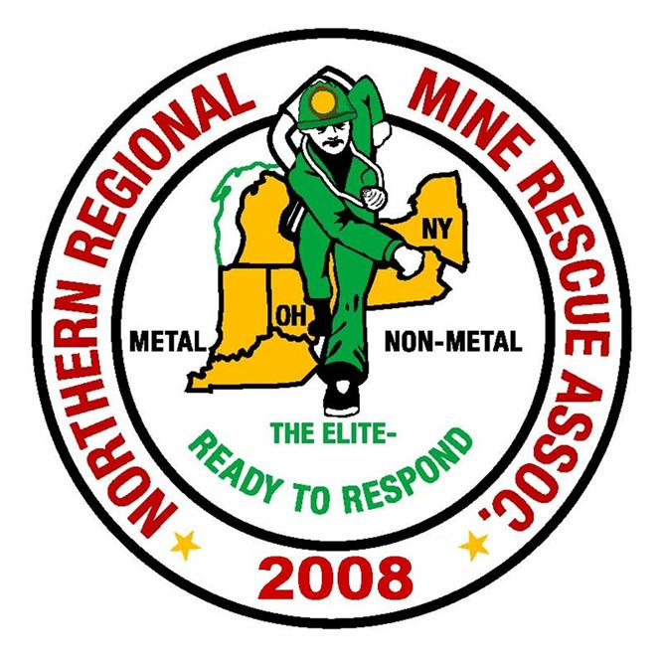
2010
2015

July 28, 2015
Clymer, New York

2015 Northern Mine Rescue Contest
Written Exam – First Aid Competition

Directions: Fill in the corresponding bubble on your Scantron sheet to indicate the letter preceding the correct answer to each of the following questions. Select only one answer per question.
- What type of move is used to ensure stability of the head and spine where a trauma injury is suspected?
- Clothing drag
- Cradle carry
- Direct carry
- Log roll
- When ventilating a patient with a stoma the head tilt chin lift is not required.
- True
- False

- Specific signs and symptoms that indicate some type of emergency relating to the heart best describe:
- Heart failure
- Myocardial infarction
- Angina pectoris
- Cardiac compromise
- What is the prescribed amount of time to flush a chemical burn with water?
  - 5 minutes
  - 10 minutes
  - 15 minutes
  - 20 minutes
- Work in EMS means that exposure to pathogens is likely. Pathogens can enter the body in which of the following way/ways?
- Ingestion
- Injection
- Absorption
- All of the above
- A patient found in respiratory distress exhibits pale skin and cyanosis of the nail beds. These are signs of:
  - Respiratory failure
  - Asthma
  - Hypoxia
  - Respiratory arrest

- Decompensated shock is very serious and can quickly become:
  - Irreversible
  - Hypoperfusion
  - Compensated
  - Anaphylaxis
- Positional Asphyxia is the proper application of mechanical restraints to a combative patient.
- True
- False
- The main function of which body system is to provide structure, support and protection for the body and internal organs and allow for body movement?
- Cardiovascular
- Skeletal
- Muscular
- Nervous
- The amount of air being moved in and out of the lungs with each breath is the definition of ____________________ .
- Tidal volume
- Dyspnea
- Agonal respirations
- Positive pressure ventilation
- Assessment of circulation in an adult or child (one year or older) is accomplished by checking the ____________________ .
- Brachial pulse
- Carotid pulse
- Femoral pulse
- All of the above
- One of the most common tools used for obtaining a patient’s medical history at all levels of EMS is called the SAMPLE history tool. In the acronym the “M” stands for:
- Major complaint
- Medications
- Medical history
- Mental status
- Of the four diseases of most common concern to Emergency Medical Responders tuberculosis and meningitis do not have a vaccine available.
- True
- False

- Patient assessment at an accident scene reveals the patient has a slight droop to the left side of his face and he seems confused. These signs are most likely indicative of __________________.
- Seizure
- Stroke
- Heart attack
- Shock
- The loss of body heat to the atmosphere or nearby objects without physical contact is the definition of:
- Radiation
- Convection
- Evaporation
- Conduction
- During a large-scale emergency, the __________________ is responsible for all aspects of emergency response.
- Triage Officer
- Staging Officer
- Incident Commander
- Mobile Command Officer
- An employee was found in the break area unresponsive. It was reported that her pulse is rapid and weak, there is swelling of her tongue and a rash on her neck. What type of medical emergency is the employee likely suffering?
- Hyperglycemia
- Hypoglycemia
- Poison ingestion
- Allergic reaction
- Patients that have an internal automated defibrillator must not have an AED used on them
- True
- False
- The air we exhale contains approximately _______% oxygen.
- 34
- 21
- 16
- 5

- After completing scene size-up and performing primary assessment of a trauma patient with no significant MOI what is the next step in the patient assessment algorithm?
- Obtain history of chief complaint
- Perform rapid assessment
- Obtain base-line vital signs
- Perform focused assessment for specific injury
- Oxygen should not be given to a patient hyperventilating as it prevents the ability to slow breathing rate.
- True
- False
- Which quadrant of the body contains the appendix and part of the small and large intestine?
- Right upper quadrant
- Right lower quadrant
- Left upper quadrant
- Left lower quadrant
- Perfusion is defined as:
- The adequate supply of well-oxygenated blood to parts of the body
- One entire cycle of breathing in and out
- The act or process of inhaling and exhaling
- Breathing that requires increased effort by the patient
- Of the below situations which is least likely that a patient may benefit from supplemental oxygen?
- Apnea
- Heart Failure
- Shock
- Convulsions
- In an attempt to control profuse external bleeding of a patient, direct pressure and elevation have been applied without stopping blood flow. What should the next step be?
- Apply dressing and bandage
- Apply tourniquet
- Apply pressure to pressure point
- Administer oxygen and treat for shock

- Identifying the mechanism of injury or the nature of illness is part of which of the following?
- Scene size-up
- Scene safety
- Secondary assessment
- BSI precautions
- _____________ is a form of distributive shock caused by a severe allergic reaction.
- Hemorrhagic shock
- Cardiogenic shock
- Anaphylactic shock
- Psychogenic shock
- A patient exposed to a hot environment, perspiration is present and has severe cramps in the legs and abdomen accompanied by moist pale skin is at what level of heat emergency?
- Heat stroke
- Heat cramps
- Heat exhaustion
- None of the above
- Which one of the following is the most appropriate care for an open abdominal injury?
- Pack the inside of the wound with clean dressing
- Pour sterile saline over the wound
- Cover the wound with a dry, clean dressing
- Cover the wound with moist, sterile dressing
- Which of the following acronyms is a common tool used to assess chest pain?
- OPQRST
- SAMPLE
- AVPU
- SNAFU

ANSWER KEY
Written Exam– First Aid Competition

Q Answer Source (Reference Brady’s 9th Edition)
1. D. Chapter 5, pg. 108
2. A. Chapter 8, pg. 147
3. D. Chapter 13, pg. 277
4. D. Chapter 17, pg. 388
5. D. Chapter 3, pg. 40
6. C. Chapter 14, pg. 291
7. A. Chapter 18, pg. 401
8. B. Chapter 5, pg. 111
9. C. Chapter 4, pg. 72
10. A. Chapter 8, pg. 140
11. B. Chapter 10, pg. 190
12. B. Chapter 11, pg. 218
13. B. Chapter 3, pg. 43
14. B. Chapter 15, pgs. 311-312
15. A. Chapter 16, pg. 335
16. C. Chapter 26, pg. 585
17. D. Chapter 15, pg. 324
18. B. Chapter 10, pg. 207
19. C. Chapter 9, pg. 171
20. D. Chapter 12, pg. 242
21. B. Chapter 14, pg. 299
22. B. Chapter 4, pg. 66
23. A. Chapter 11, pg. 221
24. D. Chapter 9, pg. 180
25. B. Chapter 17, pg. 360
26. A. Chapter 12, pg. 248
27. C. Chapter 18, pg. 399
28. C. Chapter 16, pg. 337
29. D. Chapter 21, pg. 474
30. A. Chapter 13, pg. 281

