2014 Northern Mine Rescue Contest
Written Exam
(First Aid Competition)

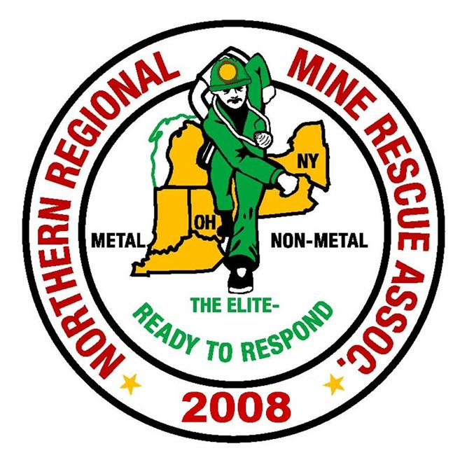
2010
2014

June 17, 2014
Findley Lake, New York

2014 Northern Mine Rescue Contest
Findley Lake, NY
Written Test – First Aid Competition

Name____________________________ Company___________________________

Team Name_______________________ Contest Position No.__________________

Team Member No._________________

Directions: Circle the letter preceding the correct answer to each of the following questions. Circle only one answer per question.

- Which quadrant contains the appendix and part of the small and large intestine?
- Right upper quadrant
- Right lower quadrant
- Left upper quadrant
- Left lower quadrant
- In directional terms, the nose is _____ to the mouth.
- superior
- lateral
- inferior
- medial
- Emergency situations in which it may be necessary to move a patient include all but which of the following?
- Patient is at further risk of injury
- Cannot adequately access bleeding
- Patient comfort
- Unable to access other patients
- Patients suffering a spinal injury should not be moved under any emergency situation due to the possibility of further injury.
  - True
  - False
- Once a cervical collar is in place on a patient with a suspected spine injury you should:
- Conduct a head to toe examination
- Maintain manual stabilization of the head
- prepare the spine board to immobilize the patient
- Assess the airway, breathing and circulation
- Noisy breathing is a sign of a/an _______________ airway obstruction.
  - Bilateral
  - Complete
  - Adequate
  - Partial

- The air we exhale contains approximately _____ % oxygen.
  - 5
  - 16
  - 21
  - 34
- The adequate supply of well-oxygenated blood to the vital organs and tissues is called _______.
- circulation
- arterial flow
- perfusion
- oxygenation
- The proper rate of compression for effective CPR is _____ per minute.
- 30
- 60
- 50
- 100
- A patient with unequal pupil size may be exhibiting a sign of _____________.
- stroke
- central nervous system damage
- reaction to certain medications
- cardiac arrest
- To minimize the effects of fatigue and ensure good chest compressions rescuers should change positions after every set of ____ cycles during two-rescuer CPR.
- 2
- 3
- 5
- 7
- All of the below are conditions you would stop CPR once begun except for:
- you are exhausted and can no longer continue
- spontaneous pulse and breathing begin
- you turn over patient care to a physician
- a family member informs you of the patients wished not to be resuscitated
- The use of a tourniquet will lead to loss of limb and should be avoided.
- True
- False
- After splinting a patient’s extremity what needs to be done?
- Assess circulation, motor function and reflexes
- Assess circulation, sensation and motor function
- Assess the ABC’s and mental status
- Give the patient a strong pain medication
- The “rule of tens” is a system used to estimate the amount of body surface area burned.
- True
- False
- One of the most common tools used for obtaining a patient’s medical history at all levels of EMS is called the SAMPLE history tool. In this acronym the “M” stands for:
- major complaint
- medications
- medical history
- mental status
- A victim that has a punctured lung or internal injuries may exhibit which type of respiration sign?
- rapid, shallow breaths
- snoring
- wheezing
- coughing blood
- Identifying the mechanism of injury or the nature of illness is part of which of the following?
- scene size-up
- scene safety
- secondary assessment
- BSI precautions
- Upon arrival and after conducting scene size-up, you must state your name and identify yourself as a trained Emergency Medical Responder. In addition to this you must also:
- relieve any person already providing care
- gain consent from patient to provide care
- seek assistance from bystanders
- none of the above
- Certain combinations of vital signs point to possible serious medical or traumatic conditions. Shock in the presence of a significant mechanism of injury can be identified by which combination of vital signs?
- cool, clammy skin; a rapid but weak pulse; and an increased breathing rate
- cool, clammy skin; a rapid but strong pulse; and a decreased breathing rate
- hot, dry skin combined with a rapid pulse
- hot, dry skin combined with a rapid but weak pulse
- A patient exhibiting convulsions, muscular twitching, and hot/dry or moist skin constitutes what level of heat emergency?
- heat cramps
- heat exhaustion
- heat stroke
- heat stress
- Arterial bleeding can be identified by _______ blood.
- a steady flow of dark red
- a slow oozing of bright red
- a steady flow of bright red
- spurting bright red
- ______________ help to promote the formation of clots directly at the wound site.
- Bandages
- Hemostatic agents
- Splints
- Tourniquets
- ______________ is a form a distributive shock caused by a severe allergic reaction.
- Hemorrhagic shock
- Cardiogenic shock
- Anaphylactic shock
- Psychogenic shock
- Hypothermia caused by a significant loss of blood can result in shock and victims must be kept warm to maintain normal body temperature.
- True
- False
- There are three primary forces that cause musculoskeletal injuries. Which of the following is not one of them?
- impact force
- direct force
- indirect force
- twisting force
- What type of dressing is best suited for an open chest wound?
- Inclusive
- Occlusive
- Hemostatic
- Balsamic
- Organs exposed as a result of abdominal evisceration should be pushed back into the cavity to reduce the risk of infection.
- True
- False
- The START triage system uses respirations, perfusion, and mental status assessments to classify patients into ____ treatment categories.
- 2
- 3
- 4
- 5
- During a large- scale emergency, the _________________ is responsible for all aspects of emergency response.
- Triage Officer
- Staging Officer
- Incident Commander
- Mobile Command Officer

2014 Northern Mine Rescue Contest
Findley Lake, NY
Written Test – First Aid Competition
ANSWER KEY

Q Answer Source
1. B. pg. 472 Brady’s Emergency Medical Responder, 9th Edition
2. A. pg. 60 (Questions 1 to 30)
3. C. pg. 95
4. B. pg. 96
5. B. pg. 455
6. D. pg. 149
7. B. pg. 171
8. C. pg. 358
9. D. pg. 196
10. A. pg. 312
11. C. pg. 200
12. D. pg. 204
13. B. pg. 364
14. B. pg. 415
15. B. pg. 385
16. B. pg. 218
17. D. pg. 223
18. A. pgs. 246 - 248
19. B. pgs. 248 - 249
20. A. pg. 264
21. C. pg. 337
22. D. pg. 358 - 359
23. B. pg. 365
24. C. pg. 399
25. A. pg. 402
26. A. pg. 413
27. B. pg. 470
28. B. pg. 474
29. C. pg. 588
30. C. pg. 585

