2014 Northern Mine Rescue Contest
Written Exam
(Technician Team – MX6)

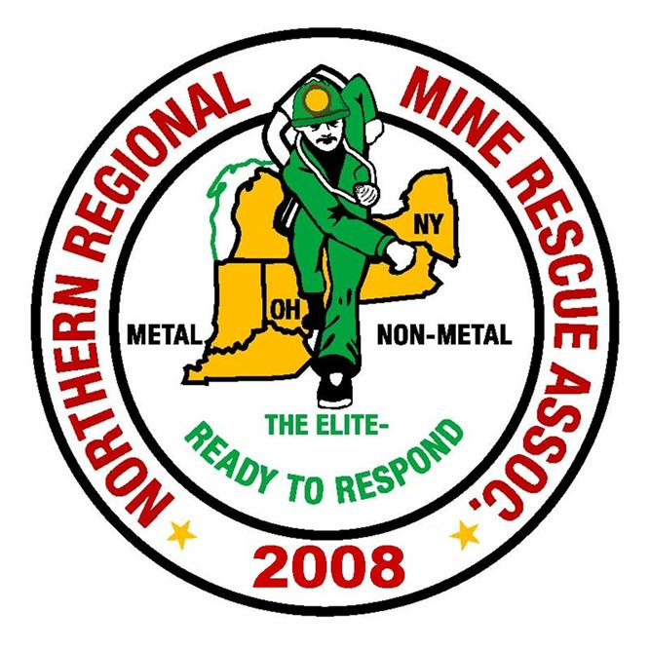
2010
2014

June 17, 2014
Findley Lake, New York

2014 Northern Mine Rescue Contest
Findley Lake, NY
Written Test – Technician Team – MX6

Name____________________________ Company___________________________

Team Name_______________________ Contest Position No.__________________

Team Member No._________________

Directions: Circle the letter preceding the correct answer to each of the following questions. Circle only one answer per question.

- Specific gravity is the weight of a gas compared to an equal volume of normal air under different temperature and pressures.
- True
- False

- Elevated nitrogen levels indicate an oxygen ______ atmosphere.
  - Deficient
  - Rich
  - Normal
  - Elevated

- The most dangerous aspect of methane is that it is _____.
  - Toxic
  - An oxygen displacer
  - Water Soluble
  - Explosive

- Smoke is defined as tiny particles of ____ and liquid suspended in air.
  - Solid
  - Gas

- Ethane, Propane and Butane are classified as light hydrocarbons.
  - True
  - False
- If a CO₂ sensor is present in the instrument it will be zeroed last in fresh air.
- True
- False
- Oxygen deficient atmospheres may cause combustible gas readings to be lower than actual concentrations.
- True
- False

- When the instrument sustains a high alarm for oxygen the gas reading is________________.
- above the high alarm
- below the low alarm
- A and B
- None of the above

- Sensor types are displayed as solid black text during normal operation, and solid red text during alarm conditions.
- True
- False

- What is the recommended flow rate during calibration of the gas instrument?
- 1.0 liters per minute (lpm)
- 1.5 liters per minute (lpm)
- 2.0 liters per minute (lpm)
- 2.5 liters per minute (lpm)
- None of the above

- The infrared methane sensor is not to be used for methane concentrations below 5% in air.
- True
- False

- A bump test measures the accuracy of the sensor.
- True
- False

- The recommended calibration gas for infrared methane sensor calibration is _______.
- 2.5% volume methane
- 100 % volume methane
- 5% volume methane
- 99% volume methane

- In a low battery situation, if the run time is less than 10 minutes, the instrument alerts the user of impending shutdown by showing ___________ on the lower central part of the display.
- Turn off
- Battery Warning
- Low Battery
- Change Battery
- Error

- Sudden changes in atmospheric pressure may cause temporary fluctuations in the oxygen reading.
- True
- False

- The data log feature saves all of the following, except ?
- Gas type
- Time of day
- Temperature
- Barometric pressure
- Battery level

- The measurement range for the hydrogen sulfide sensor is _____________.
- 0 to 999 ppm
- 0 to 1,500 ppm
- 0 to 500 ppm
- 0 to 150 ppm

- The instrument alarms are activated during calibration.
- True
- False

- It is recommended to perform a calibration ____________.
- when a bump test fails
- when exposed to over range gas concentration
- prior to each day’s use
- All of the above
- A and B
- A and C

- Alarm event information stored in the FIFO queue includes ___________.
- Gas type
- Fault error code
- Peak exposure level
- All of the above
- A and B
- A and C

- The measurement range of the oxygen sensor is _____________.
- 0 to 20. 9 % Volume
- 0 to 100 % Volume
- 0 to 30 % Volume
- 0 to 23 % Volume

- The run time for the Li-ion battery pack is _______without pump and _______ with pump.
- 24 hours and 12 hours
- 36 hours and 12 hours
- 24 hours and 10 hours
- 36 hours and 10 hours

- Bump test can be activated from the configuration-mode root menu.
- True
- False

- The settings accessible from the configuration-mode root menu are________.
- Bump test
- Alarms
- Profiles
- All of the above
- A and B
- B and C

- The LCD backlight flashes as part of the alarm sequence for low battery condition.
- True
- False

- During mine rescue contests, blankets are an acceptable form of brattice material.
- True
- False

- During mine rescue contests, it is not necessary to ventilate in front of a barricade if Nitrogen Dioxide levels are measured at 22 ppm.
- True
- False

- During mine rescue contests, the ____ will decide whether to seal a fire in its entirety or to regulate the fire.
- Mine manager
- No. 1 judge
- Mine Superintendent
- Team

- During mine rescue contests, a ventilation change will be considered as _______ the air current.
- starting
- stopping
- redirecting
- All of the above

- All mine rescue team members must have completed physical examinations in the past ___ months preceding the mine rescue contest.
- 7
- 13
- 12
- 6

2014 Northern Mine Rescue Contest
Findley Lake, NY
Written Test – Technician Team Competition – MX6
ANSWER KEY

Q Answer Source
- B. False - pg. 2-6 MSHA Publication 3027, Chapter 2
- A. Deficient – pg. 2-15 (Questions 1 – 5)
- D. Explosive – pg. 2-22
- A. Solid – pg. 2-74
- B. False – pg. 2-23
- B. False – pg. 34 MX6 iBrid Operation Guide, Rev 7 - 1-31-2014
- A. True – pg. 3 (Questions 6 – 25)
- C. A and B – pg. 6
- B. False – pg. 17
- E. None of Above (0.5 LPM) – pg. 35
- A. True – pg. 5
- B. False – pg. 11
- D. 99% volume methane – pg. 5
- C. Low Battery – pg. 33
- A. True – pg. 4
- D. Barometric Pressure – pg. 7
- C. 0 to 500 ppm – pg. 39
- B. False – pg. 34
- E. A and B – pg. 12
- F. A and C – pg. 7
- C. 0 to 30 % volume – pg. 38
- A. 24 hours and 12 hours – pg. 37
- B. False – pg. 35
- F. B and C – pg. 28
- B. False – pg. 6
- B. False – pg. 32 2014 MNM Contest Rules
- B. False – pg. 28 (Questions 26 – 30)
- D. Team – pg. 33
- D. All of the above – pg. 31
- C. Twelve – pg. 11

