2014 Northern Mine Rescue Contest
Written Exam
(Technician Team – BG-4)

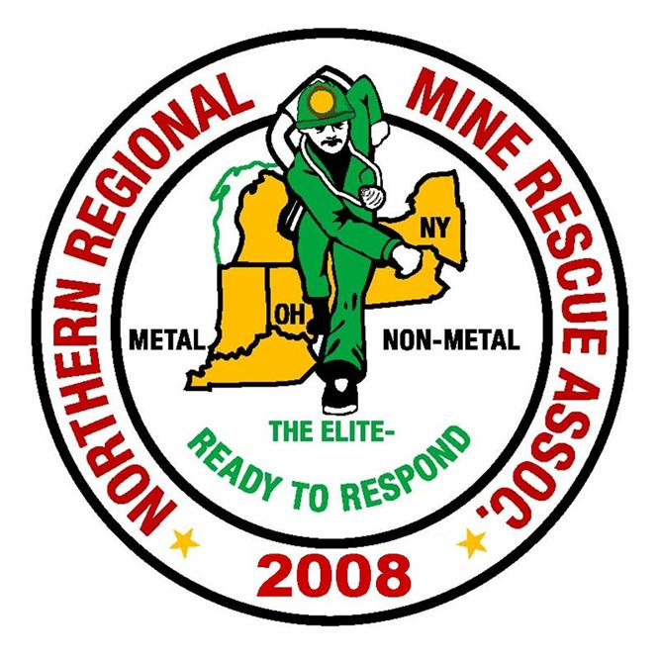
2010
2014

June 17, 2014
Findley Lake, New York

2014 Northern Mine Rescue Contest
Findley Lake, NY
Written Test – Technician Team – BG-4

Name____________________________ Company___________________________

Team Name_______________________ Contest Position No.__________________

Team Member No._________________

Directions: Circle the letter preceding the correct answer to each of the following questions. Circle only one answer per question.

- Specific gravity is the weight of a gas compared to an equal volume of normal air under different temperature and pressures.
- True
- False

- Elevated nitrogen levels indicate an oxygen ______ atmosphere.
  - Deficient
  - Rich
  - Normal
  - Elevated

- The most dangerous aspect of methane is that it is _____.
  - Toxic
  - An oxygen displacer
  - Water Soluble
  - Explosive

- Smoke is defined as tiny particles of ____ and liquid suspended in air.
  - Solid
  - Gas

- Ethane, Propane and Butane are classified as light hydrocarbons.
  - True
  - False
- A battery warning 1 allows the user to safely use the BG-4 for up to ___ hours.
- 2
- 3
- 4
- 5
- Operation without an ice pack is only permitted when ambient air temperatures are below 32 degrees Fahrenheit.
- True
- False

- Oxygen used in the BG-4 must have a purity of 99.25% or greater.
- True
- False

- When checking the inhalation valve, the RZ 25 tester is placed into the pump ________ pressure position.
- Positive
- Negative

- The oxygen cylinder should be recharged when below ____ psi.
- 3120
- 3680
- 2600
- 1957

- When checking the minimum valve, the admission pressure of the minimum valve must be between 0.5 and ___ mbar.
- 2.0
- 3.0
- 2.5
- 3.5

- The last low pressure warning occurs when the pressure has dropped to approximately ____ Bar.
- 15
- 10
- 17
- 25
- The motion sensor on the BG-4 alarms after approximately ____ seconds of no movement.
- 10
- 20
- 15
- 25

- The first residual pressure warning is generated when the pressure drops below _____ psi.
- 700
- 735
- 680
- 820

- Acetone, trichloroethylene and bleaches are acceptable to use as a detergent when cleaning the BG-4.
A. True
B. False

- The maximum drying temperature for BG-4 parts is _____ degrees Fahrenheit.
- 120
- 130
- 140
- 150

- When the Sentinel is not used for longer periods of time, the battery should be removed.
- True
- False

- The weight of a BG-4 including 1.4 kg of ice, full-face mask, CO₂ absorber and a charged oxygen cylinder is ____ lbs.
- 32
- 41
- 35.7
- 30

- The BG-4 sentinel unit requires a ___ battery.
- 9 volt
- AA
- AAA
- C

- Ice packs which are small, broken up or not completely frozen will increase available service time.
- True
- False

- The protective cover of the BG-4 is cosmetic and its use is optional.
- True
- False
- Because the battery in the BG-4 is of a low voltage, it is OK to change the battery in an explosive atmosphere if necessary.
- True
- False

- Which should be pressed to administer more oxygen to the wearer of the BG-4?
- LH button on sentinel
- RH button on sentinel
- Bypass valve
- Inhalation valve

- How many reinforcing rings should be on each breathing hose?
- One
- Two
- Three
- Four

- How many icons are used to represent the capacity left in the battery?
- One
- Two
- Three
- Four

- During mine rescue contests, blankets are an acceptable form of brattice material.
- True
- False

- During mine rescue contests, it is not necessary to ventilate in front of a barricade if Nitrogen Dioxide levels are measured at 22 ppm.
- True
- False

- During mine rescue contests, the ____ will decide whether to seal a fire in its entirety or to regulate the fire.
- Mine manager
- No. 1 judge
- Mine Superintendent
- Team

- During mine rescue contests, a ventilation change will be considered as _______ the air current.
- starting
- stopping
- redirecting
- All of the above

- All mine rescue team members must have completed physical examinations in the past ___ months preceding the mine rescue contest.
- 7
- 13
- 12
- 6

2014 Northern Mine Rescue Contest
Findley Lake, NY
Written Test – Technician Team Competition – BG-4
ANSWER KEY

Q Answer Source
- B. False - pg. 2-6 MSHA Publication 3027, Chapter 2
- A. Deficient – pg. 2-15 MSHA Publication 3027, Chapter 2
- D. Explosive – pg. 2-22 MSHA Publication 3027, Chapter 2
- A. Solid – pg. 2-74 MSHA Publication 3027, Chapter 2
- B. False – pg. 2-23 MSHA Publication 3027, Chapter 2
- C. Four - pg. 19 Instructions for Use, 5th Edition, March 2006
- A. True - pg. 17 Instructions for Use, 5th Edition, March 2006
- B. False - pg. 26 BG-4 Service Manual, 2nd Edition, July 2004
- A. Positive - pg. 33 BG-4 Service Manual, 2nd Edition, July 2004
- C. 2600 - pg. 53 BG-4 Service Manual, 2nd Edition, July 2004
- C. 2.5 - pg. 37 BG-4 Service Manual, 2nd Edition, July 2004
- B. 10 - pg. 13 BG-4 Service Manual, 2nd Edition, July 2004
- D. 25 - pg. 30 Instructions for Use, 5th Edition, March 2006
- A. 700 - pg. 31 Instructions for Use, 5th Edition, March 2006
- B. False – pg. 40 Instructions for Use, 5th Edition, March 2006
- C. 140 – pg. 40 Instructions for Use, 5th Edition, March 2006
- A. True – pg. 12 Instructions for Use, 5th Edition, March 2006
- C. 35.7 – pg. 61 Instructions for Use, 5th Edition, March 2006
- A. 9 volt – pg. 61 Instructions for Use, 5th Edition, March 2006
- B. False – pg. 17 Instructions for Use, 5th Edition, March 2006
- B. False – pg. 17 Instructions for Use, 5th Edition, March 2006
- B. False – pg. 12 Instructions for Use, 5th Edition, March 2006
- C. Bypass valve – pg. 27 Instructions for Use, 5th Edition, March 2006
- C. Three – pg. 46 Instructions for Use, 5th Edition, March 2006
- C. Three – pg. 57 Instructions for Use, 5th Edition, March 2006
- B. False – pg. 32 2014 MNM Contest Rules
- B. False – pg. 28 2014 MNM Contest Rules
- D. Team – pg. 33 2014 MNM Contest Rules
- D. All of the above – pg. 31 2014 MNM Contest Rules
- C. Twelve – pg. 11 2014 MNM Contest Rules

