2013 Northern Mine Rescue Contest
Written Exam
(First Aid Competition)

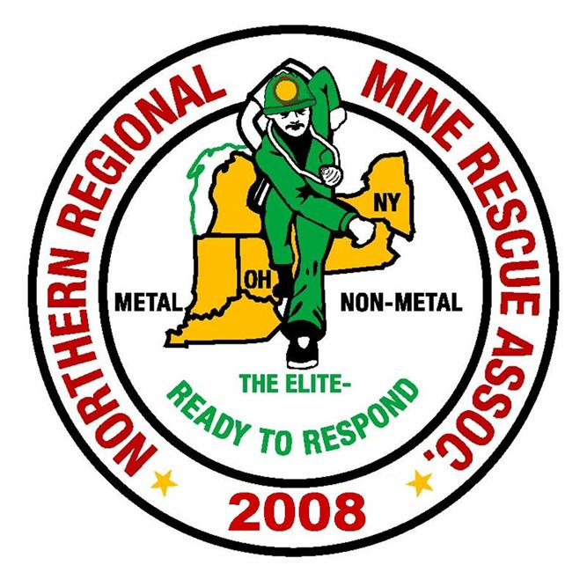
2010
2013

July 16, 2013
Rochester, New York

2013 Northern Mine Rescue Contest
Rochester, NY
Written Test – First Aid Competition

Name____________________________ Company___________________________

Team Name_______________________ Contest Position No.__________________

Team Member No._________________

Directions: Circle the letter preceding the correct answer to each of the following questions. Circle only one answer per question.

- Facial droop and arm drift are two assessment tools that can be helpful to evaluate an unresponsive patient for the likelihood of a stroke.
a. True
b. False
- Supine refers to the body lying face down.
a. True
b. False
- The human body has _______________ major body cavities.
a. Two
b. Four
c. Six
d. Eight
- If bleeding from the lower leg is not controlled with direct pressure, you should also:
a. utilize a pressure point
b. elevate the extremity
c. use a tourniquet
d. rapidly apply an air splint
- When apply a bandage to a limb, always bandage from the top to the bottom of the limb.
a. True
b. False
- When adjusting a patient’s position on a spine board, maintaining the victims head and spine position is commonly referred to as positive alignment.
a. True
b. False
- Which quadrant contains the appendix and part of the small and large intestine?
a. Right upper quadrant
b. Right lower quadrant
c. Left upper quadrant
d. left lower quadrant
- Once a cervical collar is in place on a patient with a suspected spine injury you should:
a. Conduct a head to toe examination
b. Maintain manual stabilization of the head
c. prepare the spine board to immobilize the patient
d. Assess the airway, breathing and circulation
- The term “anterior” refers to the ______.
a. back of the body or body part
b. top of the body or body part
c. front of the body or body part
d. side of the body or body part
- A BEST properly fitted cervical collar should ______________.
a. have the sides of the collar extend above the earlobes
b. extend well beyond the chin
c. have the sides of the collar come very close to or slightly overlap the earlobes
d. have the sides of the collar extend above the earlobes and extend beyond the chin
- A cervical collar only minimizes movement of the neck.
a. True
b. False

- The adequate supply of well-oxygenated blood to body tissue is called __________.
a. circulation
b. arterial flow
c. perfusion
d. oxygenation
- A rapid and weak pulse indicates _____________.
a. stroke
b. cardiac arrest
c. blood loss
d. brain injury
- Unequal pupils may typically indicate _____________.
a. stroke
b. central nervous system damage
c. certain medications
d. cardiac arrest
- You are walking through the plant and notice a co-worker walking ahead of you approximately 50 yards away that suddenly drops. You immediately __________.
a. begin CPR
b. call 911
c. check the scene for safety
d. a and b
e. none of the above
- A patient with hyperventilation is experiencing __________.
a. too much carbon dioxide and too little oxygen in his respiratory system
b. too much oxygen and too little carbon dioxide in his respiratory system
c. too much carbon dioxide in his respiratory system
d. too little oxygen in his respiratory system

- Sudden severe abdominal pain is commonly called ____________.
a. referred pain
b. appendicitis
c. inflamed abdominal pain
d. acute abdomen
- An adult male weighing approximately 154 pounds will have suffered a lethal, rapid blood loss as soon as he loses as little as _________ of blood.
a. 0.5 liters
b. 1.3 liters
c. 2.2 liters
d. none of the above
- The routes of poison exposure are ingestion, inhalation, absorption, and injection.
a. True
b. False
- The first priority when assessing a patient is:
a. Level of consciousness
b. Airway
c. Breathing
d. Circulation
e. None of the above
- Hepatitis B is a virus transmitted by which of the following mechanisms?
a. Blood-blood contact
b. Airborne aerosolized droplets
c. Saliva
d. Skin secretions
e. None of the above

- The aorta supplies blood to the __________.
a. Superior Vena Cava
b. Pulmonary arteries
c. Peripheral arteries
d. Heart
e. None of the above
- After splinting a patient’s extremity or positioning them on a backboard what needs to be done?
a. Assess motor function, reflexes and circulation
b. Assess circulation, motor function and sensation
c. Position the patient with injuries above the heart
d. Give the patient a strong pain medication
e. None of the above
- The average blood volume for an adult male is _________.
a. 4 liters
b. 6.6 liters
c. 3.3 liters
d. 8 liters
e. none of the above
- The rule of tens is a system used in determining the amount of skin surface burned.
a. True
b. False
- A triangular bandage used to stabilize an elbow and an arm is called a __________.
a. Swathe
b. Cravat
c. Sling
d. None of the above

- The most common signs and symptoms of a spinal injury are ____________.
a. impaired breathing
b. loss of bowels or bladder control
c. weakness, numbness, or tingling sensation or paralysis of arms or legs
d. all of the above
- Which of the following is NOT a component of the scene size up?
a. Take BSI precautions
b. Determine scene safety
c. Assess the patient’s airway, breathing and circulation
d. Identify the mechanism of injury or nature of illness
- Your patient’s level of responsiveness or mental status is determined by using the letters:
a. AEIOU
b. OPQRST
c. DCAP-BTLS
d. AVPU
- The human body can be divided into five regions
a. True
b. False

