2013 Northern Mine Rescue Contest
Written Exam
(Team Trainer)

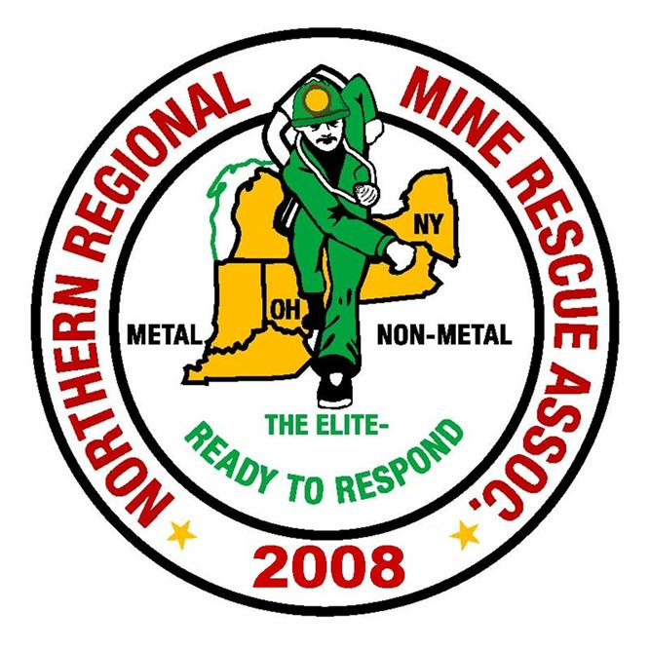
2010
2013

July 16, 2013
Rochester, New York

2013 Northern Mine Rescue Contest
Rochester, NY
Written Test – Team Trainer

Name____________________________ Company___________________________

Team Name_______________________ Contest Position No.__________________

Team Member No._________________

Directions: Circle the letter preceding the correct answer to each of the following questions. Circle only one answer per question.

- It is much easier for concentrations of explosive gases to build up when the barometric pressure is low and the temperature is high.

A. True
B. False

- The ___________ determines whether to advance fresh air or build an air lock to rescue survivors.

A. Team Captain
B. Gas Man
C. Map Man
D. Command Center
E. None of the above

- Hydrogen Sulfide is most explosive at _________ percent.

A. 7 to 8
B. 5.9
C. 14.2
D. 15
E. None of the above

- A body at 68 degrees Fahrenheit or higher will decay very rapidly.

A. True
B. False

- During a rescue and recovery operation, one of the duties of the outside Supervisor is to:

A. Arrange for guards and state and/or local police.
B. Notify all persons on the notification plan of the emergency.
C. Provide materials for additional telephone communications as needed.
D. Obtain gas samples from the main exhaust.
E. None of the above

- 30 CFR 49.6(a) (6) requires gas detectors must measure concentrations of methane from:

A. 0.0 percent to 20 percent of volume
B. 0.0 percent to 15 percent of volume
C. 0.0 percent to 70 percent of volume
D. 0.0 percent to 90 percent of volume
E. None of the above

- __________ is a mixture of carbon dioxide, nitrogen, and air.

A. Afterdamp
B. Whitedamp
C. Blackdamp
D. Firedamp
E. None of the above

- A hazard of direct firefighting is:

A. Electrocution
B. Heat
C. Smoke
D. Both B and C
E. All of the above

- _________ has a slight garlic odor.

A. Propane
B. Acetylene
C. Butane
D. Both A and C
E. None of the above
- In natural ventilation greater temperature differences result in larger airflow.

A. True
B. False

- Spatial disorientation can be caused by traveling in dense smoke.

A. True
B. False

- Re-ventilation after an explosion in a single-level, room-and-pillar mine is usually accomplished by progressive ventilation.

A. True
B. False

- It is recommended that you don’t eat within 2 hours prior to wearing apparatus.

A. True
B. False

- The gallbladder is located in the _______________ abdominal quadrant.

A. Right Upper
B. Left Upper
C. Right Lower
D. Left Lower

- Initial assessment is an overview of the scene to identify any obvious or potential hazards.

A. True
B. False

- When the heart stops beating, the oxygen supply remaining in the brain is then used up in about _________ minutes:

A. 2 to 3
B. 4 to 6
C. 7 to 8
D. 7 to 9

- The volume of the chest cavity is increased by muscle contraction.

A. True
B. False

- Fear is a symptom of shock.

A. True
B. False

- Broken bone ends protruding through the skin is a (n) _____________ wound.

A. Open
B. Closed
C. Complex
D. Superficial
E. None of the above

- _________ is a sign of partial airway obstruction.

A. Snoring
B. Crowing
C. Stridor
D. None of the above
E. All of the above

- The human body is (can) be divided into _________ regions.

A. 4
B. 5
C. 6
D. 7
E. None of the above

- Over ventilating a person can cause gastric distention.

A. True
B. False

- ___________ is a sign of hypoglycemia.

A. Altered mental state.
B. Normal or shallow breathing.
C. Very hungry
D. A and B
E. All of the above

- MSHA Forms 5000-3 must be kept on file for a period of

A. 1 year
B. 2 years
C. 3 years
D. 5 years
E. None of the above

- Mine rescue team communication systems must be at least _________ feet in length.

A. 100
B. 500
C. 1,800
D. 1,000
E. None of the above

- A mine rescue team member will be ineligible to serve on a team if more than six hours of training is missed during one year.

A. True
B. False

- During a mine rescue contest, the team must “count off”

A. Prior to entering the mine the first time.
B. Every time the mine is exited.
C. When completing the problem.
D. Both A and B
E. Both A and C

- During a mine rescue contest, where crosscuts are blocked, no team member may advance more than 2 feet beyond the second intersection before tying across and/or behind into all unexplored areas that intersect.

A. True
B. False

- is the symbol for:

A. Water
B. bad ground
C. ladder
D. Track
E. None of the above
- During a mine rescue contest, apparatus checks are conducted at the first team stop and then at not more than _________ minute intervals while the team is working the problem.

A. 15
B. 20
C. 30
D. None of the above

