PROBLEM 2
DEH: JANUARY – 2013

STATEMENT

YOU ARE LOCATED IN THE FRESH AIR BASE

3 PEOPLE ARE MISSING

MINE MAP IS UP TO DATE

FAN IS OPERATIONAL

POWER IS LOCKED OUT AND GUARDED

BACK UP TEAM IS AVAILABLE

AGENCIES HAVE BEEN NOTIFIED AND ARE PRESENT

MINE IS WALKING HEIGHT

SUPPORTED BY ROOF BOLTS UNLESS OTHERWISE NOTED

METHANE IS PRESENT

CARBON MONOXIDE HAS BEEN DETECTED

LOW OXYGEN MAY BE FOUND

TEAM INSTRUCTIONS

LOCATE THE MISSING PEOPLE

BRING LIVE PEOPLE TO THE FRESH AIR BASE

EXPLORE THE MINE IN ITS ENTIRETY

FAN CAN BE STARTED WHEN NEEDED

AIR WILL ENTER THE MINE IN THE NUMBER 3 ENTRY

FAN CANNOT BE STOPPED, STALLED OR REVERSED

BRIEFING OFFICER’S STATION IS AIRTIGHT WHEN
BRIEFING OFFICER IS IN IT!

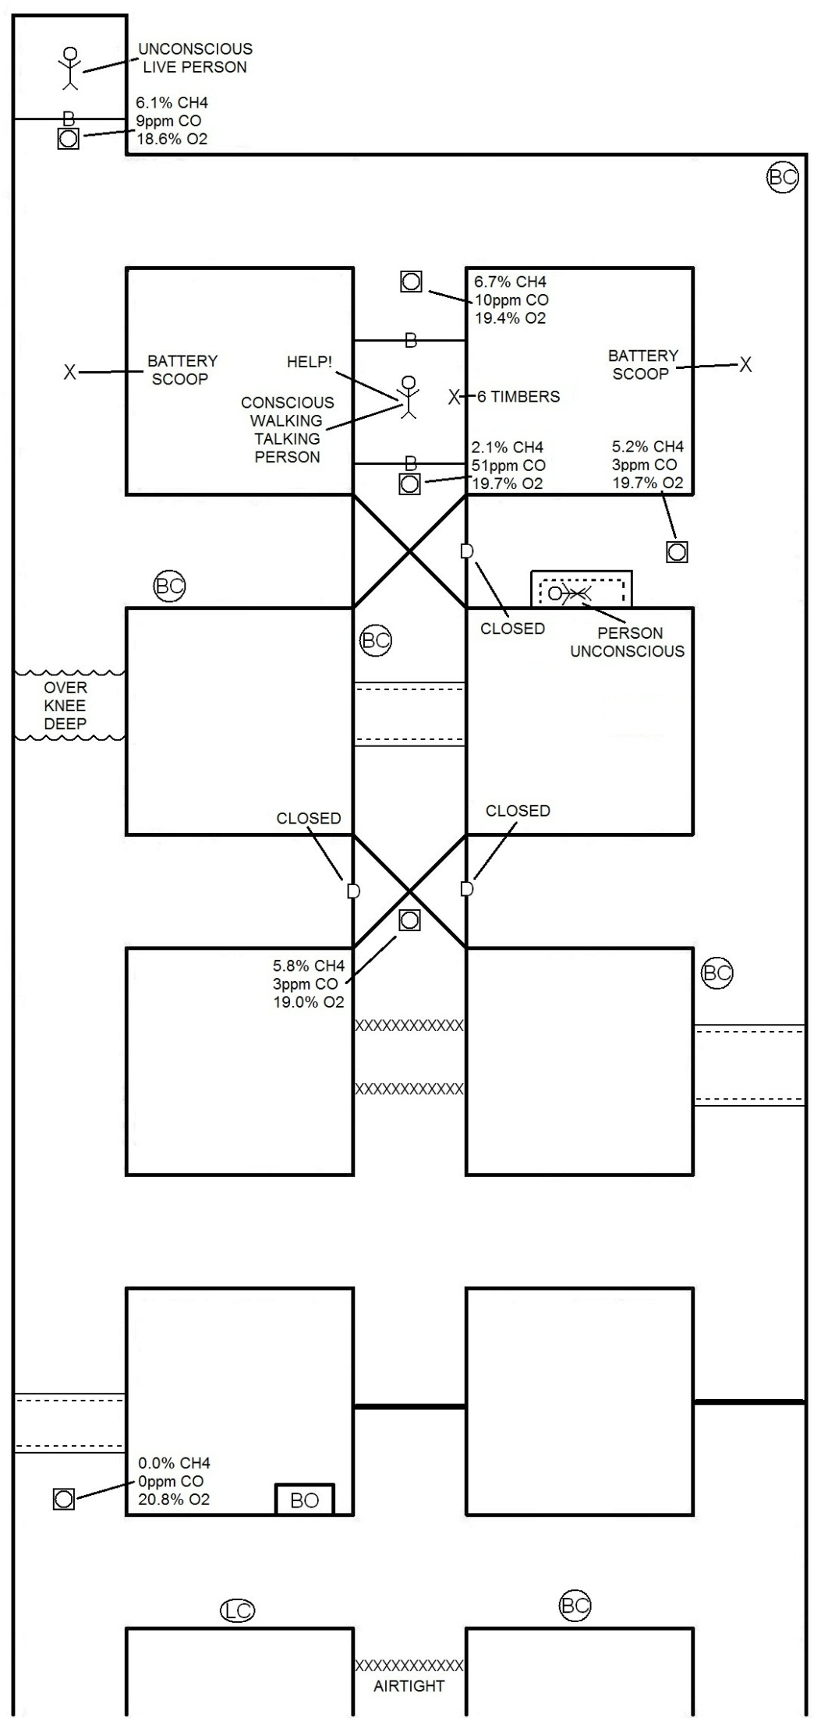
PROBLEM EXPLANATION

PROBLEM PROVIDES SEVERAL DISCUSSIONS.

FIRST: DEPENDING ON THE OPENING AIR IS DIRECTED INTO THE INTERSECTION FROM, DOES ALL VENTILATION FROM ONE SOURCE PASS OVER THE GAS PLACARD, UNDER THE FIRST OVERCAST, WHEN TEAM VENTILATES. (Scenario has been submitted to the National Chief Judges)

SECOND: EXTENT OF GAS IN #2 TO #3 CROSSCUT WHEN THE TEAM TRAVELS TOWARD SECOND OVERCAST IN THE #2 ENTRY FROM THE #3 ENTRY.

THIRD: GAS MIXTURE AT BARRICADE VENTILATED THROUGH OVERCAST DOOR BY LINE CURTAIN. DOES THE LINE CURTAIN HAVE TO BE HELD FROM THE OUTBY CORNER OF THE INTERSECTION OR AT THE OVERCAST WALL OUTBY THE DOOR?

FOURTH: CAN THE BRIEFING OFFICER LEAVE HIS STATION TO ERECT A TEMPORARY STOPPING IN THE FRESH AIR BASE WHEN VENTILATING IRRESPIRABLE MIXTURES?

BARRICADE IN #2 ENTRY IS INBY THE CORNER OF THE INTERSECTION. THERE SHOULD NOT BE ADEQUATE ROOM FOR TEAM TO AIRLOCK INBY THE CORNER. TEAM SHOULD HAVE TO BUILD OUTBY THE #2 INTERSECTION (OVERCAST). TEAM WILL NEED TO CLOSE THE DOOR IN THE OVERCAST TO CREATE AN AIRTIGHT SEPARATION.

PERSON IN #2 BARRICADE IS RESCUED FIRST. DEPENDING ON THE TEAMS STOPPING POINT, THE TEAM MAY BE ABLE TO TIMBER THE ELONGATED UNSAFE ROOF FROM THE TEAM STOP AND REACH THE PERSON IN THE ELONGATED UNSAFE ROOF, PRIOR TO RETREATING TO THE FRESH AIR BASE WITH PERSON IN BARRICADE #2.

***PERSON IN ELONGATED UNSAFE ROOF IS UNCONSCIOUS. TRAINER COULD ELECT TO HAVE THE PERSON IN THE #2 BARRICADE INJURED OR UNCONSCIOUS. IF TEAM CHOSE TO TIMBER THE ELONGATED UNSAFE ROOF BEFORE TAKING THE PERSON IN THE #2 BARRICADE TO THE FRESH AIR BASE, CREATES SITUATION OF TWO PATIENTS AND ONE STRETCHER.

THREE VENTILATIONS REQUIRED TO REMOVE THE PERSON IN THE #2 BARRICADE.

FOURTH VENTILATION IS REQUIRED TO REMOVE THE PERSON IN THE #1 BARRICADE.

PERSON IN ELONGATED UNSAFE ROOM MUST BE RECOVERED PRIOR TO FOURTH VENTILATION.

MUST TIMBER UNSAFE ROOF IN #2 ENTRY PRIOR TO FOURTH VENTILATION.

***NOTE: Builds in each ventilation step may vary as long as air cannot move in any area other than shown in ventilation step.

TEAM STOPS
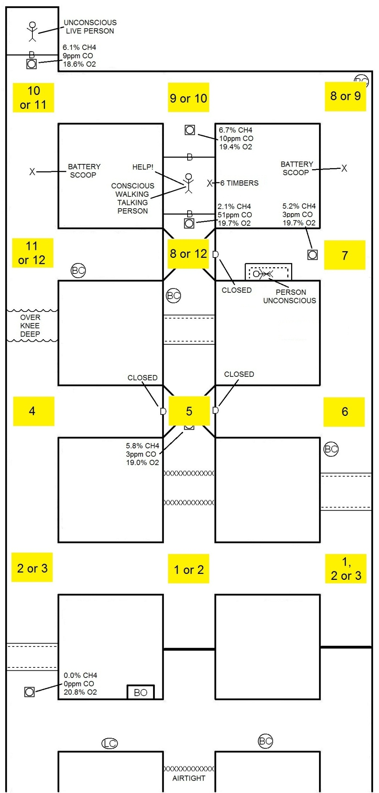
VENTILATION 1
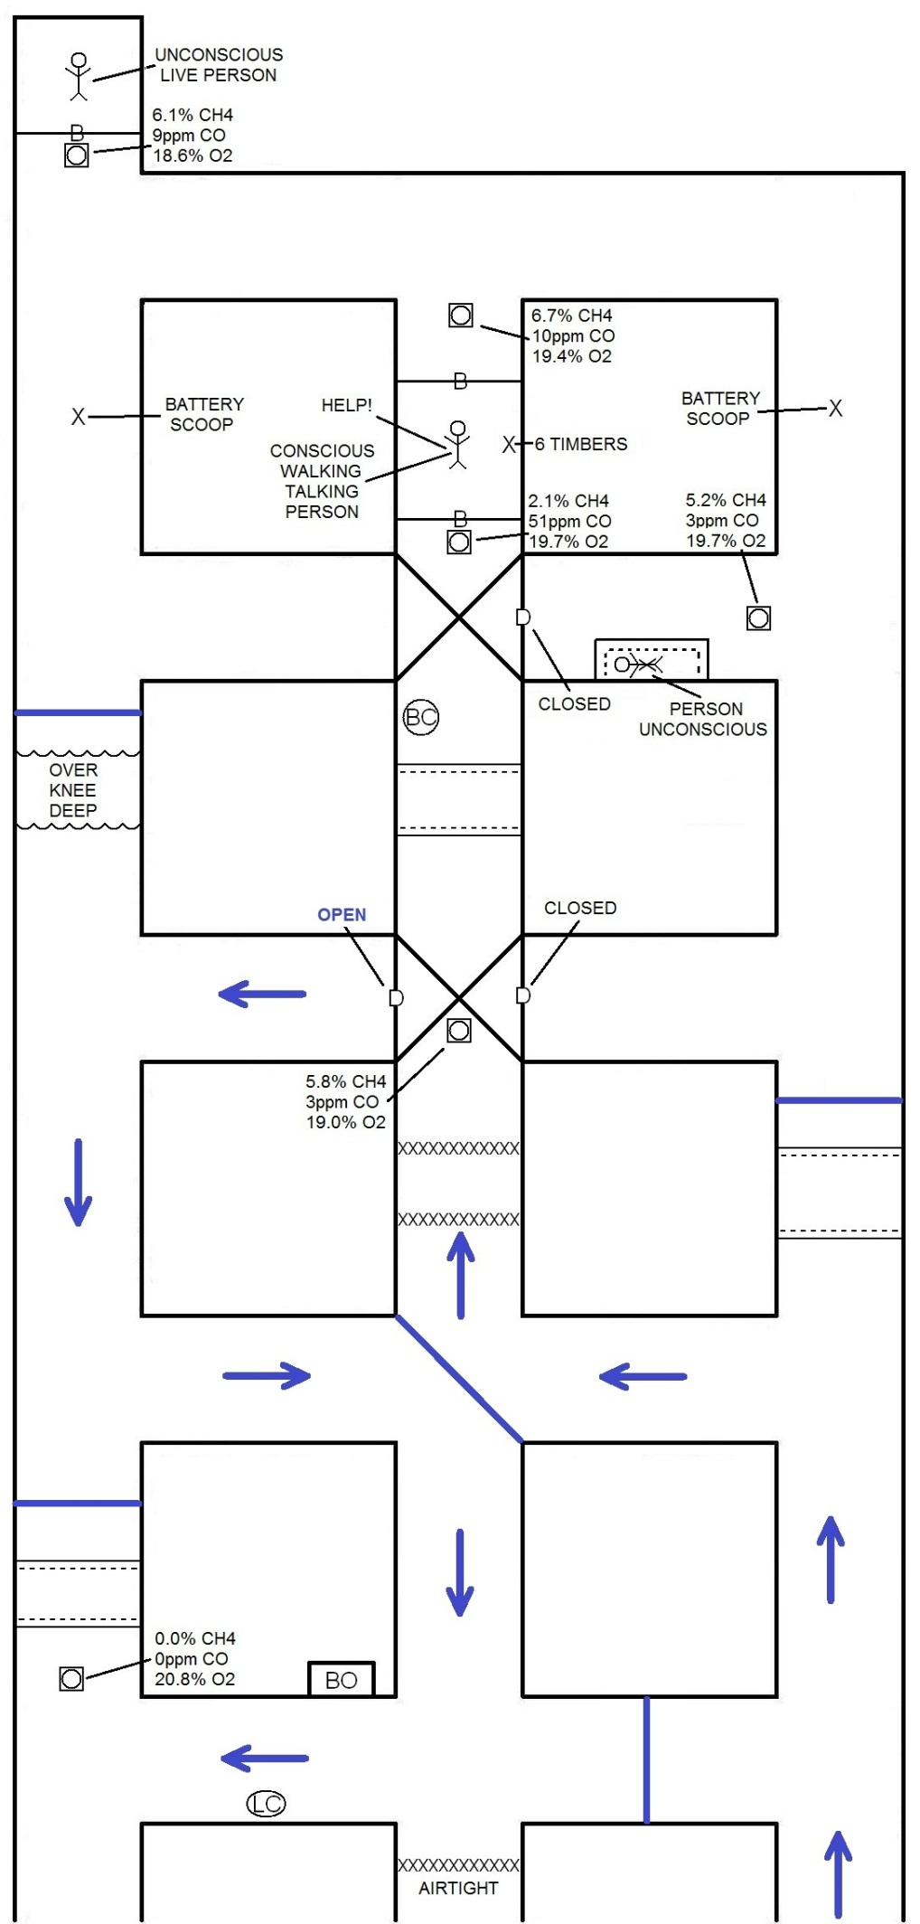
VENTILATION 1 ALTERNATIVE
(First Discussion)
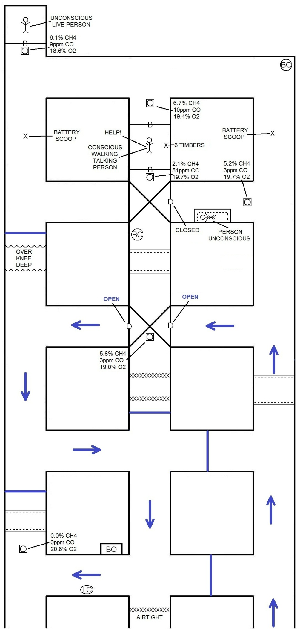
VENTILATION 2
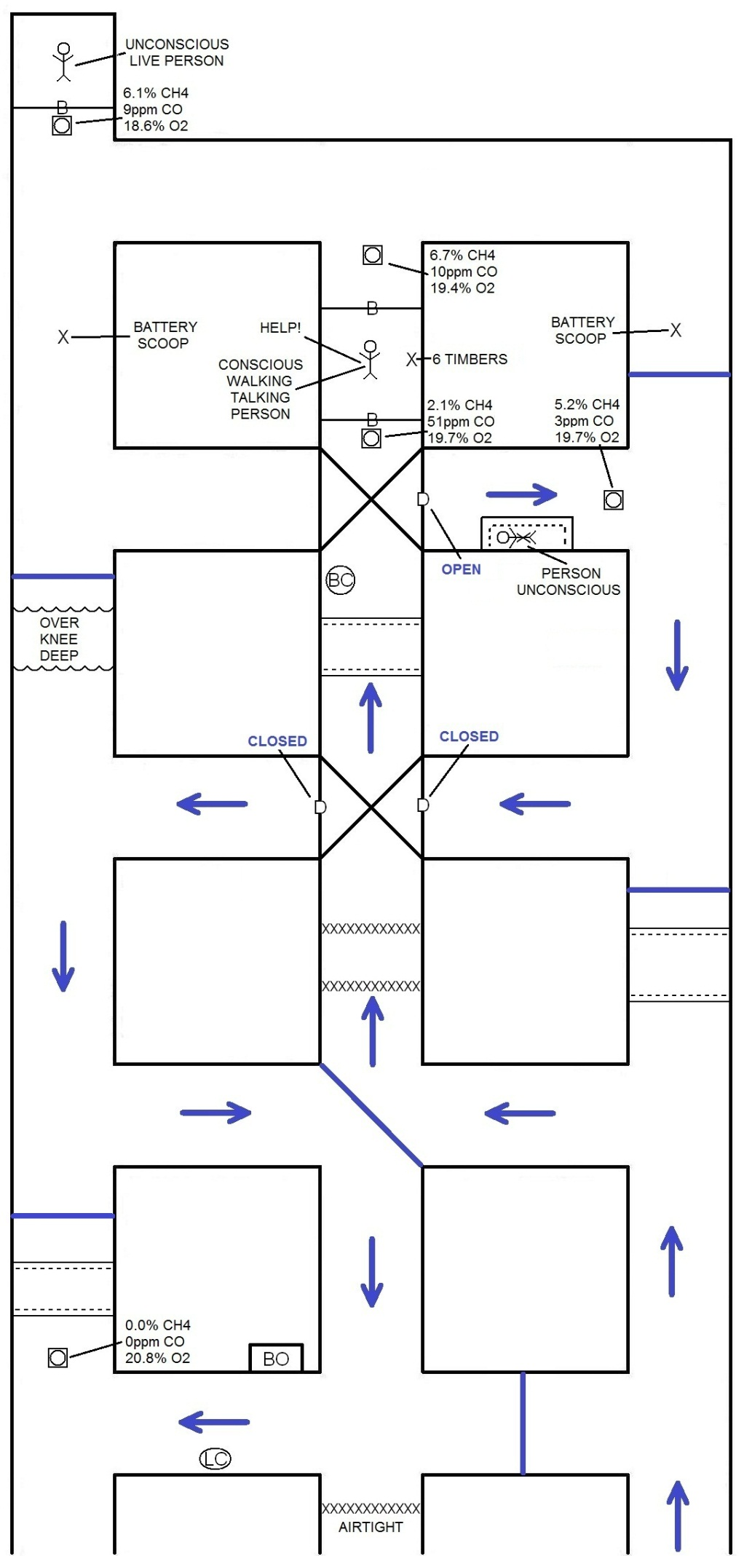
VENTILATION 3
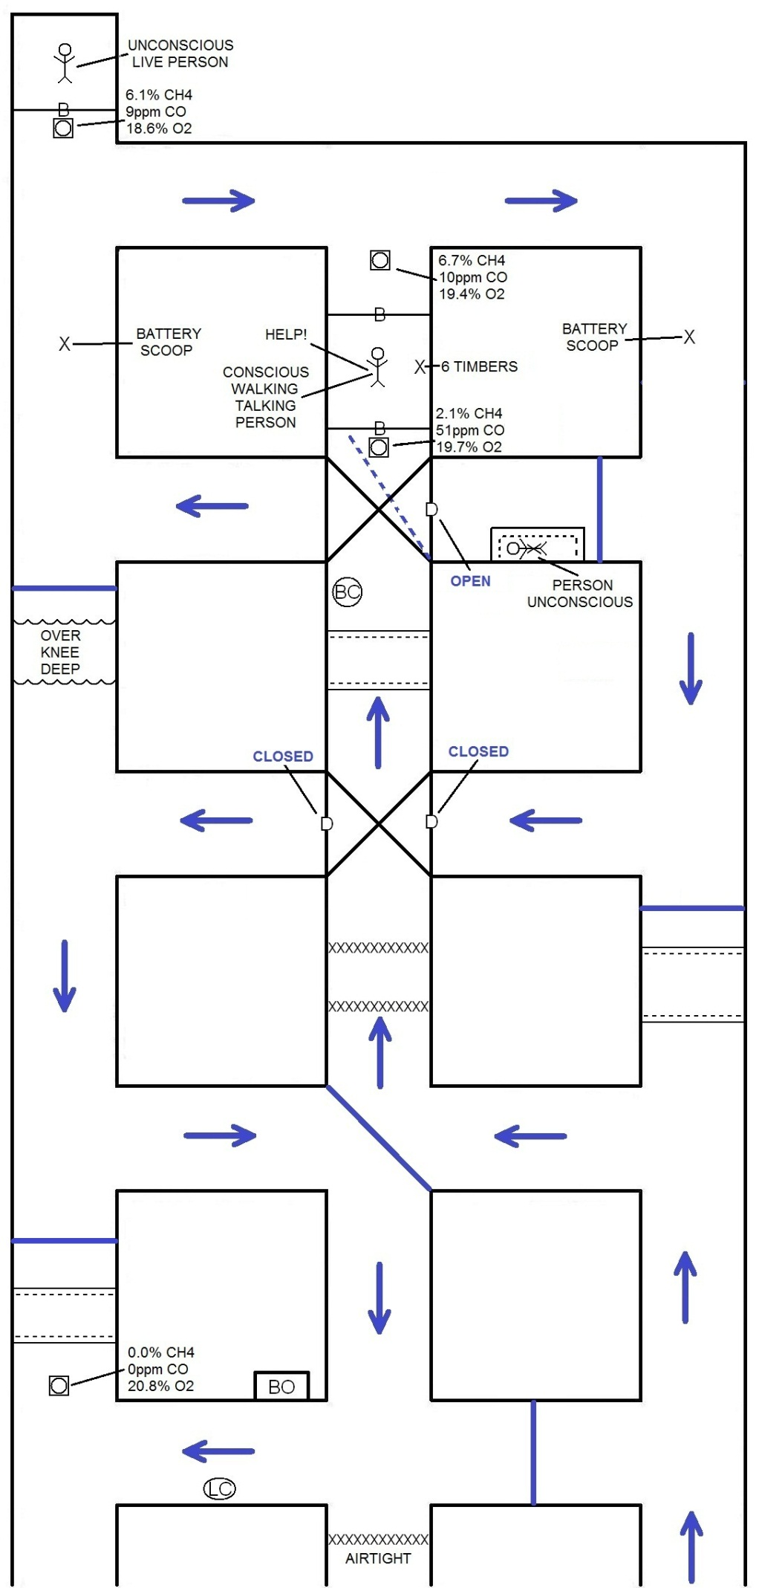
VENTILATION 4
