TEAM ____________________ FIELD____________________

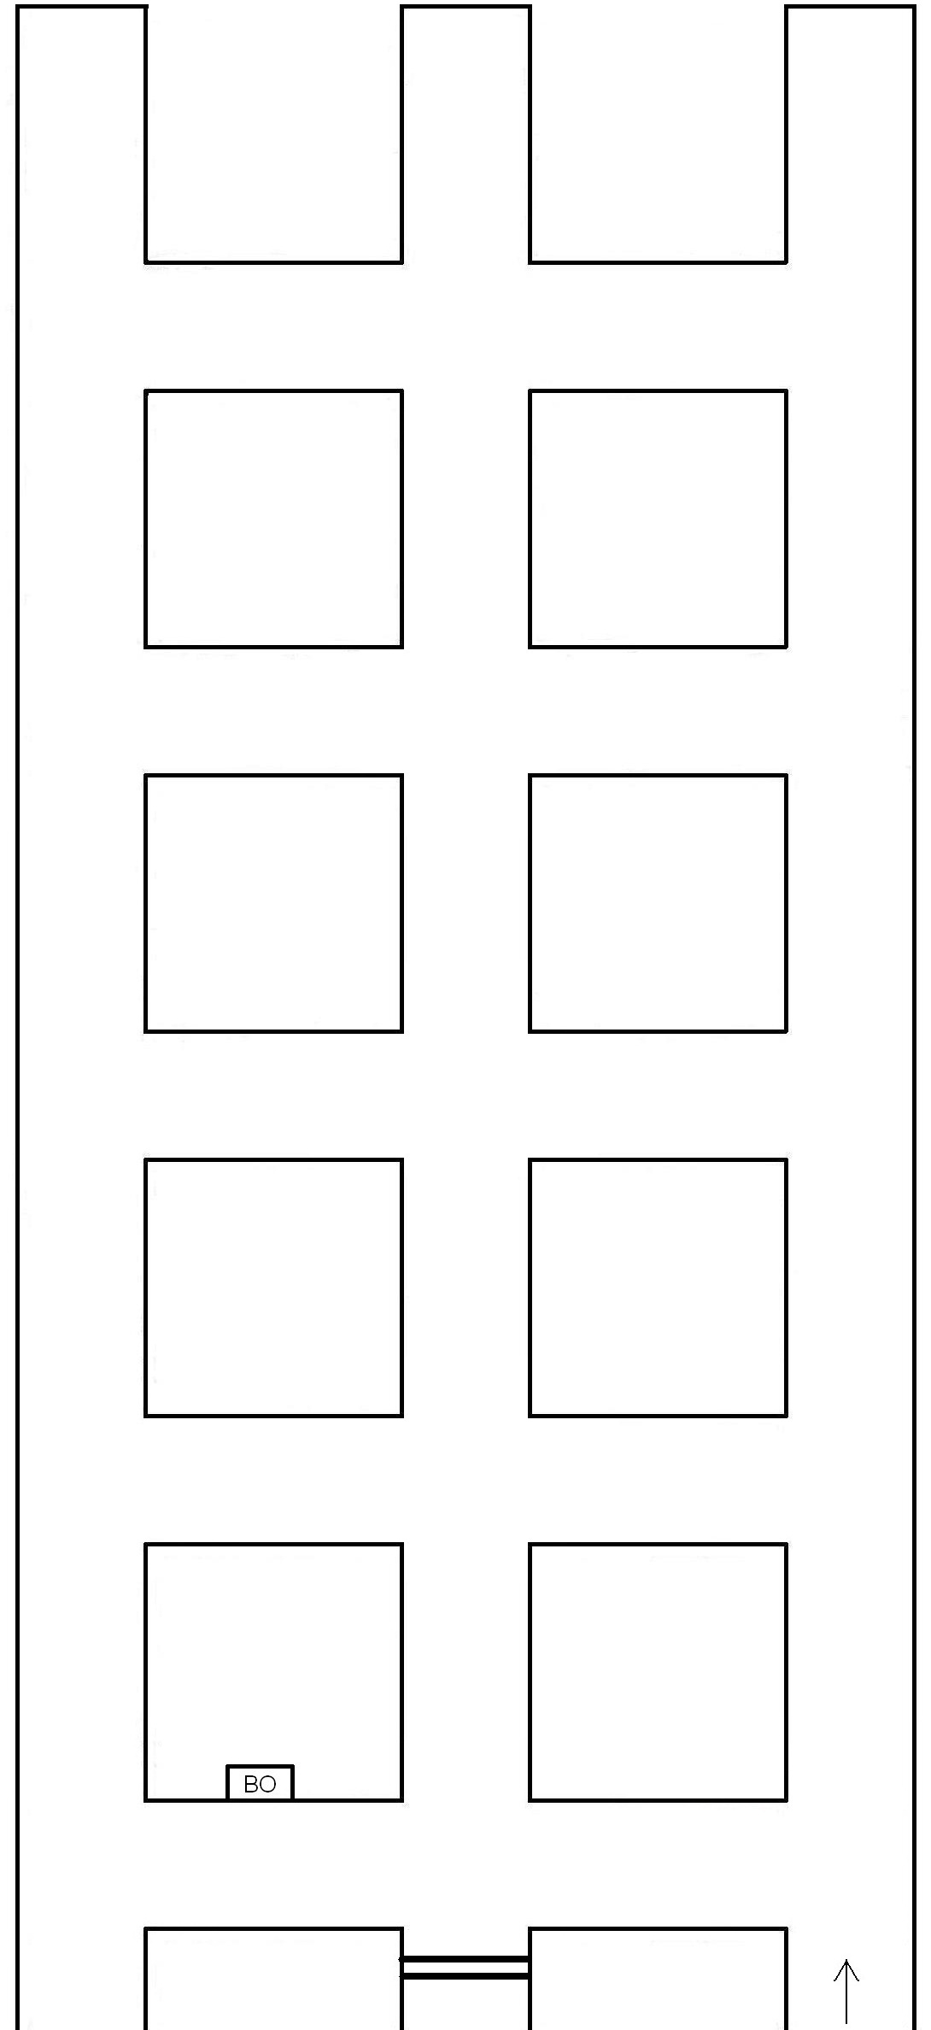

BRIEFING OFFICER’S MAP

