PROBLEM 3
DEH: MARCH – 2013

STATEMENT

TEAMS ARE CURRENTLY ADVANCING IN THIS DIRECTION
(TOWARD YOU) FROM THE OPPOSITE END OF THE MINE

YOU ARE LOCATED IN A FRESH AIR BASE

5 PEOPLE ARE MISSING

MINE MAP IS UP TO DATE

FAN IS OPERATIONAL

POWER IS LOCKED OUT AND GUARDED

BACK UP TEAM IS AVAILABLE

AGENCIES HAVE BEEN NOTIFIED AND ARE PRESENT

MINE IS WALKING HEIGHT

SUPPORTED BY ROOF BOLTS UNLESS OTHERWISE NOTED

METHANE IS PRESENT

CARBON MONOXIDE HAS BEEN DETECTED

LOW OXYGEN MAY BE FOUND

TEAM INSTRUCTIONS

TEAMS EXPLORED FROM THE OPPOSITE END OF THIS MINE
TO WITHIN 6 CROSSCUTS OF THIS FRESH AIR BASE.

SINCE YOUR TEAM IS WITHIN 6 CROSSCUTS OF THE
OTHER TEAMS FURTHEST POINT OF ADVANCE, WE HAVE
STOPPED EXPLORING FROM THE OPPOSITE END OF THE MINE.

ALL EXPLORED AREAS INBY AND OUTBY THIS AREA
HAS BEEN DEEMED SAFE TO USE FOR VENTILATION

MAPS UPDATED TO SHOW THE OTHER TEAMS PROGRESS

LOCATE THE MISSING PEOPLE

BRING LIVE PEOPLE TO THE FRESH AIR BASE

FAN CAN BE STARTED WHEN NEEDED

FAN CAN BE OPERATED BLOWING OR EXHAUSTING

FAN IS LOCATED ON SURFACE IN NUMBER 1 ENTRY

YOU OPERATE THE FAN BY TALKING TO THE SUPERINTENDENT

BRIEFING OFFICER’S STATION IS AIRTIGHT WHEN
BRIEFING OFFICER IS IN IT!

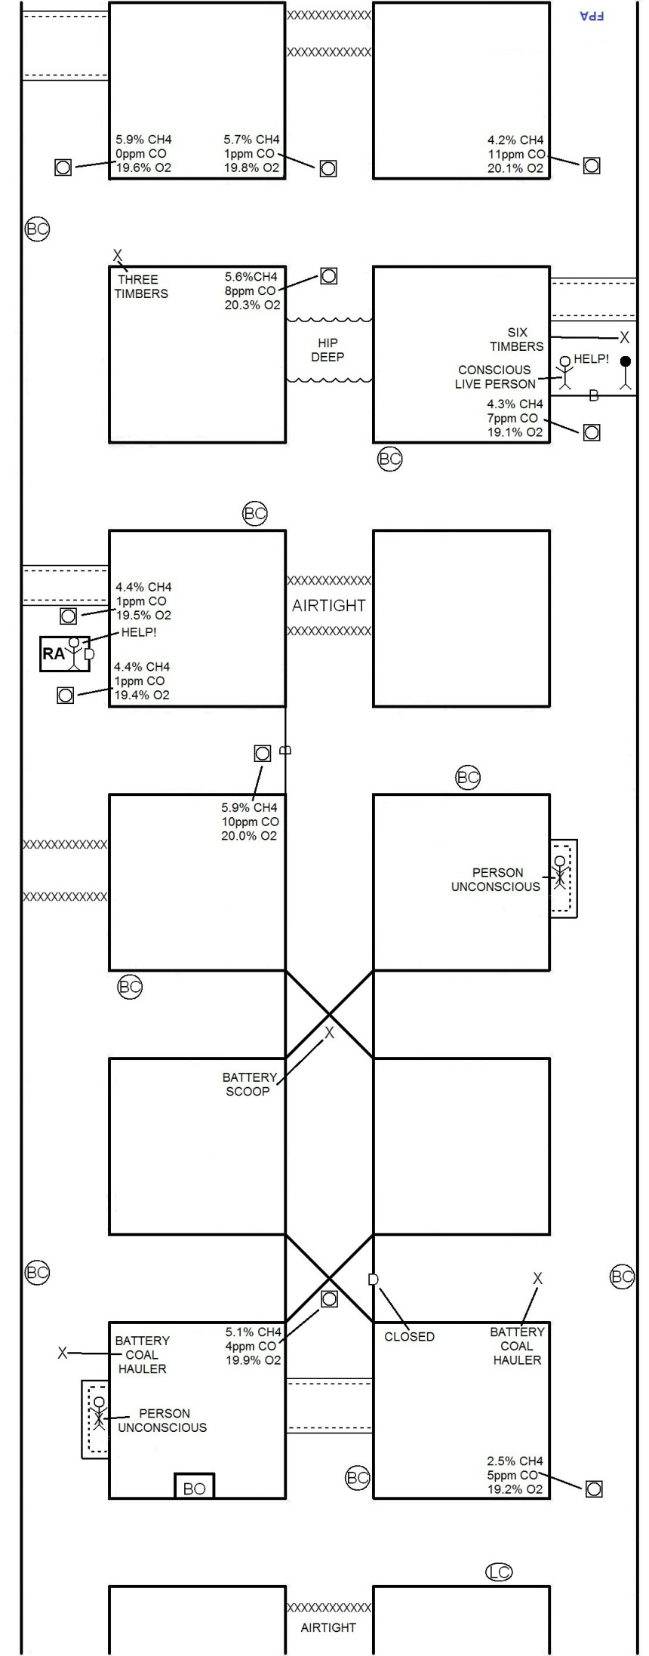
PROBLEM EXPLANATION

FAN CAN BE STARTED AND STOPPED.

PROBLEM DOES NOT REQUIRE MINE BE EXPLORED IN ITS ENTIRETY.

TEAM HAS THE MEANS TO RESCUE ALL SURVIVORS ONCE TEAM STOP 12 IS EXPLORED.

TIMBERS AND BRATTICE CLOTH LOCATED IN WHAT WOULD BE TEAM STOP 13, ARE NOT NEEDED TO WORK THE PROBLEM.

IF TEAM ADVANCES BEYOND TEAM STOP 12 BEFORE RECOVERING LIVE PERSONS THEY HAVE DELAYED PATIENT!

IF TEAM ADVANCES BEYOND TEAM STOP 12 AND HAS NOT ENTER FIRST BARRICADE THEY HAVE EXCEEDED THE TWO CROSSCUT LIMIT!

THREE VENTILATIONS ARE REQUIRED TO REMOVE PERSON IN THE REFUGE ALTERNATIVE.

FOURTH VENTILATION IS REQUIRED TO REMOVE PERSON IN THE #3 BARRICADE.

***NOTE: Builds in each ventilation step may vary as long as air cannot move in any area other than shown in ventilation step.

USE TIMBERS FOUND IN THE NUMBER 3 BARRICADE TO TIMBER TO BODIES IN ELONGATED UNSAFE ROOF.

MAPS REQUIRE FPA IF TEAM DOES NOT EXPLORE THE MINE IN ITS ENTIRETY!

***NOTE: There is no quitter in this problem. Other team has explored any area that
might be in question!!!

TEAM STOPS
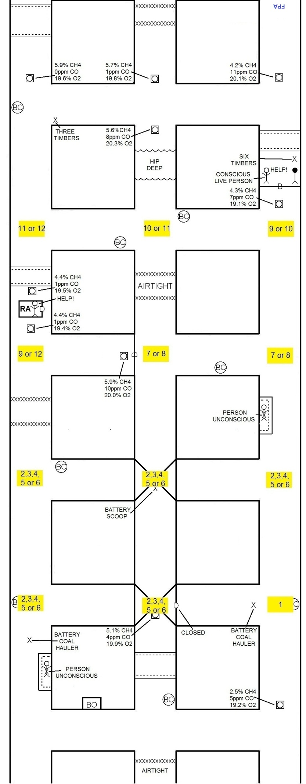
ENTERING FIRST BARRICADE
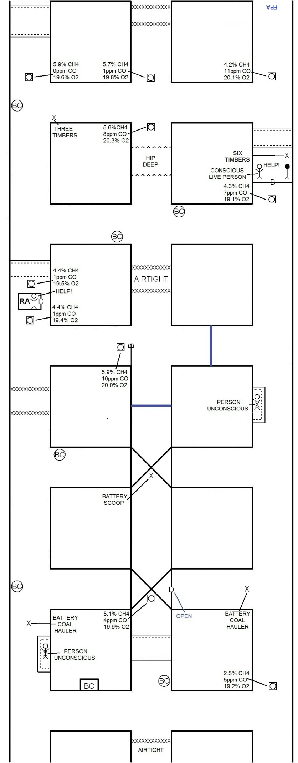
VENTILATION 1
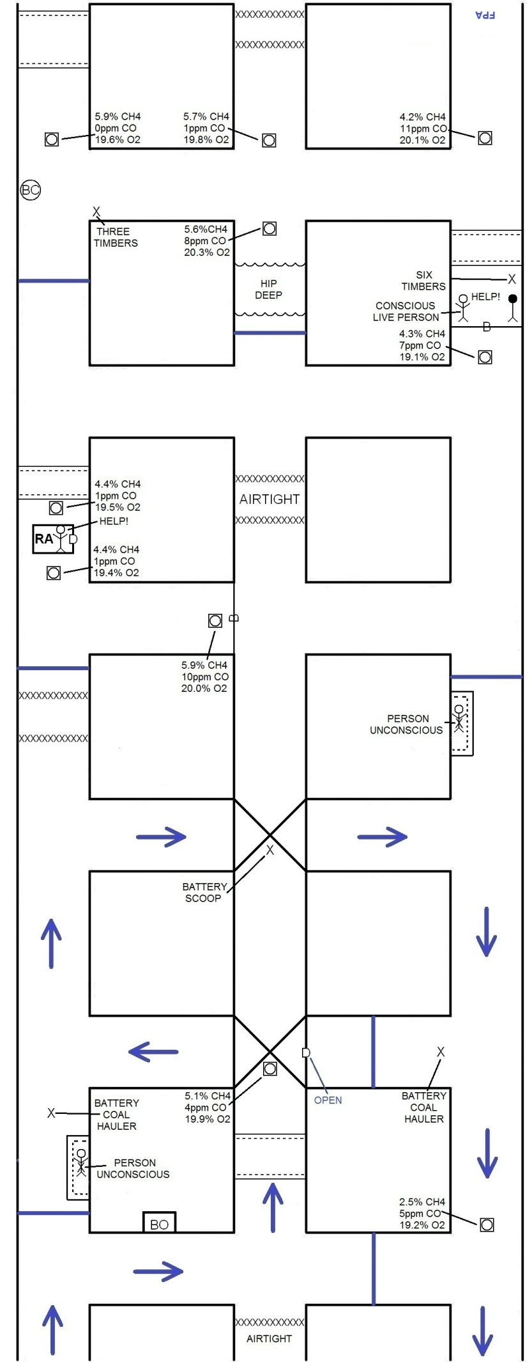
VENTILATION 2
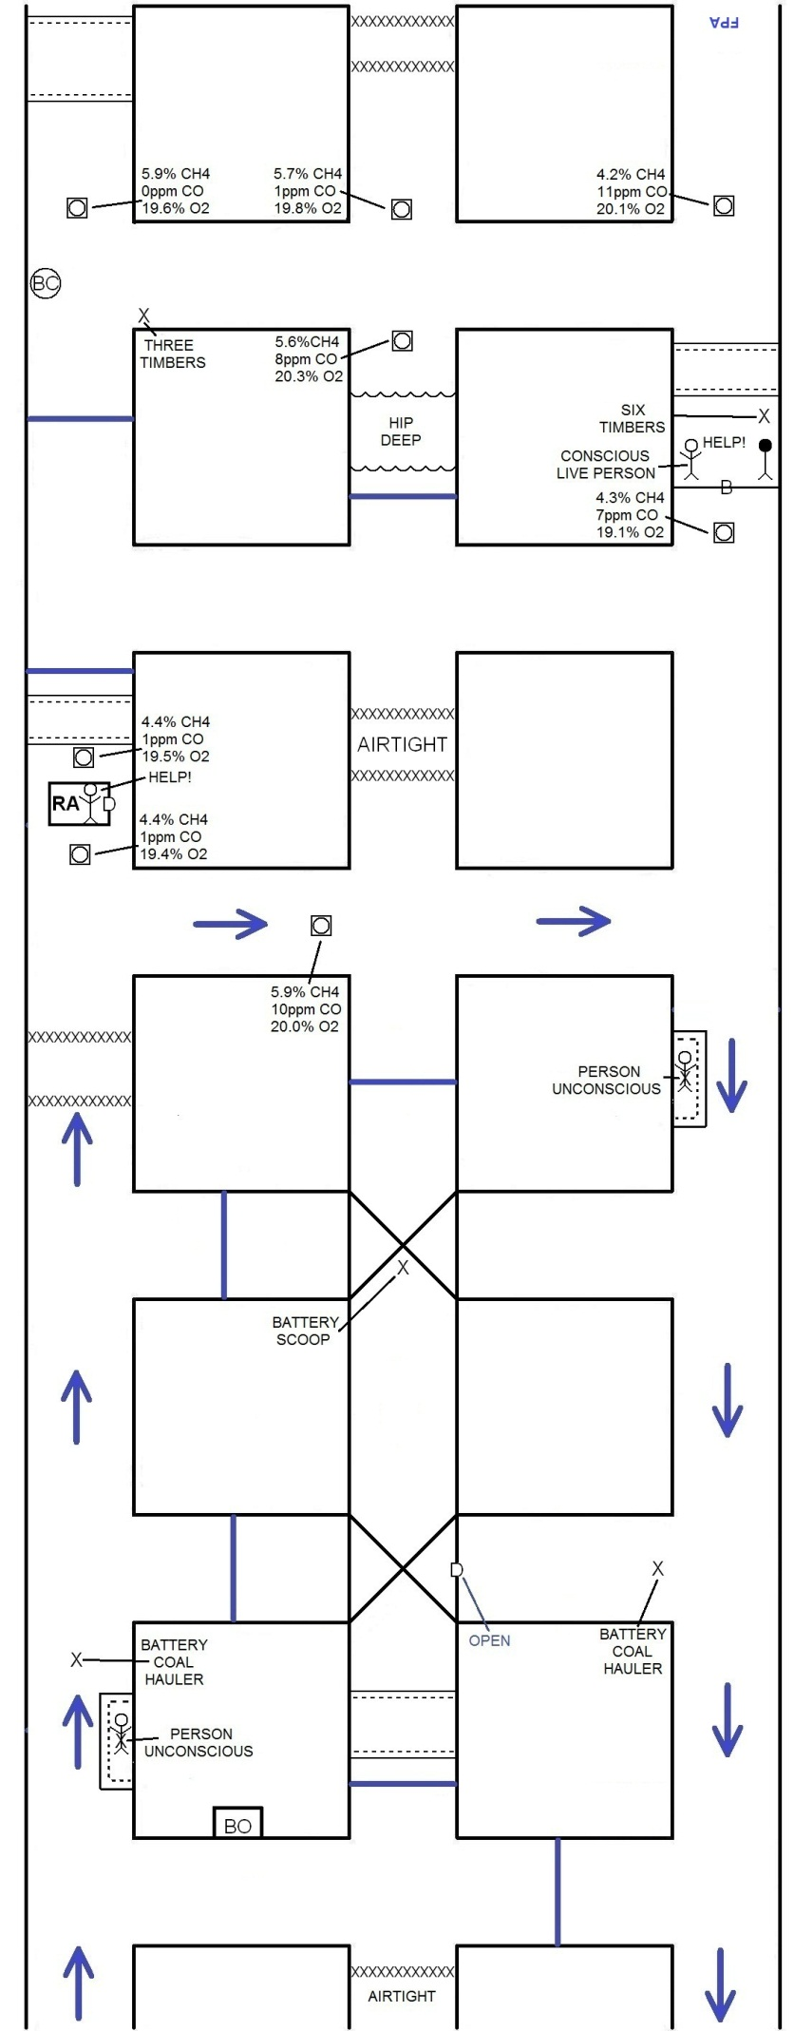
VENTILATION 3
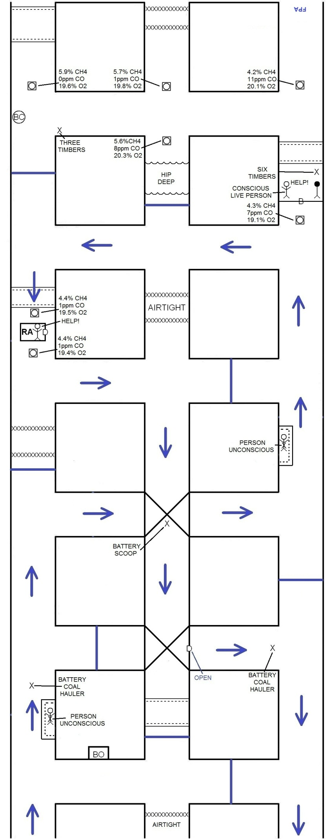
VENTILATION 4
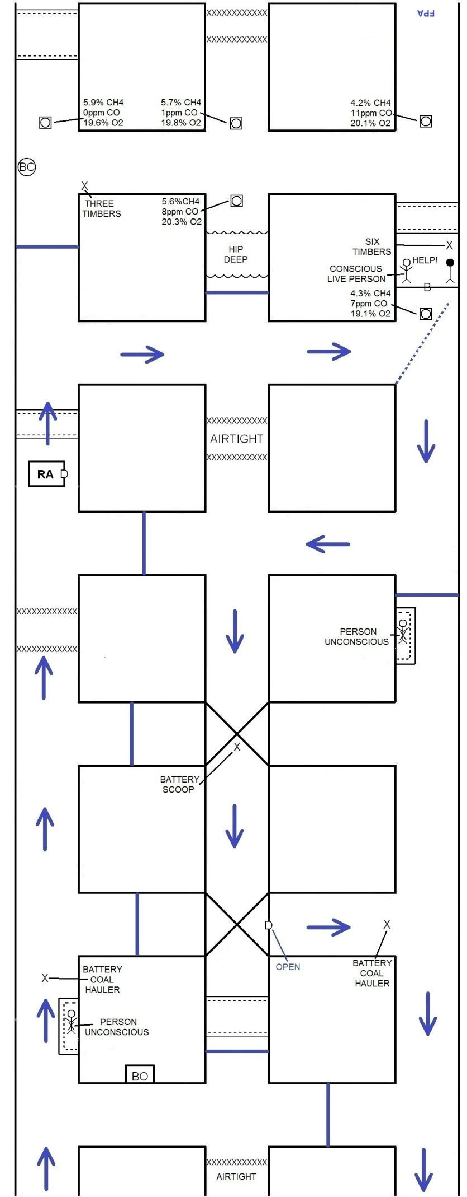
FPA AND ELONGATED UNSAFE ROOM
