TEAM __________ FIELD __________
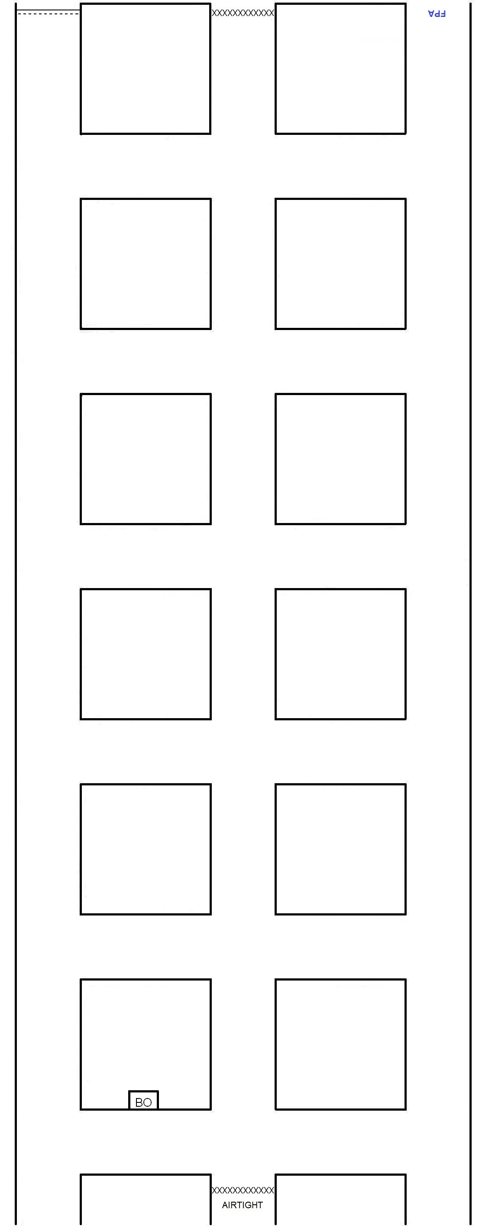
BRIEFING OFFICER’S MAP

