Statement;
Welcome to the Olivia Run Mine we are thankful that you responded for our call for assistance, you and your team will have seven (7) minutes to review this statement, and lay your equipment from the time you were handed this statement. A one (1) minute left warning will be give your team left to start the clock.

Last night on the owl shift a three-man crew was sent to deliver a tail drive motor and supplies using a battery scoop up the tailgate side of Longwall # 235. The men radioed out to the dispatcher at 2:30 A.M. and stated that, (the brakes on the scoop had locked up, overheated and caught fire that they were trying to extinguish the fire). The three men on the tailgate radioed outside that they could not put out the fire and that they were heading to the Refuge Chamber. Due to the reported active fire in the mine the decision was made to evacuate the entire mine and to call the rescue teams out. Everyone has been withdrawn from the mine except for the three men at the longwall tail area.

You have now arrived at the fresh air base located on the longwall tailgate entry which was set up by previous mine rescue teams. The intake air is moving up the #1 entry across the fresh air base to the return in #3 entry. The entries are number from left to right as #1, #2 & #3 entries. Intake air is also coming up the headgate side of the longwall and moving across the longwall face toward the tail as well as into the gob then into the return and out to the exhaust fan which is located on the surface. The longwall return and the return coming from the fresh air base are in common outby the fresh air base. Radio communications to the tailgate area are maintained by a leaky coaxial cable run down the longwall face which requires line of sight to operate should the line of sight signal get blocked radio communication will fail. The exhaust fan is running, guarded, monitored and cannot be stopped or reversed. Temporary stoppings have been built in entries #1, #2, and #3 just inby the fresh air base by a previous rescue team. Efforts to reach the tail area by previous rescue teams traveling down the longwall face were blocked by water over waist deep. This information is shown on the maps that you will be provided as well as the intake air movement across the longwall face toward the tailgate and the intake air moving across the fresh air base.

The mine maps that you will be provided are up to date and accurate, all power is locked out coming into the mine, the mine is walking height and supported by roof bolts. All Federal and State agencies are on site to assist and several mine rescue teams with apparatus are here to serve as your backup while you are in the mine. This mine has bad roof, and water can accumulate quickly along with build-ups of methane. Good luck

Instructions to the Team:

Explore all areas of the mine that can be done safely

Bring all survivors to the Fresh Air Base

There will be a 60-minute time limit on the problem any team who does not return to the Fresh Air Base to shut off the timing devise will be discounted for not completing the problem. At the 55 minute mark the time judge will give the team on the field a 5-minute warning.

The enclosure for the briefing officer that is located in the fresh air base is equipped with a flap (for a door) that once the flap is closed it will make the briefing officer’s station an air tight enclosure. Once the briefing officer is inside with the flap is closed this enclosure will protect the Briefing Officer from irrespirable atmospheres as long as the flap is kept closed while he is inside of the enclosure.

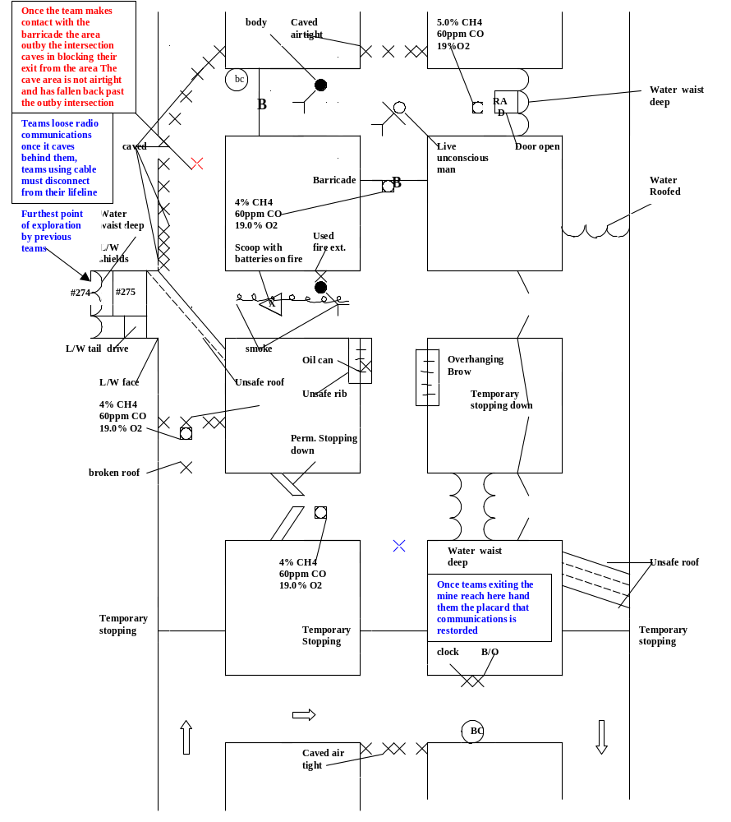
Once the flap is closed at the B/O station it will be an airtight enclosure
Caved airtight

BC
Clock
B/O enclosure
Caved airtight
Temporary stoppings
Temporary stopping
Water waist deep
#274 #275
#272 #273
Furthest point reached by previous Mine Rescue Team
L/W Face
L/W gob area
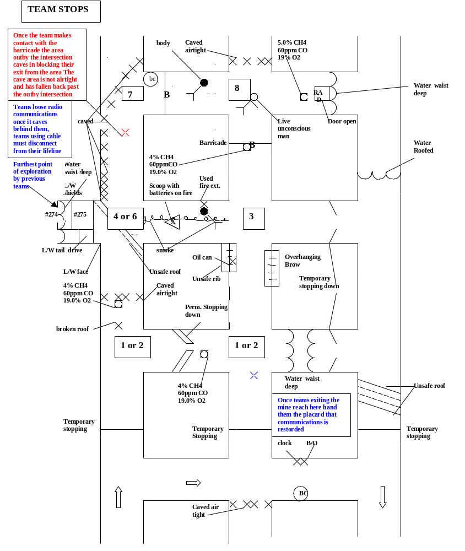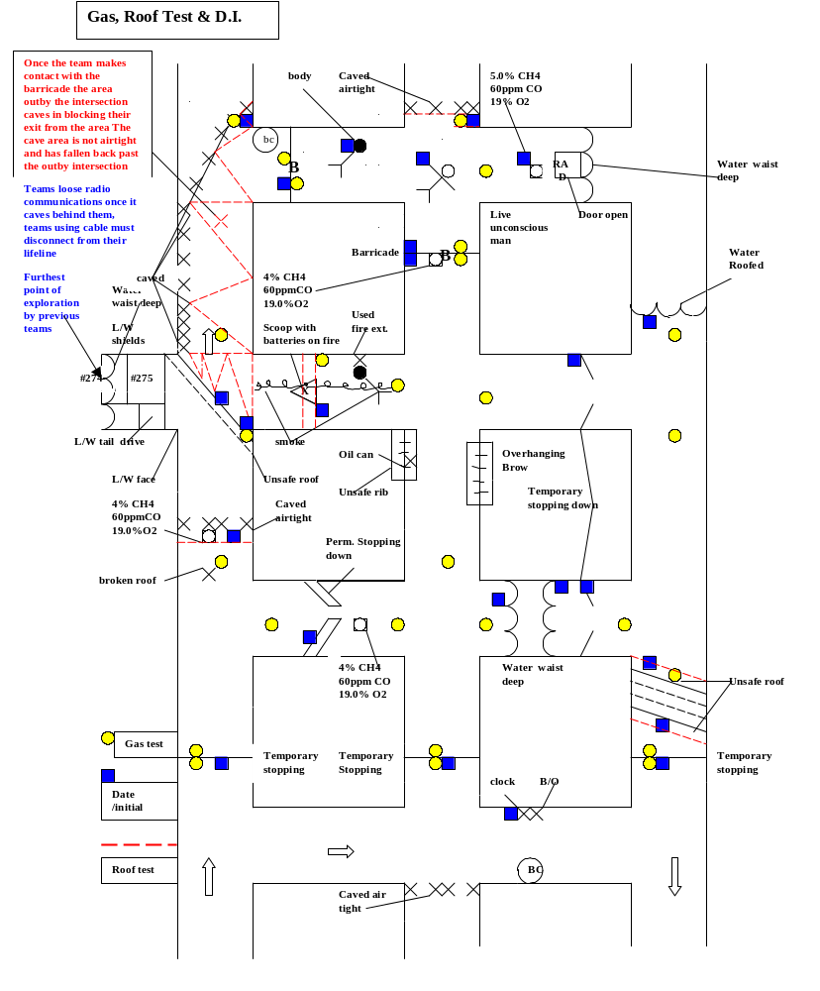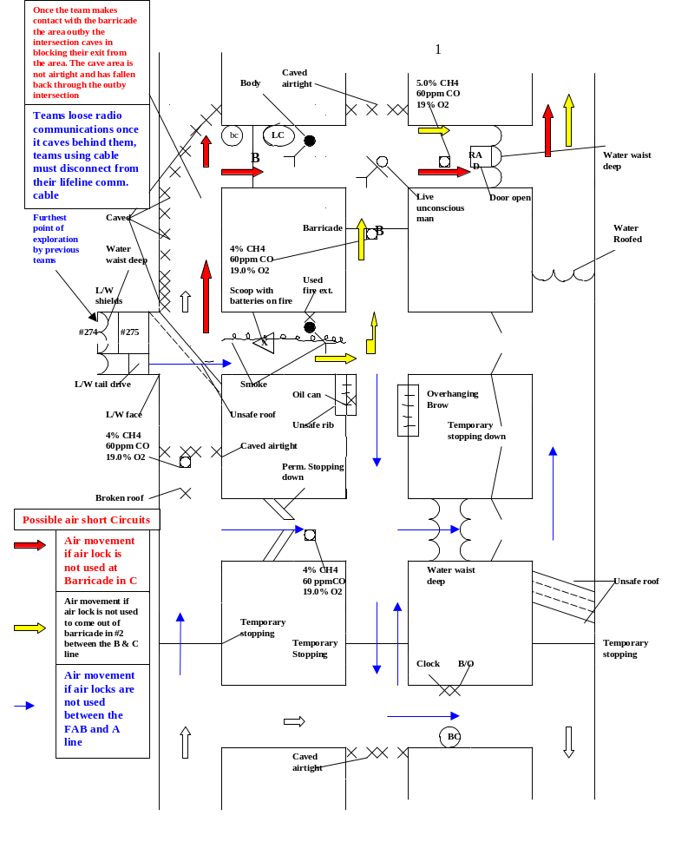Key Points of the Problem;
5 or 6
4 or5

- Air locks must be maintained in entries # 1, #2, and #3 so that no air movement is allowed from the fresh air base in or out of the unexplored area. If a stopping is left open at the fresh air base area air may move inby into unexplored areas in #1 entry (in two separate areas) and may move from the longwall face area. So entry into the mine will allow the team to make team stops #1 or #2 in either #1 or #2 entries.

- If the team enters the mine in #1 entry the gas located in (A) cross cut will extends into the intersection in #2 entry in (A) line. If the team enters the mine in #2 entry first they will encounter the gas mixture between #1 and #2 entries in A line in direction of travel toward #1 that gas mixture will extend into the first intersection in #1 entry in (A) line instead.

- At team stop #3 in B line in #2 entry teams will be able to reach the barricade from that stop, but they can not ventilate it since they do not have means (no line curtain) and they have no response. The cross cut 2 to 3 is open and clear but the cross cut 2 to 1 has smoke in it 4 foot into the cross cut. For teams using radios this will require the team to get onto the link line and for the # 5 person to tie off in fresh air prior to the team travels into the smoke (Rule 22). If the team is using the communications cable they already are tied to the Fresh air base, but need to be on the link line between team members (Rule 22)

While at team stop #3 the first thing the team encounters in the smoke will be a body. The body which requires the captain to touch (Rule 32) and date and initial (Rule 27) before passing it. Further into the cross cut toward #1 entry, the captain will encounter a fire which prior to passing it requires a Roof and Rib test (Rule23) a gas test (Rule 24) and date and initial (Rule 27) because it stops travel. Then prior to passing the fire the team must extinguish it (Rule 30 C).

From this stop the team may advance towards #1 entry since the end of smoke placard can be reached at the imaginary line of the intersection indicating the end of the contaminate. Or it may advance towards #3 entry through the open and accessible crosscut to tie behind before proceeding inby.

- Team stop # 4 or #6 can be in #1 entry in B line at this stop there is diagonal unsafe roof across the entry which is on the corner of the intersection on the left inby corner this will require the intersection to have a roof and rib test in a zig zag pattern (Rule 23 Paragraph #3 fig. 1a pg. 36) also the outby end of the unsafe roof is below the intersection this is an opening of the entry and requires a gas test (Rule 24) and date and initial since it stops travel into this opening (Rule 27). Please note that due to the caved area on the inby corner of the intersection the captain cannot reach into this area while making his roof and rib test (Rule 30).
The captain as he makes his reach inby in #1 entry will have to perform roof and rib test up the entire entry till the 25 ft. reach mark is made due to the caved area on the left rib (Rule 23 paragraph 6 fig. 1a pg. 36).
If the team has not yet tied to #3 entry it will need to return to team stop area #3 which will require the team to enter the smoke again and prior to any team member passing the fire area the captain must perform a roof and rib test (Rule 23 paragraph 8).

- Team stop #4 or # 5 in B line in the intersection in #3 entry the team is required to tie # 3 entry outby before exceeding the 2 break limit also this is an open and accessible cross cut which must be explored prior to passing it (Rule 45 E).

- Team stop #5 or #6 is in the first intersection in # 3 entry is will tie all outby areas in #3 entry also the captain’s presence has traveled above and below the unsafe roof in # 3 entry so conditions are know in the unsafe roof area there.

7. Team stop # 7 will be in the C line in # 1 entry please note that for the team to arrive there the team will again have to travel pass the fire area between # 2 to # 1 entries and prior to anyone passing the fire area the captain must test the roof and ribs (Rule 23), and the #5 man must be tied off in an area clear of smoke prior to the team moving into smoke if they are using radios. The intersection in #1 entry at C line has a diagonal caved area that goes inby the intersection corner to the rib this again is an opening requiring a gas test and the roof and rib test along with a date and initial since it stops travel into this opening (Rule 27) also since the intersection has an unsafe roof condition this will require a zig zag roof and rib test in the intersection (Rule 23 paragraph 6 last sentence). Once the team stops at this intersection Judges please place a placard on the ground 4 feet outby the intersection in #1 entry that says caved. Also please hand a placard to the # 5 man that states [The area in #1 entry has caved outby this intersection to the outby intersection and the team has lost communications to the Fresh Air Base] Judges please have the superintendent at the Fresh Air Base have the briefing officer turn off his radio. There will be no further communications between the team and briefing officer until the team returns to the area of team stop #1 or #2 at the intersection in #1 or # 2 entry in (A) line or if the team chooses the fresh air base. For teams that are using the communications cable system for communications have the # 5 man disconnect from his communications cable. The Superintendent at the fresh air base can tell the briefing officer that he has loss communications with the team.
From this stop the team will need to air lock through the barricade (Rule 43) if they do not air lock through they will allow air to move from the longwall face inby into unexplored areas. There is an explosive mixtures in the #2 to # 3 cross cut of the C line that will be moved through unexplored areas (Rule 31 C) also since two people are unaccounted for at that time irrespirable will also be ventilated through the unexplored are (Rule 30 F). As the captain opens the barricade the captain is required to make the gas test (Rule 24 D). The captain will then move towards #2 entry and encounter a body which will require his touch and date and initial before any team member passes the body. He then can advance toward # 2 entry and team stop # 8.

- Team stop # 8 will be in the intersection of #2 entry in C line here the captain will encountered a live unconscious live man who will require the captains touch and date and initial then the captain can let another team member perform an initial assessment under (Rule 12). The captain may then complete his inspection of the intersection, (Rule 42 B paragraph 1) allows exploring ahead of the patient to be limited to 25 feet. The area inby the intersection will require a gas test and date and initial for the Roof and Rib test at the caved airtight. The captain as he explores toward the cross cut #2 to # 3 in C line will find an explosive mixture and evidence of fire on the same placard (8 feet) into the cross cut. The team now has accounted for everyone that is missing, the captain has an imminent danger of an explosion and means to remove the patient along with the team safely from the mine. If he explores toward the cross cut #2 to #3 in C line any further than the gas placard he is continuing to explore and under (Rule 31 B paragraph 1) he should be discounted for this as endangering the team and the patient. Also (Rule 31 B paragraph 2) states that when a withdraw situation exist in an intersection the team can go to any location already explored at that stop prior to exiting the mine. By moving into the cross cut any further he will be continuing to explore. However if the captain explores outby the intersection first toward the barricade located in #2 entry and makes the inby side of the barricade before going toward the crosscut toward # 3 entry or inby toward the caved airtight. He now has means with the removed barricade the have traveled through in the crosscut from # 1 entry to remove the patient safely from the mine. If they do not proceed to remove him it can be considered delay under (Rule 42 B). The team will have to air lock out of the area to remove themselves and the patient to the Fresh Air base (Rule 42). Please note that if the team does not air lock out they will allow the air that is moving across the longwall face to move toward the #2 entry through B line picking up irrespirable gas mixture and smoke in that cross cut and moving it up #2 entry also picking up the irrespirable mixture in front of the barricade and moving them over the team and under (Rule 22) the team must be tied off in an area clear of smoke before traveling through or passing smoke over them the smoke. Also if the patient is not properly protected with a CareAdvent, or an apparatus these mixtures will move over him (Rule 34). This air movement will move the explosive in the cross cut #2 to # 3 into unexplored areas (Rule 31C).

- If the team properly air locks out of the barricade area they must also airlock out of the area in either #1 or # 2 entries between the Fresh Air Base and A line. At this airlock the team will be given a placard stating that radio communications is re-established and the team can communicate with the briefing officer as stated in (Rule18). Teams using a communications cable will be given back their communications cable end and allowed to re-attach and give standard lifeline signals to a judge as well as communicate with the fresh air base (Rule 18). It is important that Judges let the team know they have radio communications or give back the lifeline cable end at this air lock stop. If the team does not airlock out give them the placard or cable end when they stop to take down the stopping or inby the fresh air base. If they do not air lock out they will allow air to move from the longwall face outby to the Fresh Air Base and over the briefing officer (Rule 36), ventilation under (Miscellaneous Rule 4) and if the briefing officer comes out of his enclosure he will be exposed to the irresirable.

Please note that from the start of the problem air is shown as moving across the longwall face toward the tail as indicated on the maps provided to the team and also it is stated in the statement provided to the team. (Miscellaneous Rule 4).

10. If the choose to remove the patient from this airlock to the fresh air base without moving the #5 man they can and the # 5 man can re-establish communications with the briefing officer and transfer information about the area explored to update the B/O map. However if the team does not remove the patient to the fresh air base and choose to transfer information to the briefing officer about the area explored to update his map first this can be considered patient delay under (Rule 42 B). Since the team has been allowed to re-establish communications with the Briefing Officer who is still isolated they will not be permitted to visually compare maps between the team map and briefing officer’s map, but they may communicate with the briefing officer by radio or communications cable to update the briefing officers map before clocking out or until the time limit is reached for the working of the problem (Rule 18 paragraph 5).

11. Judges please note the time on the field clock and give the team a (5) five-minute warning before the 60-minute time limit is reached.

Key points for Field Judges
As the team enters the Fresh Airbase the Superintendent of the Fresh Airbase should ask for the captain or briefing officer of the team and hand them the written statement for the problem. This should be done within 15 to 30 seconds from when the team arrives in the Fresh Airbase. The Judge can tell the captain or briefing officer that he will have seven (7) minutes to review the statement and stretch out his life line and unload his equipment, and he will be given a warning at the 6 minute mark that there is one (1) minute left to start the clock.
Once the Captain or Briefing Officer has been handed the written instructions the Superintendent in the fresh air base should start his timing device, (not the Field Clock). At the six (6) minute mark this Judge should let the Captain or briefing Officer know there is one (1) minute remaining to start the field clock. Also the Superintendent of the Fresh Airbase must be aware when to start the team’s field clock if the captain fails to start it at the seven (7) minute time limit. The Time Keeper Judge can start his timing device simultaneously with the captain or Judge for the field time. This way the Superintendent keeps the clock for the seven (7) minute time limit and the timekeeper judge keeps the field and pack check times. (If the captain fails to start the field clock by the seven-minute limit discount the team under Rule 50)

The briefing officers station at the fresh air base with have a flap for a door once this door is closed and the briefing officer is inside it will be considered an air tight enclosure.

The areas in #2 entry outby the second intersection of unsafe rib and overhanging brow don’t require a roof and rib test.

From team stop # 3 in the second intersection of #2 entry the team must be attached to a link line before any team member enters into the smoke. The fire area will need the roof and rib area tested, and a gas test before extinguishing the fire. Before the team advances through this cross cut toward #1 entry the #5 man must tie off in air clear before advancing into smoke.

At team stop #4 or # 6 the intersection will require a roof and rib zig zag test. The area outby the intersection requires a gas test and date and initial. The entry inby the intersection requires the roof and rib test to be a zig zag pattern.

At team stop #4 or #5 the team is require to tie the open accessible cross cut toward # 3 entry and also tie across and behind before exceeding the two break limit.

At team stop # 7 the team once the # 5 man stops at the intersection the Judge will need to put a placard down four (4) feet outby the intersection in #1 entry outby C line that says (CAVED) he will hand another placard to the # 5 man that states there has been a cave in outby his location to the outby intersection and they have loss communications to the fresh air base. The Judge will need signal the Superintendent at the Fresh air base to have the briefing officer turn off his radio so no further communications between the Briefing officer and the team occurs. For teams using lifeline cable for their communications have the briefing officer take off his headset until he told that communications is re established, and hand him the statement from the packet explaining that he (the briefing officer) has loss communications with the team.

Once the team has air lock out of the barricade area in # 2 entry and traveled out to the airlock just inby the fresh air base with the patient. Judges will please give the # 5 man a placard stating that communications has been re-established with the fresh air base. Signal the superintendent at the fresh air base to let the briefing officer know that he can turn on his radio and communicate with the team. If the team is using life line cable for communications hand them back their cable end (have their alternate person pull it back for them to that location prior to them reaching it) so they can re-attach to the cable, give the judge standard life line signals and re-establish communications with the fresh air base. The superintendent at the fresh air base will need to tell the briefing officer that he can put his head set back on communicate with the team.
This will allow the team to communicate with the briefing officer what items he needs on his map in the area that the team explored after the team loss communications with the briefing officer.

Time Keeper please let the team know when they reached the 55-minute mark for their working time. Once the 60-minute limit is reached judges please take control of the team and briefing officers maps and let the captain know his time has expired. Please discount teams per (Rule #3)

Hand to the # 5 man at Team Stop # 7 once the caved placard has been laid down outby
Hand to # 5 man on the field

The entry has caved in across the entry behind you back to the outby intersection blocking your exit, and you have loss communications with the briefing officer at the Fresh Air Base.
Teams using lifeline cable for communications must disconnect from their lifeline cable.

Teams using radios for Communications will not be able to communicate with the B/O

(Judge)
Hand this to the Briefing Officer once the area has caved in behind the team at Team Stop #7
(For teams using Radios)

You have loss communications with the team please turn off your radio at this time

(Judge)
Hand this to the Briefing Officer once the area has caved in behind the team at Team Stop #7
(For teams using Communications Reel)

You have loss communications with the team please take off your head set at this time

(Judge)

Hand to the # 5 man when the team stops to airlock out as they are traveling out with the patient

Hand to #5 man

Communications with the Fresh Air Base have been Re-Established you must now communicate with the Briefing Officer using your communications system and inform him as to your team’s intentions.

Teams using lifeline cable must re-attach to the lifeline and re-establish communications with the briefing officer located in the Fresh Air base to inform him of your intentions.

(Judge)

Hand to the briefing officer once the team is at the airlock to return to the fresh air base with the patient

Communications with the team has been Re- Established you can talk to them by radio or communications cable whichever one that your team is using.

